BNG Assessment Report for Bridge Inn Caravan Park, Common Drove, Crowland, PE6 0HJ

Site address: Bridge Inn Caravan Park, Common Drove, Crowland, PE6 0HJ
Date of Site Walkover and Survey: 17th December 2025
Conducted by: Dr Fiona Watson BSc(Hons) MEd PhD, consultant ecologist.

- Introduction
This document has been prepared on behalf of Mr O’Connor to assess the existing ecological conditions and proposed biodiversity enhancements at Bridge Inn Caravan Park, Common Drove, Crowland, PE6 0HJ. Following the preliminary survey on 17th December 2025, this report outlines the site’s current condition and use and the planned biodiversity improvements as per BNG Net Gain regulations.
Coastal and Floodplain Grazing Marsh is found along the banks of the Welland River to the South of the Site (see Fig 1.1). However, the current access to the site in the proposed development will not change and, therefore, it is not expected that the development will negatively impact the grazing marsh.

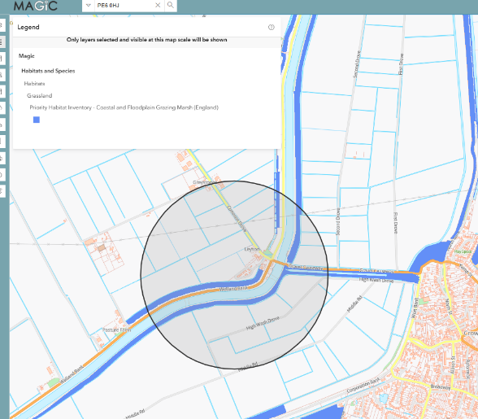

Fig 1.1 MagicMap showing area of Coastal and Floodplain Grazing marsh within 500m of site boundary.

- Site description
The site is currently in use as holiday caravan park, with 13 static caravans situated on unsealed, unvegetated surface (17% of total area) surrounded by modified grass assessed to be in poor condition (83% of total area). See Fig 2.1 (Google maps). The proposed development will replace these with three, larger, static caravans.
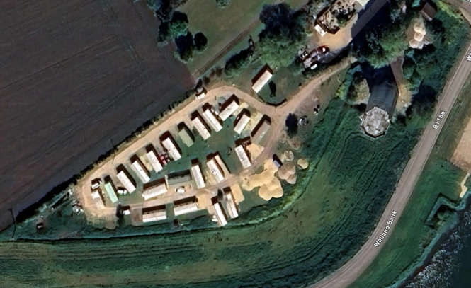

Fig 2.1 Google Maps image of current caravan site.

- Assessment of habitat conditions.
The initial site walkover and survey was conducted during December. The grass was dominated by Lolium spp. with small patches (<5%) of Trifolium spp. Lolium spp. is characterised as being hardy and fast growing; this, coupled with the mild conditions in the autumn and early winter, meant that the condition of the grass was suitable for assessment in terms of density, species present and height of swards. Additionally, photographic evidence (provided by the owner) of the conditions in the previous summer was also used as a reference point in order to uphold the BNG principles of a fair and ecologically appropriate starting point. See Figs 3.1 and 3.2, below.
Over 90% coverage of grass was recorded, with few patches of bare ground. Despite being a caravan park, there was no evidence of vehicular use of the grass such as tyre marks / worn areas left from recurrent parking. However, species diversity was low, the variation in sward height was minimal. The grass around the electricity points provided for the caravans was longer, but in poor condition, with less than 50% being in a condition that would ensure growth the following season (see Fig 3.1)
There were no scrub, bracken, nor trees present on the site.
The unsealed surface showed sufficient run-off as to provide the grassland with necessary water.

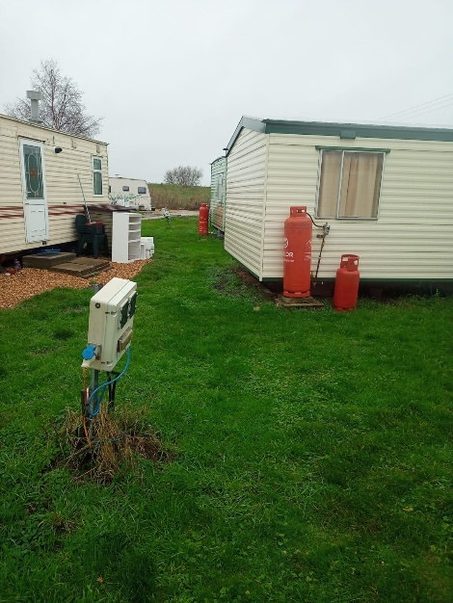
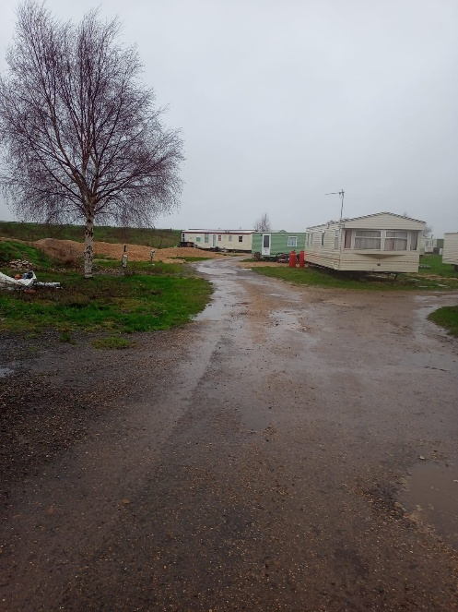

Fig 3.1 modified grassland. Fig 3.2 unsealed surface

- Biodiversity Net Gain Compliance, Proposed Enhancements and Off-site Requirements
The proposed development and associated biodiversity measures do not meet the required 10% net gain (see accompanying small site metric). As such, an offsite requirement of 0.9951 area habitat units will be required to offset the development. Despite this, Mr O’Connor has expressed that biodiversity should be enhanced within the site as much as possible. Therefore, the following measures have been recommended.
The proposed development will retain 698 m² of the existing, modified grass. As per the accompanying condition assessment sheet, the dominant grass species present (Lolium spp) is suitable for the intended use due to its being hardy and fast growing; these characteristics mean that the retained grass areas can be reseeded and watered during the growing season to improve the condition to good. Additionally, the location of the retained areas on the boundary of the property (see Fig 4.1) will enable the area to be fenced off during establishment of the new seedlings, restricting degradation from footfall and further enhancing the growth and improved condition of this area.
To enhance biodiversity within the site, two areas of mixed scrub species will be planted and maintained. As above, the location of these at the site boundary (see Fig 4.1) will enable these areas to be screened off during the first growth seasons to allow them to establish. Low level guards can be put in place to protect from grazing by herbivores beyond the boundary. To ensure these are kept in ‘good’ condition, watering of the scrub may be necessary in extended periods of hot and dry conditions.
The proposed development has vegetated gardens associated with each of the three, new caravans; these fall out of the remit of the BNG net gain maintenance of 30 years and, whilst the intention is for these to be planted with a diversity of species, they will still offer low habitat distinctiveness and a condition assessment is not necessary.
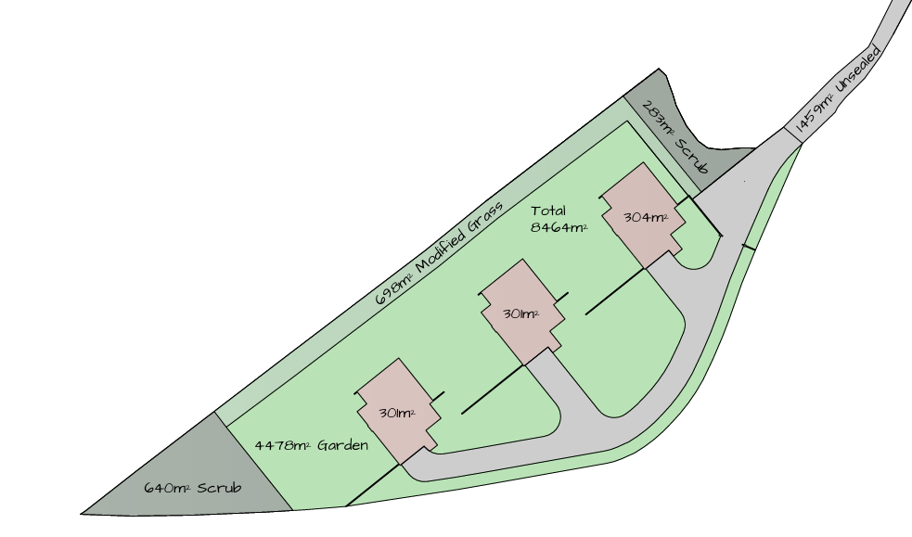

Fig 4.1 Outline of proposed habitat types within new development.

- Suggested enhancement methods

5.i Modified Grassland
Current condition: poor
Target condition: good

- Prior to reseeding (b) the area should be aerated using a light harrow or fork to break up compacted soil, allow water infiltration and penetration of root growth.

- Reseed the grass with a hardy, fast-growing species such as a rye grass (Lolium spp). Introduce mixed wildflower seeds into the grass seed mix and include species such as meadow grasses (Festuca rubra) and wildflowers such as Oxeye daisy (Leucanthemum vulgare), which will benefit pollinators.

- Seeding should take place in autumn or early spring and watered during periods of extended hot and dry conditions.

- The seeded area should be screened to prevent access during establishment and allow rapid establishment and growth.

- The area should be left to grow during the spring until late summer, and any cutting should only take place after the final flowering of the wildflowers (July onwards). This will allow maximum pollinator activity and natural reseeding in the following growth season.

5.ii Introduced Scrub
Current condition: N/A
Target condition: good

- The area to be planted should be prepared before planting, digging over the soil to improve water infiltration and aeration.
- The species selected should represent native species such as hawthorn (Crataegus monogyna)and bramble (Rubus fruticosus). These will increase structural diversity and therefore a greater range of ecological niches; additionally, once established, the flowers of both species will benefit pollinators and the flowers will provide nourishment for birds.
- After planting, low level screening from herbivores should be put in place and the areas containing the scrub should be fenced off to prevent damage from people and animals. This will allow the bushes to establish more rapidly.
- Annually, any weaker specimens within the scrub should be thinned out and removed, as should non-native species. This will reduce inter and intra specific competition and allow the remaining plants to thrive. The woody stems of the scrub that are removed can be placed at the edge of the scrub area and provide habitats for invertebrates and small mammals.
- Organic mulch should be applied around the root bases to retain moisture and improve soil health. During prolonged hot, dry conditions, the mulch will retain moisture. A watering regime can also be introduced to ensure sufficient water is provided.
- Regular weeding of the area will be needed and any grassland bordering the scrub should be monitored and cut back so it does not invade the area under the leaves: invasive grass of any species can compete for nutrients and lead to weaker growth in the scrub.

- Conclusion
The baseline conditions at the site represent poor habitat diversity and, of the grass that is present, it is in poor condition. Whilst the proposed development will not meet the 10% net gain, and offsite units will be required, the recommended enhancements will provide a diversity of natural species which will be of benefit to pollinators, invertebrates and small mammals.

Dr Fiona Watson, BSc (Hons) MEd PhD. Consultant Ecologist

