Pictures showing the proposed building plot at 20 barbers Drove North

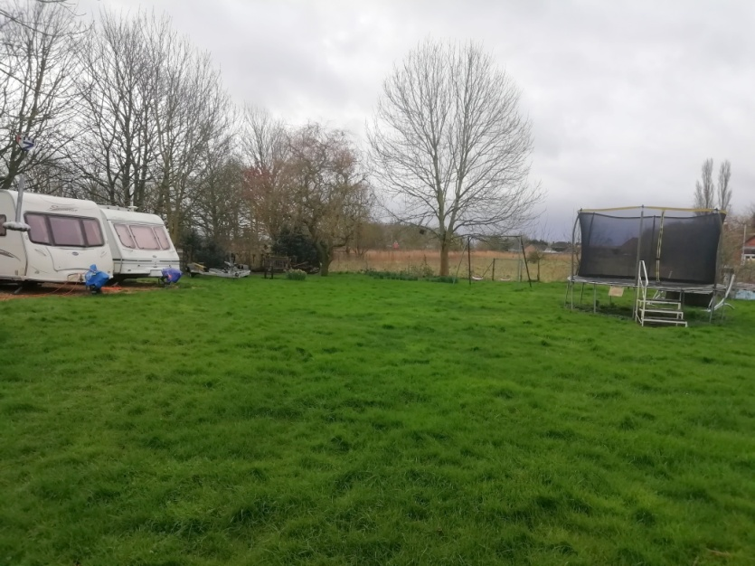 Facing South
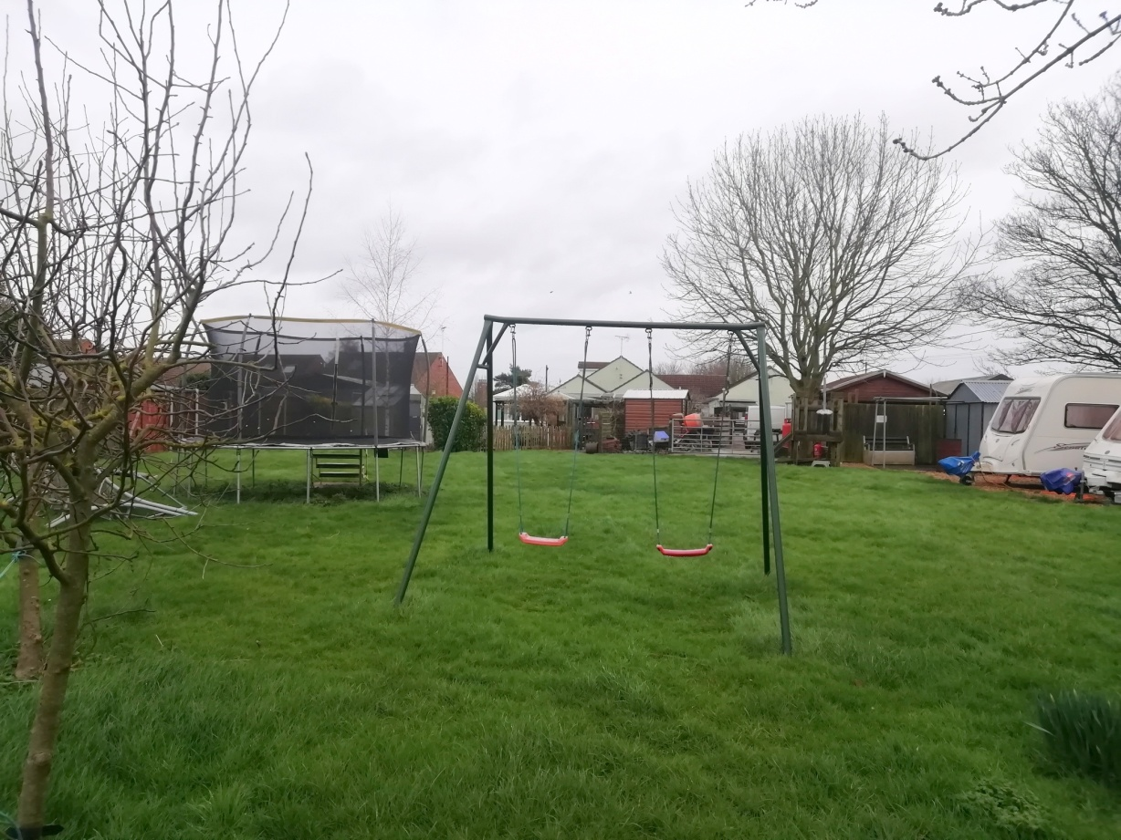 facing north

