Design and Access Statement 20 barbers Drove North

1. What are the features on the existing site?

Garden with existing trees.
- boundary to the west – existing 6ft high wooden fences belonging the the properties in Harrington Way
- Boundary to the north separating the plot of land from the existing property - proposed 6ft high fence.
- Boundary to the East – currently wire fencing with trees on the adjoining strip of land at the side of James Rd
- Boundary to the South - .to be decided by purchaser of land and any requirements laid down by the planners.
- There are a number of trees on the land but no protection orders in place.

2. access

- Approach to the land to be via shared drive with existing property. Opening to the highway 5.5mt. Minimum width of drive 4.4mt.
- Access to existing parking areas to be maintained providing space for parking of circa 7/8 vehicles for existing property.

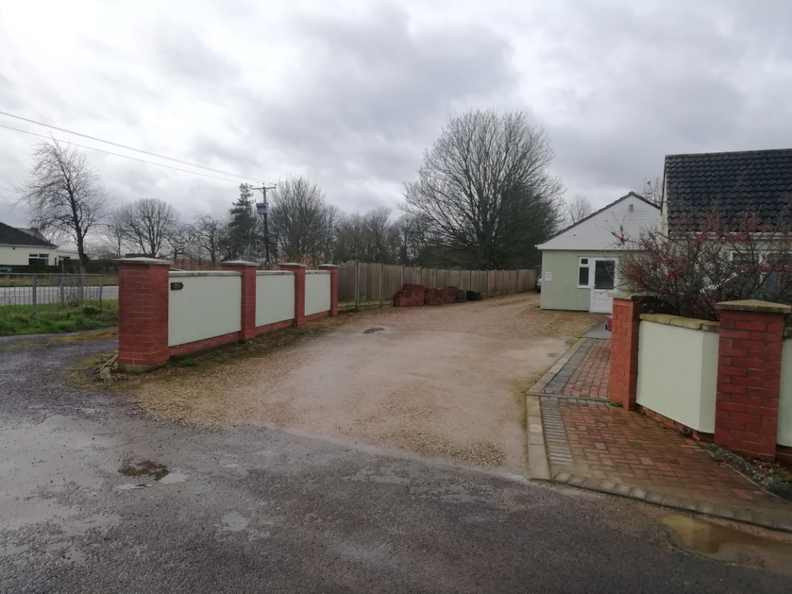

Access from Barbers Drove North

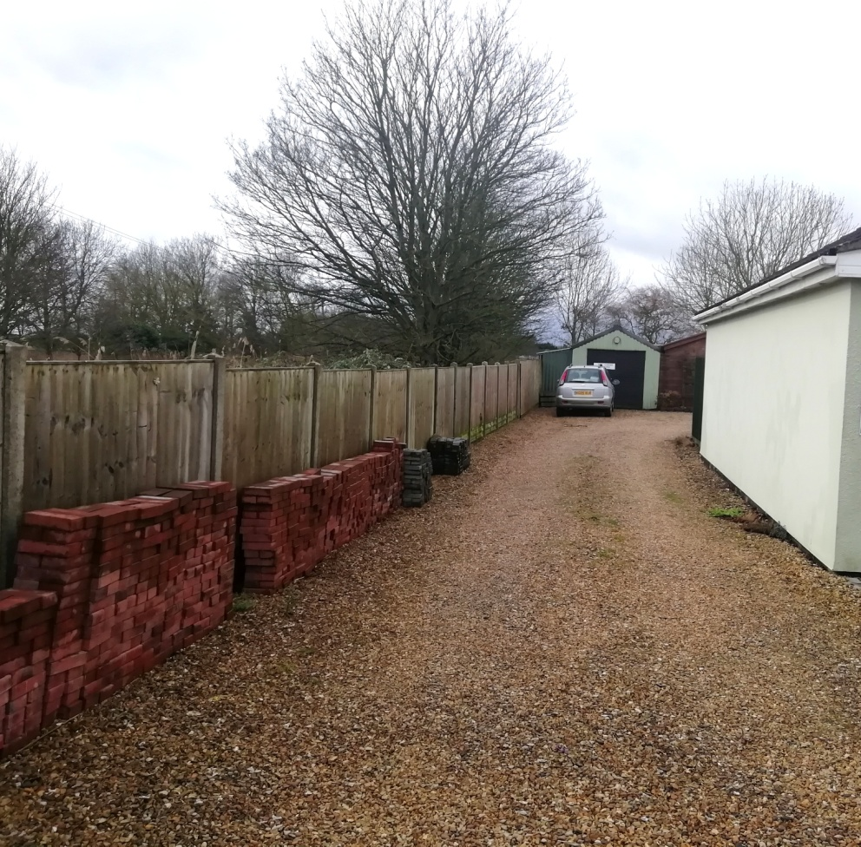

Drive showing shed at bottom to be removed

Sitting of property to provide 4.4mt drive to front, 9mt for rear garden and 8mt either side, sufficient for erection of separate garage if required by purchaser.
Proposed property to be a chalet bungalow with either dormer or rooflights facing East so not to overlook existing properties.

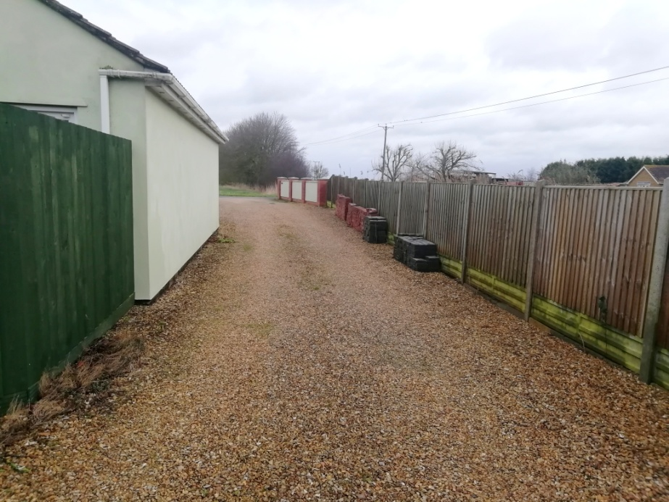
Drive from rear parking area

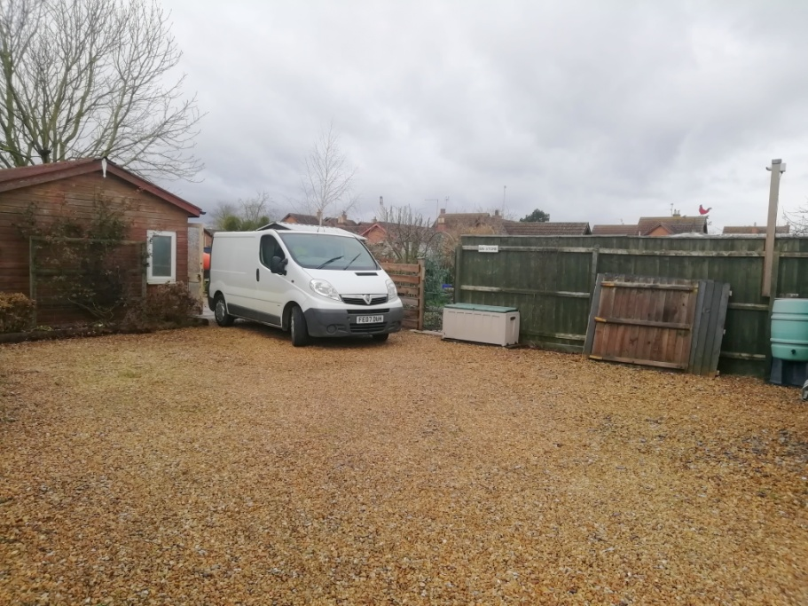

Rear parking area

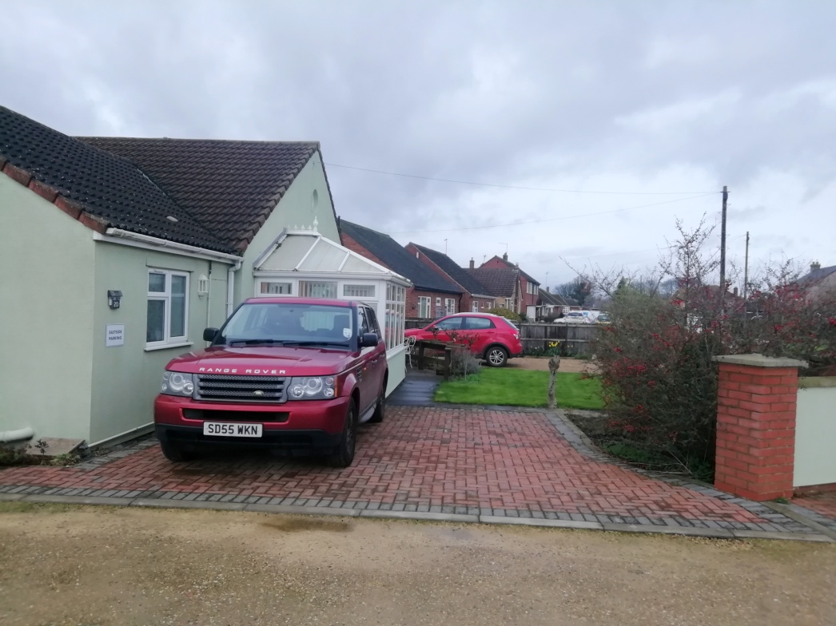
Front parking area

5.

