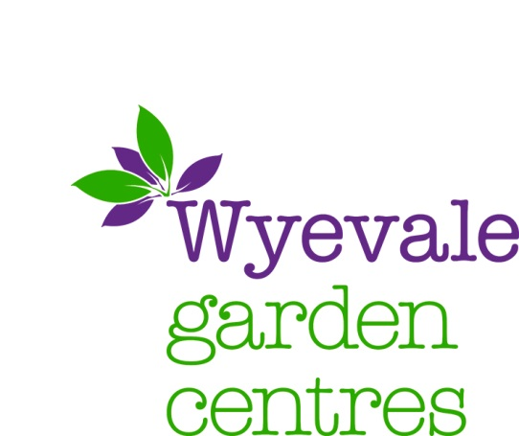
21st August 2017 Via Planning Portal

Dear Sir/Madam,

TOWN AND COUNTRY PLANNING (CONTROL OF ADVERTISEMENTS) REGULATIONS 2007
APPLICATION BY WYEVALE GARDEN CENTRES LIMITED
CROWLAND GARDEN CENTRE POSTLAND ROAD CROWLAND PETERBOROUGH PE6 0JB
PLANNING PORTAL REF: PP- 06326138

Please find enclosed an application for 2 non-illuminated entrance signs at the access to Crowland Garden Centre off Postland road.

The application comprises the following documents in addition to this cover letter:

- Application Forms
- Site location plan
- Proposed entrance sign 1 elevation, details and block plan
- Proposed entrance sign 2 elevation, details and block plan

The planning application fee of £110 has been submitted alongside this application via the planning portal.

The Proposal

Express advertisement consent is sought for the erection of two free standing non-illuminated single sided entrance signs at the access road to the garden centre. Sign 1 will measure 2.6m in height and 1.525m in width as shown on the submitted drawings. It will be 0.5m from the ground. Sign 2 will measure 2.6m in height and 1.525m in width as shown on the submitted drawings. It will be 1.5m from the ground. The proposals are necessary to inform passers-by of the location and access point of Crowland Garden Centre, which is a key local employer and business. The application is coming forward as a response to customer and visitor feedback that the entrance of the Garden Centre is hard to find, as there is no roadside signage or presence – see below images. The lack of any visibility of the garden centre was exacerbated by the bypass works undertaken in 2011 and the resultant vegetation that has established itself on land outside the Garden Centres control – see below images. This poor visibility means that customers and visitors are required to do U-turns, creating longer journeys and potential safety hazards.
The centre has significant vegetation screening along James Road, limiting views of the Garden Centre buildings, so does not have any road frontage presence or prominence, which is key requirement for the viable operation of any retail business. So clear and prominent signs are required to highlight the centre to customers, visitors and passer-by’s of the Garden Centre - see below images.

This poor visibility of the garden centre, combined with the lack of advertisements at the access road to the garden centre, is affecting the vitality and viability of the centre. This proposal looks to enhance the presence and access route of the Garden Centre.

Application site

The application site is located at the entrance to Crowland Garden Centre on Postland road, which is on the edge of the urban area. The site is adjacent to Crowland caravan and camping company, fields and residential properties.

Planning policy

National planning policy

The National Planning Policy Framework (the NPPF) adopts a presumption in favour of sustainable development, with paragraph 186 highlighting that “Local planning authorities should approach decision-taking in a positive way to foster the delivery of sustainable development”.

National Planning Policy Framework, Policy 7 – ‘Requiring Good Design’, seeks to ensure that advertisements are not poorly placed or have a negative impact on the surrounding built environment, being efficient, effective and simple in concept and operation and that advertisements should only be subject to control in the interests of amenity and public safety, taking account of cumulative impacts. It adds that only those advertisements which will clearly have an appreciable impact on a building or on their surroundings to be subject to the local authority’s detailed assessment.

Planning analysis

In accordance with paragraph 67 of the NPPF, the impact on amenity and public safety are the main considerations in respect of this application.

Amenity

The proposed signs are not visible from any residential properties, and therefore it will not impact on the amenity of any local residents.

The style of the advertisements in this application have been designed to be of a nature that is consistent with the existing garden centre branding on the site so maintaining the character and look of the area.

Public Safety

The 2no proposed signs are not illuminated and the proposed materials will not create any glare which could distract users of the highway. The proposed sign does not include any moving or flashing parts. The proposed signs are located within private land and no part are located within the public highway.

The requirement for the new signs is to highlight the existing access point of the Garden Centre as it is often missed, creating further road movements as visitors have to U-turn to return to the Garden Centre. Therefore highlighting the access point to the Garden Centre will make small localised improvements to highway safety.

Furthermore, the proposed sign does not obstruct any visibility splays, it does not obstruct or confuse road-user’s view or reduce clarity of traffic signs. The proposed colour and materials used would not be mistaken for or confused with traffic signs. Therefore, the proposed sign is not considered to cause a danger or distraction to road users.

Summary

In summary, the proposed signs are necessary to advertise and inform passers-by of the location, facilities and access point of Crowland Garden Centre.

The proposed signs are of a scale, design and nature in keeping with the traditional look and feel of the centre. They are sympathetic to the character of the area, so will not impact on the visual amenity of the surrounding area or any residential properties. Furthermore, the proposed design, scale and siting of the advertisements will not impact on public or highway safety.

The proposal therefore complies with both national and local planning policy, and should be supported by the council.

Yours sincerely,
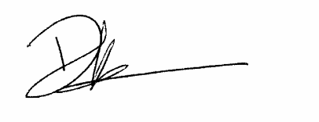

David Lazenby
Town Planning Manager

View of Garden Centre when approaching Westbound along James road:

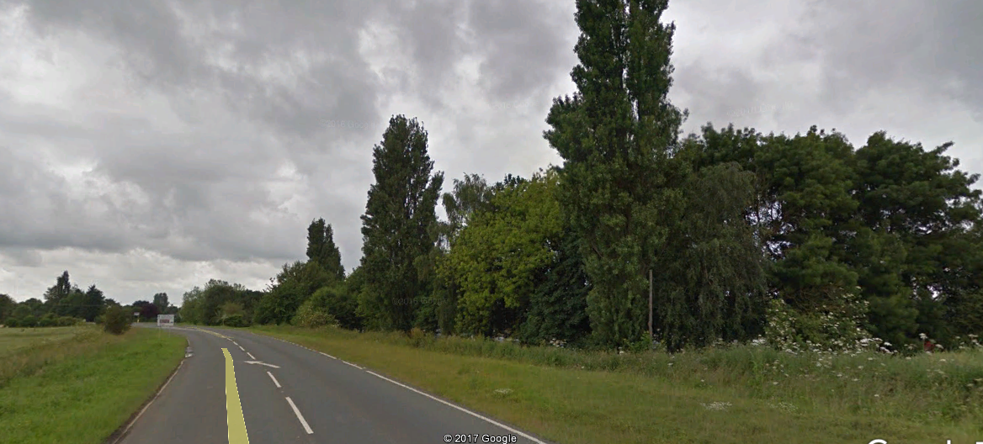

View of Crowland Garden Centre when approaching Eastbound along James road:

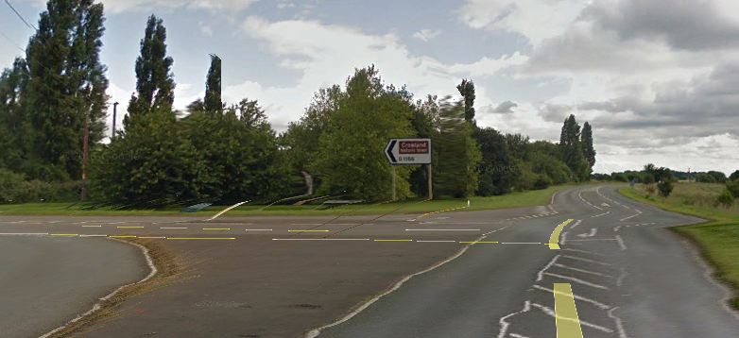

View of existing Crowland Garden centre entrance:

