Flood Risk Assessment

- Development site and location.

This flood risk assessment has been prepared to support the planning application for a drop kerb at 1 Stonehouse Cottage, Main Road, Deeping St Nicholas, Spalding PE11 3DJ. Easting 518104, Northing 313355.

We would like to submit an application for a drop kerb for driveway access to our residential property at the above address and as per the location plan, included with this application. We believe the development will be safe for its lifetime and will not increase flood risk elsewhere.

The site is within Flood Zone 3 as shown on the Environment Agency’s Flood Zone Map below.

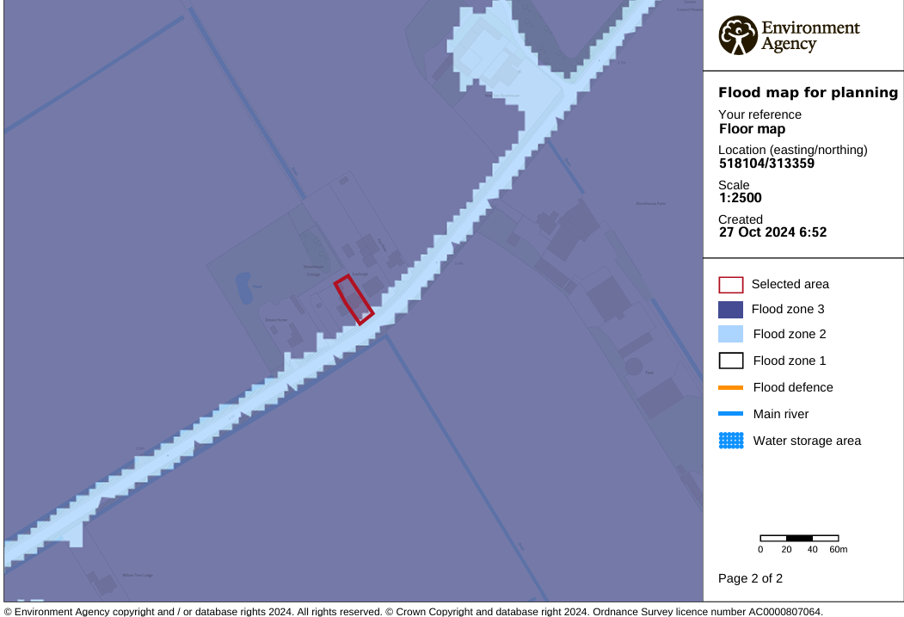
The Guidance for planning states that if a development lies within Flood Zone 3 a Flood Risk Assessment should be carried out. I have attached the correspondence from the Environment Agency with this application, together with the Flood map for this area. The map indicates the area at risk of flooding has 0.5% chance of occurring in any year for flooding from the sea or a 1% chance of occurring for fluvial flooding. It also shows the extent of the Extreme Flood outline represents the extent of a flood with a 0.1% chance of occurring in any year. They state there is no history of flooding in this area and it’s not considered to be at risk of flooding from main rivers or from Tidal flooding.

- Development Proposal

Included with this application is a current and proposed block plan to show the changes needed to install a drop kerb. A drop kerb is not listed under the National Planning Policy Framework making it difficult to assess it’s vulnerability classification and therefore whether a sequential test should be completed. The Sequential test is designed to guide development to those areas at less risk of flooding. On applying the sequential test, in this case, due to the location of our property, we are unable to locate the drop kerb to a lower or medium risk area. However the development is appropriate for a residential property and we believe it could be considered a minor development as it is an ‘alteration’ and will not increase the size of a building and there will be no change to ground levels. The development is unlikely to raise significant flood risk issues. Therefore we consider the sequential test has been passed.

As the sequential test demonstrates, there are no reasonably available, lower risk sites suitable to which this development could be steered. As its not possible for the development to be located in zones with a lower probability of flooding I have considered the exception test. It can’t be demonstrated that the development would provide wider sustainability benefits to the community as it’s a personal change of use and not one the wider community can benefit from, however the development will be beneficial to the owners of the property, now and in the future, and we believe the development is safe throughout its lifetime without increasing flood risk elsewhere. This can be demonstrated by the following information.

On reviewing the Strategic Flood Risk Assessment depth mapping the peak depth for the area is considered less than 0m – 0.25m.

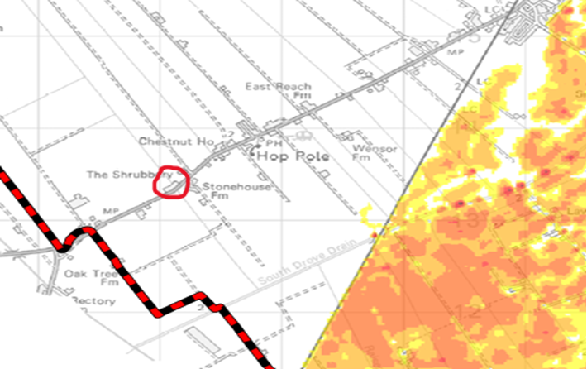

On referring to the strategic flood risk assessment hazard mapping, the maximum hazard for the area is considered to be less than 0.75 (low hazard).

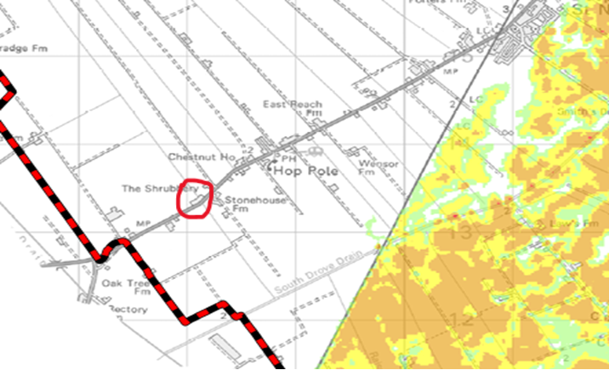

On reviewing the Surface Water Flooding on the Environment Agencies website for this area, surface water flooding is considered ‘very low’, less than 0.1% chance of flooding each year.

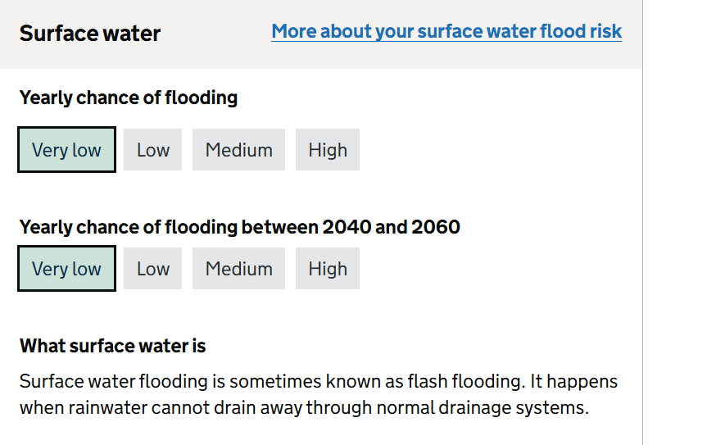

Climate Change Allowances

The Environment Agency states climate change will increase flood risk due to overtopping of defences. The climate change data included has an allowance for 20% increase in flow.

The following table provides the peak river flow allowances for the Welland Management Catchment/Anglian River basin district

Central Higher Upper

2020s 5% 10% 22%
2050s 4% 10% 26%
2080s 17% 28% 53%

The Environment Agency advises using the Central allowance for less vulnerable developments.

The following table provides the peak rainfall allowances for the Welland Management Catchment/Anglian River basin district

3.3% annual exceedance rainfall event

Central Upper
2050s 20% 35%
2070s 25% 35%

1% annual exceedance rainfall event

Central Upper
2050s 20% 40%
2070s 25% 40%

For our development and in line with The Environment Agency guidelines I would apply the central allowance for the 2070s epoch.

Sea level allowances for the Anglian River basin district for each epoch in mm for each year (based on a 1981 to 2000 baseline) – the total sea level rise for each epoch is in brackets

Allowance 2000 to 2036 to 2066 to 2096 to Cumulative
2035(mm) 2065(mm) 2095(mm) 2125(mm) rise 2000 to
2125 (metres)
Higher 5.8 8.7 11.6 13 1.20
Central (203) (261) (348) (390)
Upper end 7 11.3 15.8 18.1 1.60
(245) (339) (474) (543)

Offshore wind speed and extreme wave height allowance

Applies all around the English Coast 2000 to 2055 2056 to 2125
Offshore wind speed allowance 5% 10%
Offshore wind speed sensitivity test 10% 10%
Extreme wave height allowance 5% 10%
Extreme wave height sensitivity test 10% 10%

The development of the drop kerb should not be impacted by climate change due to the minimum changes that will be made. The development will not increase flood risk elsewhere as existing drainage systems on the road and surrounding areas will be unaffected and will continue to be effective. There are currently drains situated every 3-4 metres along the road, which provide sufficient drainage.

We have consulted with one of Lincolnshire Councils approved suppliers, Breaker Surfacing Ltd, who will install the drop kerb in-line with the Lincolnshire Highways specifications using permeable materials to allow drainage. Due to the design of the driveway, no water will flow from our property onto the highway.

