Railway Cottage Appendix III
Site sampling Plan

Sample Location 2

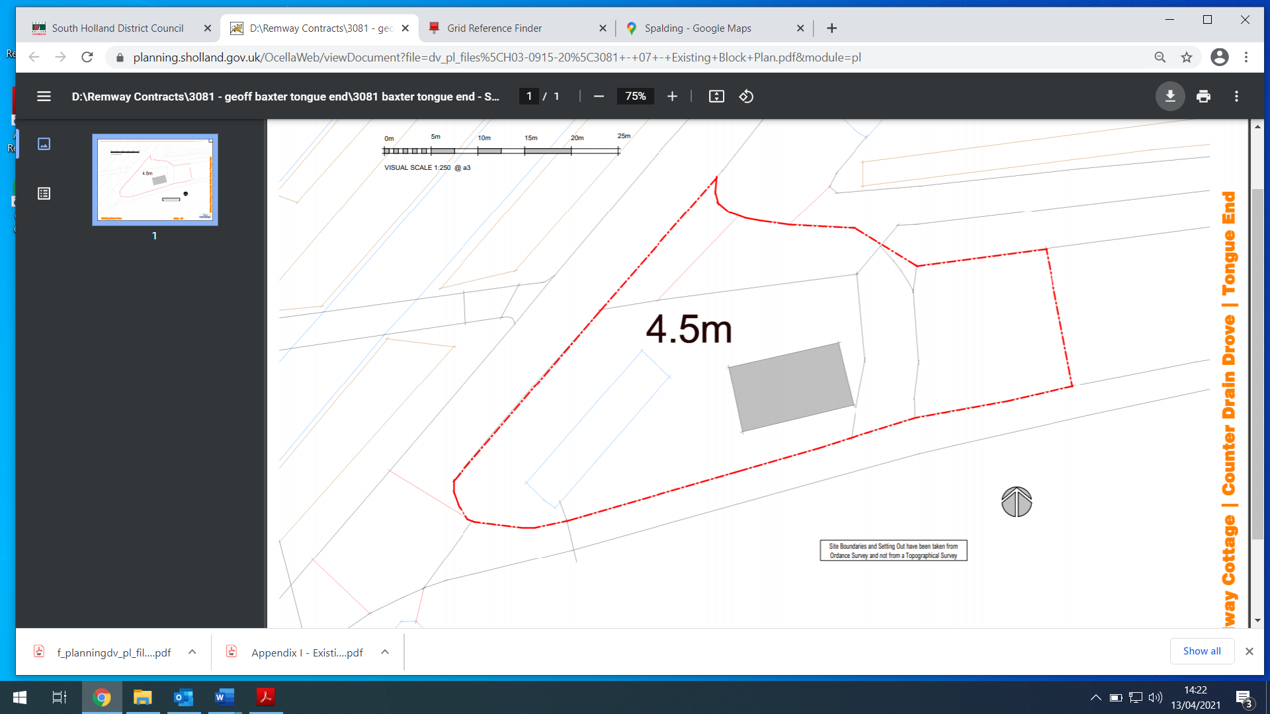
Sample Location 1

