Appendix VIII
Site Photographs – Railway Cottage
Railway Cottage (with old railway crossing gate, access following former track line)
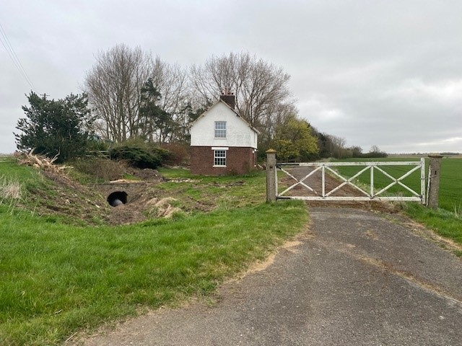
Railway Cottage showing more recent extension.
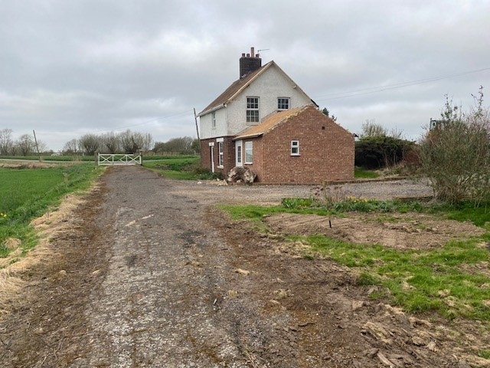

Sampling position 1 (South westerly elevation)
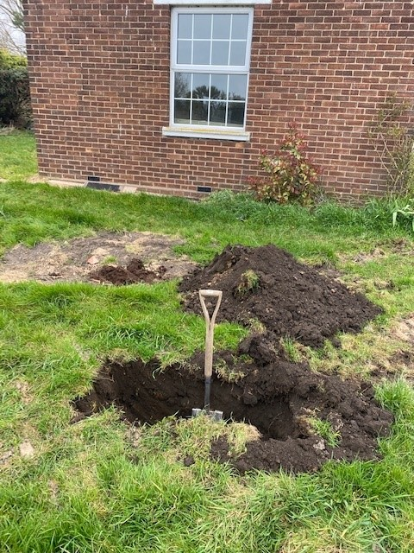
Sampling position 2 (North westerly elevation)
