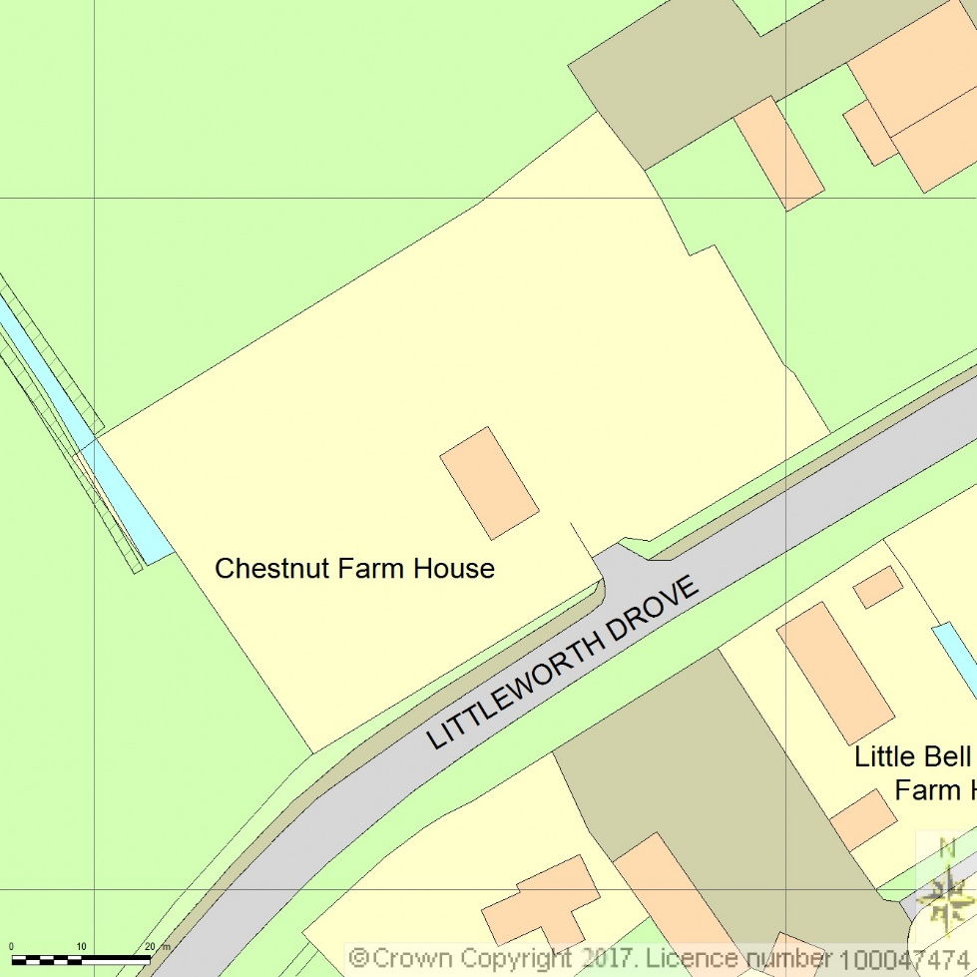
SITE LOCATION PLAN
AREA 2 HA
SCALE 1:1250 on A4
CENTRE COORDINATES: 518457, 313758



Supplied by Streetwise Maps Ltd
www.streetwise.net
Licence No: 100047474
31/05/2017 10:30

