
Habitat Management and Monitoring Plan
Site Name: | Park Farm
Date: | 28/07/2026
Version: | 1.0
Lord Carrington

Author:


Client:

Contents
1. Project Background 2

Site Boundary Plan PB-F01 3
Phasing strategy 5
Roles and Responsibilities 5
Land Use Summary 7
Site Baseline, Environmental Information and Associated Impacts Checklist PB-T01 8
Baseline and Environmental Information 9
2. Planned Management Activities 10
Principles Informed by Design Stage 10
Habitat and Condition Targets PM-T01 11
3. Monitoring Schedule 16
Monitoring Strategy 16
Monitoring Methods and Intervals MS-T01 16
Monitoring Reports 17
Adaptive Management 17

Version Control
The version control is used for updates to the content. Record the initial version and further version control details in this table each time the management plan is altered throughout the management and monitoring period.
Version | Issue Status | Prepared by / Date | Approved by / Date
1.0 | Issued | Ryan Clark 28/07/2026 | Ryan Clark 28/07/2026

Document Details
Provide ownership, copyright and licensing information within this table.
Authorship Details
This report was authored by Ryan Clark BSc (Hons) MSc MCIEEM, Principal Ecologist at Brown&Co, The Fairways, Wyboston Lakes, Great North Road, Wyboston, Bedfordshire, MK44 3AL.

This report was prepared for Lord Carrington, Manor House Farm, Perry Lane, Bedlow, Buckingham, HP27 9PA

All information set out in this report was obtained by the author and sets out a thorough and accurate assessment of the Site, its ecological context, and the proposed scheme to the best knowledge of the author at the time of writing.

Any unauthorised duplication of this report or elements within it should not take place without the express permission of the author and the client.

Project Background
Summarise the key aspects of your management plan in this section. Table PB-B01 can be extended to suit the specific needs of individual projects.
Site Overview PB-B01
Project type | Planning
Development Name and Address | N/A
BNG Project Name and Address | Park Farm, Banks Drove, Spalding, Lincolnshire, PE11 3BE
Author Organisation | Brown&Co
Landowner | Lord Carrington
Land Manager | N/A
Responsible person/organisation for creating or enhancing the habitat | Lord Carrington
Period covered by this management plan | 01/01/2027 – 01/01/2057
Planning authority | South Holland LPA
Planning reference (if applicable) | H03-0177-26
BNG register reference (if applicable) | N/A
Central OS grid reference | NGR: SK 88277 53775
Metric revision/title | Revision 03/07/2025  The Statutory Biodiversity Metric_BCEnv.26.0046_Park Farm_ACTUAL 1
Are any Irreplaceable Habitats present onsite | Yes: ☐ No: ☒

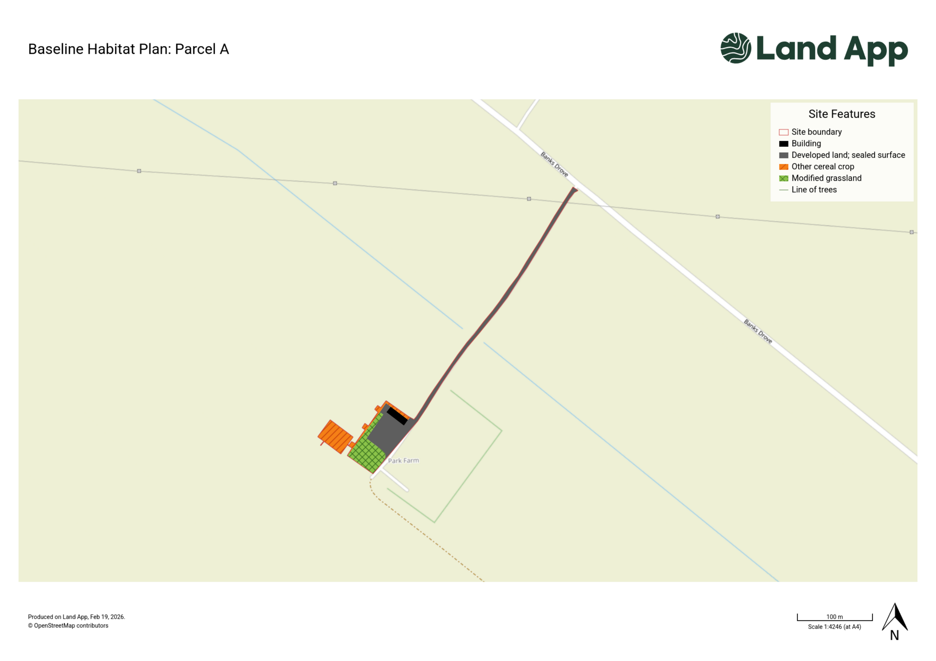
Site Plans PB-F01

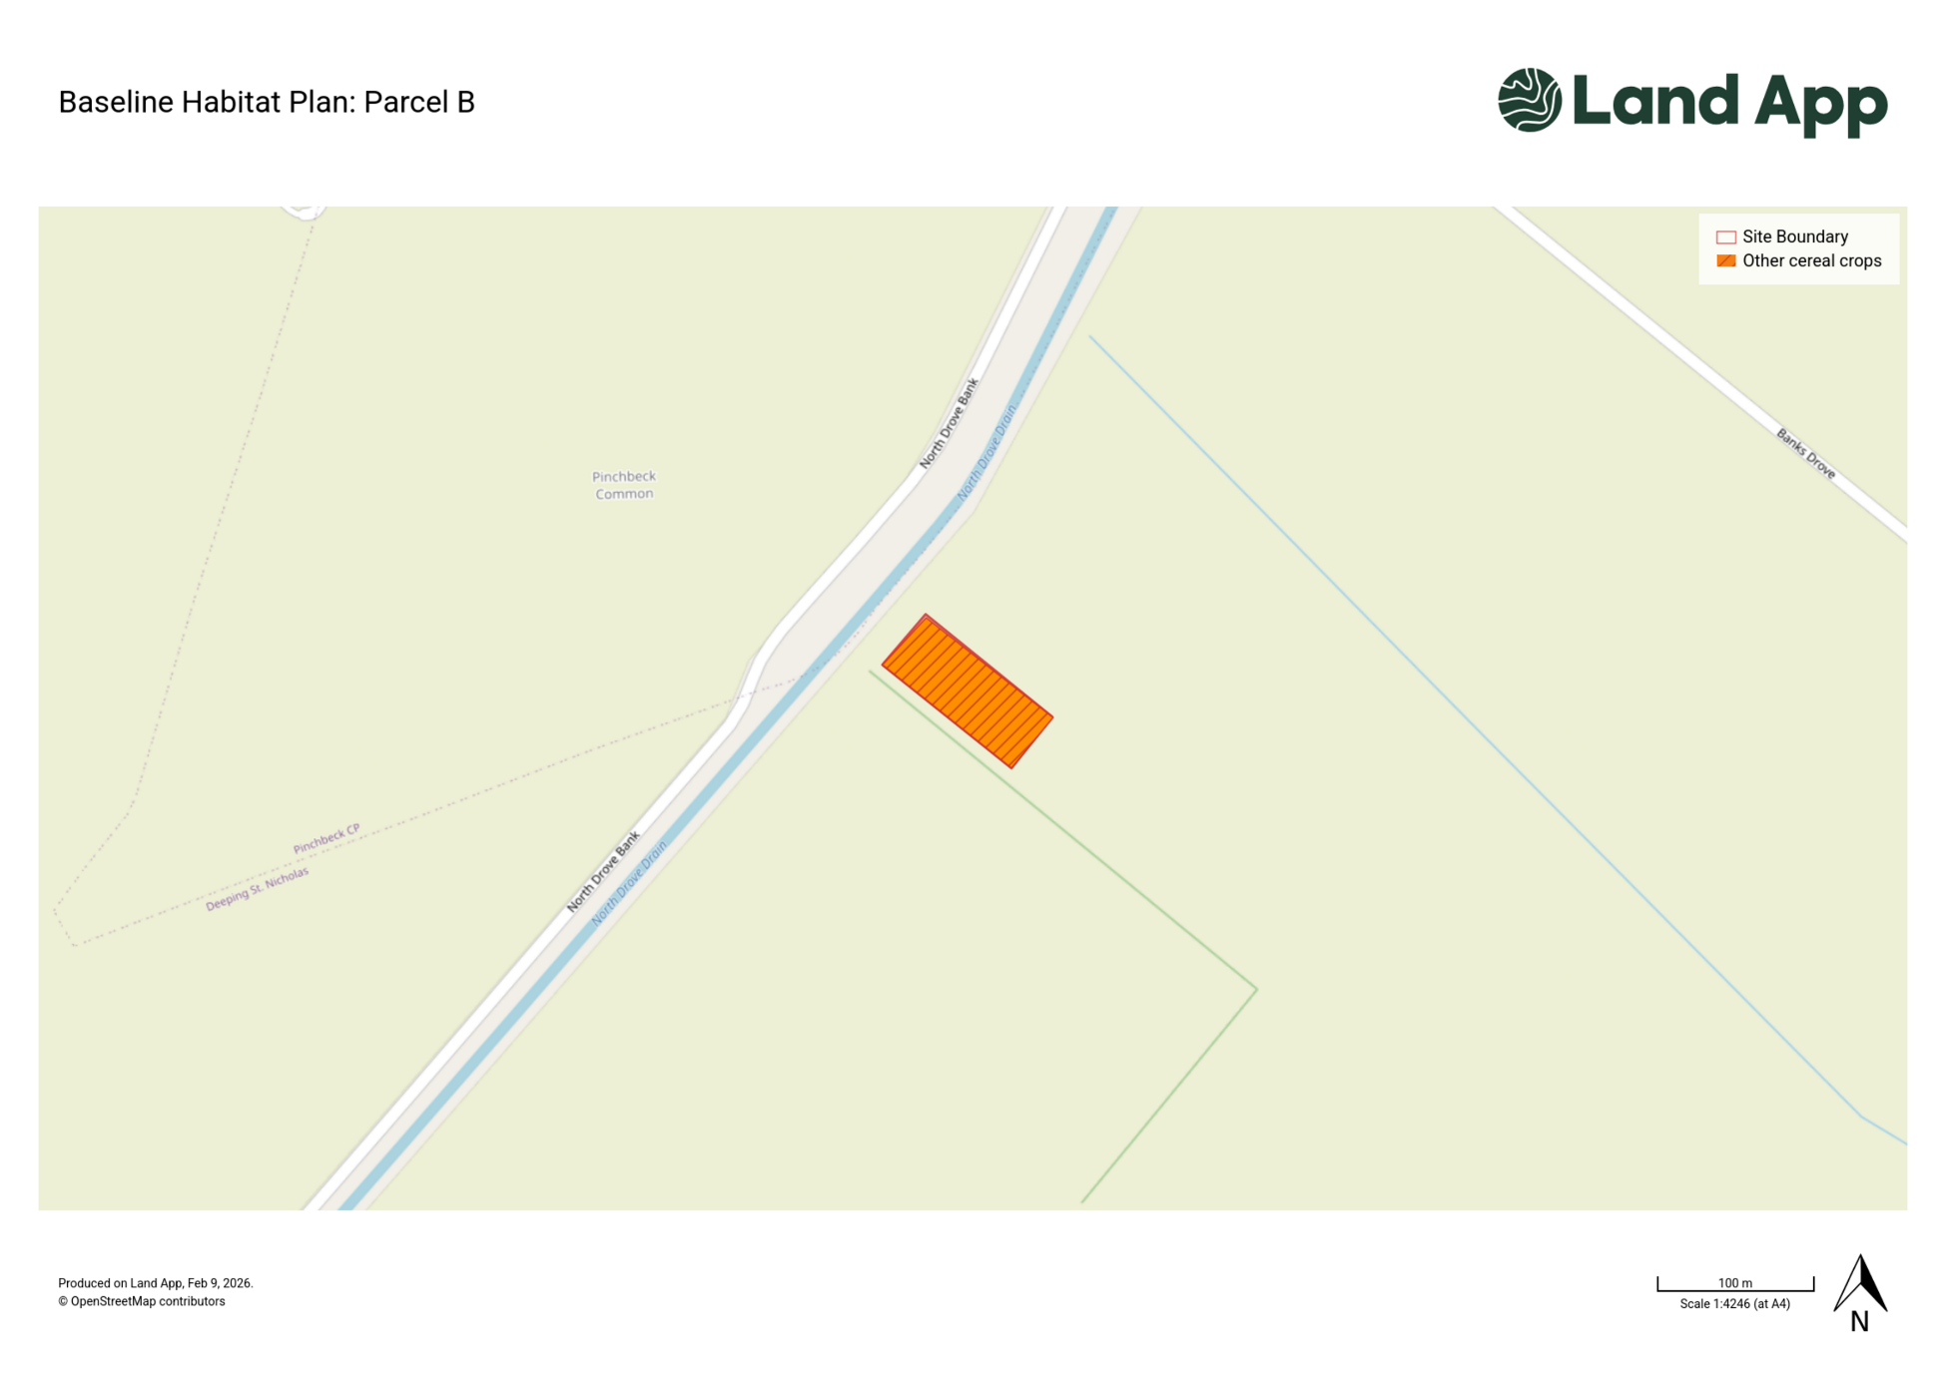

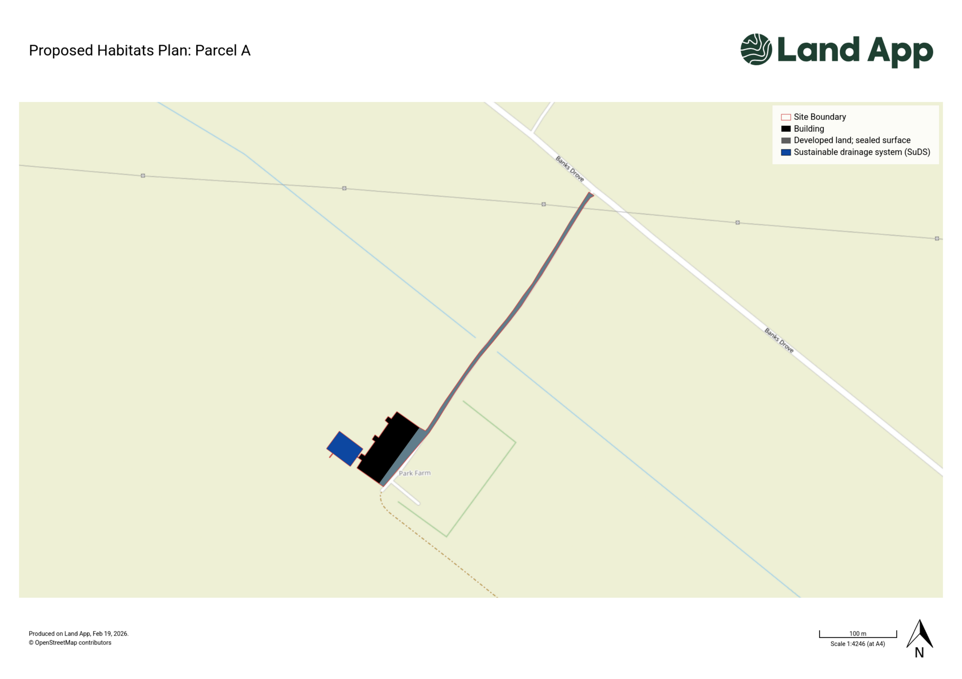

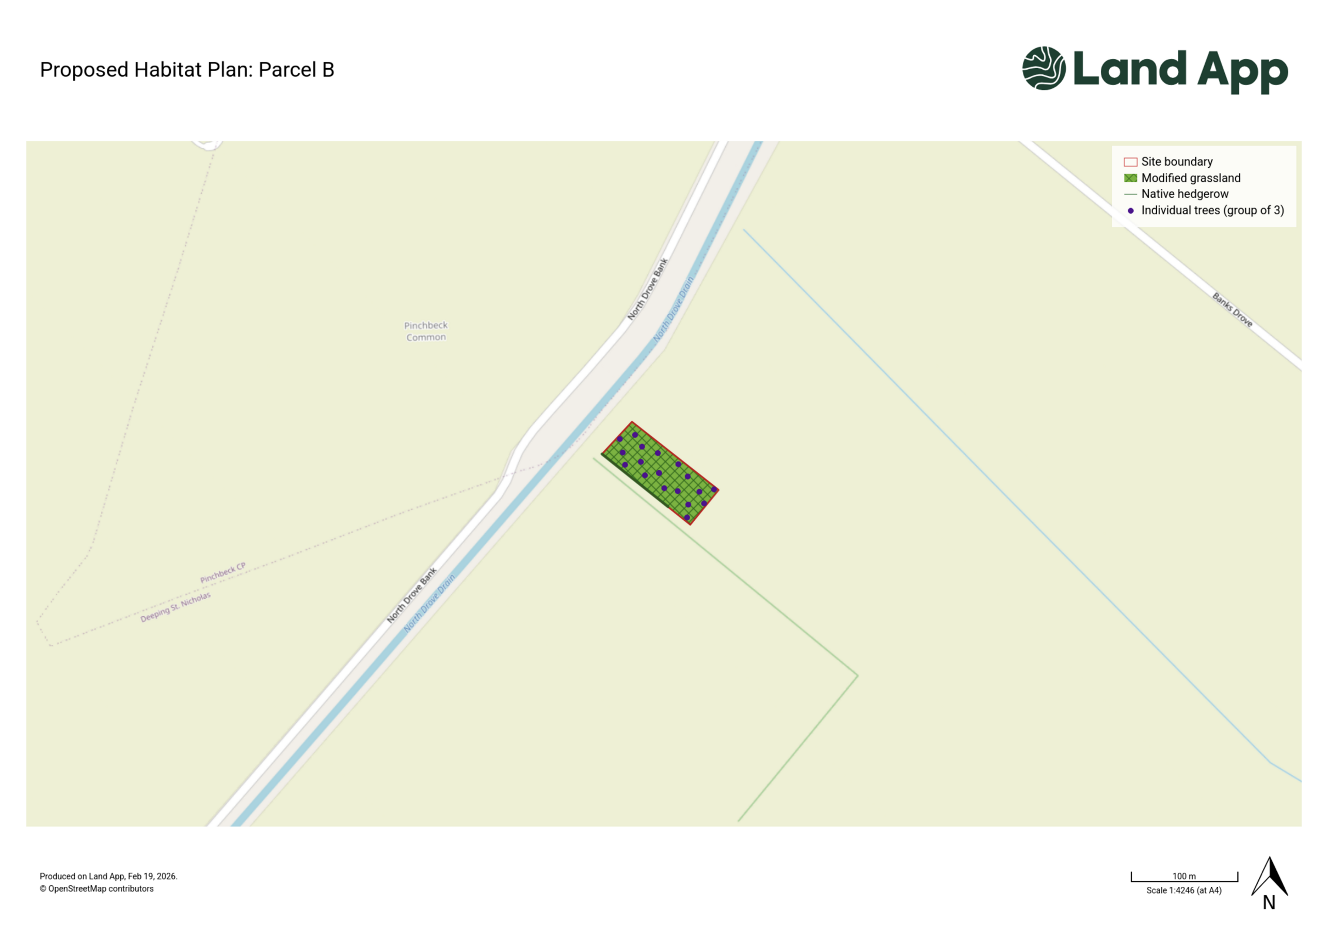

Phasing strategy
Will the proposed work measures be delivered in phases? PB-B08 | Yes: ☐ No: ☒
This is a Site-wide management plan and will be self-funded.

No intrusive ground-preparation phase is deemed necessary owing to the scale of the works.

As part of the proposed scheme, new areas of developed land, associated hardstanding and a SuDS are proposed to be created. These habitats form part of developed land, and do not have an associated condition score to be maintained as an obligation under BNG legislation and guidance. Thus, these habitats are not considered to be subject to a specific management and monitoring regime and are not considered further in this report.
Enhancement will be achieved by creating a new sward of Poor condition modified grassland and the planting of 51 new individual small trees of Moderate condition. A new Moderate condition native hedgerow will also be created.

Habitat creation and enhancement works in accordance with the Habitat Management and Monitoring Plan will be completed no later than 12 months after the completion of development work.

Ongoing interventions thereafter will be bespoke and should be determined by the ecological context at the time by the project ecologist; these could include the manual management of injurious weeds or other detrimental flora.

Roles and Responsibilities
Provide details of the responsible persons and organisation(s) for delivering this management plan.

Ecologist or Other Professional Responsible for HMMP PB-B09
Name or Initials |  | Ryan Clark
Organisation |  | Brown&Co
Responsibility | Start Date: | 01/01/2027 | End Date: | 01/01/2057
The Ecologist will:
- Author the HMMP and any relevant updates.
- Organise, undertake and report on any monitoring visits to the Site. The exact process and reporting output should be agreed with the local authority and is estimated to evolve significantly over the lifespan of the project and agreement.
- Provide advice and consultation on the delivery of any remedial measures as and when required.
- Provide ongoing dynamic advice on the overall delivery of the outlined habitat uplift; this is considered likely to evolve significantly over the lifespan of the project and agreement.
- Evaluate the ongoing potential for further habitat uplift, both within the Biodiversity Net Gain framework and additional enhancements for local ecology.
Statement of Competency
Ryan Clark BSc (Hons) MSc MCIEEM is a Principal Ecologist with Brown&Co and has worked within ecology and the wider environmental sector for the last 16 years. Ryan manages a portfolio of 100+ clients and sites across England and Wales that have included a variety of ecological complex features, including regional level landscape recovery schemes, habitat restoration delivery (including riparian restoration) and large strategic development/infrastructure projects.
Ryan holds ongoing project connections and good working relationship with 10+ local authority teams, including multiple schemes to deliver new habitat banks and offsite BNG enhancement throughout England.

Landowner or Land Manager PB-B10
Name or Initials |  | Lord Carrington
Organisation |  | N/A
Responsibility | Start Date: | 01/01/2027 | End Date: | 01/01/2057
The landowner will be responsible for the implementation of the details set out in this HMMP.
Statement of Competency
Lord Carrington is the current landowner and manages the habitats within the Site. The proposals seek to establish a common and widespread habitats that are commensurate with the current Site layout. Therefore, Lord Carrington is considered competent to ensure the delivery of the prescriptions within this assessment.

LPA or Responsible Body for Reviewing HMMP PB-B12
Name or Initials |  | South Holland LPA
Organisation |  | South Holland LPA
Responsibility | Start Date: | 01/01/2027 | End Date: | 01/01/2057
The LPA will be responsible for the ongoing review and auditing process of this HMMP throughout the scheme.

Land Use Summary
Overview of Baseline Site Use PB-B13
Baseline Habitats
Currently the Site comprises the following habitats (habitats with a BNG value = 0.00 are not included).
A Sustainable Drainage System (SuDS) attenuation basin will be created. This feature will be an artificial inundation area that is proposed to achieve Poor condition. As such, no monitoring of this habitat is required.

Modified grassland
Modified grassland sward present in the south of Parcel A. The grassland does not appear to be regularly managed and comprised Cock's-foot (Dactylis glomerata) alongside occasional Common nettle (Urtica dioica), Cow parsley (Anthriscus sylvestris) and Cleavers (Galium aparine). Bare ground was present.

Other broadleaved woodland
A line of recently felled Leyland cypress trees was present within an area modified grassland within Parcel A. Opensource aerial imagery was used to estimate the location of this line of trees.
Current Management
The Site is managed for poultry shed units.
For additional and in certain instances more detailed information on the baseline habitats and management within the Site, please see document Biodiversity Net Gains Assessment_BCEnv.26.0046_AP066898_Park Farm_ACTUAL 1 (ref: BCEnv.26.0046).

Overview of Proposed Site Use PB-B14
New onsite buildings and associated access and amenity infrastructure are proposed, as well as a new area of grassland with tree planting
.

Site Baseline, Environmental Information and Associated Impacts Checklist PB-T01
Consider the Baseline and Environmental Information listed below. These are likely to be appropriate factors informing your proposals and project design. They can provide the reviewer with important contextual information for the management prescriptions provided later in this document. Use your professional judgement to determine which factors are relevant to your specific project.
Please use the check box to indicate which are included in your plan. For any not included, provide brief reasons why the factor is not relevant to your project using your professional judgement. Where this information is provided elsewhere, you can reference existing reports and, or, plans that have informed your decisions. For the templates for each heading see pages 3-20 of the Companion Document.
Baseline and Environmental Information | Prompts for when these may be relevant.  This is not an exhaustive list. Use your professional judgement to determine which are required for your HMMP | Check box if included | Document Reference or Reason if not included
Statutory / Non-statutory Designated Sites | Will your proposals lead to direct or indirect effects on designated sites? | ☐ | No statutory or non-statutory designated sites are present within the Site. The existing habitats within the Site is considered common and widespread within Britain. Considering this, and the low impact nature of the proposals, potential for impacts to statutory and non-statutory designated sites are negligible.
Protected and Notable Species | Does the presence or proximity of specific species on or near your site present any constraints or opportunities to project design or management? | ☒ | It is estimated that the Site does have potential to support badger, foraging reptile and commuting great crested newt in their terrestrial phase and could be impacted by the proposed works. A Non-licenced method statement has been produced to mitigate the risk to badger, reptile and great crested newts.
Invasive Non-Native Species (INNS) | Are any INNS present onsite that could affect the proposals? |  | No INNS were identified at the time of survey.
Biological Records Plan - Sites and Species | Does the presence of designated sites or specific species on or near the site present any constraints or opportunities to proposals? | ☐ | The potential for the proposed works to impact adjacent sites and species is considered low. The proposed works are considered likely to provide a new resource for local ecology.
Baseline Habitats Survey | Is this current and important HMMP information located in a separate document? If so, provide details on where it is located. | ☐ | Evaluated in Biodiversity Net Gains Assessment_BCEnv.26.0046_AP066898_Park Farm_ACTUAL 1
Public Access | Has public access, or proposals to allow public access, influenced your management prescriptions? If so, how? | ☐ | No public access is proposed for the Site.
Geology and Topography | Any geological or topographical constraints or opportunities? | ☐ | No such features known.
Agricultural Land Status | Does the site support any land favourable for agricultural management? Could this affect the proposals? | ☐ | Existing adjacent agricultural practices will continue.
Soils and Substrates | Do soils and substrates present any constraints or opportunities? | ☐ | No such features known.
Contaminated Land | If there is any contaminated land, will this present any constraints? | ☐ | No such features known.
Hydrology and Drainage | Will the site hydrology present any constraints or opportunities? | ☐ | No such features known.
Flood Risk Zones | Is the site within a flood risk zone? Will that present any site management risks? | ☐ | The Site does not lie within a flood zone—no flooding is anticipated.
Historic Land Use | Does the historic land use present any constraints or opportunities? | ☐ | No such features known.
Historic Environment and Earth Heritage | Are there any historic environment designations? What are the implications for your plan? | ☐ | No such features known.
Other – please specify | Any other details - for example underground services or overhead powerlines, which may impact habitat management. | ☐ | N/A

Planned Management Activities
Provide the site-wide aims and objectives. These should consider the Project Background information section outlined above as well as the outcomes of the Metric.
Management Plan Aims and Objectives PM-B01
This HMMP will deliver the following aims and objectives:
- Create a new area of Poor condition modified grassland.
- Establish 51 new small native trees of Moderate condition within the newly created grassland.
- Creation of a Moderate condition native hedgerow.

Principles Informed by Design Stage
The project's BNG target(s) should be set and documented early in the design process. Outline how background and baseline information influenced key design principles for the project from an early stage. This can provide useful context for the proposed retention, creation and enhancement measures.
Design Principles Informed by Baseline Information PM-B02
The Site comprises primarily common and widespread habitats in Britain. It is considered that multiple new native trees and a hedgerow would be beneficial in the context of the relatively low baseline value.

The presence of local parcels of Priority habitat is estimated to bolster the value of the project to local ecological networks by providing a benefit to ecological connectivity through the surrounding landscape and to provide the potential for range extension of a number of locally present species, particularly invertebrates and birds.

Habitat and Condition Targets PM-T01
This table presents a summary record of what you have agreed to deliver based on the biodiversity metric. These habitat condition targets form the basis of what the management plan is setting out to achieve. Include the relevant ‘Area’, ‘Hedgerow’, and ‘Watercourse’ types to be implemented and managed throughout the period of 30 years or more.
Baseline Habitat Type | Target Habitat Type | Baseline Condition | Targeted Condition | Years to Targeted Condition | Condition Assessment Targets
N/A | Native hedgerow | Moderate | Good | 2 | Hedgerow estimated to fail Condition Criteria C1, C2 and D2; Therefore, achieving Moderate condition.
Arable | Modified grassland | N/A | Poor | 1 | Habitat is anticipated to fail Condition Criteria A; therefore, achieving Poor condition.
N/A | Individual trees | N/A | Moderate | 27 | Five newly planted small trees are anticipated to pass condition criteria A, B and F; therefore, achieving Moderate condition.

Hedgerow

Creation, Enhancement and Management Summary (HD-T01)
Provide details of the approach to delivering each of the targeted condition criteria and hedgerow type. Conditions from Statutory Biodiversity Metric habitat condition assessment sheets – Sheet 8. Hedgerow
Target Hedgerow Type:
Condition Assessment Criteria |  | Targeted? | Creation Approach | Management Approach
A1 | Height  >1.5m average along length. | Yes | Hedgerow will be laid using traditional and local methods and left to grow to an appropriate height. | Hedgerows will be monitored continuously; targeted pruning will be provided on an as-needed basis so as to retain the appropriate size, structure, and composition of the hedgerow structure.
A2 | Width  >1.5m average along length. | Yes | Hedgerow will be laid using traditional and local methods and left to grow to an appropriate width. | Hedgerows will be monitored continuously; targeted pruning will be provided on an as-needed basis so as to retain the appropriate size, structure, and composition of the hedgerow structure.
B1 | Gap – hedge base  Gap between ground and base of canopy <0.5m for >90% of length. | Yes | Hedgerows will be established with no significant gap at their base. | Hedgerows will be monitored continuously; targeted pruning will be provided on an as-needed basis so as to retain the appropriate size, structure, and composition of the hedgerow structure.
B2 | Gap – hedgerow canopy continuity  Gaps make up <10% of total length; and no canopy gaps >5m. | Yes | Hedgerows will be established as continuous features with no significant gaps between hedge structural elements. | Hedgerows will be monitored continuously; targeted pruning will be provided on an as-needed basis so as to retain the appropriate size, structure, and composition of the hedgerow structure.  This could include planting additional plants/saplings to fill any gaps that may appear.
D1 | Invasive and neophyte species  >90% of the hedgerow and undisturbed ground is free of invasive non-native plant species (including those listed on Schedule 9 of WCA) and recently introduced species. | Yes | No invasive species have been recorded at baseline surveying, both within the Site or within adjacent areas. | Ongoing monitoring will identify any colonising invasives; appropriate treatment/removal will follow if any occurrences are noted.
E2 | At least 95% of hedgerow trees are in healthy condition | Yes | Hedgerows will be established as healthy plant species. | Any hedge species or trees that do not take or are damaged, will be replaced

Hedgerow

Creation, Enhancement and Management Methods (HD-T02)
Provide detailed prescriptions for the creation and management of the habitat.
Action | Timing | Prescriptions
Ground preparation | Start of project | This action should proceed in the following way:  - Lay hay and/or straw, then rotted manure along the route of the proposed hedgerow.  - Place topsoil (dug from onsite excavations with any grass turf facing downward) along the route, on top of the laid hay/straw and manure.  - Repeatedly apply these layers, straw/hay, rotted manure, and topsoil, along the proposed route. Topsoil should be the last layer.
Planting of hedge saplings | Year 1: Jan-March (following emergent tree planting) | Hedge Planting should occur under the following conditions:  - Hedge saplings (each to be a minimum of 60cm in height) to be soaked in a mixture of milk and water (1:100) for 2-4 hours immediately prior to planting in January-March. The same mixture should be poured into each hedge sapling hole as planting occurs. This mixture activates mycorrhiza and encourages rapid early growth.  - Species should be planted in a randomised order in a staggered ‘zig-zag’ formation that approximately creates two planting rows. Each sapling should be spaced 40-60 cm apart, with there being approximately 18-22 saplings per 5 m length of hedge.  - Once inserted into the planting holes, each hedge sapling should be covered round by mulch, hay, or woodchipings to a depth of 10-15 cm.  - Within 4 weeks of hedge saplings being planted 2m either side of the hedgerow should be seeded with Woodland Edge Seed Mix – Including Grasses (available at: habitataid.co.uk) at a rate of 2g/m2.  Hedge species should be of the following species and composition:  - Blackthorn (Prunus spinosa) 30%  - Hawthorn (Crataegus monogyna) 30%.  - Hazel (Corylus avellana) 20%  - Wild privet (Ligustrum vulgare) 10%.  - Guelder rose (Viburnum opulus) 10%.

Individual Trees

Creation, Enhancement and Management Summary (UT-T01)
Provide details of the approach to delivering each of the targeted condition criteria and habitat. Conditions from Statutory Biodiversity Metric habitat condition assessment sheets – Sheet 9. Individual Trees
Target Habitat:
Condition Assessment Criteria |  | Targeted | Creation Approach | Management Approach
A | The tree is a native species (or more than 70% within the block are native species). | Yes | All planted trees will be native British species and should be sourced from local provenance if possible. | Ongoing management should seek to maintain the health of trees via targeted pruning and avoidance of physical damage.
B | The tree canopy is predominantly continuous, with gaps in canopy cover making up <10% of total area and no individual gap being >5 m wide (individual trees automatically pass this criterion). | Yes | All trees will be individual trees and will therefore automatically pass this criterion.
F | More than 20% of the tree canopy area is oversailing vegetation beneath. | Yes | All trees will be planted within an existing area of grassland. | Grassland should be maintained beneath tree canopies throughout the lifespan of the project.

Individual Trees

Creation, Enhancement and Management Detailed Methods (UT-T02)
Provide detailed prescriptions for the creation and management of the habitat.
Action | Relevant Features | Timing | Prescriptions
Tree establishment | Planted trees (within new grassland) | Year 1-5 | Ground Preparation – pre-designated planting areas should be cleared of surface debris and herb cover. A hole should be dug that is approximately x3 diameter of the tree root to be planted and at least the same depth at the height of the rootball. Applying organic matter, such as leaf litter, can be undertaken and may help initial establishment.  Planting – trees should be planted from November to March; consistent periods of temperatures below 0 degrees Celsius should be avoided. All trees to be planted should be soaked in water immediately prior to being planted. Roots should be loosened by hand to encourage outward growth. Trees should be sunk into the dug holes; it should be ensured that the point that the trunk meets the rootball should be level with the soil surface. Soil should be repacked around the now plated trees, ensuring that no air pockets are present. A check should be conducted after planting to ensure that stems are perpendicular to the soil surface.  Management and maintenance – Immediately following planting:  - Install a tree guard/spiral on the stem of each tree to protect against herbivore damage.  - Apply a biodegradable weed mat at the base of each tree.  - Thoroughly water and spread mulch (comprising of 100% organic matter and in a layer no deeper than 10 cm) at the base of each tree to encourage establishment.  - Install a timber steak at a 45-degree angle that crosses each tree stem. This allows steady growth once anchored.  Management years 1-5:  - Within the first year, trees should be re-steaked and the reapplication of weed mats should occur on an as needed basis.  - Trees should be pruned annually within the first 5 years. Pruning should aim to remove all but one upright shoots, to remove side branches from the lower 1/3 of the stem, and to remove dead, damaged, or diseased wood. Ongoing attention should be paid to the establishment of a strong framework of branches.  - Adjacent vegetation should not be allowed to overcrowd/smother each tree.  - Trees should be watered twice per week for the first 3-6 months after planting, and once per week thereafter. Watering should be intensified/reduced depending on extreme weather events such as very dry periods.  Ongoing management:  - Any trees that die or become diseased should be replaced like for like in the same method described earlier.  No pesticides, herbicides, vermicides, or other environmentally harmful chemicals should be applied to the trees throughout their lifespan.

Grassland (Low Distinctiveness)

Creation, Enhancement and Management Summary (GL-T01)
Provide details of the approach to delivering each of the targeted condition criteria and habitat. Conditions from Statutory Biodiversity Metric habitat condition assessment sheets – Sheet 5. Grassland Low
Target Habitat: |  |  | Modified Grassland
Condition Assessment Criteria |  | Targeted | Relevant Parcels | Creation Approach | Enhancement Approach | Management Approach
A | There are 6-8 vascular plant species per m² present, including at least 2 forbs.  Note - this criterion is essential for achieving Moderate or Good condition.  Where the vascular plant species present are characteristic of medium, high or very high distinctiveness grassland, or there are 9 or more of these characteristic species per m², please review the full UKHab description to assess whether the grassland should be classified as a higher distinctiveness grassland. Where a grassland is classed as medium, high or very high distinctiveness, please use the relevant condition sheet. | Habitat anticipated to fail this Condition Criteria; therefore, this sward automatically cannot achieve more than Poor condition and no other Condition Criteria are targeted.

Grassland (Low Distinctiveness) Species Lists (GL-T03)
Provide a detailed species list for the habitat to be created.
Common Name | Scientific Name | Abundance / % | Comments
Common bent | Agrostis stolonifera | 9.00%
Crested dogstail | Cynosurus cristatus | 31.50%
Red Fescue | Festuca rubra | 27.00%
Smaller Cat’s-tail | Phleum bertolonii | 4.50%
Smooth meadow grass | Poa pratensis | 18.00%
Common Knapweed | Centaurea nigra | 1.50%
Wild Carrot | Daucus carota | 1.00%
Oxeye Daisy | Leucanthemum vulgare | 1.00%
Ribwort Plantain | Plantago lanceolata | 1.50%
Salad Burnet | Poterium sanguisorba ssp sanguisorba | 0.80%
Selfheal | Prunella vulgaris | 1.50%
Meadow Buttercup | Ranunculus acris | 1.00%
Yellow Rattle | Rhinanthus minor | 0.20%
Red Campion | Silene dioica | 0.50%

Monitoring Schedule
To deliver BNG, a robust strategy is critical to monitor successes and challenges. Routine monitoring informs progress and facilitates the required management plan updates at set intervals.

Monitoring Strategy
Provide details of the monitoring strategy to encourage successful implementation of the management plan (MS-B01)
Evidential photographs will be obtained before and following the proposed interventions.
Surveys of the grassland, hedgerows and trees will be undertaken to ensure that the target condition scores are achieved; vascular plant species abundance and diversity will be a core component of such surveys.

Monitoring Methods and Intervals MS-T01
Provide details of the methods you will use to adequately monitor the progress towards the targets stated in the management plan and as agreed with the Local Planning Authority.
Habitat Type | Monitoring Methods | Monitoring Interval and Timing
Individual trees and hedgerow | A Site walkover will be performed at each monitoring interval by a suitably qualified Ecologist where trees and hedgerow will be visually scanned and compared against the target condition criteria. | At years 1, 2, 3, 4, 5, 10, 15, 20, 25 and 30.
Grassland | A Site walkover will be performed at each monitoring interval by a suitably qualified Ecologist where a minimum of 5 equal-sided quadrats (1 m x 1 m) per hectare will be established at randomly generated locations throughout the sward. At each quadrat a total species list and number of vascular plant species present will be recorded, as well as any notes on conditional features, e.g. areas of bare ground.  A survey of the wider habitat parcel will also be performed where the grassland will be visually scanned and compared against the target condition criteria. | At years 1, 2, 3, 4, 5, 10, 15, 20, 25 and 30.

Monitoring Reports
Following completion of habitat creation and initial enhancement works, prepare for your monitoring report for the Local Planning Authority or Responsible Body. You should monitor each habitat type comprising the BNG project. Provide sufficient detail for the reviewing authority to assess the progress. The ‘Monitoring Report Template’ can help you do this. The requirements and regularity with which the monitoring reports are required are at the discretion of the LPA or Responsible Body. Prepare the monitoring requirements below.

Monitoring Report Schedule MS-T02
Provide details of the person or organisation that will be responsible for submitting the monitoring reports. Also state the responsible organisation for receiving and reviewing the reports.
Organisation Responsible for Submitting the Monitoring Reports | Organisation Receiving and Responsible for Reviewing Reports
Lord Carrington | South Holland LPA

Provide details of when the monitoring surveys and reports will be undertaken and submitted. You can extend the table and adjust according to your required schedule.
Project Year | Month Report to be Submitted | Month Management Plan to be reviewed | Comments
Y1, 2, 3, 4, 5, 10, 15, 20, 25, and 30 | June-August | October-December | Report on Tree, hedgerow, grassland condition criteria.  The monitoring reports as referenced shall contain as a minimum:  - a summary of management actions taken over the previous monitoring period and their timing  - a summary of problems encountered in meeting management objectives and any mediation actions taken or planned to address problems  - A current UK habitat condition assessment for each post-development habitat accompanied by the following supporting evidence:  - species composition and % cover quadrat data for grassland habitats following sampling methods of the National Vegetation Classification or similar (NVC; Rodwell 1992*);  - species composition of hedgerow and individual trees; and  - representative photographs of each habitat parcel

Adaptive Management
Summary of Adaptive Management Approaches (MS-B02)
The ongoing monitoring and management of the Site will be dynamically held and fed into the adaptive re-design and other changes in the project delivery to meet the ecological context at the time. Recommendations delivered during the onsite monitoring or within formal reporting points thereafter will be reviewed minimally on an annual basis, and any outputs to take forward will be expedited and integrated into the existing schedule of the scheme.

This adaptive process will focus on the input of the Project Ecologist but will also take into account the incidental and professional reporting from the client/landowner, onsite contractors and lay-persons involved within the project.

