PLANNING STATEMENT AND HERITAGE IMPACT ASSESMENT
THOMAS COWLEY HIGH SCHOOL.
SCHOOL LANE, DONINGTON, PE114TF.

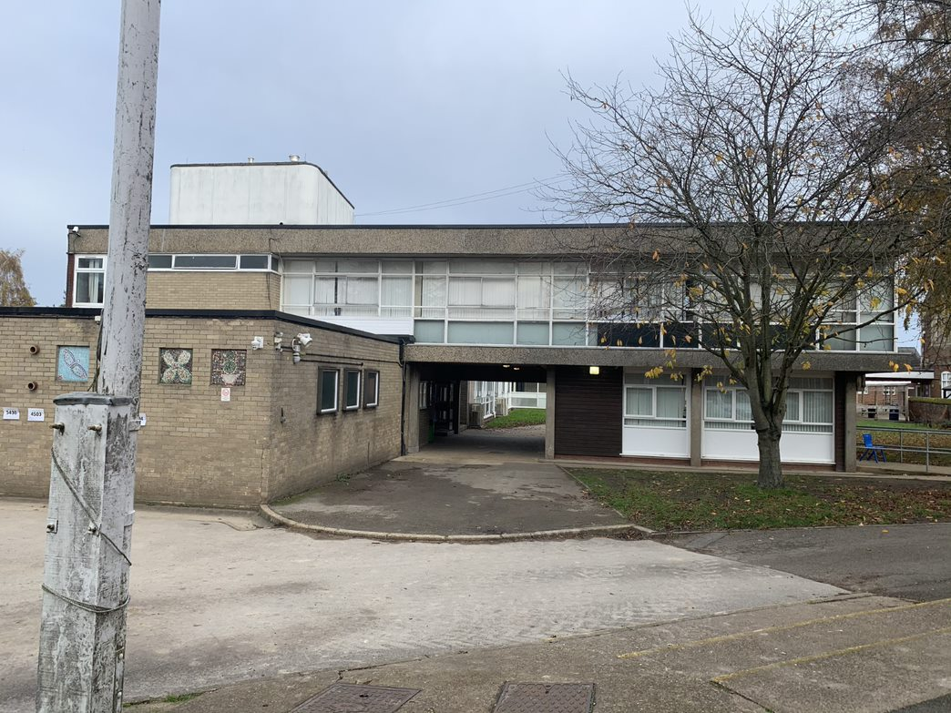

Contents

- Introduction ………………………………………………………………………………………. 2

- Planning Policy Context ………………………………………………………………………… 2

- Relevant Site History……………………………………………………………………………..5

4.0 Assessment of Significance ……………………………………………………………………. 5

5.0 Proposed Development and Impact Assessment…….……………………………………… 19

6.0 Conclusions ……………………………………………………………………………………… 26

- Introduction

1.1 Paragraph 189 of the National Planning Policy Framework requires applicants to describe the significance of any heritage assets affected by a proposed development with a view to understanding the potential impact on its significance. This report aims to satisfy this requirement.

1.2 This Heritage Impact Assessment has been prepared on behalf of Charles Garth in support of full planning and listed building consent applications for the replacement of windows and doors at the Thomas Cowley High School, School Lane, Donington. PE114TF.
1.3 The building is found within the curtilage of a school building which is a Grade II listed building with 2 further listed buildings found within its curtilage. Listed buildings are designated heritage assets which are awarded protection both in law and by local and national planning policy.

2.0 Planning Policy Context
2.1 Section 66(1) of the Planning (Listed Buildings and Conservation Areas) Act 1990 establishes that “in considering whether to grant permission which affects a listed building or its setting, the local planning authority, or as the case may be, the Secretary of State, shall have special regard to the desirability of preserving the building or its setting or any features of special architectural or historic interest which it possesses.”
2.2 Section 72(1) of the same Act states “with respect to any buildings or other land within a conservation area… special attention must be paid to the desirability of preserving or enhancing the character and appearance of that area.”
2.3 As previously noted, the host building is located within the curtilage of a listed building
2.4 The National Planning Policy Framework (‘NPPF’) was revised in February 2019 and overwrites all previous national planning policy. It establishes that the purpose of the planning system is to contribute to the achievement of sustainable development by pursuing three overarching and interdependent objectives, which are economic, social and environmental. It is considered that the historic environment poses implications and opportunities for the achievement of sustainable development in relation to all three objectives.
2.5 Section 16 of the NPPF relates specifically to ‘conserving and enhancing the historic environment’. Paragraph 184 establishes that heritage assets are “an irreplaceable resource and should be conserved in a manner appropriate to their significance, so they can be enjoyed for their contribution to the quality of life of existing and future generations.”
2.6 NPPF Paragraph 189 requires applicants to describe the significance of any heritage assets affected by a proposed development, including any contribution made by their setting. It clarifies that the level of detail should be “proportionate to the assets’ importance and no more than is sufficient to understand the potential impact of the proposal on their significance. As a minimum the relevant historic environment record should have been consulted and the heritage assets assessed using appropriate expertise where necessary.”
2.7 The NPPF defines heritage ‘significance’ as “the value of a heritage asset to this and future generations because of its heritage interest. The interest may be archaeological, architectural, artistic or historic. Significance derives not only from a heritage asset’s physical presence, but also from its setting.”
2.8 The ‘setting of a heritage asset’ is defined in the NPPF as “the surroundings in which a heritage asset is experienced. Its extent is not fixed and may change as the asset and its surroundings evolve. Elements of a setting may make a positive or negative contribution to the significance of an asset, may affect the ability to appreciate that significance or may be neutral.”
2.9 The NPPF does not have a definition for archaeological, architectural, artistic or historic interest with respect to heritage significance. However, Paragraph 16 of the Principles for Selection of Listed Buildings (DDCMS 2018) provides the following definitions:

Relevant National Planning Policy and Guidance

2.10 Historic England’s Conservation Principles, Policies and Guidance (2008) also offers useful definitions which underpin a value-orientated approach to assessing heritage significance.

2.11 Paragraph 192 of the NPPF states “in determining applications, local planning authorities should take account of:

Architectural interest – “to be of special architectural interest a building must be of importance in its design, decoration or craftsmanship. Special interest may also apply to particularly significant examples of building types or techniques… and significant plan forms. For more recent buildings in particular, the functioning of the building… will also be a consideration. Artistic distinction can also be a factor relevant to the architectural interest of buildings and objects and structures fixed to them.”
Historic interest – “to be able to justify special historic interest a building must illustrate important aspects of the nation’s history and/or have closely substantiated historical associations with nationally important individuals, groups or events; and the building itself in its current form will afford a strong connection with the valued aspect of history.”
Evidential value – the potential of a place to yield evidence about past human activity.
Historical value – the ways in which past people, events and aspects of life can be connected through a place to the present. This can be illustrative or associative.
Aesthetic value – the ways in which people draw sensory and intellectual stimulation from a place.
Communal value – the meaning of a place for the people who relate to it or for whom it figures in their collective experience or memory.
- a) The desirability of sustaining and enhancing the significance of heritage assets and putting them to viable uses consistent with their conservation;
- b) The positive contribution that conservation of heritage assets can make to sustainable communities including their economic vitality; and
- c) The desirability of new development making a positive contribution to local character and distinctiveness.” 2.12 NPPF Paragraph 193 relates to development proposals affecting designated heritage assets, such as listed buildings and conservation areas. It states “when considering the impact of a proposed development on the significance of a designated heritage asset, great weight should be given to the asset’s conservation (the more important the asset, the greater the weight should be). This is irrespective of whether any potential harm amounts to substantial harm, total loss or less than substantial harm to its significance.”
- 2.13 NPPF Paragraph 194 states “any harm to, or loss of, the significance of a designated heritage asset (from its alteration or destruction, or from development within its setting), should require clear and convincing justification.” Substantial harm to or loss of Grade II listed buildings should be exceptional.
- 2.14 NPPF Paragraph 195 establishes that “where a proposed development will lead to substantial harm to (or total loss of significance of) a designated heritage asset, local planning authorities should refuse consent, unless it can be demonstrated that the substantial harm or total loss is necessary to achieve substantial public benefits that outweigh that harm or loss, or all of the following apply:

- a) The nature of the heritage asset prevents all reasonable uses of the site; and
- b) No viable use of the heritage asset itself can be found in the medium term through appropriate marketing that will enable its conservation; and
- c) Conservation by grant-funding or some form of not-for-profit, charitable or public ownership is demonstrably not possible; and
- d) The harm or loss is outweighed by the benefits of bringing the site back into use.” 2.15 NPPF Paragraph 196 states “where a development proposal will lead to less than substantial harm to the significance of a designated heritage asset, this harm should be weighed against the public benefits of the proposal including, where appropriate, securing its optimum viable use.”
- 2.16 The most recently revised Planning Practice Guidance provides a useful definition of ‘public benefits’. It states “public benefits may follow from many developments and could be anything that delivers economic, social or environmental progress as described in the National Planning Policy Framework. Public benefits should flow from the proposed development. They should be of a nature or scale to be of benefit to the public at large and should not just be a private benefit. However, benefits do not always have to be visible or accessible to the public in order to be genuine public benefits.”
- 2.17 Section 38(6) of the Planning and Compulsory Purchase Act 2004 requires planning applications to be determined in accordance with the development plan unless material considerations indicate otherwise.
- Statutory Development Plan
- 2.18 The statutory development plan for The South Holland District Council Area is the South East Lincolnshire Local Plan. (Prepared jointly with Boston Borough Council and Lincolnshire County Council.

2.19 The Plan was adopted on the 8th March 2019.

2.20 Policy 29 of the South East Lincolnshire Local Plan entitled “The Historic Environment” states:

Distinctive elements of the South East Lincolnshire historic environment will be conserved and, where appropriate, enhanced. Opportunities to identify a heritage asset’s contribution to the economy, tourism, education and the local community will be utilised including:
• The historic archaeological and drainage landscape of the Fens;
• The distinctive character of South East Lincolnshire market towns and villages;
• The dominance within the landscape of church towers, spires and historic windmills;
To respect the historical legacy, varied character and appearance of South East Lincolnshire’s historic environment, development proposals will conserve and enhance the character and appearance of designated and non-designated heritage assets, such as important known archaeology or that found during development, historic buildings, conservation areas, scheduled monuments, street patterns, streetscapes, landscapes, parks (including Registered Parks and Gardens), river frontages, structures and their settings through high-quality sensitive design.
A. Listed Buildings
1. Proposals to change the use of a Listed Building or to alter or extend such a building will be granted where the Local Planning Authority is satisfied that the proposal is in the interest of the building’s preservation and does not involve activities or alterations prejudicial to the special architectural or historic interest of the Listed Building or its setting.
2. Proposals involving the demolition of Listed Buildings will not be permitted, unless in an exceptional case, or wholly exceptional case (depending on their grade) where a clear and convincing justification is made in line with national policy9.
South East Lincolnshire Local Plan 2011-36
3. Proposals that affect the setting of a Listed Building will be supported where they preserve or better reveal the significance of the Listed Building.
B. Conservation Areas
Proposals within, affecting the setting of, or affecting views into or out of, a Conservation Area should preserve (and enhance or reinforce, as appropriate) features that contribute positively to the area’s character, appearance and setting. Proposals should:
1. Retain buildings/groups of buildings, existing street patterns, historic building lines and ground surfaces;
2. Retain architectural details that contribute to the character and appearance of the area;
3. Where relevant and practical, remove features which are incompatible with the Conservation Area;
4. Retain and reinforce local distinctiveness with reference to height, massing, scale, form, materials and plot widths of the existing built environment;
5. Assess, and mitigate against, any negative impact the proposal might have on the townscape, roofscape, skyline and landscape;
6. Aim to protect trees, or where losses are proposed, demonstrate how such losses are appropriately mitigated against.
C. Archaeology and Scheduled Monuments
1. Proposals that affect archaeological remains, whether known or potential, designated or non-designated, should take every reasonable step to protect and, where possible, enhance their significance.
2. Planning applications for such development should be accompanied by an appropriate and proportionate assessment to understand the potential for and significance of remains, and the impact of development upon them.
3. If initial assessment does not provide sufficient information, developers will be required to undertake field evaluation in advance of determination of the application. This may include a range of techniques for both intrusive and non-intrusive evaluation, as appropriate to the site.
4. Wherever possible and appropriate, mitigation strategies should ensure the preservation of archaeological remains in-situ. Where this is either not possible or not desirable, provision must be made for preservation by record according to an agreed written scheme of investigation submitted
South East Lincolnshire Local Plan 2011-36
by the developer, undertaken by a suitably qualified person, and approved by the Local Planning Authority.
5. Any work undertaken as part of the planning process must be appropriately archived in a way agreed with the Local Planning Authority.
D. Registered Parks and Gardens
Proposals that cause substantial harm to a Registered Park or Garden, or its setting will not be permitted, unless in an exceptional case, where a clear and convincing justification is made in line with national policy.
E. Enabling Development
Proposals for enabling development adjacent to, or within the setting of, a heritage asset and used to secure the future of a heritage asset through repair, conservation, restoration or enhancement will only be permitted where:-
1. it will not materially harm the heritage values of a heritage asset or its setting;
2. it avoids detrimental fragmentation of management of the heritage asset:
3. it will secure the long-term future of the place and, where applicable, its continued use for a sympathetic purpose;
4. it is necessary to resolve problems arising from the inherent needs of the heritage asset rather than the circumstances of the present owner or the purchase price paid
5. sufficient subsidy is not available from any other source;
6. it is demonstrated that the amount of enabling development is the minimum necessary to secure the future of the heritage asset and that its form minimises harm to other public interests; and
7. the public benefit of securing the future of the heritage asset through such enabling development decisively outweighs the dis-benefits of breaching other policies within the Local Plan and national policy
F. Development Proposals
Where a development proposal would affect the significance of a heritage asset (whether designated or non-designated), including any contribution made to its setting, it should be informed by proportionate historic environment assessments7 and evaluations (such as heritage impact assessments, desk-based appraisals, field evaluation and historic building reports) that:
1. identify all heritage assets likely to be affected by the proposal;
2. explain the nature and degree of any effect on elements that contribute to their significance and demonstrating how, in order of preference, any harm will be avoided, minimised or mitigated;
3. provide a clear explanation and justification for the proposal in order for the harm to be weighed against public benefits; and
4. demonstrate that all reasonable efforts have been made to sustain the existing use, find new uses, or mitigate the extent of the harm to the significance of the asset; and whether the works proposed are the minimum required to secure the long term use of the asset.

3.1 Relevant site history.
3.1 Upon inspection of the Councils website there are no recent relevant entries within the site history. The last planning application determined on the school site sought approval for the erection of a single storey IT classroom extension. This was granted planning permission in 2007.

4.0 Assessment of significance
4.1 The School is described within the listing as:
DONINGTON SCHOOL LANE TF 23 NW (north side) 2/30 Old School Building 25.10.51 at Cowleys School (formerly listed as Donington Cowley's Secondary School) ) G.V. II School. Founded by Thomas Cowley in 1719, partly rebuilt after a fire in 1812, altered C19 and C20. Red brown brick in English bond, ashlar and stucco dressings. Machine plain tiled roof with reused stone coped gables and decorative knops. Wooden bellcote with shaped lead roof. To the rear a tall wall stack. 2 storey, 6 bay front with ashlar plinth, first floor band and quoins. Timber dentillated eaves cornice. Central C19 lead roofed stucco porch with angle pilasters, plain frieze, moulded cornice to segmental pediment. Double half glazed doors with bordered lights. To left 3 and to right 2 large cross mullioned windows. To right a doorway with moulded ashlar surround and cornice, beyond a narrow C19 fixed light. To first floor are 6 two light casement windows. All windows have flat splayed brick arched heads with keyblocks and moulded ashlar cills. Above the door a C18 oval sundial, with inscription above. Beneath it a tablet records the foundation of the school by T. Cowley in 1719 and its rebuilding in AD 1812. On the quoins are many graffiti inscriptions, including a footprint dated 1795.
4.2 This section of the report seeks to describe the significance of the school and the host building which is the subject of this application including any contribution made by its setting, with a view to understanding the impact of the proposed development in accordance with the National Planning Policy framework Paragraph 189.

4.3 The element of the school which is the subject of this development is a later modern addition. On its own right the modern school building has no significance or heritage value. It does not contribute to the significance of the listed elements of the school. By virtue of its current condition it detracts from the significance and character of the setting of the listed building. The improvement in the visual appearance and character of this building can only serve to preserve and enhance the listed elements of the school.

4.4 The windows and doors to be replaced are in an extremely poor condition. They are also not uniform in design or construction materials. This further detracts from both the significance and importance of this building which is in urgent need of urgent improvement so that it may continue to serve the needs of the school.

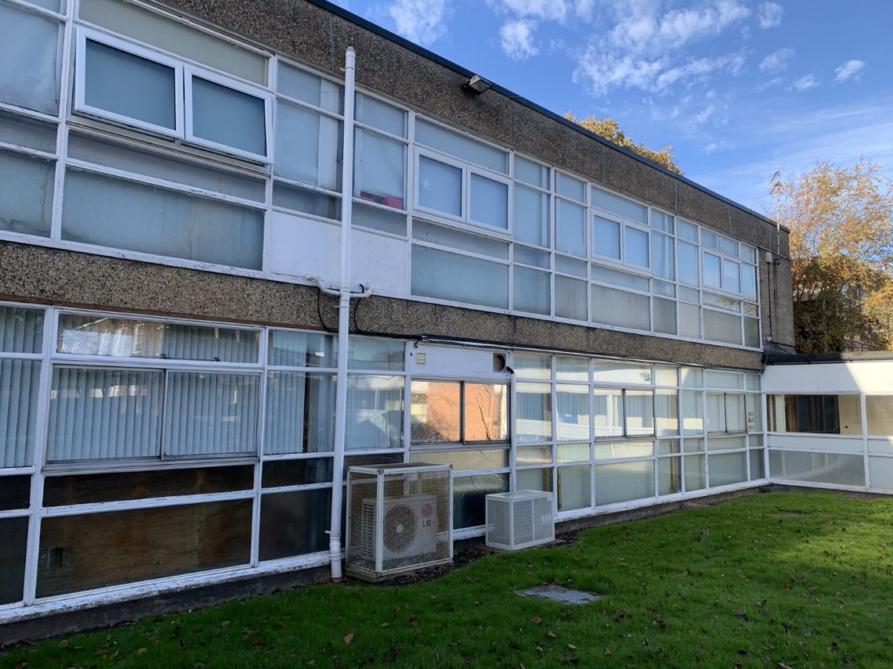

5.0 Proposed development and Impact assessment
5.1 The use of uPVC as a window construction material would not normally be appropriate within a listed building. However the host building which is the subject of this application is a modern addition to the school facility and is simply found within the grounds / curtilage of a listed building.

5.2 It is considered that the appropriately designed windows and doors which are the subject of this application will result in a considerably visual improvement of the host building which can only improve the setting of the host listed building
5.3 Although uPVC frames are thicker in appearance than the existing aluminium windows, they will result in a uniform appearance throughout. The existing frames are in a very poor condition. Overall this scheme will refresh the site and vastly improve the visual appearance of the wider school.
5.4 Furthermore it is recognised that money is in limited supply towards the upkeep and maintenance of school buildings. Therefore weighing in favour of the development is also the public benefits which would flow from the proposed development. The scheme will secure an extension to the lifespan and viable use of the school building alongside various enhancements to its significance and improvements to energy efficiency which lower its carbon cost, in accordance with NPPF Paragraph 196. Reduced costs in these areas also frees up resources available to maintain the listed elements of the school.
5.5 The development proposals have been found to sustain and cause no substantial harm to the significance of the listed building. The alterations are justified by the need to secure a sustainable, viable future for the building.
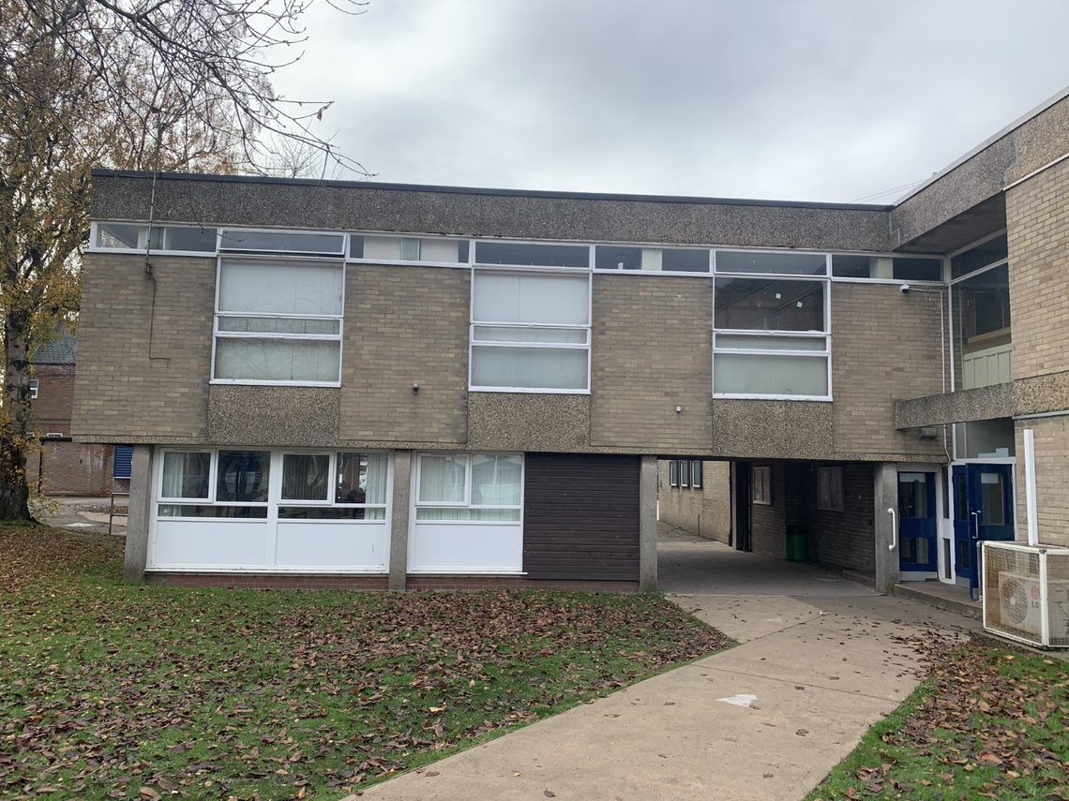

6.0 Conclusion
6.1 This Heritage Impact Assessment has been prepared on behalf of Charles Garth in support of a full planning and listed building consent application for the replacement of existing windows and doors within an existing school building.
6.2 The school building is found within the curtilage of a Grade II listed and which is a designated heritage asset.
6.3 The development proposals have been found to sustain and cause no substantial harm to the significance of the listed building. The alterations are justified by the need to secure a sustainable, viable future for the building.
6.4 Weighing in favour of the development is also the public benefits which would flow from the proposed development. This proposal will secure an extension to the lifespan and viable use of the school building alongside various enhancements to its significance and improvements to energy efficiency which lower its carbon cost, in accordance with NPPF Paragraph 196.
6.5 Overall, the proposed development accords with local and national planning policy relating to conservation of the historic environment.

