Heritage Impact Assessment

Kings Cross House
2 Quadring Road
Donington
Splading
Lincolnshire
PE11 4TB

Details provided by:
Keith Edge (Propieter)
Dated: 01st July 2020

Introduction

The property in which this impact assessment is against is Kings Cross House, 2 Quadring Road, Donington, PE11 4TB. It is a Victorian property on the junction of Quadring Road and Badgate road. Image e-documentsdv_pl_filesH04-0455-152015-05-19 19-43.pdf
refers to the location.

The property is currently covered by an Article 4 notice, reference DON 01/08 and was served on the 8th May 2001. This Article 4 applies only to the front elevation of the property.

Previous planning applications have been submitted for the front porch roof. This was submitted and the work was to replace an existing flat roof to a pitch roof. Also, an application was submitted for the front door to be replaced, under ref H04-0455-15. The original door had been removed at some point in the past and when the article 4 was served on the property it had a 60-70s style multi glazed panel door fitted (see Image e-documentsdv_pl_filesH04-0455-15Front elevation.jpg). The application was submitted to replace the excisting door with a composite door in a more traditional style, in keeping with the property. (Image 20200408_093158.jpg).

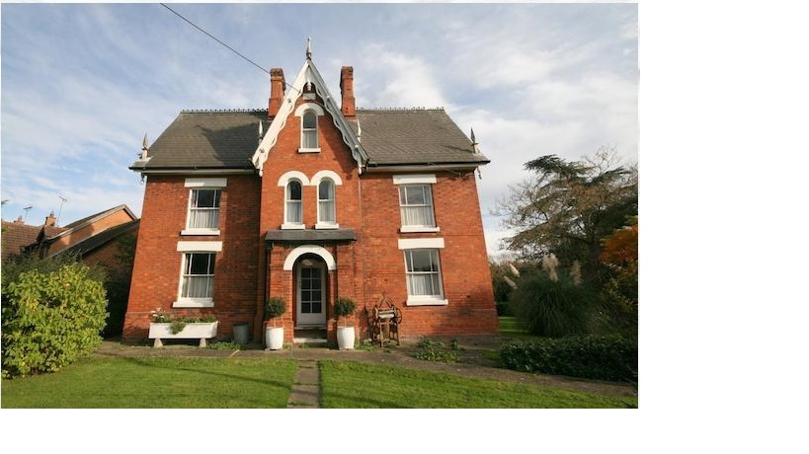
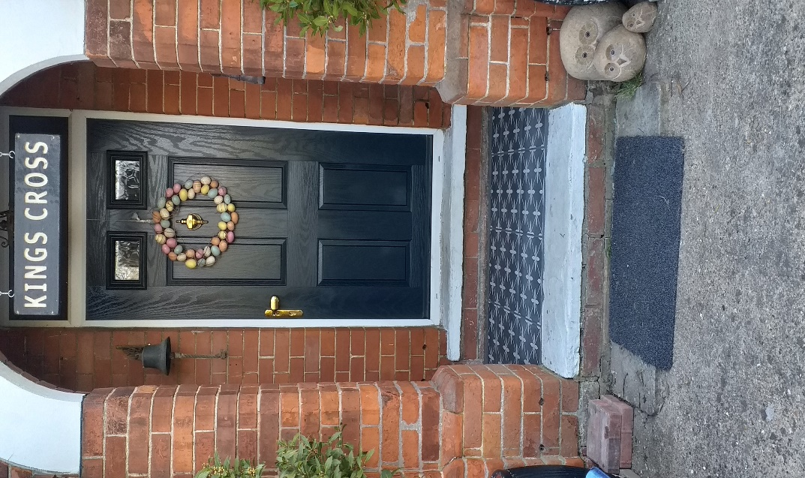

Proposal and Justification.

The proposal of the work to be undertaken is the replacement of the 4 large rectangular windows to the front elevation of the property, see image 20200514_154409.jpg.
Current sash windows fitted in the front of the property are wood with single glazing. These windows have not been looked after over the years and have deteriorated; rotten frames, replacement glass fitted, which is badly scratched and not secure. When we have had these windows inspected by a window company they have informed us that the replacement glass is actually greenhouse glass and non-household glass. The current windows lose a lot of heat (energy) and this creates condensation. This condensation is now causing mould on the inner frames which has affected the proprietor’s health. In one of the front bedrooms there is an excess of condensation which drips from the windows and has marked the flooring. Having rotted frames and loose and incorrect glazing has allowed the windows to become a security issue to the property.
With the location of the property to the busy A152 the current windows do not provide any noise reduction from the large HGV vehicles which use this road 24/7. Furthermore, due to the poor condition of the windows the large vehicles cause the windows to vibrate, thus degrading them further.

Proposed plan to replace with secure, double glazed wood sash windows in the exact style to keep the same outlook and style as the old windows reference Window Drawing Q32211-02.pdf. The replacement windows will increase energy conservation (Energy Rating.jpg), security, noise pollution and risk of ill health due to mould.

By allowing the proposal it will improve the outlook of the property and will enhance the property for years to come.

As a note to the planning office the rest of the windows around the property are of modern sash window style of a UPVC construction. They are invited to note that the current vendor has set about a scheme of improvements enhancing the property for the future.

