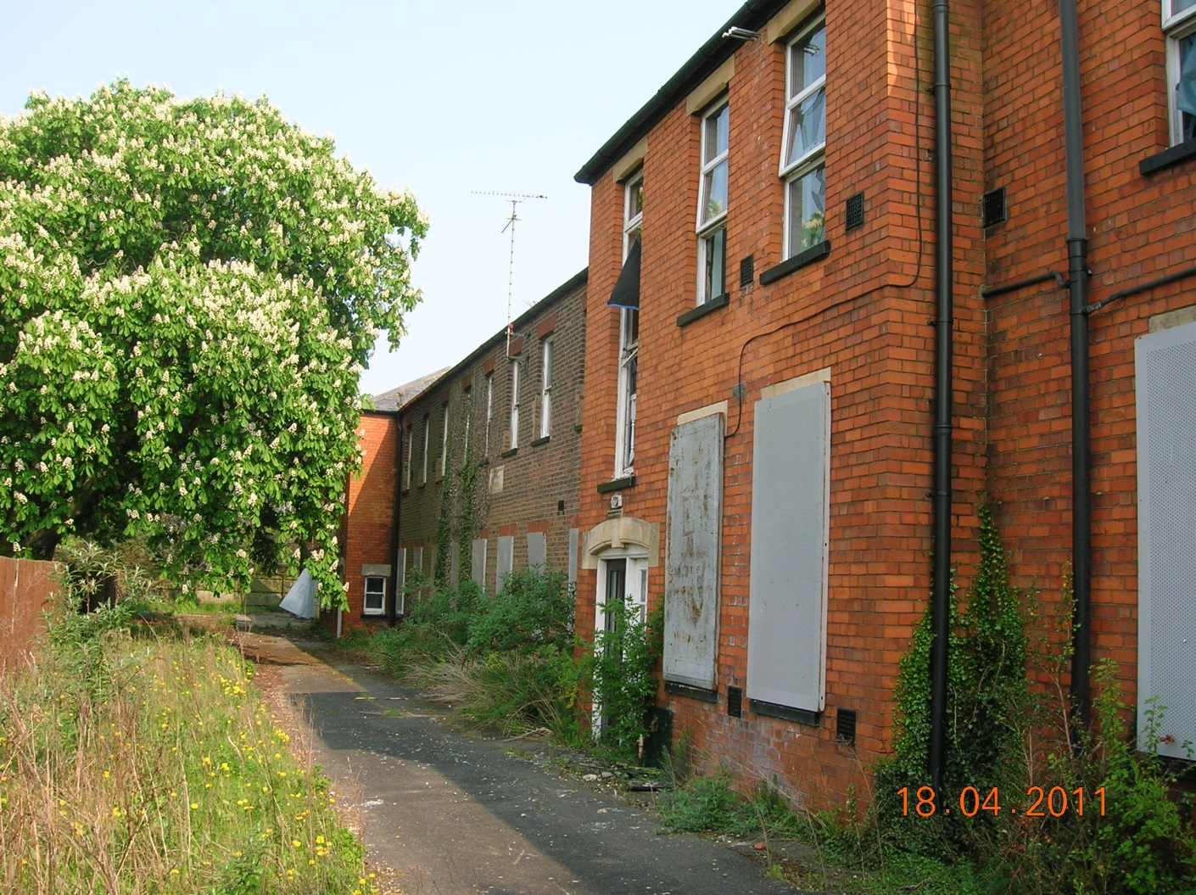

DATE: 1st September 2015
Revised 25th July 2016

Phase 1 Land Contamination Survey

Assessment/Preliminary Risk

Phase 1

Contents
1.0 Phase 1 Land Contamination Assessment / Preliminary Risk Assessment

1.1 Desk Study

1.2 Site Walkover

1.3 Conceptual Site Model

1.4 Risk Assessment

1.5 Conclusion to Assessment

References (Useful Documents)

Appendix Al – “Sitecheck” Checklist for Phase 1 Assessment
Appendix A2 Site drawing showing areas of contamination

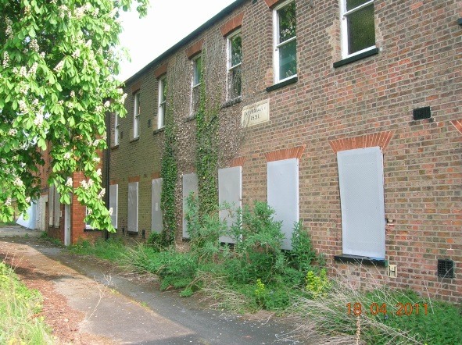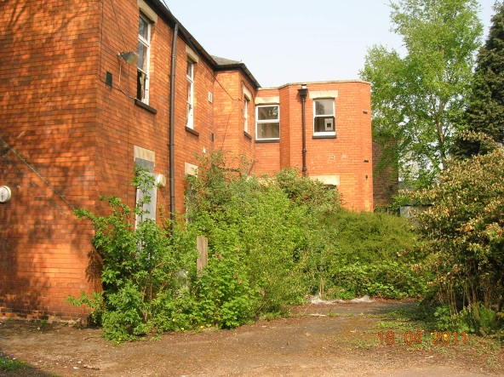

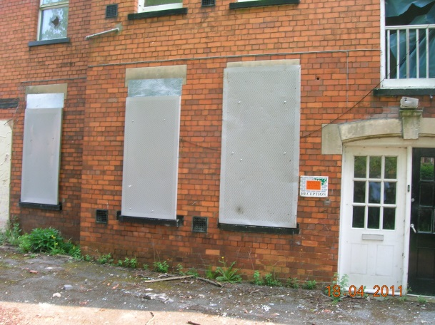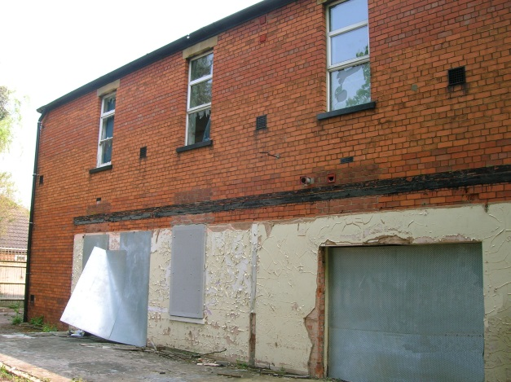

Land Contamination Plan

- Land Contamination Assessment/Preliminary Risk Assessment
The purpose of a Phase 1 Land Contamination Assessment or Preliminary Risk Assessment (PRA) is to establish the previous uses of the land under consideration or land nearby or adjacent to it, and to identify potential sources of contamination, receptors and pathways. It is important to identify all past uses of the site, and adjacent or nearby sites, since pollutants have the potential to travel away from the source, depending on the geology, groundwater and surface water of the area.

The Phase 1 Land Contamination Assessment should contain an outline conceptual site model based on the findings of a desktop study and site walkover that characterises all actual or potential pollutant linkages. This will then form the basis of any subsequent work undertaken such as intrusive investigations, risk assessment etc and set out any necessary remediation works required as part of a subsequent Phase II assessment. Alternatively the findings will rule out the need for further work at an early stage.

1.1 Desk Top Study (Desk Study)
1.1.1 The desk top study comprises a search of available environmental information and historical maps, which can be used to identify changes in land usage from old maps, trade directories and other publicly available historical records, to determine the physical characteristics of the site and to identify the likelihood of contamination. This should not just be constrained to the application site. A study of adjacent sites and the surrounding area should also be provided as contaminants can migrate from elsewhere.

1.1.2 Information about the site can be obtained from many sources, including
• Previous investigations and monitoring
• Historical maps (e.g. O.S. 6" to a mile County Series)
• Trade directories
• Aerial photographs
• Local authority records of development on site and in the vicinity
• Current use of the site and adjacent sites
• Environment Agency
• Local history groups
• Utility companies
• Land registry
• Industry profiles
• British Geological Survey
• Petroleum Officer
• Company records
• Records of pollution incidents (local authority, Environment Agency, Health and Safety Executive)
• Local knowledge
• Coal Authority

1.1.3 The desktop study will also include information on the general
characteristics of the site including details of the geological setting, e.g.:
• Sequence of strata at the site
• Variation of strata across the site
• Composition of formations
• Likely thickness of beds
• Aquifer classification
• Aquifer vulnerability
• Significance of geology as a source, pathway or receptor
• Surface water on or near the site
• Classification of surface water
• Distance and direction of each watercourse from the site
• Made ground
• Flood potential

Topography
1.1.4 Other information which will be included to substantiate the desktop study
to enable a comprehensive assessment includes:
• Part A and B processes within 250m
• Radioactive Substances Authorisations within 250m
• Licensed waste disposal sites and closed landfill sites within 250m
• Other industry within 250m
• Sewage works
• Protected habitats (e.g. Sites of Special Scientific Interest)

1.1.5 This initial part of the PRA should include a detailed site plan showing the site location, extent and boundaries of the site in context with the findings of the Desktop study.

1.2 Site Walkover

1.2.1 A simple walkover survey of the site has been conducted to identify pollution linkages not obvious from the desk study.

1.2.2 Having identified potential contaminative uses within the desktop study a site walk over survey will also help to locate potential problem areas on the
ground.

1.2.3 Contamination of soil, groundwater and building fabrics all impart valuable visual information. Old foundations, backfilled areas, subsidence and drainage may indicate changes of use, and identify areas requiring detailed sampling. Features to look for include :
• Buildings
• Surface materials
• Underground and above ground tanks
• Surface disturbance, subsidence and discoloration • Chemical stores
• Dirty' work areas
• Waste storage areas
• Adjacent properties

1.2.4 The report produced following the site walkover should include a description of structures, soils and vegetation.

1.3 Conceptual Site Model

1.3.1 After carrying out a detailed desktop study and walk over survey it should be possible to identify pollutant linkages and develop a preliminary conceptual site model . The conceptual site model (CSM) comprises three elements:
• Potential sources of contamination
• Potential receptors that may be harmed
• Potential pathways linking the two

1.3.2 The CSM is a written and diagrammatical summary of the environmental processes on a site and its surrounding area, the potentially significant sources of contamination, pathways through which contaminants can travel, and receptors that eventually could be harmed. This must be included at all stages of the Site Investigation. A CSM will provide a summary of the site including details such as;
• Its current status, history, geology and hydrogeology.
• Any potential contaminants, pathways and/or receptors.
• A summary of 'Significant Pollutant Linkages' — where there is a potential link between the potential contaminants and receptors.
• Any uncertainty in the information collected.

Pathways Migration pathways between the above potential contaminant sources and receptor targets could include, with respect to the various human and environmental receptors / targets: Pathways to Animal / Human Targets: o
On-site (Construction Workers, End Users and members of the Public)
Dermal contact.
Ingestion of soils. Inhalation of dusts, etc.
Off-site Inhalation of dusts, etc.
Pathways to environmental Receptors / Targets:
In ground migration/leaching to ground waters.
1.4 Risk Assessment

1.4.1 The final part of the Land Contamination Assessment is then the Risk Assessment and Conclusions derived from the conceptual site model addressing each potential source, pathway and receptor in turn and should indicate if any, what the risk of contamination is.

1.5 Conclusion to Assessment

1.5.1 The conclusion should then state whether the findings of the PRA are satisfactory and that no further work is required i.e no risk to human health or whether additional Phase 2 contamination works (intrusive site investigation and risk assessment) are required to identify and confirm potential pollutant linkages.
See checklist A in Appendix Al for more information on what information should be submitted as part of a Phase 1 Land Contamination Assessment..

1.5.2 If it can be confirmed that your site is underlain solely by 'natural ground' and there is no evidence of any potential contamination then there MAY be no need to carry out any further investigation. However, if there are significant amounts of 'made ground' (e.g. rubble and cinders used in the past to level up the ground; or signs of a former infilled agricultural pond, etc.) or evidence of contamination (e.g. oil staining from a former heating oil storage tank; or pieces of broken asbestos sheeting in the soil from a former garage on the site etc.) then you will need to engage professional consultants to carry out a detailed Phase 2 investigation of the site.

1.5.3 The Phase 2 investigation, consists of excavations into the ground and the recording of the ground conditions. Samples will need to be taken from the excavation at appropriate depths, this is normally from made ground or where there is staining of the soil or odours. These samples can then be analysed for contaminants. The record of ground conditions can be used to assess if there is any likelihood of the ground producing gas, either from organic matter or hydrocarbon contamination. Gas wells may need to be installed and a programme of sampling undertaken. If potential ground water contamination has been identified it will also be necessary to install ground water monitoring wells and a programme of ground water sampling and analysis undertaken. A competent geo-environmental consultant will be familiar with this type of investigation. Full guidance on producing a Phase 2 report can be found in the Councils supplementary guidance "Phase 2: Intrusive Ground Investigations and Quantitative Risk Assessment".

2.0 Key Points
• It is important to identify the potential for contamination to be present at an early stage in order that unexpected costs and delays can be avoided should a potential problem be identified during development works.
• Only a Phase 1 Land Contaminated Assessment is required at the application stage and although further investigations may be documented these can be conditioned if required. Examples of likely conditions can be found in Appendix 2.
• It is advised that a Phase 1 assessment is carried out by a suitably qualified professional.
• The Assessment should produce a conceptual site model that characterises all plausible pollutant linkages. This will form the basis of the Preliminary Risk Assessment and conclusions of the Phase 1 assessment as well as any subsequent work undertaken as part of a Quantitative Phase 2 Risk Assessment.
• An example of a basic Phase 1 Assessment can be found in appendix A3.

References (Useful Documents)
MANDATORY GUIDANCE
• The Contaminated Land (England) Regulations 2000
• Contaminated Land (England) (Amendment) Regulations 2012. • The Environment Act 1995
• The Environmental Protection Act 1990
• Department for Communities and Local Government, 2012. National Planning Policy Framework.
• Department for Environment, Food and Rural Affairs, April 2012. Environmental Protection Act 1990, Contaminated Land Statutory Guidance. The Stationery Office Ltd.
ADVISORY GUIDANCE
• Model Procedures for the Management of Contaminated land (CLR11): 2004
Department for Environment Food and Rural Affairs & Environment Agency, www.environmentagency.qov. uk/commondata/105385/model procedures 88 1483. pdf
• Environment Agency, Human health toxicological assessment of
contaminants in soil (Science Report Final SCO50021/SR2), 2009
• Environment Agency, Updated technical background to the CLEA model
(Science Report Final SCO50021/SR3), 2009
• CLEA software V1.06 licence agreement (PDF, 114KB)
• BS 10175:2011 — Investigation of Potentially Contaminated Sites — Code of
Practice
• Environment Agency/NHBC R&D Publication 66 - `Guidance for the Safe
Development of Housing on Land Affected by Contamination', 2008
• www.communities.gov.uk/documents/planningandbuilding/pdf/pps2annex2.pdf
• DOE (Department of the Environment) Contaminated Land Research Report:
Guidance on Preliminary Site Inspection of Contaminated Land: 1994.
• DOE Contaminated Land Research Report: Sampling Strategies for
Contaminated Land: 1994.
• BRE Construction of New Buildings on Gas Contaminated Land: 1991.

•Environment Agency, Methodology for the Derivation of Remedial Targets for Soil and Agency R&D Groundwater to Protect Water Resources, R&D Publication 20,1999
•DoE, 1995 Industry profiles (various titles)
•CIRIA, 1995 Remedial Treatment for Contaminated Land, SP 104,Classification and Selection of Remedial Methods
•DoE, 1994 Guidance on Preliminary Site Inspection of Contaminated Land, CLR2
•DoE, 1994 Sampling Strategies for Contaminated Land
•EA, 2001 Secondary Model Procedure for the Development of Appropriate Soil Sampling Strategies for Land Contamination
•INFO-PM2b CIRIA, 1996 A Guide for Safe Working on Contaminated Sites, R132
•CIRIA C659, Assessing risks posed by hazardous ground gases to buildings, 2006
•The Chartered Institute of Environmental Health: The Local Authority Guide to Ground Gas, 2009
•Chartered Institute of Environmental Health and Land Quality Management, Generic Assessment Criteria for Human Health Risk Assessment, 2006 www.lqm.co.ukilqmpress/0823°/020GACV020web%20brochure.pdf
•British Standards Institute, BS5930:1999 Code of practice for site investigation, 1999
•www.bsi-qlobal.cornien/Shop/Publication-Detail/?pid=000000000030176112
•Environment Agency, Guidance on Requirements for Land Contamination Reports, 2005 www.environmentagency.gov.uk/commondata/acrobatidevguidev1_1155225.pdf
•Environment Agency, Remedial Targets Methodology — Hydrogeological Risk Assessment for Land Contamination, 2006 publications.environmentagency.qov.uk/pdf/GEH00706BLEQ-e-e.pdf

Appendix Al
Checklists for Phase 1

A checklist is attached below of the necessary information required. Please note that
the checklist is not exhaustive and a site may need further information may be
required.

CHECKLIST A
Phase 1 Land Contamination Assessment/PRA
A Requirements
1 Site area in hectares.
2 Description of site and surroundings (including adjacent land uses which may affect, or be affected, by this site).
3 Details of desk study researches undertaken
4 Information on past and current activities on the site.
5 Information on history of surrounding area.
6 Historical Ordnance Survey maps and site plans and if available, aerial photographs
7 Geological strata (including man made) present, vertical & horizontal variation across the site.
8 Hydrology.
9 Hydrogeology including factors such as aquifer classification, position of water table,
groundwater flow direction, generic details and surface groundwater interaction.
10 Relevant water quality factors i.e. river quality, discharges, abstractions.
11 Details of any IPC processes or radioactive substances relevant to the site.
12 Information on site drainage and other man-made potential pollutant pathways, e.g.
underground services.
13 Identification of potential contaminants of concern and source areas.
14 Details of waste disposal activities at or in the vicinity of the site.
15 Consultations with the Local Authority, Environment Agency and appropriate bodies.
16 Review and summary of previous reports, with report references.
17 Details of any site visits/ walkovers conducted
18 Outline conceptual site model including nature and location of potential sources, pathways and receptors clearly identified. Also show potential pollutant linkages between these factors.
19 Description and justification of possible pollutant linkages for all potential receptors identified within the conceptual site model.
20 Identification of potentially unacceptable risks to potential receptors including the screening criteria used to identify those risks (state degree of confidence).
21 Justification of why any possible pollutant linkages have been assessed as posing an
acceptable risk.
22 Description and justification of next steps proposed at the site, e.g. carry out site investigation and quantitative risk assessment (including timescale).

DESK TOP STUDY/PRA

See Appendix I for Envirocheck Site Check by Lamdmark

The site lies to the north of Fleet Road Holbeach and is 0.48ha in area. Holbeach is an important town within the area. Lying to the south of the A17 ,an important route from the east coast to the midlands, it serves a mainly farming community within the area to the south of the town and has good public transport services which link to rail services at Spalding.Fleet Road is a main route in and out of Holbeach from the A17 to the town centre.
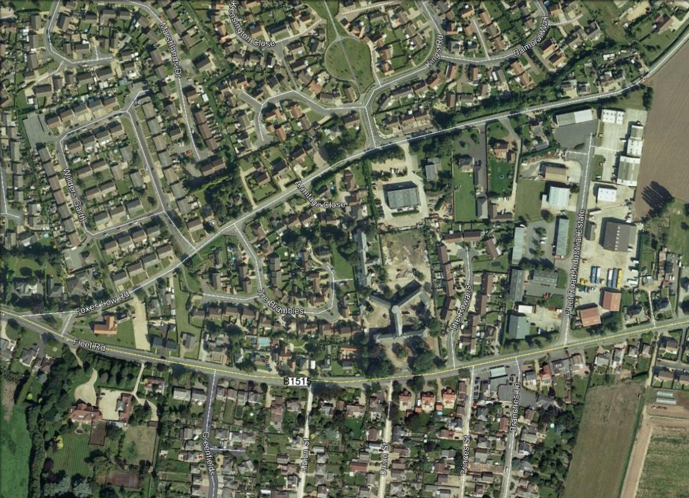
SITE
Orchard House
The building lies behind (to the north) of Holbeach House, which has earlier approvals for the change of use to residential. To the west lies a relatively modern housing estate with associated open space which characterises the western boundary of the site. Orchard House is listed by virtue of its location within the curtilage of a Listed Building, Holbeach House.
Historically, Orchard House consisted of an original building dating from around the same date as Holbeach House and a later building which elates from 1851. The newer 'extension' dates from 1904.
Some later extensions have been removed leaving evidence of their existence on the external fabric. The treatment of these areas will be covered in the listed building application.
The application scheme will have little or no effect on the exterior of the building.

When the land to the east is developed, it is intended that the overall site will be accessible by the occupiers via the use of communal gardens etc. Due to the private, un-adopted nature of the roads, however, there will be no wider public access.
In general, the new use of the building relates well to the surrounding land uses, which are predominantly residential. The land to the east of the whole site has now been developed into private residential use and is now established within the local community.
Land Use
The current land use surrounding the site is shown on Pages 3-7 of “Sitecheck” document attached to this desk top study.
The site report highlighted 1 item of “On site” industrial use contamination under the heading “Past Land Use “ and three items of pathway & receptors sensitivity.
There were 34 items logged within the site centred 250m radius zone. All but four of the items logged were situated in the vicinity of the industrial estate 160M to the east of the proposal site these sites are designated as “active”. The items as shown other than those above were deemed to be inactive except for “Fleet Road Garage which is 155M from the site centre but this site is subject to LA pollution & control.
Historical Land Use
As shown on historical maps 1891- 1956 the land was used as hospital (see maps below)
The following historical features outside the site but within 250m zone are noted:-
Electrical Sub Station
Areas of possible filled ground to North and West of proposal site, mapped 1956-1959.

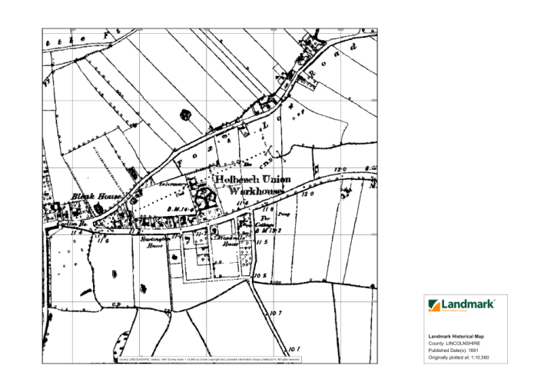

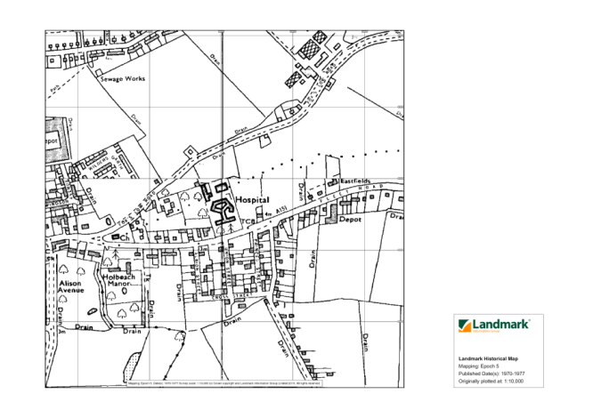

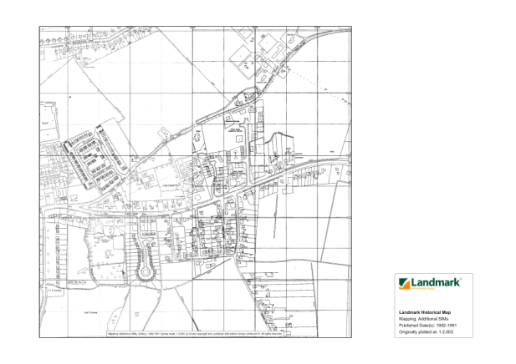

Pathways and Receptors

Underlying strata

The main superficial strata is Alluvium /clay /silt/sand with the bedrock being mudstone.

Hydrology

Negligibly permeable Non Aquifer. There may be some groundwater flow through rocks at lower levels but with no persistent pollutants present these can be ignored.

Water Quality

There is no discharge to rivers or abstraction of water activities from or on site.

Flooding

The site is located in a flood zone 3 as shown by the Environment Flood Plain Map
However as the Flood defences map below shows the area is well protected from flooding.
As there appears to no fluvial or pluvial flooding this negates any contamination via flooding

SITE

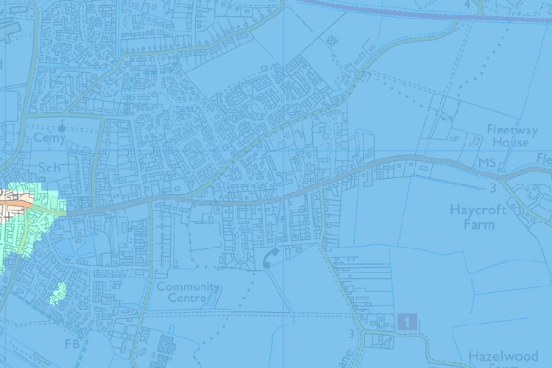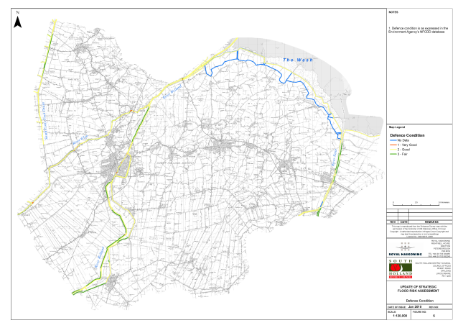

Site Drainage & Services

Storm water discharge from Orchard House existing building will be as existing to existing Soakaways. The roof water discharge from the 18 new dwellings will be via “Polystorm soakaway” units .

Foul Disposal will be a combination of new “Polypipe” or similar drainage system linking to existing system which discharge to Anglian Water sewer in Fleet Road.

Domestic waste will be stored in purposed built store for weekly collection.

Services will be placed in trenches.
The ground surrounding the buildings has only recently been disturbed to lay drainage systems.
There are existing services on site however there exact routes /positions are unknown as no records have been found.

All existing services to be exposed and made safe and isolated

Other possible areas of contamination

A site walkover was carried.
The surface of the site is covered in a mixture of hard standing and permeable hard standing with grass and overgrown landscaped areas. The underlying sub strata is predominately clay.
The existing redundant building (Orchard House) has concrete floors which would prevent contamination leaching from the ground.
The site inspection gave no indication of land fill or any made up ground.
As the site has had no commercial or manufacturing use certainly from 1888 and more than likely previous to that date, the risk of any contamination is extremely low to no contamination at all.
The site has no factories using any manufacturing process within the locality.
On walkover examination of the site, no signs of contamination or localized sites of contamination were obvious.
The only use the site has had since 1851 has been as a hospital/nursing home and there is no evidence on site of any hospital waste or radioactive substances of any kind being deposited on site.

Risk Assesment
The desk study has not identified any landfill sites and / or significant areas of in filled ground within or within 250m of the site. Furthermore, the site specific assessment advises that no radon protection measures are required at the site. However it is always prudent to provide taped joints to the damp proof membranes fitted to all new floors with the membrane carried over the cavity to the external leaf.

The Assessment has shown that there are no known pollutants on site or within the site strata. There are no known receptors on or near the site.

As the site has no visible contaminants the only risk could be contamination found on excavating foundation or service trenches.
If this situation arises further intrusive investigation in the potential contaminated area will be required and the local authority notified of the course of action the developer intends to take.

Conclusions
The site has had no previous manufacturing/commercial use. It would not have been affected by any other adjacent processes as there are none in the locality.
In conclusion there will be very little risk of the presence of contaminates to be present on the site . The historical use as a hospital has not given rise to any contamination.
The occupiers of new dwellings and converted dwellings will have the benefit of solid concrete floors on the ground floor and will be protected from any extremely small risks by the design of the dwellings and there environs.

.

.

