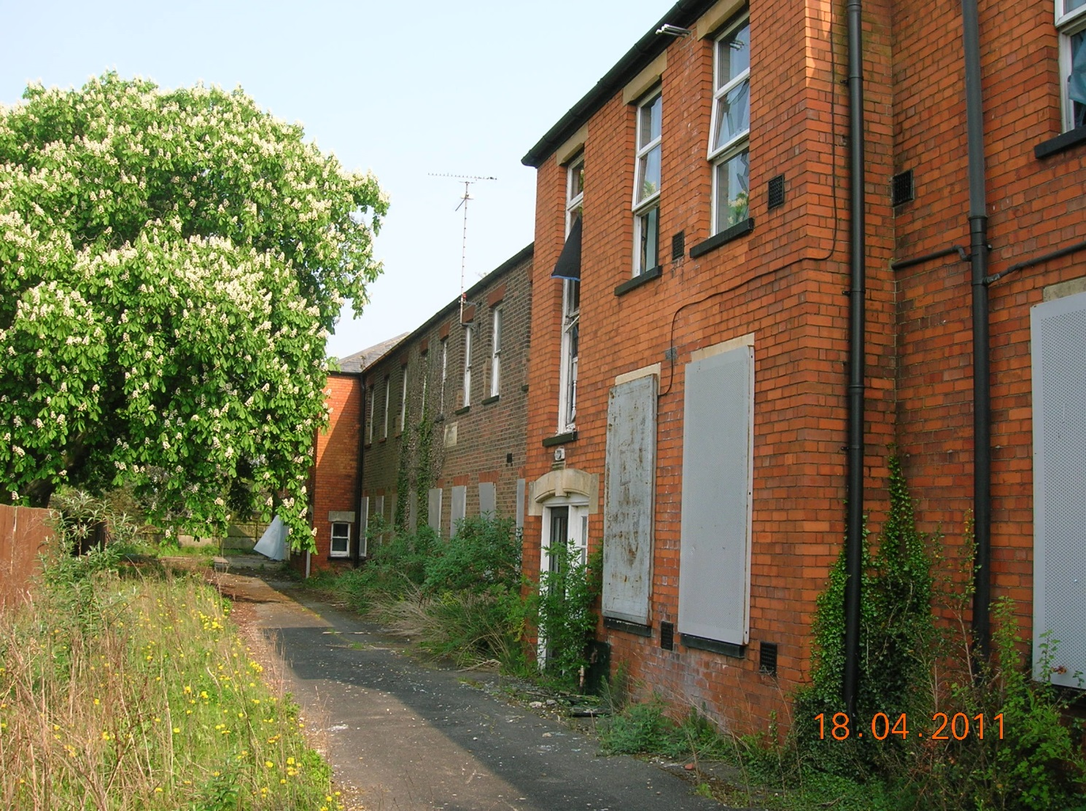

Reference:- H05-0077-16

Applicant :- Invicta Developments Ltd
C/O Plan-It Design Ltd
Richmond House
Long Bennington Newark Notts
NG23 5JR

Location:- Orchard House Fleet Road Holbeach

Description:- Conversion of redundant health facility into 14 dwellings and erection of 18 terraced dwellings with parking facilities- approved under H05-0563-11.
Modification of Condition 2 of H05-0563-11 to allow amendments to previously approved plans.

Revisions to Details to Discharge Conditions:-

15: Waste Collection Points as shown on Drawing No IDHH/OH/16/Con17-18-19 /011
2: Existing and proposed levels as shown on Drawing No IDHH/OH/16/Con 2 /012
4: Contamination Revised Desk Top/Risk Assessment
17: Foul and Surface Water Disposal Drawing No IDHH/OH/16/Con17-18-19 /011
18: Materials for Means of Enclosure Drawing No IDHH/OH/16/Con17-18-19 /011
19 Details of External Illumination Drawing No IDHH/OH/16/Con17-18-19 /011

Condition 3

A meeting was held at South Holland District Council Offices on 26th August 2015.
Those attending were :-
David Goodridge Invicta Developments Ltd.
Richard Fiddler South Holland District Council
Richard Willows Plan-It Design Ltd (Agent)

At that meeting it was agreed that Invicta Developments would make an off-site single once and for all contribution of £38,000.00 by which the applicant proposes to discharge the above condition regarding affordable housing allocation.

