Planning Statement
Change of Use

Detached Garage to Semi-Private Fitness Suite
The Grange
Gedney Broadgate
Spalding
PE12 0DE

Feb 2021

Contents
- Introduction p 1
- Site Context p 2

- Proposal
Design/purpose p 3
Appearance/materials p 3
Access/parking p 3
Refuse p 3
Impact on neighbouring amenity p 3
Opening hours p 3-4

- Conclusion p 5

1. Introduction

1.1 This Planning Statement is provided in support of a planning application seeking the change of use of the detached garage building of The Grange, Gedney Broadgate from domestic garage and garden room use to a semi-private fitness suite.
1.2 This statement has been produced by the proprietor Mr William Newell to explain the proposal and to set out the planning considerations.

2. Site Context

2.1 The property is located in a semi rural location south of the A17 Gedney roundabout.
2.2 The main house was built c1792, Georgian design with later Victorian elevations. It is rendered on 3 sides with York stone coloured cement render and has white timber sash windows. The roof tiles on the garage and main house are blue slate. The grounds are 2/3 acre consisting of lawn grass and lined by various trees. The property is enclosed by wire fencing, wooden fencing (North aspect) and wall/metal driveway gate (West aspect). Vehicle access is provided via a double entrance/exit gravel driveway for multiple cars. The property is not listed or located in a conservation area.
2.3 The detached triple garage and garden store building which is the subject of this application is situated approximately 9.5metres adjacent to the main house. The garage is constructed of block walls with common red brick frontage and has buff coloured cement rendered rear elevation and gable ends. The individual garages have white double wooden doors with single glazed sections. The building has a first floor consisting of 2 rooms in the roof space with internal stair access. See photo below of the garage building.

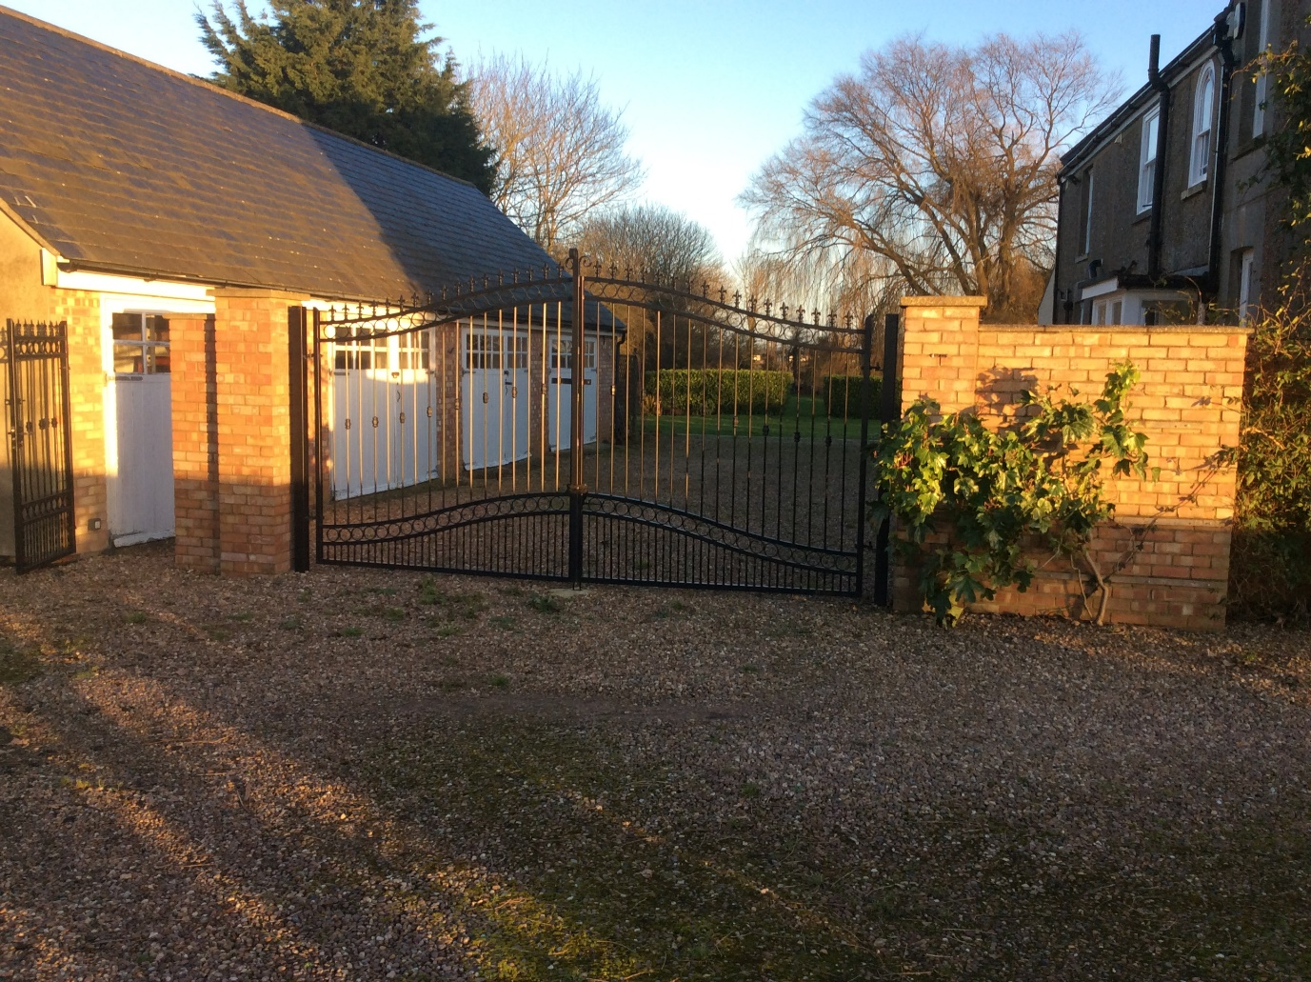
Photo showing front of the garage building.
3. Proposal

3.1 Planning permission is sought for the change of use of the triple garage and garden store unit from a private detached garage to class E(d) semi-private fitness studio. The first floor would be used by the owners only. When the studio is not used as a fitness suite it will be used for the enjoyment/recreation of the owners/applicant.
Design/purpose
3.2 The internal ground floor area of the garage is approximately 92sq m. It is proposed to use the space as a personal and small group training studio. The applicant is a qualified fitness/rehabilitation instructor and currently works as a contractor for the military in this role. The aim is to provide a similar health and fitness service for the local and wider community.
3.3 The use of the space as a personal fitness studio requires no external alterations to the building other than planned replacement of doors/windows (for security and to reduce heat loss) and creating a narrow path to the front of the unit to allow safe access.
3.4 Alterations internally include (a) creating a double door size opening to the garden store room; (b) extending the existing toilet area to include a shower; (c) creating a small kitchen/sink area (d) plumbing for heating/electrics.
Appearance/Materials
3.5 The proposal does not require any alterations to the fabric of the building other than those stated in Ser 3.3 & 3.4. The garage building faces the main house and the frontage is not easily seen from the main road. It is proposed to replace the unsuitable solid white wooden doors with white, double glazed aluminium, thermally efficient and secure, bifold doors. I trust this would be acceptable as neighbouring dwellings (one of which is Grade II listed) each have similar looking doors (whole paned units) to the main house.
Access/ parking
3.6 The property has a separate driveway entrance and exit. The drive area can cater for up to nine vehicles/cars. There will be no changes required to current access into and out of the property or current parking capacity.
Refuse
3.7 Minimal litter/rubbish collection is anticipated. Users will be encouraged to bring their own water bottles/refreshments with them and take them away when they leave, therefore no change to the current bin storage area is deemed necessary.
Impact on neighbouring amenity
3.8 There are no large scale internal/external alterations necessary to facilitate the proposal. The use of the premises as a personal training studio will not result in noise or disturbance to neighbouring occupiers.
Opening hours
3.9 The proposed use is relatively small scale with physical training taking place either on a one to one basis or small groups (2 – 6 persons max but typically 2-4 persons). The intent is to provide the following service:
a. One to one training between 07:00-20:00, Monday to 1200 Saturday (by appointment only).
b. Small group training between 09:00-20:00, Monday to 1200 Saturday. (One to three planned daily 60min classes, subject to demand).

4. Conclusion

4.1 The proposed change of use from a garage to fitness studio will not result in any negative impact to the amenity of neighbouring occupiers. The proposal is wholly sustainable in terms of its location and the provision of a social and community facility.
4.2 Given the above, I trust that the council will consider the application favourably.

