Application reference and title:
H06-0324-25 – Installation of two new target barges.
Raf Holbeach Bombing Range, Durhams Road, Gedney, Dawsmere, Spalding, PE12 9NJ

Assessment made by: Chris De Ruyck, South Holland District Council

Date: 19/09/2025

European Site(s): The Wash SPA; The Wash and North Norfolk Coast SAC; The Wash Ramsar site

Assessment Contents:

Part A – | Introduction and information about the plan or project and initial assessment of credible risk to sites………………………..………. 2
Part B – | Information about the European Site(s) likely to be affected…...8
Part C – | Screening of the plan or project…………………………………..…11
Part D – | Appropriate assessment and conclusions on site integrity (where required)…………………………………………………………..….….15
Part E – | Permission decision with respect to European Sites……….…..19

References to science/evidence ……..………………………………………….….20
Appendices 1 – 4 …………..……………………………………………………….….22

PART A:

Introduction and information about the project and an initial assessment of credible risk to European Sites

A1. Introduction

This is a record of the Habitats Regulations Assessment (‘HRA’) undertaken by South Holland District Council in its role as competent authority and in accordance with the assessment and review provisions of the Conservation of Habitats and Species Regulations 2010 (as amended) (‘the Habitats Regulations’). Some information contained herein has been extracted from the “Shadow Habitat Regulations Assessment” produced by ECOSA (Ecological Survey and Assessment, ltd) in December 2024.

SHDC must make a decision as to whether to grant permission to RAF Holbeach to install two new target barges on intertidal mud within the RAF Holbeach air weapons range located within the Wash (SPA, SAC, Ramsar), hereby referred to as ‘the project’.

Where such a proposal might affect a European Site, Regulation 61 of the Habitats Regulations requires an assessment to be made of such proposals by a competent authority.

In making this HRA as the competent authority in this case, SHDC may only grant permission to the project where it is able to ascertain either:
- that it will not have a likely significant effect on a European site (either alone or in combination with other plans and projects), or;
- that it will have no adverse effect on the integrity of a European Site following an appropriate assessment.

If such effects cannot be ruled out, the proposal cannot proceed unless the further tests given in Regulations 62 and 66 of the Habitats Regulations can be satisfied.

A2. Details of the plan or project

Name of applicant: RAF Holbeach

Location:

The site lies within the Ministry of Defence weapons range danger area (EGD 307), located along a 3,875 ha region of The Wash (Wikipedia, 2025), and is reserved for Royal Air Force, Army Air Corps and NATO-allied bombing and air weapons training. The weapons range is accessed via a driveable track, which leads from an observation tower on the coastline, across the saltmarsh to a gravelled parking area.

The project site comprises an area of approximately 1,500 m² of intertidal mudflat located within the range, approximately 1.75 kilometres north-east of the Lincolnshire coastline; National Grid Reference (NGR) TF 4755 3305 (Appendix 1).

Description of the plan or project and its constituent elements:

The project entails the installation of two replacement barges within the air weapons range at a new location in the intertidal zone to be used as targets for training. The installation corresponds to the abandonment of two old target barges at a different intertidal location that will remain in place elsewhere on the range. These targets are no longer fit for purpose and require replacement (see Appendix 2 for photo of old target site).

Prior to moving into position, the barges will be stripped of engines and fuel tanks and cleaned. On favourable spring tides, small tugs will tow the barges to the location, where they will then be temporarily moored in place and left to ground. Once ground, flood ports will be opened allowing water to flood the barges on the next flood tide to keep them in place on the mudflat. Over time, mud will accumulate inside the barges, wherein they will essentially become permanent features of the intertidal zone (see Appendix 3. Site Plan).

The application that this HRA is supporting is only seeking permission to install the barges and operate the target site, and due to the abandonment of an existing target site, there will not be an increase in the number of practice bombs being dropped, or an increase in capacity for the site, nor will operational hours change or increase.

The practice bombs consist of a metal shell filled with solid concrete, which will be used during the operation of the target site. The risk of pollution from these is apparently considered low due to the use of inert and solid materials.

Target Barge Preparation prior to towing:
- The barge is to be docked.
- High-pressure wash of the external hull to remove all marine growth and loose material.
- High-pressure wash of the internal hold space to remove all loose material, followed by pumping out.
- All internal spaces are to have loose rust, corrosion products, and any other material removed from the bottom shell, horizontal frames, or other surfaces.
- Remove all anchors, masts, machinery, and associated pipework and tanks, and seal any redundant deck penetrations.
- Install flooding ports and create waterways through internal frames as noted on the flooding port drawings.
- Facilitate and provide access for inspection surveyors from the client team and MCA, assuming two inspections.
- Amend deck-level compartment access hatches so they can be used as vents once the barge is positioned on site. Details to be agreed with Marmus Ltd.
- Re-launch the barge.

Specification Notes: All steelwork to be carried out in accordance with National Structural Steelwork Specification (NSSS) 7th Edition at grade S275 JR unless noted otherwise. All new steelwork to be left unfinished unless noted otherwise. All burrs and sharp edges to be removed. All fillet weld leg lengths to be 2/3rds parent metal thickness. Weld certification to match weld procedure qualifications. Weld testing to be 100% visual and 50% magnetic particle inspection.
Gaskets: All gaskets to be neoprene rubber gaskets in accordance with BS 2752. Bolts: All bolts to be grade 8.8 unless noted otherwise.

A.3 Habitat Regulations Assessment Methods

This HRA has been completed in the following stages:
- European sites have been identified, which may be impacted by the development.
- The potential development impacts, both alone and in combination were established.
- The proposals were screened for likelihood of significant effect on the qualifying features of the European sites.
- An appropriate assessment of the likely significant effects was undertaken.
- Measures are introduced to mitigate likely significant effects to be considered as part of the appropriate assessment.

Information Sources
- Multi-agency Geographic Information for the Countryside (MAGIC; Defra 2024).

- Natural England Designated Sites View (https://designatedsites.naturalengland.org.uk/)

- British Trust for Ornithology WeBS Reports (https://app.bto.org/webs-reporting/alerts.jsp)

- Van der Kolk, H. et al. 2019. Cumulative energetic costs of military aircraft, recreational and natural disturbance in roosting shorebirds. Animal Conservation, 23:359–372.

- Thompson, Onoufriou & Patterson. 2016. Report on the distribution and abundance of harbour seals (Phota vitulina) during the 2015 and 2016 breeding seasons in The Wash. SMRUC-DOW-2016-016, December 2016 (unpublished). 43 pp.

- Woodward et al. 2015. The Wash bird decline investigation 2014. BTO Research Report No. 660. 113 pp.

- Ross-Smith, Calbrade & Austin. 2011. Analysis of wetland bird survey (WEBS) data for The Wash SSSI/NNR. BTO Research Report No. 587. 116 pp.

- Dare et al. 2004. Historical and current status of cockle and mussel stocks in The Wash. Centre for Environment, Fisheries, and Aquaculture Science. 85 pp.

- Yates et al. 2004. Low tide survey of The Wash Special Protection Area, final report of the winter 2002-2003 shorebird survey. English Nature Research Report No. 589. 63 pp.

A.4 Initial assessment of risks to European sites

This section sets out the potential ways in which the plan or project might credibly affect European Site(s) based on a rapid assessment of location, proximity, type, scale, extent, duration, frequency and timing of the operations / activities which might take place if implemented.

A rapid assessment of risk indicates:

- The location of the project is directly within The Wash SPA, SAC, SSSI, and Ramsar site.

- Subtidal sandbanks and reefs are widespread throughout The Wash and North Norfolk coast. Commercially important fish species use sandbanks as nursery grounds and reefs are associated with elevated biodiversity and species abundance. The site has an outstanding example of the habitat Sabellaria spinulosa reef, which is of European significance. The large areas of intertidal sand and mudflats form important habitat for polycheate worms, bivalves and crustaceans and foraging ground for breeding and wintering waterbird bird species. Mussel and cockle beds found on the intertidal flats also support important fisheries and wintering bird populations in the area.

Physical Effects:

- The project will result in direct disturbance and loss of intertidal mud habitat from sinking the barges, which will permanently remain in situ.

- The barges will create a permanent physical barrier in the seabed and alter tidal flow and suspended sediments around them.

- Boat movements and disturbance to the mudflat may result in the spread of invasive non-native species (INNS).

- Pollution of surface and groundwater, e.g., accidental spillages during construction, as well as accumulating low-level pollution resulting from dropping metal encased concrete practice bombs.

- Dropping practice bombs in this new location will also further disturb benthic flora and fauna through systematic habitat loss and mortality from bomb strikes and periodically increasing the suspended solids in the water column.

Indirect Effects:

- Noise and visual disturbance from boats, machinery, and personnel during installation will disturb fauna.

- Noise and visual disturbance from aircraft, practice bombs and the barges will disturb fauna in this new location, including breeding and wintering birds that currently forage in the vicinity of this new location.

Based on the details above, there may be credible risk to designated features of the Wash, some of which overlap across SAC, SPA, and Ramsar designations.

PART B:

Information about the European Site(s) which could be affected

B1. Brief description of the European Sites and their Qualifying Features

The following qualifying features are scoped into the appropriate assessment.

The Wash and North Norfolk Coast SAC
Mudflats and sandflats not covered by seawater at low tide;
Biogenic reefs formed by the tube-dwelling polychaete worm Sabellaria spinulosa. These structures are varied in nature and include reefs which stand up to 30 cm proud of the seabed and which extend for hundreds of metres (Foster-Smith & Sotheran 1999).
Intertidal blue mussel (Mytilus edulis) beds are located along the mid-shore of the intertidal flats and the offshore banks (Dare et al. 2004).

The Wash SPA
Bar-tailed godwit, Limosa lapponica - A157
Bewick's swan, Cygnus columbianus bewickii - A037
Black-tailed godwit, Limosa limosa islandica - A616
Common scoter, Melanitta nigra - A065
Common tern, Sterna hirundo - A193
Curlew, Numenius arquata - A160
Dark-bellied Brent goose, Branta bernicla bernicla - A675
Dunlin, Calidris alpina alpina - A672
Gadwall, Mareca strepera - A051
Goldeneye, Bucephala clangula - A067
Grey plover, Pluvialis squatarola - A141
Knot, Calidris canutus - A143
Little tern, Sterna albifrons - A195
Oystercatcher, Haematopus ostralegus - A130
Pink-footed goose, Anser brachyrhynchus - A040
Pintail, Anas acuta - A054
Redshank, Tringa totanus - A162
Sanderling, Calidris alba - A144
Shelduck, Tadorna tadorna - A048
Turnstone, Arenaria interpres - A169
Wigeon, Mareca penelope - A050

The Wash NNR
Breeding bird assemblage
Invertebrate assemblage
Common seal
Sand/mudflats
Wintering passage birds

The Wash Ramsar Site
Bird assemblage of national importance (as above).
Common Seal population (Phoca vitulina) of international importance.

All other qualifying features of these three sites are not considered capable of being conceivably affected by the project and so have been eliminated from further consideration in this HRA.

B2. European Site Conservation Objectives

Natural England’s Conservation Objectives (including any Supplementary Advice which may be available) provides the necessary context for all HRAs.

The overarching Conservation Objectives for every European Site in England are to ensure that the integrity of each site is maintained or restored as appropriate, and that each site contributes to achieving the aims of the Habitats and/or Wild Birds Directive, by either maintaining or restoring (as appropriate):

- The extent and distribution of their qualifying natural habitats,
- The structure and function (including typical species) of their qualifying natural habitats,
- The supporting processes on which their qualifying natural habitats and/or on which their qualifying features rely,
- The population and distribution of each of their qualifying features within the site.

In light of the European Sites which could be affected by the plan or project, this assessment will be informed by the following site-specific Conservation Objectives

The Wash and North Norfolk Coast SAC and SPA
https://publications.naturalengland.org.uk/file/5213489320951808 https://designatedsites.naturalengland.org.uk/ConservationAdvice.aspx?SiteCode=UK0017075&SiteName=The%20Wash&SiteNameDisplay=The%20Wash%20and%20North%20Norfolk%20Coast%20SAC&countyCode=&responsiblePerson=&SeaArea=&IFCAArea=&HasCA=1&NumMarineSeasonality=2&SiteNameDisplay=The%20Wash%20and%20North%20Norfolk%20Coast%20SAC

The Wash Ramsar Site
https://jncc.gov.uk/jncc-assets/RIS/UK11072.pdf

The Wash Biodiversity Action Plan
https://southeastlincslocalplan.org/media/24161/The-Wash-Biodiversity-Action-Plan/pdf/The_Wash_Biodiversity_Action_Plan.pdf?m=1703961389190

PART C:

Screening of the Project

C1. Is there a likelihood [or risk] of significant adverse effects?

In accordance with case law, an effect is considered “likely” if it “cannot be excluded on the basis of objective information”, and to be “significant” if it “undermines the conservation objectives”.

To make this determination, each of the project elements (i. barge installation, ii. operation of targets site) has been tested against each of the relevant European Site qualifying features using best available evidence and professional judgement.

C1.2. Risk of Significant Effects Alone.
European Site: The Wash, SPA, SAC, Ramsar
Project Element: Installation of target barges and associated works
Conservation Feature | Impact/  Pathway | Likely Significant Effect?
Sand/mudflats | Loss of mudflat habitat | No, barges will permanently affect water flow and suspended sediment in the immediate area, and a small amount of mudflat will be lost (~1500 m²), however, this impact is insignificant in relation to the remaining area of intertidal mud.
Sand/mudflats | Pollution/toxicity | No, to mitigate, barges will be stripped of components and cleaned. Spills or equipment failure during work unlikely, but emergency mitigation procedures will be in place prior to works.
Sand/mudflats | Invasive species | No, barge hulls will be cleaned prior to installation to minimize risks.
Biogenic Reef | Loss of Sabellaria spinusloa reef | No, there is a low likelihood of significant Sabellaria spinulosa or Blue Mussel (Mytilus edulis) populations on site based on mapped distribution and due to historic weapons range activity.
Biogenic Reef | Pollution/toxicity | No, as above.
Biogenic Reef | Invasive species | No, as above.
Breeding Bird assemblage | Loss of foraging habitat | No, the amount of habitat lost (~1500 m²) is very small compared to entirety of intertidal habitat available.
Breeding Bird assemblage | Pollution/toxicity | No, as above.
Breeding Bird assemblage | Invasive species | No, as above.
Invertebrate assemblage | Loss of substrate and populations | No, the amount of substrate and invertebrate populations affected is very small compared to entirety of intertidal area.
Invertebrate assemblage | Pollution/toxicity | No, as above.
Invertebrate assemblage | Invasive species | No, as above.
Wintering passage birds | Loss of Foraging Habitat | No, the amount of habitat lost (~1500 m²) is small compared to entirety of intertidal habitat available. However, the barges will break the line of site of the horizon and my deter sensitive birds from foraging within a larger area around them. The extent of this area conceivably ranges from a 100-400 m radius.
Wintering passage birds | Pollution/toxicity | No, as above.
Wintering passage birds | Invasive species | No, as above.
Common seal | Loss of Foraging Habitat | No, the amount of habitat lost (~1500 m²) is small compared to the entirety of intertidal habitat available.
Common seal | Pollution/toxicity | No, as above.
Common seal | Invasive species | No, as above.
European Site: The Wash, SPA, SAC, Ramsar
Project Element: Operation of new barge target site
Conservation Feature | Impact/Pathway | Likely Significant Effect?
Sand/mudflats | Disturbance from ordinance strikes | No, ordinance and metal fragments will constantly be deposited around targets, however, most will sink below surface/covered by accreting sediment over time. In addition, the previous target site will begin to recover from bombardment.
Sand/mudflats | Pollution/toxicity | No, toxicity arising from the barge hulls and the metal casings and concrete from ordinance are stated to be “low”, however, aluminium and potassium can leach from concrete, and leachate may also raise the pH of water and sediments. These processes may have long term negative impacts on benthic invertebrates, though tidal flows will largely wash away and dilute contaminants in the larger marine environment. In addition, there will be a corresponding reduction of low toxicity inputs at the previous target site.
Biogenic Reef | Disturbance to Sabellaria spinusloa reef | Unknown (though low likelihood of significant Sabellaria spinulosa or Mytilus edulis populations on site based on mapped distribution, and historic weapons range activity.
Biogenic Reef | Pollution/toxicity | No, as above.
Breeding Bird assemblage | Noise and physical disturbance to foraging Birds | Unknown, foraging birds in the area will be subject to frequent disturbance in this new target area and likely prevented from feeding. However, it is possible that birds may alter their behaviour to find other feeding sites. For example, disturbance at the old target size will decease allowing birds to use nearby areas.
Breeding Bird assemblage | Pollution/toxicity | No, as above.
Invertebrate assemblage | Mortality of invertebrates from direct disturbance. | No, invertebrate populations will be subject to higher mortality from striking ordinance, as well as low-level toxic effects, however, the area affected is relatively small and there is a compensatory reduction in disturbance at the previous target site that may enable populations to recover.
Invertebrate assemblage | Pollution/toxicity | No, as above.
Wintering passage birds | Noise and physical disturbance to foraging and roosting birds | Unknown, wintering birds in the area will be subject to frequent disturbance in this new target area and likely prevented from feeding and roosting nearby. Specifically, there is a mussel bed within approx. 650 m of the new target site where waterbirds concentrate, and some species may be prevented from accessing it and incur greater energetic costs when foraging. However, disturbance at the old target size will decrease and some birds may alter their behaviour to use this area.
Wintering passage birds | Pollution/toxicity | No, as above.
Common seal | Noise and physical disturbance to pupping seals. | No, there do not appear to be any pupping sites identified by Thompson et al. (2016), which are near the target site, and other known pupping sites appear to be similarly distant from the existing target area
Common seal | Pollution/toxicity | No, as above.

C2. Overall Screening Conclusion for the Project

Based on professional judgement and input from Natural England, we conclude that there is a credible risk that the proposals may have a significant effect on the foraging habitat of The Wash’s breeding and wintering bird assemblages and undermine the conservation objectives for these qualifying features. Therefore, it is necessary to conduct an Appropriate Assessment.

In combination effects with the proposed development:
- We have not considered further in combination effects within this HR due to the remote location of the proposals, and the absence of other known intertidal development currently or recently taken place in the locality. In addition, operational impacts related to the new target site can be assumed to be largely equivalent to those that took place at the previous target site, which have now been discontinued.

PART D:

Appropriate Assessment and Conclusions on Site Integrity

D1. Scope of Appropriate Assessment

The Sites and the Qualifying Features for which significant effects cannot be ruled out and which are initially relevant to this appropriate assessment are the breeding and wintering passage bird assemblages, including:

Bar-tailed godwit, Limosa lapponica - A157, Bewick's swan, Cygnus columbianus bewickii - A037, Black-tailed godwit, Limosa limosa islandica - A616, Common scoter, Melanitta nigra - A065, Common tern, Sterna hirundo - A193, Curlew, Numenius arquata - A160, Dark-bellied Brent goose, Branta bernicla bernicla - A675, Dunlin, Calidris alpina alpina - A672, Gadwall, Mareca strepera - A051, Goldeneye, Bucephala clangula - A067, Grey plover, Pluvialis squatarola - A141, Knot, Calidris canutus - A143, Little tern, Sterna albifrons - A195, Oystercatcher, Haematopus ostralegus - A130, Pink-footed goose, Anser brachyrhynchus - A040, Pintail, Anas acuta - A054, Redshank, Tringa totanus - A162, Sanderling, Calidris alba - A144, Shelduck, Tadorna tadorna - A048, Turnstone, Arenaria interpres - A169, Wigeon, Mareca penelope - A050.

D1.1. Contextual statement on the current status, influences, management, and condition of the Qualifying features affected by the project:

Several studies have documented declines in waterbird species that winter on the Wash SPA and that are protected as qualifying features (Woodward et al. 2015, Ross-Smith et al. 2011, Yates et al. 2004). For example, nine of these wintering waterbird species have exhibited significant declines (ranging from 26% to 88%) in either the short (5yr), to long term (25 yr; Appendix 4). Of these, six species (Dark-bellied Brent Goose, Shelduck, Pintail, Goldeneye, Turnstone and Redshank) have been found to be driven or exacerbated by site-specific pressures, while two species (Bewick’s Swan and Curlew) are most likely driven by broad-scale population trends (Caulfied et al. 2025).

Identifying the causes of these waterbird declines is difficult as they face various and interacting pressures across their breeding, migrating, and wintering ranges. Many human activities have a long history on the Wash, up to the present day, including the RAF Holbeach air weapons range, which has been used as such since the mid-1920s. However, data from long-term monitoring of these activities is largely absent, and clear signals of potential anthropomorphic drivers of change in water bird abundance and distribution have not been identified by previous literature reviews (Woodward et al. 2015). Therefore, the degree of scientific uncertainty that exists warrants caution when evaluating the impacts of the proposed development on these bird populations.

Bird monitoring data, specific to the development site, suggest that the majority of bird species have demonstrated short-, medium-, and long-term declines, though a small number have also increased in number (Ross-Smith et al. 2011). The long-term monitoring and condition assessments of waterbird features on The Wash SPA are based on data from the Wetland Bird Survey (WeBS; Austin et al. 2014). Herein, The Wash is divided into count areas, known as “WeBS sectors”. The sector that the proposed project falls within is named “Holbeach St. Mathew”, and the sectors adjacent to the North and South are named Welland and Dawesmere respectively. The last available publication on WeBS data from The Wash indicates that 12 species (Pink-footed Goose, Dark-bellied Brent Goose, Shelduck, Wigeon, Teal, Mallard, Grey Plover, Dunlin, Black-tailed Godwit, Bar-tailed godwit, Curlew, Redshank) all exhibited significant short (2003-2008) to long-term declines (1993-2008) of 25% or more within the Welland and Holbeach St, Mathew sectors, and Oystercatcher showed short term declines in Welland, medium term declines in Holbeach St. Mathew, and long-term declines in Dawesmere (Ross-Smith et al. 2011). In contrast, Welland and Dawesmere exhibited increases in Wigeon and Mallard over this period, Black-tailed Godwit numbers increased overall in Welland, and Golden Plover and Knot showed an overall increase across all three sectors (Ross-Smith et al. 2011).

As stated, the reasons for declines and increases in abundance are not clear, however, analysis by Woodward et al. (2015) suggest that some declining species are likely responding to disturbance (e.g., low-flying recreational and military aircraft) and reduced shellfish stocks within their respective sectors. Yet, they also note that “some declines may be, at least in part, due to broad-scale change such as population declines or re-distribution as a response to global change and as such unlikely to be reversed by site management”. In conclusion, many of the Wash’s qualifying bird populations are exhibiting declines even as the drivers of change are less well understood. It should also be noted that the Holbeach St. Mathews sector appears to be within the top 5 (of 21) sectors across The Wash showing the largest proportion of species that have demonstrated high rates of decline (Ross-Smith et al. 2011). Therefore, a cautious approach to assessing the impacts of development on these bird populations is justified.

D2. Assessment of potential adverse effects of the project.

Installation and operation of the target-barges will increase the level of direct disturbance from low flying aircraft that will impact foraging waterbirds in the vicinity of the new location. Wintering birds must optimise their daily energy intake to preserve their body condition while minimising the risk of predation. Consequently, human disturbance can impact birds’ energy budgets because responding to disturbance by flying to a new location reduces the time spent foraging and requires additional energy expenditure. Thus, disturbance can affect the day-today survival of waterbirds, as well as reduce their body condition and their subsequent productivity (e.g., Smit & Visser 1993, West et al. 2002).

Waterbirds typically show strong responses to low-flying aircraft and will be forced to leave the area and seek alternative foraging sites when the range is in use. For example, van der Kolk et al. (2019) found that aircraft caused 51% of the total disturbance events experienced by waterbirds foraging in an intertidal military training range in the Wadden Sea, which resulted in an estimated 0.1 to 1.4% increase in total energy expenditure. These impacts were found to be most acute when birds were concentrated at high tide roosting sites (van der Kolk 2019). In addition, different species may also exhibit varying responses to periodic or unpredictable disturbance from aircraft, for example, van der Kolk et al. (2019) found that Knots and Bar-tailed Godwits responded more strongly to aircraft disturbance than other larger waders such as Oystercatchers or Curlew.

The impacts of aircraft disturbance may also be exacerbated for some species that are dependent on mussel beds for food (e.g. Oystercatchers, Knots, Eiders, Godwit sp., etc.) as NE data indicates that a mussel bed lies within ~650 m of the new target barge location. Herein, species such as Oystercatcher have been observed to variously respond to military aircraft at distances of 1 km or more (van der Kolk 2020), and thus, we can assume that bird concentrations at this mussel bed will be impacted to a greater extent by the operation of the new target site. Lastly, the barges will break the line of site, where the barge silhouette against the horizon may deter birds from foraging within a few hundred meters (reviewed by Collop 2016, Goodship and Furness 2022), even in the absence of aircraft disturbance. For example, Goodship and Furness’s 2022 review suggests waterbirds such as Oystercatchers may alter their behaviour within 150-300 m of visual disturbances such as a moving kayak.

Unfortunately, there is a paucity of data with which to evaluate these impacts on birds within the RAF Holbeach Weapons range. The frequency and periodicity of disturbance, the energetic costs to individual birds, and any associated increases in mortality rate or decreases in productivity are largely unknown and unquantified in relation to the disturbance regime from both military and recreational aircraft on the Wash. Possibly mitigating this impact is that there will be a corresponding reduction in disturbance at the previous target site, and therefore this area may become more available for birds. However, overall, there is insufficient data with which to determine the cumulative effects that these changes will have on bird populations in the larger area.

D3. Assessment of potentially adverse effects with additional mitigation measures underpinned by legally enforceable conditions/restrictions

There are two possible mitigation measures that could be imposed alone or in combination to reduce the impacts of the new target site, and which are justified because this new site has been located relatively close to an important mussel bed/feeding area:

- A condition restricting operation of the new target site to be outside of the 9th of November to 20th of February. This restriction would avoid impacting the qualifying features when wintering populations are on-site and especially vulnerable to disturbance to their energy budgets due to short day-lengths, cold temperatures, etc. The restriction window is aligned with JNCC’s Severe Weather Scheme to protect waterfowl and waders (https://jncc.gov.uk/our-work/severe-weather-scheme), which is also followed by the Inshore Fisheries and Conservation Authority.

- A condition restricting operation of the new target site to occur outside of a 2-hour window (1 hour either side) of a given day’s high water from October 1st to April 1st. This restriction would reduce the impacts on wintering birds by avoiding disturbance over the periods when birds are most concentrated above the tide level and large numbers will be impacted by a given disturbance event (e.g., a jet flyover). This restriction would partially reduce the disturbance impacts associated with use of the new target site.

- A condition combining the two previous conditions: Operation of the target site will not be permitted between 9 November and 20 February and will be further restricted to occur outside of a 1-hour period either side of high water between 1 October and 8 November, and again 21 February to 1st April.

D4. Conclusions on Site Integrity

Operation of the target site will negatively impact the qualifying features of the designated site by disturbing the foraging and roosting behaviour of birds in the locality, many of which already exhibit population declines. However, research quantifying the effects that these impacts will have on the productivity and/or mortality rates of these populations is broadly lacking. In addition, the proposals do not include a net increase in the frequency or level of disturbance from low flying aircraft and ordinance, and therefore on balance, there is a low likelihood that this development will further impact waterbirds to significantly undermine the integrity of the qualifying features for this designated site.

If a condition restricting the operational use of the target site outside of the 9th of November to 20th February severe weather period is applied to the permission, then evidence suggests that this would largely mitigate the effects of disturbance on winter bird populations in the area. However, if there are specific and justifiable reasons that this condition cannot be legitimately imposed, then a condition restricting operation of the new target site to occur outside of a 1-hour window either side of mean-high-water over the winter period (1 October to 1 April) would also reduce the level of impact, and help maintain the integrity of the protected site’s qualifying features. A combination of both conditions could likewise be imposed, which would likely reduce all impacts to the qualifying bird populations to insignificant levels.

PART E:

Permission Decision with Respect to European Sites

E1. Permission Decision

As the relevant competent authority, South Holland District Council has carried out a HRA of the planning application as required by the Habitat Regulations 2010, and has decided to permit this application. It has also been decided that the conditions restricting use of the site as described above would not be reasonable to impose.

E2. Rational
It is in the wider public interest for the RAF Holbeach air weapons range to continue to operate as a training ground. Ideally, alternative locations could have been explored for this development to minimize its ecological impacts. However, choosing an alternative location is no longer economically feasible due to the expenses that the applicants have already incurred in preparing the proposed site for barge installation. Yet, we note that the increase in disturbance to wintering bird populations at the new target site will likely be partially offset by the reduction of operations at the old target site, which may provide some compensatory foraging areas. In addition, there is a paucity of data that quantifies what the population level impacts to productivity or survival rates may be for these wintering waterbird populations as a result of changing target locations, or which assesses the impacts of the air weapons range more broadly. Thus, given this lack of evidence, and in consideration of the abandonment of activities at the previous location, our opinion is that there is a low likelihood that this development will significantly undermine the integrity of the qualifying features for this designated site. Therefore, on balance, we believe that the wider public interest is best served by permitting this development.

Unfortunately, we consider the mitigation conditions set out in section D3 to be unreasonable. The development seeks the installation of 2x new barges to replace those exiting within the site, but the proposal does not seek permission for the use of the site, which has been long established and permitted. Therefore, the conditions above would be seeking to control development that is not being sought through this application, which is unreasonable. Further, the existing use is unrestricted, with the hours of operation not being controlled by planning, or any subsequent conditions, and there is no evidence suggesting that the replacement barges would cause an increase in activity. Thus, placing a restriction on an existing use, which would ultimately be largely unaltered with the exception of the new location within the air weapons range, would be considered unreasonable.

References:

Austin, G.E., et al. 2014. Waterbirds in the UK 2012/13: The Wetland Bird Survey. BTO/RSPB/JNCC, Thetford.
Caulfield, E.B., et al. 2025. Wetland Bird Survey Alerts 2021/2022: Changes in numbers of wintering waterbirds in the Constituent Countries of the United Kingdom, Special Protection Areas (SPAs), Sites of Special Scientific Interest (SSSIs) and Areas of Special Scientific interest (ASSIs). BTO Research Report 786. BTO, Thetford. www.bto.org/webs-alerts
Collop, C.H. 2016. Impact of human disturbance on coastal birds: population consequences derived from behavioural responses. PhD. Thesis, Bournemouth University.
Dare et al. 2004. Historical and current status of cockle and mussel stocks in The Wash. Centre for Environment, Fisheries, and Aquaculture Science. 85 pp.
Foster-Smith, R.L. et al. 1999. Broad scale remote survey and mapping of sublittoral habitats and biota. Technical Report. SeaMap Research Group, University of Newcastle upon Tyne. 157 pages.
Goodship, N.M., and Furness, R.W. (MacArthur Green). 2022. Disturbance distances review: an updated literature review of disturbance distances of selected bird species. NatureScot Research Report 1283. 275 pages.
Multi-agency Geographic Information for the Countryside (MAGIC; Defra 2024).

Natural England Designated Sites View (https://designatedsites.naturalengland.org.uk/)

Ross-Smith, Calbrade & Austin. 2011. Analysis of wetland bird survey (WEBS) data for The Wash SSSI/NNR. BTO Research Report No. 587. 116 pp.

Smit, C.J. & Visser, G.J.M. 1993. Effects of disturbance on shorebirds: a summary of existing knowledge from the Dutch Wadden Sea and Delta. Wader Study Group Bull. 68: 6–19.

Thompson, Onoufriou & Patterson. 2016. Report on the distribution and abundance of harbour seals (Phota vitulina) during the 2015 and 2016 breeding seasons in The Wash. SMRUC-DOW-2016-016, December 2016 (unpublished). 43 pp.

van der Kolk, H. et al. 2019. Cumulative energetic costs of military aircraft, recreational and natural disturbance in roosting shorebirds. Animal Conservation, 23:359–372.

van der Kolk, H. et al. 2020. Spatiotemporal variation in disturbance impacts derived from simultaneous tracking of aircraft and shorebirds. Journal of Applied Ecology, 57:2406–2418.

West, A.D., Goss-Custard, J.D., Stillman, R.A., Caldow, R.W.G., Durell, S. & McGrorty, S. 2002. Predicting the impacts of disturbance on shorebird mortality using a behaviour-based model. Biol. Conserv. 106: 319–328

Woodward et al. 2015. The Wash bird decline investigation 2014. BTO Research Report No. 660. 113 pp.

Yates et al. 2004. Low tide survey of The Wash Special Protection Area, final report of the winter 2002-2003 shorebird survey. English Nature Research Report No. 589. 63 pp.

Appendix 1. Site Location (TF 4755 3305.)
(obtained from the BNG assessment submitted by ECOSA)

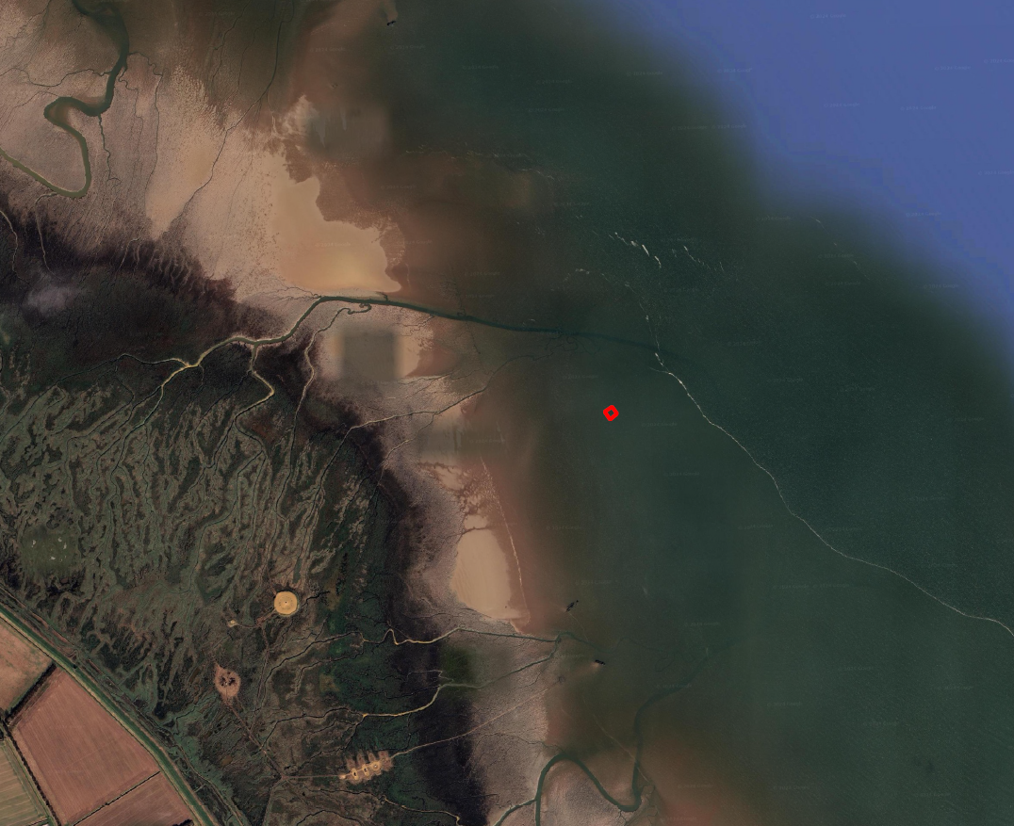

Appendix 2. Photograph of Current Target Site – Targets deemed no longer fit for purpose.
(Available from https://www.lincsonline.co.uk/spalding/news/target-barges-to-be-placed-in-the-wash-aid-raf-training-9315222/)

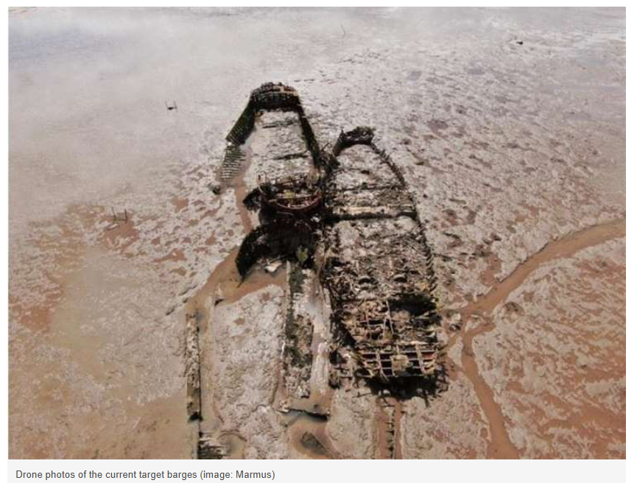

Appendix 3. Post Development Habitat Map
(obtained from the BNG assessment submitted by ECOSA)

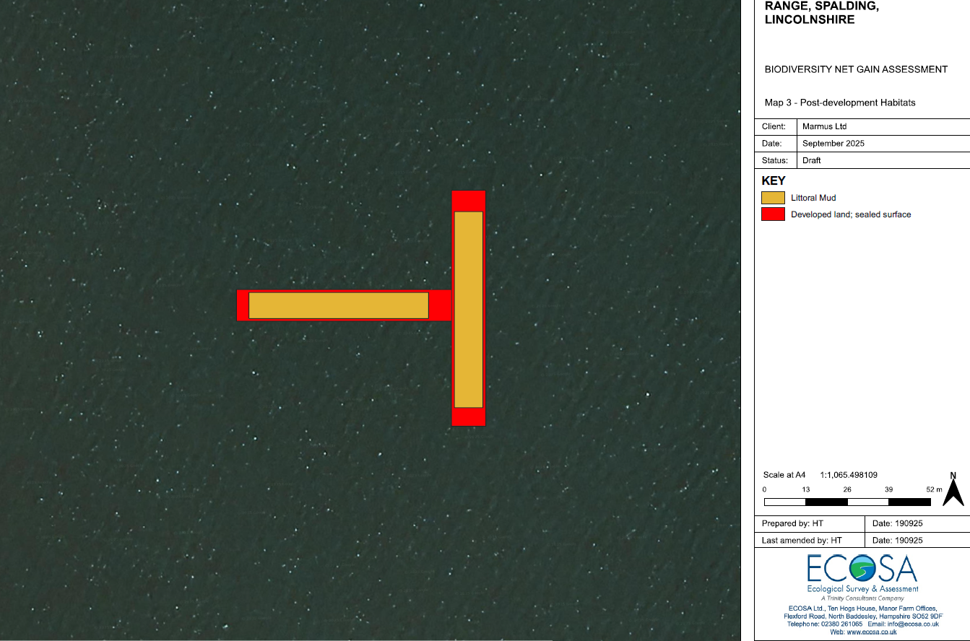

Appendix 4. WeBS Alerts: The Wash SPA
(https://app.bto.org/webs-reporting/alerts.jsp)



