Revised Design and Access Statement

TO BE READ IN CONJUNCTION WITH THE PLANNING APPLICATION

The Change of use of agricultural land to provide 5 Gypsy/Traveller family pitches each having a Static Mobile Home, Dayroom, parking for a Tourer and 2 vehicle spaces together with a treatment plant, the laying of hardstanding and associated ancillary works at:
Land southeast of Libra, referred to as ‘The Orchards’, Blazegate, Gedney, Spalding, Lincolnshire, PE12 0AD on behalf of Mr J. Rooney

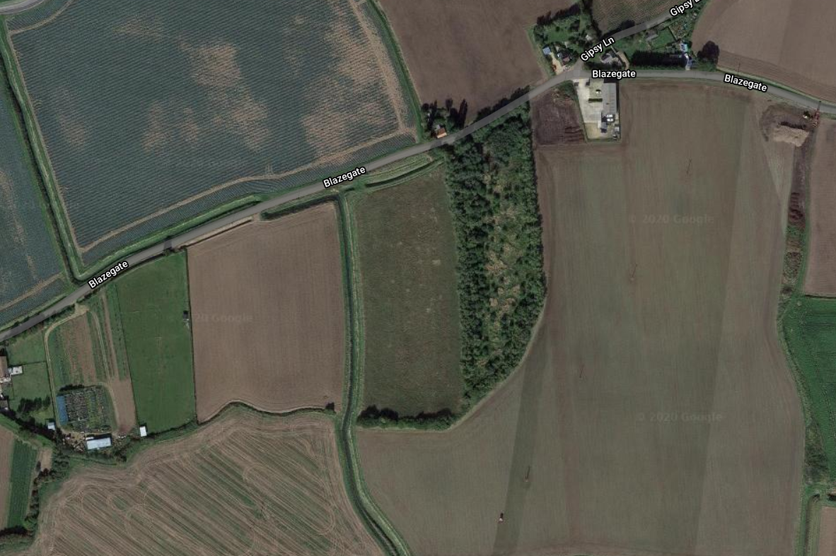
Libra
The Site

Application prepared and submitted by: Keith Smith Design Consultant

Contents Page
1.0 Introduction 3
2.0 The Site Location 3
3.0 The Proposal 3
4.0 Local President 3
5.0 The Design and Access Statement 4
6.0 Planning History 17
7.0 Relevant Planning Policy and Legislation 17
8.0 Conclusion 21

1.0 Introduction
1,1 This Design and Access Statement has been prepared on behalf of Mr J. Rooney (the Applicant) and should be read in conjunction with the Drawing Numbers 20/BLAZE/01, and 02, in relation to the Planning Application for Change of use of agricultural land to provide 5 Gypsy/Traveller family pitches each having a Static Mobile Home, Dayroom, parking for a Tourer and 2 vehicle spaces together with a treatment plant, the laying of hardstanding and associated ancillary works.

2.0 Site Location
2.1 The site is to the east of Spalding, to the west of King’s Lyn, 541900 easting and 324513 northings, to the east of the village of Gedney, and southeast of Chaplegate. Specifically, the site lies southeast of the property known as Libra. and south of Blazegate the road connecting Chaplegate and Lutton. The site comprises of a level parcel of ex orchard agricultural land with an existing access. The site is approximately 1.13 hectares in area.

3.0 The Proposal

3.1 This proposal seeks planning permission for change of use of agricultural land to create 5 Gypsy/Traveller family pitches each having a Static Mobile Home, Dayroom, parking for a Tourer, 2 further parking spaces and a treatment plant with reed bed soakaways, the laying of hardstanding and associated ancillary works.

3.2 The access to the site will be altered to provide improved visibility and will have a tarmac surface leading up to timber gates set back from the road giving access into the site. To the frontage of the site two Play Arears are proposed, with a further Pay Area towards the rear of the site. The new drive into the site together with turning area and pitches will have new rolled natural stone hardstanding, parking for Tourer, and two vehicles. A ‘Kingspan Klargester’ BioDisc treatment plant with soakaways will be installed to each pitch.

4.0 Local President

4.1 It is accepted that Planning Authorities do not to set a president by approving applications that are of a similar nature, however, it must be recognised that similar applications have been recently approved in the area of this application. They being:

- H23-0848-19 - Proposed Gypsy/Traveller Site consisting of 4No. Pitches at Bleu Raye Farm, Wallgate, Spalding – 10km away.
- H06-0233-19 - Change of use of land (part retrospective) to provide 5No. additional gypsy/traveller pitches with one day room per pitch and existing stables converted to dayrooms. Also, erection of one new store and retention of sheds for pitch 1, with construction of internal road to facilitate separate ingress and egress to and from the site, including hardstanding - 1km away.

5.0 The Design and Access Statement

5.1 The key issues in the consideration of this application are as follows: -

5.1a The Need for Provision
5.1b The Suitability of the Location/Sustainability
5.1c Impact upon Visual Amenity and Landscape Character
5.1d Impact upon Highway Safety
5.1e Impact upon Neighbour Amenity
5.1f Flood risk Assessment

5.1g Potential Source of Flooding

5.1h Flood Evacuation

5.1a The Need
The Applicant, and other proposed occupants have no permanent home currently, the applicant parks beside highways in any unoccupied laybys which is totally unacceptable. Further the applicants Mother is registered Disabled with a degenerative bone disease and at present lives in the London area, however her condition has deteriorated recently to the extent that she requires full time care. It is therefore intended for her to move to Lincolnshire where she can receive the care required provided by her son and his dependants.
With respect to the supply of gypsy and traveller sites, the Planning Policy for Traveller Sites (PPTS) at paragraphs 4 and 9 sets out the national requirement for local planning authorities to plan over a reasonable timescale for an appropriate supply of suitable traveller sites, including private sites. The supply should comprise specific, deliverable sites for the first 5 years and developable sites or broad locations for later years. With respect to deciding specific planning applications, PPTS paragraph 22 cites the existing level of provision among relevant matters for consideration.
The Southeast Lincolnshire Local Plan 2011 - 2036
Paragraph 5.12.1 In Planning policy for traveller sites, 201546, the Government identifies that its ‘overarching aim is to ensure fair and equal treatment for travellers, in a way that facilitates the traditional and nomadic way of life for travellers while respecting the interests of the settled community’. It goes on to identify that it expects Local Plans to:
• be based upon robust evidence of the likely accommodation needs of gypsies, travellers and travelling showpeople.
• set targets to meet these needs.
• identify enough sites to accommodate at least the first ten years’ needs; and
• set out criteria to guide land supply allocations and decisions on planning applications.
The redevelopment or change of use of an Existing Residential Gypsy/Traveller Site or Existing Residential Travelling Showperson’s Site (as identified on the Policies Map) will be permitted only if an assessment has been undertaken which has clearly shown that the site is no longer required to meet the accommodation needs of the Gypsy/Traveller or Travelling Showperson’s communities. Between 2011 and 2036, evidence suggests that, in Southeast Lincolnshire, there will be a need for the provision of:
• 4 new permanent residential pitches for gypsies and travellers; and
• 1 new permanent residential plot for travelling showpeople. This need will be met through the development of the sites identified on the Policies Map and listed below:
• Land at The Stables, Baulkins Drove, Sutton St James allocated as a ‘Proposed Residential Travelling Showperson’s Site’, to provide accommodation for one additional household: and
• Land at Bleu Raye Farm, Mill Gate, Whaplode Fen allocated as a ‘Proposed Residential Gypsy/Traveller Site’, to provide accommodation for four households.
Planning permission will be granted for the development of these sites, provided that proposals:
1. will be adequately provided with appropriate infrastructure such as electricity, drinking-water, waste-water treatment and recycling/waste management; - Electricity, drinking-water, treatment and recycling of waste will be provided.
2. will not have a significant adverse effect on the amenities of existing local residents or adjoining land users (and proposals must therefore give careful consideration to layout, landscaping, external lighting schemes, and the type of business uses that would be appropriate (if mixed residential and business use is proposed)); - The proposed development will not have an adverse effect on local amenities, local residents, and adjoining land users. A Landscape and Management Scheme will be implemented ensuring that there will be minimum impact on the environment. LED lighting is proposed all on sensors that will be kept to a minimum.
and
3. will be successfully assimilated into both their immediate environs and the wider landscape. Additional needs which may arise during the Local Plan period will be met through the determination of planning applications on other, unallocated sites. - The proposed development can achieve the required needs.
Planning permission will be granted for proposals on such sites, provided that they meet criteria 1 to 3 above, and they:
a. provide occupants with an acceptable standard of amenity; - The proposed development accords with the guidance contained within the ‘Designing Gypsy and Traveller Sites – Good Practice Guide- May 2008 (Withdrawn)’ for reference and is consistent with the layout of other sites approved recently by South Holland District Council. For example, Bleu Raye Farm, Millgate, Whaplode, and the close by development at Green Acres Park, Ropers Gate, Gedney.
b. are not located adjacent to uses likely to endanger the health of occupants, such as a refuse tip, water recycling centres or contaminated land; - The proposed development is not located by any adjoining uses that would put the occupants at risk.
c. respect the scale of the nearest settled community.
d. will not place undue pressure on local infrastructure; -The proposed development would not put undue pressure on the local infrastructure. e. will not adversely affect heritage assets or areas of importance to nature conservation; - The proposed development would not adversely affect the local environment as it is proposed to introduce a Landscape and Management scheme that will encourage wildlife.
f. will not prejudice highway safety or give rise to problems of parking or highway access; - The proposed development will not adversely affect highway safety as it is intended to improve the exiting access onto the highway as shown on Drawing Number 20/BLAZE/02.
g. for sites for permanent residential use they:
i. provide occupants with access to education, health care and recreational facilities, shops and employment within reasonable travelling distances, preferably by walking, cycling or public transport; The proposed development is located close to the settlements of Chaplegate, Lutton, Gedney with larger Towns such as Holbeach and Long Sutton which have the required infrastructure.
ii. are suitable (or capable of being made suitable) for mixed residential and business use; The proposed development lends itself to such development.
iii. are not located within Flood Zone 3a or 3b and, if located in Flood Zone 2, the Sequential and Exception Tests have been passed; and h. for sites for transit or stopping place use, are not located within Flood Zone 3b and, if located within Flood Zone 3a, the Sequential and Exception Tests have been passed. – Refer to Item 51f Flood Risk and its resolution.
Paragraph 5.12.2 Interviews conducted with gypsy, traveller and travelling showperson households for the Boston and South Holland Gypsy and Traveller Accommodation Assessment, 2016 - 2036 (GTAA)47 identify that there is a ‘known’ need for the provision of:
• 1 residential pitch in Boston Borough and 4 residential pitches in South Holland District for gypsy and traveller households; - Identifies a local need which can be achieved through the proposed development.
• 1 residential plot in South Holland District for a travelling showperson’s household; and
• no new transit pitches.
Paragraph 5.12.4 The GTAA47 also identifies an ‘unknown’ need for up to 16 additional residential pitches for gypsy and traveller households (up to 3 in Boston Borough, and up to 13 in South Holland. [‘Unknown’ needs are those which may arise from gypsy, traveller and travelling showperson’s households who were not interviewed by the GTAA consultants.] This ‘unknown’ need will be met by determining planning applications, taking into account the provisions of the NPPF9, Planning policy for traveller sites46, and the policies of this Local Plan (in particular Policy 20) – The proposed development would enable this target to be met.

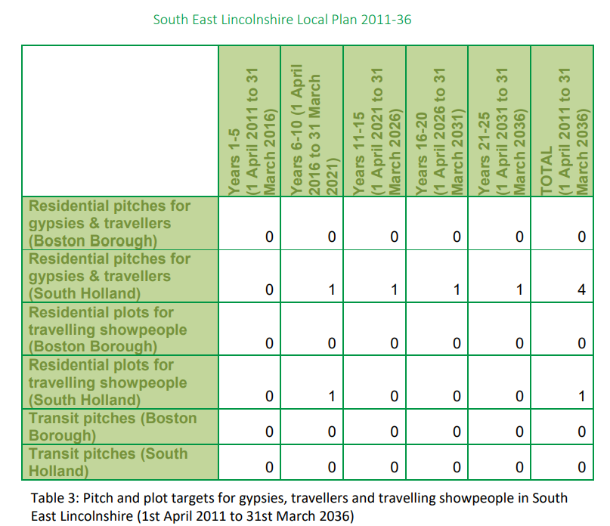

5.1b The Suitability of the Location/Sustainability
Whilst paragraph 23 of the PPTS advises that Local Planning Authorities strictly limit new traveller site development in open countryside that are away from existing settlements or outside areas allocated in the development plan,
the site is within easy driving distance of local villages such as Chaplegate, Gedney, Long Sutton, and Lutton. As depicted in the aerial view hereafter. Access to public transport is limited but this is also the position for most of the neighbouring rural settlements. Having regard to the nature of the proposal and the use of touring caravans, there is an expectation that the private car will be used as the principal mode of transport. Sustainability and the location of gypsy and traveller sites has been the subject to several recent appeal decisions within some local authorities and this site is consistent with the approach taken by Inspectors in determining sustainability issues.

Aerial View.
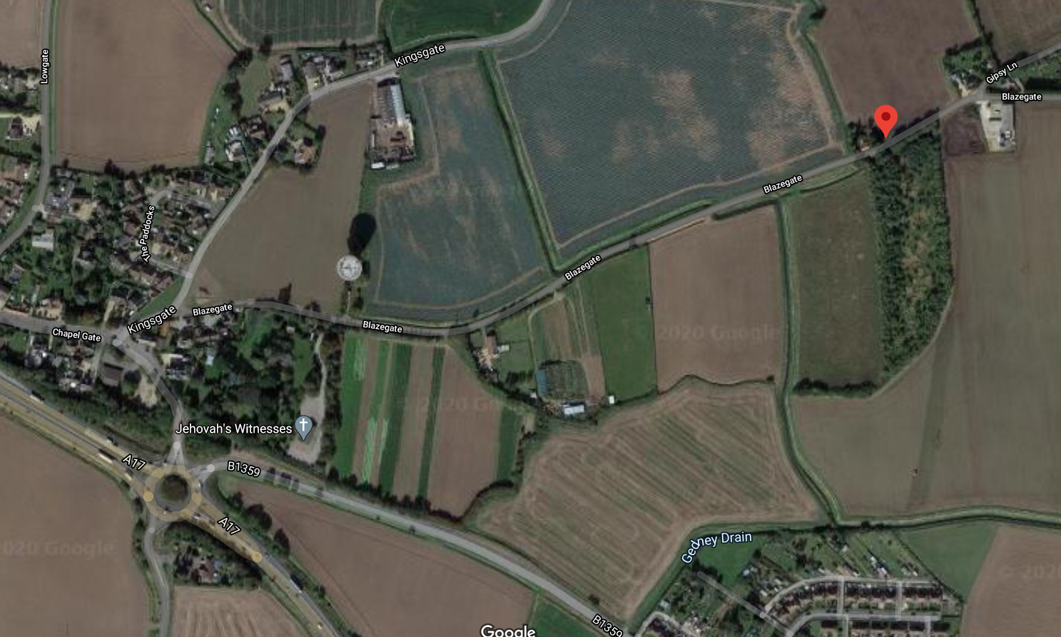
Chaplegate
The Site

5.1c Impact upon Visual Amenity and Landscape Character
One of the core planning principles of the National Planning Policy Framework (NPPF) 2018 is to recognise the intrinsic character and Landscape Character of the countryside. The objective of subsection 6 of saved LP Policy PD1 is to ensure landscape proposals are adequately addressed. However, the PPTS indicates that gypsy sites are acceptable, in principle, in rural areas, a position that has been well established at appeal.
The site is situated within a rural location mostly open countryside with no specific designation. With this in mind, the design of the Dayroom and landscaping have taken this into account. Every effort has been made within reason to reduce the overall impact of the proposed development. The site is screened to the north, south, west, and east boundaries by a well-established treeline. It is proposed to provide further planting with hedging screen facing onto Blazegate in front of the proposed two play areas as shown on Drawing Number 20/BLAZE/02. With this in mind, there would be insignificant impact on the visual amenity or landscape character.

Landscape Schedule and Management Plan.
(To be read in conjunction with Drawing Numbers 20/BLAZE/02)

Landscape Schedule
Treatment onto Blazegate.
New hedge and gapping to existing hedge to be 2 rows of a mix of Blackthorn and Hawthorn there will also be new Common Oak and Mountain Ash replacement trees all as schedule hereafter.
Species Stock Size Density/m Quantity Container
A - prunus spinosa 50 - 75cm 5 500 3lt pot
(Blackthorn)
A - crataegus 50 – 75cm 5 500 3lt pot
(Hawthorn)

B - quercus robur 150 – 180cm 1 8 10lt pot
(Common Oak)
C - sorbus aucupavia 150 – 180cm 1 8 9lt pot
(Mountain Ash)
All hardstanding areas including the driveways are to be permeable clean well rolled stone. Site entrance up to gates and on-site footpaths to be tarmacadam.
All soft landscape areas to be grass.
Management Plan.
All existing trees and hedge planting to be protected during the development of the site with galvanized tree guards. All soft landscaping comprised in the approved details of landscaping shall be carried out in the first planting and seeding season following the first occupation of the buildings or the completion of the development whichever is the sooner; All shrubs, trees and hedge planting shall be maintained free from weeds and shall be protected from damage by vermin and stock. Any trees or plants which, within a period of five years, die, are removed, or become seriously damaged or diseased shall be replaced in the next planting season with same.
General maintenance, pruning etc. should not take place during bird breeding times, March – October unless undertaken by hand.

5.1d Impact upon Highway Safety

There is an existing entrance that serves the site however, it is planned to improve the access and visibility. The visibility splays are indicated to be set back 2000mm from the road frontage, with a flat splay of 90m in both directions, so as not to impact on highway safety, as shown on Drawing Number 20/BLAZE/02. Blazegate is a relatively quiet and straight rural road with no footpaths or street lighting, this being the case the proposed visibility in both directions is satisfactory and therefore approving this development would have limited impact upon highway safety.

5.1e Impact upon Neighbour Amenity
Heritage - A review of the Heritage Gateway and South Holland District Council’s online mapping indicates that there are no designated or non-designated heritage assets near the site. In addition, there are no preserved trees affected by the proposal and we are not aware of any archaeological interest in the site.
The proposal represents a relatively modest traveller site which due to its location and design will have limited impact upon residential amenity.

5.1f Flood risk

Flood Risk Assessment – A Flood Risk Assessment is required as part of the planning application under the principles of the Planning Practice Guidance of the National Planning Policy Framework (NPPF) and approved by the Environmental Agency.

The site is located adjacent to a property known as Libra, on Blazegate which runs between Chaplegate and Lutton, and is within a Flood Zone 3 area which is land highly likely to be affected by flooding on the Environment Agency’s flood mapping, as indicated in Fig. 1.
The site is located within ‘Danger for Most’ Hazard Zone of the South Holland District Council’s Strategy Flood Risk Assessment Map as indicated in Fig. 2 and as defended by Tidal Defences and the Internal Drainage Board system as indicated in Fig. 3. During preparation of this assessment, no evidence of the site nor adjoining land had been flooded.

A Sequential Test is met as whilst the site is located within Flood Zone 3 and in a ‘Danger for Most’ Hazard Zone the development may be permitted as the site is protected against both the 1 in 200-year return period tidal event and 1 in 100-year return period fluvial event meeting the requirements of NPPF.

Additional flood mitigation measures have been incorporated within the design and construction of the permanent structures such as the Dayrooms by raising the finished floor levels by 1000mm above the external ground level as shown on Drawing Number 20/BLAZE/02. The Static Mobile Homes will be anchored to concrete bases as well as also being raised 1000mm above ground level. The existing Gedney Drain Dyke is to be extended to the north boundary together with incorporating a culvert beneath the access drive in accordance with South Holland District Council’s Internal Drainage Board requirements in accordance with ‘Under the Land Drainage Act 1991 – Section 23, as shown on Drawing Number 20/BLAZE/02. The proposed measures are to safeguard against the risk of the site flooding as a result of the River Nene tidal defence and to ensure the proposals pass Part 2 of the Exception Test with the adequate exclusion strategy.

The site is within a defended floodplain, as defined in Appendix 1 of the Environmental Agency’s ‘Policy and Practice for the Protection of Floodplains’ and considered passive until such time as a flood greater than that for which the defences were designed. The likelihood of flooding due to overtopping or failure of flood defences is considered to be low.

The site is located within South Holland Internal Drainage Board at Gedney which is defended by the River Welland tidal defences, the River Nene tidal defences and the Wash coastal defences against a minimum flood return of up to 1 in 200 years.

Potential Sources of Flooding – Four possible sources of flooding have been identified: -
1. Local blockages to the Sea Dyke main drain.
2. Storm return period of 1 in 50 years being extended.
3. Failure of Lutton Leam Outfall Sluice.
4. Overtopping and breaching of the River Nene tidal defences and/or the Wash Coastal defences.
Probability of flooding due to source 1 – Low.
Probability of flooding due to source 2 – Low.
Probability of flooding due to source 3 – Low.

The probability of flooding from 1 is low due to maintenance standards already achieved by IDB.

The probability of flooding from 2 is low due to the Sea Dyke design standard incorporating a minimum 900mm freeboard to the lowest level which provides adequate storage in events greater than 1 in 50 years.

There are many hectares of agricultural land that would flood before the development site was put at risk.

Previous historic rainfall events of 1968 and 1978, estimated to be greater than 1 in 100-year events, caused no flooding to any residential properties at the time and the Boards policy is to provide a standard of drainage which satisfies (NPPF) requirements of a 1 in 100-year return period for fluvial protection inclusive of the effects of climate change and developments to the arterial system enables a flexible approach to be adopted to meet the criteria for ‘sustainable urban drainage’.

Failure of Lutton Leam Outfall Sluice, 3, may occur due to mechanical breakdown or electrical power failure, however the IDB would take emergency action to maintain the drainage level. This being the case the probability of flooding is considered to be low.

The South Holland Internal Drainage Board district at Gedney is protected against the 1 in 200-year tidal event by the west embankment of the River Nene tidal defences at 6.30m aOD and the Wash costal defences provide similar protection with the embankment level of 7.00 aOD.

More recent (2016) hydraulic modelling work carried out on behalf of the Environmental Agency has produced Tidal Hazard Mapping which is now included in the South East Lincs. Strategic Flood Risk Assessment Maps.

The site is shown affected by floodwaters of up to 1m as result of breaching and/or overtopping of the tidal defences to The Wash and River Nene in the year 2115. The site is located some 5.5kms from the nearest point of tidal defence. It is therefore necessary to mitigate against risk and flood resilient construction should be incorporated into the proposed residences by raising the finished floor levels of the Dayrooms, Static Mobile Homes, and Community Hub Building to 1m above ground level. Further that the Static Mobile Homes will be anchored to concrete blocks together with a solid concrete base.

The Environmental Agency has recently published The Wash Shoreline Management Plan 2 from Gibraltar Point to Old Hunstanton, summary as follows: -
‘The intent of management for this policy Development Zone (PLZ) is to sustain flood defence for the communities and their hinterland on the low-lying areas around The Wash. This includes an increase of management as needed to sustain the current level of flood risk in the face of climate change’.

Proposed Drainage Systems – Soakaways are proposed which will accommodate the 1 in 100-year rainfall event. The drainage system will include rainwater harvesting with the soakaways designed to BRE:365 requirements.

Probabilities and Trends of Flooding.
The probability of the site flooding from localised drainage systems is very low. Regardless it is still proposed to raise the finished floor levels of the accommodation by 1m above ground level.

The probability of the site flooding with water from the River Nene and/or The Wash tidal system is less than 0.5% because of the standards of the existing flood defences.

If under very extreme events, levels of floodwater from the Sea Dyke main drain rose sufficiently to affect the site, the event would not be sudden. It is probable that sufficient time would be available to take precautionary action to limit the extent and impact of any flooding.

The water levels in any drainage channel will tend to rise due to any climate change affect. However, the existing systems and defences together with raising finished floor levels will be appropriate for the design life of the development.

Impacts of Flooding.
No significant impacts of flooding are anticipated.

By raising finished floor levels of the accommodation to 1m above ground level offers additional protection to the occupiers for any extreme localised event.

The site is within the catchment area of the IDB main drain and the River Nene tidal system defences therefore sufficient warning time would be available.

Residue Risk – Extreme Events.
The residue risk from extreme events is low due to being located within the internal drainage system.
The site is within a ‘Danger for Most’ Hazard Zone according to NPPF classification, but the site actually has very low risk of flooding due to the current standards of drainage and flood defence and land levels.

South Holland District Council and Boston Borough Council in conjunction with the Environmental Agency and the local IDB’s have carried out a Strategic Flood Risk Assessment of the whole District. South East Lincs. Strategic Flood Risk Assessment have also produced more definitive Flood Risks Maps published by the Environmental Agency to address the possible effects of climate change, identifying Flood Risk Zones.

As a result of the South East Lincs. Strategic Flood Risk Assessment: The South Holland IDB area has been determined as providing protection against a 1 in 100-year return period event whilst the River Nene tidal defences at Sutton Bridge and The Wash costal defences provide protection against a 1 in 200-year return period event.

In the extreme event of a serious pump station failure occurring to the IDB main drain system, or the overtopping/breaching of tidal defences, protection will be afforded by raising finished floor levels of the accommodation to 1m above ground level offers additional protection to the occupiers.

Conclusion.
The proposed development is not in a Functional Floodplain as defined in NPPF. It is located in the Passive Floodplain protected by fluvial defences to a 1 in 100-year tidal defence of a 1 in 200-year standard.

The site is in Flood Zone 3 with the actual risk of flooding being low (less than 0.5%). It is defended by the South Holland IDB system, the River Nene and The Wash tidal defences in South East Lincs. Strategic Flood Risk Assessment.

It is necessary to mitigate against risk and flood resilient construction should be incorporated into the proposed residences by raising the finished floor levels of the Dayrooms, and Static Mobile Homes 1000mm above ground level. Further that the Static Mobile Homes will be anchored to concrete blocks together with a solid concrete base.

The proposed surface water drainage system will discharge into soakaways to BRE 365 and the Building Regulation requirements.

Fig. 1 – Environmental Flood Risk Map
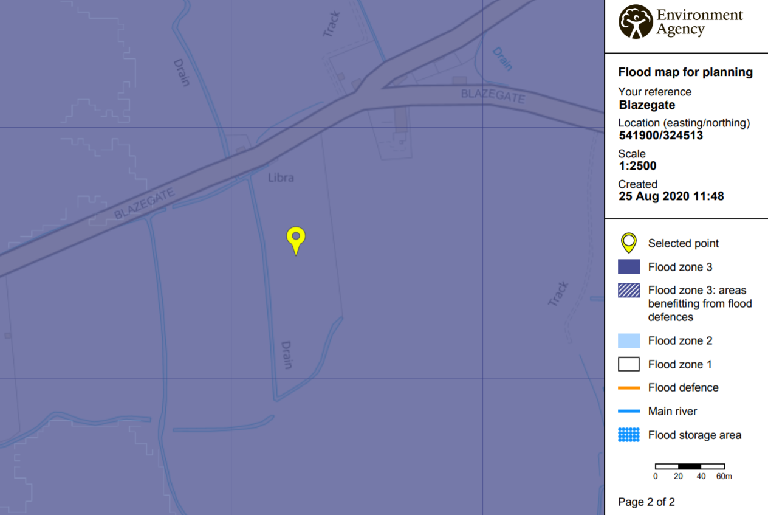
Fig 2 – Existing Dykes
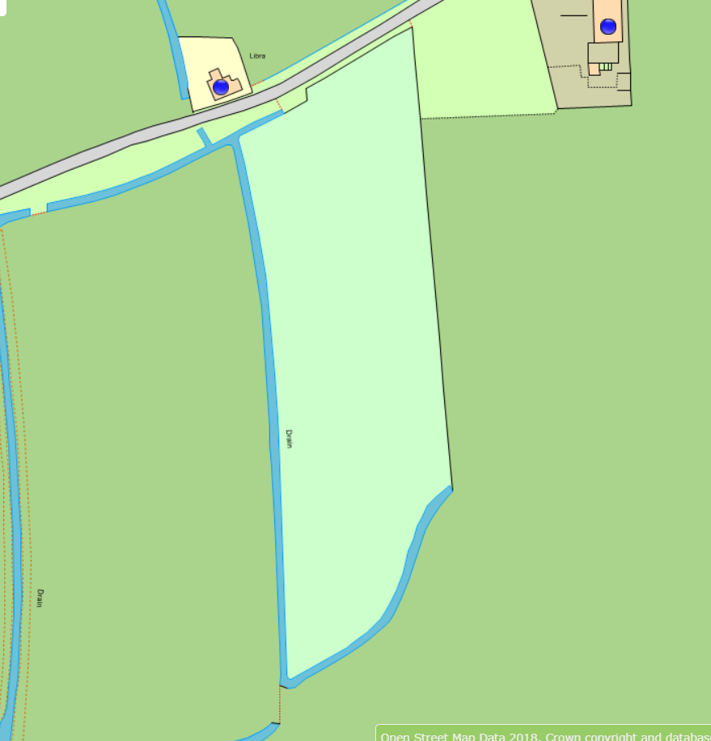
The Site
Fig. 2 South East Lincs. Strategic Flood Risk Assessment Map – Residual Hazard
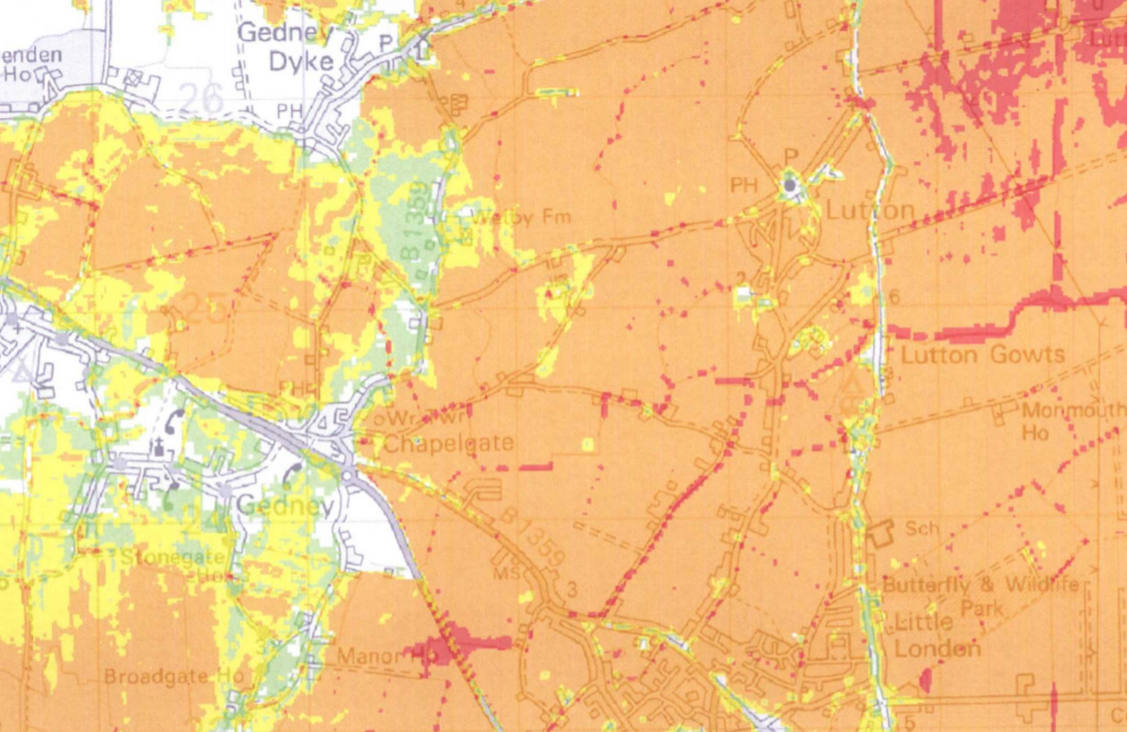
The Site

Fig. 3 South East Lincs. Flood Risk Assessment Map – Residual Depth
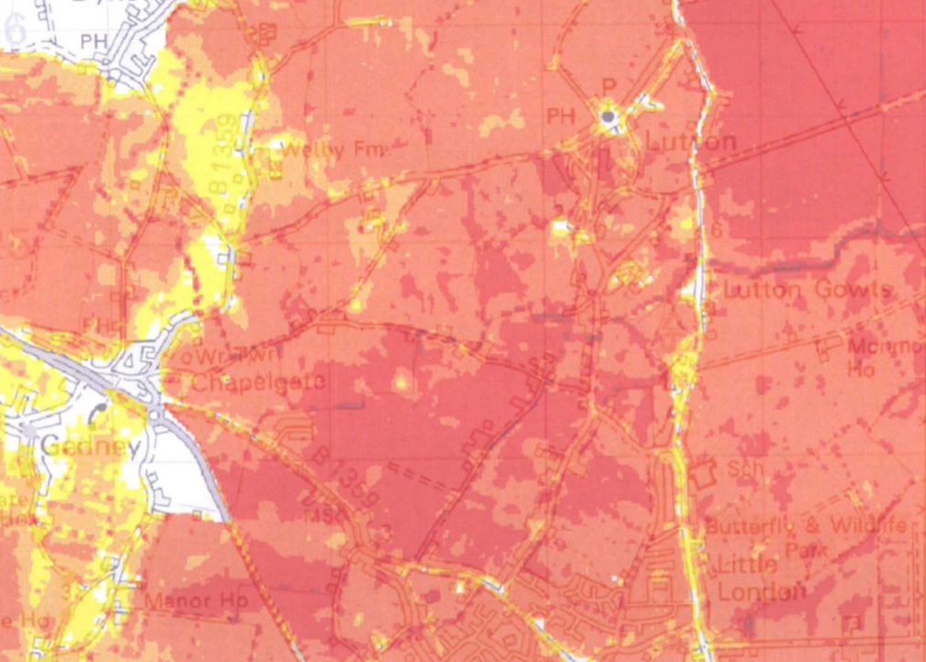
The Site
Fig. 4 South Holland District Council’s Internal Drainage Board District Plan
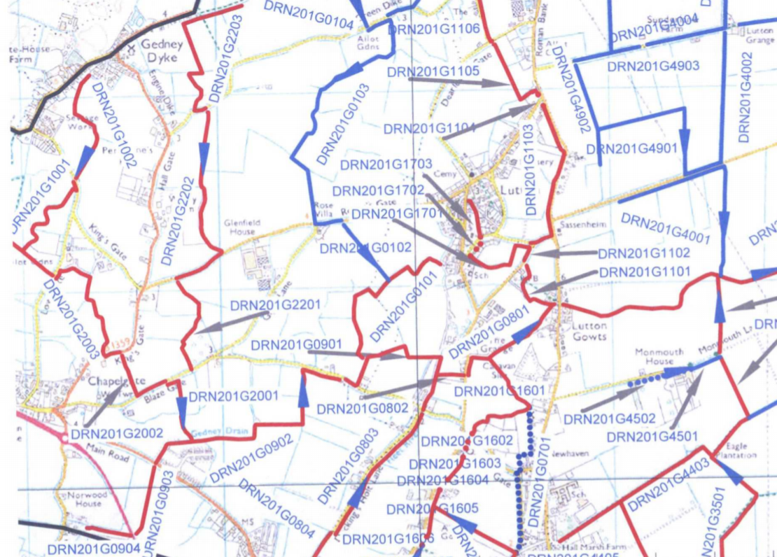
The Site
Evacuation Plan
Flood Risk
The site is within Zone 3 and benefits from flood defences of the Environmental Agency Flood Map for Planning and is in a ‘Danger for Most’ Hazard Zone

Flood Warning
The occupants of the site should register with the 24hr Environment Agency Flood Direct Warning Service which includes Flood Warning Codes and uses direct warning methods where the risk and impacts of flooding are high. Warnings are manifested by media broadcasts via local radio and television. The site is covered by the Environmental Agency Flood Warning Area for Tidal Flooding from the Wash and tidal estuaries.
Occupants can register by calling floodline on 0345 988 1188.

Category of Flood Warnings
Flood Alert: Flood is possible – Be prepared
Flood Warning Flood is expected – Immediate action required
Severe Flood Warning: Severe flooding – Danger to life

Evacuation
Where required the occupiers will be notified of what action to take by the Environmental Agency, further they should refer to the South Holland District Council Emergency Plan and the South Holland Internal Drainage Board Emergencies Information Sheet for further local information.

Flood Action
If a flood is forecast listen to the local radio or check with the Environmental Agency, taking the following action advise:
Pack a flood kit should you need to leave your home, which should contain the following: -
Important contact numbers i.e., Environmental Agency and South Holland District Council.
Money/bank cards if you have one.
Medicines.
Any medical assistance items such as hearing aids and batteries.
Glasses/contact lenses.
Clothing.
Personal items i.e., toothbrush/paste.
If you have very young children their baby food, clothing and nappies.
Remember to turn off your electric and water before leaving.
Evacuate to areas of Flood Zone 1 such as Holbeach where facilities should be available.
Information obtained by Applicant from previous applications.

6.00 Planning History
There is no evidence of previous planning activity on this land. Due to COVID-19 restrictions it is not possible to access historic information not recorded on the Planning Portal.
6.01 Previous Planning Application – None known.

6.02 Previous Appeals – None known.

7.0 Relevant Planning Policy and Legislation

7.1 The relevant local and national planning policy / guidance is as follows:

7.2. South East Lincolnshire Local Plan Section 38(6) of the Planning and Compulsory Purchase Act 2004 states that, “If regard is to be had to the development plan for the purpose of any determination to be made under the Planning Acts the determination must be made in accordance with the plan unless material considerations indicate otherwise.”

7.3 The development plan for the purposes of this application is the South East Lincolnshire Local Plan (the ‘Local Plan’) 2019. Those policies considered relevant for the proposal are set out hereafter.

7.4 Policy 2: Development Management, sets out the criteria in respect of the sustainable considerations for development and these include the impact on the amenity of the area, access and vehicle generation levels, impact on neighbouring land uses and Flood Risk.

7.5 Policy 4: Approach to Flood Risk, outlines proposals within an area of risk at flooding will be permitted where a sequential test is passed, and a site-specific flood risk assessment demonstrates the development will be safe from flooding. The application site is allocated in the Local Plan for its proposed use and is therefore considered to be in a sequentially preferable location.

7.6 Policy 20: Accommodation for Gypsies, Travellers and Travelling Showpeople, confirms the Council’s commitment to providing sufficient accommodation for travellers and the application site is allocated in the Local Plan to provide such accommodation.

7.7 The National Planning Policy Framework July 2018 (the “NPPF”) sets out Central Government’s planning policies for England and how these are expected to be applied.

7.8 Paragraph 8 of the NPPF confirms the commitment to sustainable development based on three dimensions:
A - An economic objective – to help build a strong, responsive and competitive economy, by ensuring that sufficient land of the right types is available in the right places and at the right time to support growth innovation and improved productivity; and by identifying and coordinating the provision of infrastructure.

B - A social objective – to support strong, vibrant and healthy communities, by ensuring that a sufficient number and range of homes can be provided to meet the needs of present and future generations; and by fostering a well-designed and safe built environment, with accessible services and open spaces that reflect current and future needs and support communities’ health, social and cultural well-being.

C - An environmental objective – to contribute to protecting and enhancing our natural, built and historic environment; including making effective use of land, helping to improve biodiversity, using natural resources prudently, minimising waste and pollution, and mitigating and adapting to climate change, including moving to a low carbon economy.

This is followed by a commitment to a presumption in favour of sustainable development and at paragraph 11.
“For decision-taking this means:

D - Approving development proposals that accord with an up-to-date development plan without delay.
or
E - Where there are no relevant development plan policies, or the policies which are most important for determining the application are out of date, granting permission unless:

(i) The application of policies in this Framework that protect areas or assets of particular importance provides a clear reason for refusing the development proposed.
or
(ii) Any adverse impacts of doing so would significantly and demonstrably outweigh the benefits, when assessed against the policies in this Framework taken as a whole.

7.9 Paragraph 38 confirms this to be the case stating decision makers at every level should seek to approve applications for sustainable development wherever possible.

7.10 Paragraph 47 states that planning law requires application should be determined in accordance with the development plan.

7.11 Paragraph 61 states: “the size, type and tenure of housing needed for different groups in the community should be assessed and reflected in planning policies (including, but not limited to, those who require affordable housing, families with children, older people, students, people with disabilities, service families, travellers”.

7.12 Planning Policy for Traveller Sites 2015 outlines the Government’s planning policy for traveller sites.
7.13 Paragraph 4 states the Government’s aims in respect of traveller sites:
A - That local planning authorities should make their own assessment of need for the purposes of planning.

B - To ensure that local planning authorities, working collaboratively, develop fair and effective strategies to meet need through the identification of land for sites.

C - To encourage local planning authorities to plan for sites over a reasonable timescale.

D - That plan-making and decision-taking should protect Green Belt from inappropriate development.

E - To promote more private traveller site provision while recognising that there will always be those travellers who cannot provide their own sites.

F - That plan-making and decision-taking should aim to reduce the number of unauthorised developments and encampments and make enforcement more effective.
G - For local planning authorities to ensure that their Local Plan includes fair, realistic and inclusive policies.

H - To increase the number of traveller sites in appropriate locations with planning permission, to address under provision and maintain an appropriate level of supply. to reduce tensions between settled and traveller communities in plan making and planning decisions.

J - To enable provision of suitable accommodation from which travellers can access education, health, welfare and employment infrastructure.

K - For local planning authorities to have due regard to the protection of local amenity and local environment”.

7.14 One of the core planning principles of the National Planning Policy Framework (NPPF) 2018 is to recognise the intrinsic character and Landscape Character of the countryside. The objective of subsection 6 of saved LP Policy PD1 is to ensure landscape proposals are adequately addressed. However, the PPTS indicates that gypsy sites are acceptable, in principle, in rural areas, a position that has been well established at appeal.

7.15 Designing Gypsy and Traveller Sites - Good Practice Guide - May 2008 (Withdrawn). The layout of the site accords with the guidance contained within the ‘Designing Gypsy and Traveller Sites – Good Practice Guide- May 2008 (Withdrawn)’ for reference and is consistent with the layout of other sites approved recently by South Holland District Council. For example, Bleu Raye Farm, Millgate, Whaplode, and the close by development at Green Acres Park, Ropers Gate, Gedney.

7.16 Housing Act 2014 - The Housing Act 2004 requires South Holland District Council to plan for accommodation needs including undertaking a survey based on robust evidence of need for the Gypsy and Traveller community. The use of a robust evidence base to establish accommodation needs is also a key aim of the PPTS in advising local authorities in the preparation of local plans and when making planning decisions.

7.17 Planning law requires that applications for planning permission must be determined in accordance with the development plan unless material considerations indicate otherwise. Planning Policy for Traveller Sites (PPTS) must be considered in the preparation of development plans and is a material consideration in planning decisions. Local planning authorities preparing plans for and taking decisions on traveller sites should also have regard to the policies in the National Planning Policy Framework July 2018 so far as relevant.

7.18 Saved Policy HC45 seeks to ensure that proposals for gypsy sites within or outside existing settlements will be considered against the sustainable development, design and landscape policies of the Plan to ensure that the proposal has minimum impact on character, appearance and amenity of the area and are well located on the major road network.

7.19 Two of the key aims of the PPTS is for local authorities to: ‘increase the number of traveller sites in appropriate locations with planning permission, to address under provision and maintain an appropriate level of supply’ and ‘to enable provision of suitable accommodation from which travellers can access education, health, welfare and employment infrastructure’.

7.20 Whilst there remains identified need for further gypsy and traveller sites, even if there were not, S.10 of the PPTS requires of the decision maker, where there is no identified need, to apply criteria-based polices as a basis for decision making when determining applications for gypsy and traveller sites.

7.21 The Gypsy and Traveller Accommodation Assessment 2016 – 2036, Paragraph 5.12.2 Interviews conducted with gypsy, traveller and travelling showperson households for the Boston and South Holland Gypsy and Traveller Accommodation Assessment, 2016 - 2036 (GTAA)47 identify that there is a ‘known’ need for the provision of:
• 1 residential pitch in Boston Borough and 4 residential pitches in South Holland District for gypsy and traveller households;
• 1 residential plot in South Holland District for a travelling showperson’s household; and
• no new transit pitches.
Paragraph 5.12.4 The GTAA47 also identifies an ‘unknown’ need for up to 16 additional residential pitches for gypsy and traveller households (up to 3 in Boston Borough, and up to 13 in South Holland. [‘Unknown’ needs are those which may arise from gypsy, traveller and travelling showperson’s households who were not interviewed by the GTAA consultants.] This ‘unknown’ need will be met by determining planning applications, taking into account the provisions of the NPPF9, Planning policy for traveller sites46, and the policies of this Local Plan (in particular, Policy 20).

8.0 Conclusion
8.1 This application demonstrates that the proposal accords both with local and national planning policy.

8.2 In light of this information, it is respectfully requested that this application be granted permanent planning permission.

