South Holland District Council
Council Offices
Priory Road
Spalding
Lincolnshire
PE11 2XE

31 August 2026

Dear Sirs,

RE: MATERIAL CHANGE OF USE OF LAND TO RESIDENTIAL CARAVAN SITE COMPRISING 4 GYPSY/TRAVELLER PITCHES, TOGETHER WITH LAYING OF HARDSTANDING, ERECTION OF AMENITY BUILDINGS AND, IMPROVEMENT OF EXISTING ACCESS.

Please find attached completed planning application forms, plans and supporting information in respect of the above-mentioned proposal.

DESIGN AND ACCESS STATEMENT

Site Location

The application site comprises about 0.33 hectare of land located along the south side of Blazegate, and along the western side of Gedney Drain. The site contains a corrugated metal barn in the north-east corner. Otherwise, it is mainly laid to grass.

The site is surrounded by open fields. However, there is sporadic development along the length of Blazegate, including an existing traveller site (The Orchards) located about 440 metres west of the application site.

Use, Scale and Layout

This planning application seeks planning permission for a change of use of agricultural land to create a residential caravan site that will comprise of 4 Gypsy/Traveller family pitches each accommodating a static caravan/mobile home, amenity building, parking for a tourer, 2 further parking spaces and the laying of hardstanding and associated ancillary works.

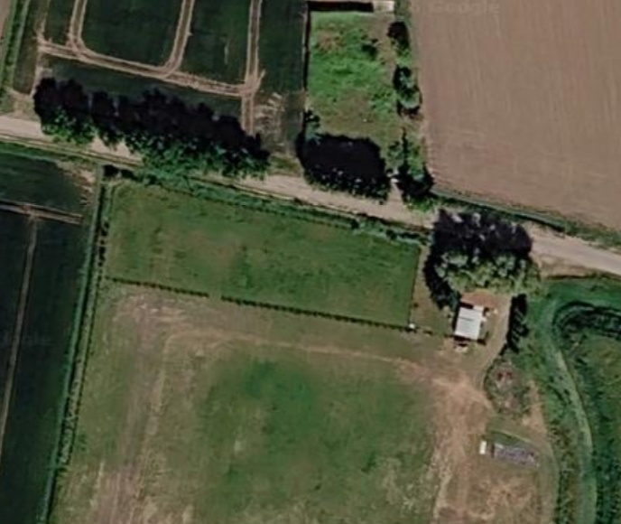

Figure 1 : The application site

Access

The proposed development includes the improvement of an existing access to provide an improved visibility splay that will have a tarmac surface leading up to timber gates set back from the road giving a safe access into the application site. The proposed access driveway, vehicle turning area and pitches will comprise permeable natural stone hardstanding. There will be sufficient parking for a touring caravan and two vehicles within each pitch.

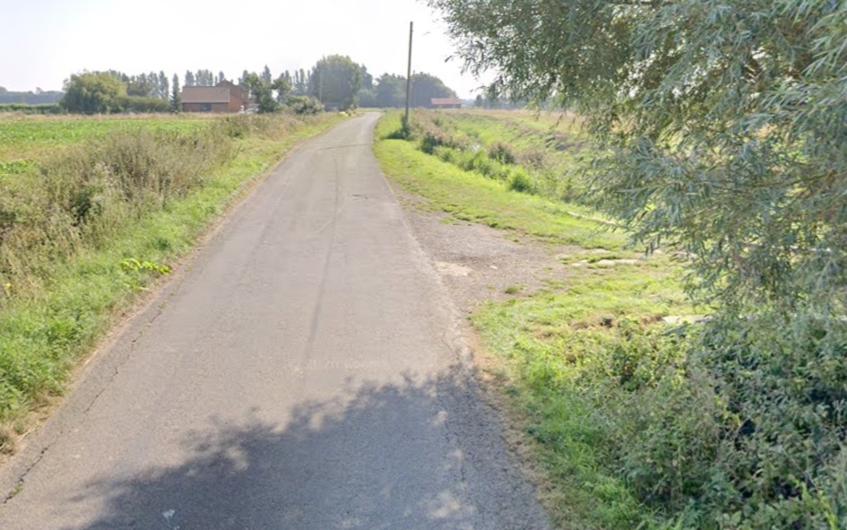

Figure 2: Existing access

Landscaping

Landscape planting to comprise:
New hedgerows, as shown on Drawing No. PBA 02, to comprise 45% Hawthorn, 15% Blackthorn, 10% hazel, 10% Guelder Rose, 10% Dog Rose and 10% Holly, planted in a double row, with rows 350cms apart planted at staggered centres: at a density of 5 plants per running metre. Plants to comprise 45-60cms tall transplants, planted at 35cm centres, randomly arranged by species. Plants to be protected using plastic spiral rabbit guards.
Trees to be planted within the tree planting beds delineated on the Site Layout Plan (Drawing No. PBA 02) to be feathered whips, 1.2 – 1.8 metres tall, staked and tied, and protected by plastic spiral rabbit guards. Tree species to comprise a mixture of 40% Silver Birch, 40% Wild Cherry and 20% Native Crab Apple planted in a single line at 5.0 metre centres, randomly arranged by species.

Government Planning Policies

Policy S3 of the National Planning Policy Framework sets out the presumption in favour of sustainable development which, for sites outside of settlements, means applying Policy S5. Policy S5 sets out a list of developments that can be appropriately carried out on land outside of settlements, including “Development which would address an evidenced unmet need for gypsy, traveller or travelling showpeople accommodation, provided it meets the criteria in policy HO12”.
Policy HO12 makes no mention of distances to services or modes of travel when assessing the sustainability of gypsy sites. The NPPF expects local planning authorities to ensure that gypsy sites are sustainable economically, socially and environmentally – by promoting access to appropriate health services, and ensuring that children may attend school regularly. “Access” in this sense is related to the fact that gypsies may only have the right to register with a GP or obtain education if they have a settled base.
With regard to the wider sustainability objectives of providing permanent traveller sites, the proposed development would provide the opportunity to promote peaceful and integrated co-existence between the site residents and the local community. The provision of a settled base would allow the siteresidents to register with a local GP, and access appropriate health services; it would allow children to attend school; and, avoid the need for long distance or frequent travelling. There is no suggestion that occupants of the site would be subject to any adverse environmental effects, such as noise or poor air quality; the site would not place undue pressure on local infrastructure and services; and the proposed caravan pitches are not at high risk of flooding, as shown by the submitted Flood Risk Assessment. The proposed site is therefore sustainable economically, socially and environmentally for the purposes of Policy HO12.

Local Planning Policy

The South-East Lincolnshire Local Plan, adopted in March 2019 includes Policy 20: Accommodation for Gypsies, Travellers and Travelling Showpeople which states as follows:
“The redevelopment or change of use of an Existing Residential Gypsy/Traveller Site or Existing Residential Travelling Showperson’s Site (as identified on the Policies Map) will be permitted only if an assessment has been undertaken which has clearly shown that the site is no longer required to meet the accommodation needs of the Gypsy/Traveller or Travelling Showpersons communities.
Between 2011 and 2036, evidence suggests that, in South East Lincolnshire, there will be a need for the provision of:
- 4 new permanent residential pitches for gypsies and travellers; and
• 1 new permanent residential plot for travelling showpeople.
This need will be met through the development of the sites identified on the Policies Map and listed below:
- Land at The Stables, Baulkins Drove, Sutton St James allocated as a ‘Proposed Residential Travelling Showperson’s Site’, to provide accommodation for one additional household; and

- Land at Bleu Raye Farm, Mill Gate, Whaplode Fen allocated as a ‘Proposed Residential Gypsy/Traveller Site’, to provide accommodation for four households.

Planning permission will be granted for the development of these sites, provided that proposals:

- will be adequately provided with appropriate infrastructure such as electricity, drinking-water, waste-water treatment and recycling/waste management.

- will not have a significant adverse effect on the amenities of existing local residents or adjoining land users (and proposals must therefore give careful consideration to layout, landscaping, external lighting schemes, and the type of business uses that would be appropriate (if mixed residential and business use is proposed)); and

- will be successfully assimilated into both their immediate environs and the wider landscape.

Additional needs which may arise during the Local Plan period will be met through the determination of planning applications on other, unallocated sites. Planning permission will be granted for proposals on such sites, South East Lincolnshire Local Plan 2011-36 provided that they meet criteria 1 to 3 above, and they:

a. provide occupants with an acceptable standard of amenity;

b. are not located adjacent to uses likely to endanger the health of occupants,
such as a refuse tip, water recycling centres or contaminated land;

c. respect the scale of the nearest settled community;

d. will not place undue pressure on local infrastructure;

e. will not adversely affect heritage assets or areas of importance to nature
conservation;

f. will not prejudice highway safety or give rise to problems of parking or
highway access;

g. for sites for permanent residential use they:

- provide occupants with access to education, health care and recreational facilities, shops and employment within reasonable travelling distances, preferably by walking, cycling or public transport;

- are suitable (or capable of being made suitable) for mixed residential and business use;

- are not located within Flood Zone 3a or 3b and, if located in Flood Zone 2, the Sequential and Exception Tests have been passed; and

h. for sites for transit or stopping place use, are not located within Flood Zone
3b and, if located within Flood Zone 3a, the Sequential and Exception Tests
have been passed.

Need for Traveller Sites

The latest Gypsy and Traveller Accommodation Assessment (GTAA) appears to have been published in 2016 and, the Council clearly does not have an up-to-date understanding of the accommodation needs of Gypsies and Travellers living in its area. The Local Plan has only allocated land for travellers identified as Gypsies in the GTAA, based on the 2015 definition which has subsequently been found by the Courts to unlawfully discriminate against Gypsies and Travellers. The target set out in the Local Plan pre-dates and hence fails to take into account the change in definition that occurred in December 2024. Reliance on the target figure in Policy 20 would likely unlawfully discriminate against those travellers whose status was unknown in 2016 and, therefore, without an up-to-date GTAA, the Council cannot demonstrate that it has a five-year supply of deliverable land for traveller sites. As such, Policy S5 and the “tilted balance” is engaged by which planning permission should be granted unless the adverse impacts substantially outweigh the benefits.

Adverse Impacts – Flood Risk

In the appeal decided in July 2024 granting approval for 5 traveller pitches on The Orchards, the Inspector identified the main issue as whether the development and its occupiers are at unacceptable risk from flooding. The Inspector, in granting planning permission, stated that:

- It is not disputed by the parties that the site is within flood zone 3a. This is defined in the national Planning Practice Guidance (the ‘PPG’) as being land which has a high probability of flooding i.e. a 1% or greater annual probability of river flooding or a 0.5% or greater annual probability of sea flooding. It is agreed that the risk of flooding at this site is from the sea. It is also not disputed that the development, by primarily comprising caravans, falls into the classification of ‘highly vulnerable’ development as set out in the National Planning Policy Framework (the ‘Framework’). The PPG says that highly vulnerable development in flood zone 3a should not be permitted, though it is noted that this national guidance takes no account of flood defences, and it is agreed that there are defences against tidal flooding in the District.

- Nonetheless, policy 4 of the South East Lincolnshire Local Plan (the ‘Local Plan’), which relates to flooding, reflects this guidance in stating that caravans will not be permitted in areas at risk of flooding. Similarly, Local Plan policy 20, which relates to gypsy and traveller sites, says that such accommodation will not be permitted in flood zone 3a.

6. However, the explanatory text to policy 4 acknowledges that much of the land in South Holland is at significant risk of flooding and so identifies the need to facilitate development in a way that is resilient to flooding. To that end, the policy generally allows for development in flood zones 2 and 3 subject to a number of criteria, including where a site specific flood risk assessment identifies the predicted flood risk level and demonstrates flood resistance and resilience measures.

7. It is agreed by the parties that the flood risk at the appeal site primarily arises from a failure or breach of the sea defences, and that these defences comprise an earth embankment around 7km from the site. The Environment Agency would aim to fix the breach within 72 hours of it occurring.

8. Two breach scenarios have been modelled; a 1 in 200 year flood event (0.5% annual probability) and, due to the highly vulnerable nature of the development, a 1 in 1000 year flood event (0.1% annual probability). Both scenarios were modelled based on such events happening now, and in 2115.

9. The data shows that were either event to happen now there would be very little impact on the site. Flood water could reach the site, but it would be very shallow; less than 0.25m, and slow moving and therefore it is considered to be a low hazard.

10. Were such flood events to happen in 2115, the hazard would be greater as flood water would be deeper as a result of climate change. A 1 in 200 year event could result in flood water at the site being up to 1m in depth and a 1 in 1000 year event could result in water at the site reaching a depth of up to 1.6m. In both scenarios the water would be slow moving.

11. However it was agreed by both parties that as the risk is from tidal flooding, the depth of water would rise and fall with the tides. These maximum depths would only occur after a number of high tides, with the depth of water at the site increasing with each high tide. Indeed after the first high tide, the water may not reach the site at all. It is also the case that other obstacles, such as historic defences between the site and the sea, may impede the flow of flood water. No account of these is made in the modelling.

12. Clearly, were flood water depths to reach 1.6m or even 1m at the site this could be dangerous to the residents. However it is more likely, in my view, that even in these most serious flood events, because of the slow rate of increase in the depth of flood water and because it would rise and fall, occupiers would take the opportunity to evacuate the site during one of the low tide times, before these dangerous depths of flood water were reached. This evacuation would be prompted by text alerts from the Environment Agency warning the residents of imminent flood events, starting from a basic flood alert to a severe flood warning.

13. Notwithstanding the above, paragraph 173 of the Framework and Local Plan policy 4 both advise that applications should be supported by site specific flood-risk assessments and should demonstrate that there are no other reasonably available sites appropriate for the development with a lower risk of flooding. The Council accept there are no public gypsy and traveller sites in the district and do not dispute there is no availability for the appellant and his family on other private sites. This demonstrates there are no other sequentially preferable sites, and hence the sequential test is passed.

14. As the PPG states the proposal should not be permitted, the exception test is not applicable. This test would require the development to demonstrate wider sustainability benefits to outweigh the flood risk, and that the development would be safe for its lifetime and without increasing flood risk elsewhere. However even if the exception test did need to be passed, the appellant suggests the provision of 5 gypsy and traveller pitches to the provision in the District is a wider sustainability benefit. The Council do not dispute this. The parties also agree that the development does not increase flood risk elsewhere.

15. With regard to making the development safe, it has been proposed that the dayrooms would be built with floor levels 1.6m above ground level and that static homes would also be set 1.6m above ground level on brick plinths. This would allow for damage to most possessions to be avoided. However were residents to take refuge in those spaces, they would be surrounded by deep floodwater at times of the severest flood events. Although the static mobiles and day rooms would provide a safe space for a short amount of time, the occupiers would ultimately need to be rescued, which would place additional burden on emergency services. However, as set out above, it is more likely that the occupants would vacate the site, prompted by text alerts from the Environment Agency, before floodwater reached dangerous depths. As such I am satisfied the exception test would be passed.

16. Consequently, whilst there is conflict with some parts of policies 4 and 20 and the PPG, I find that that conflict is outweighed by the specific circumstances here as set out above such that the residents are not at unacceptable risk of flooding.

A site specific flood risk assessment is submitted with this application which makes the same findings in relation to flood risk at the application site and, therefore, flood risk does not provide a strong reason for refusal and, is not a matter that would substantially outweigh the benefits of the scheme.

Effect on the Countryside

Local and national planning policies allow for the location of traveller sites within the open countryside. This would not be the case if caravans were deemed to be intrinsically harmful to the character or appearance of the countryside.

The site is not located within an area designated as being of landscape importance. The site is located in a fen landscape softened locally by the planting of hedgerows. In this case, new hedgerows would be planted along the northern and western boundaries of the proposed caravan site, to supplement the existing vegetation along the eastern boundary, alongside Gedling Drain. Screen fencing would be erected along the inside of the new hedgerows in order to provide privacy for the site residents whilst the hedgerows become established.

Gypsy sites are not unexpected features within the fens and, the Inspector in the Orchards appeal considered that, in a flat landscape such as this, hedgerows would provide adequate screening and, assimilate the caravan site into the rural landscape. The same would be true in this case and, therefore, any harm to the landscape would diminish over time and, would not substantially outweigh the benefits of the scheme.

Planning Balance

There is an undoubted need for traveller sites in the District and, in view of the age of the GTAA, the Council can neither know the size of the need or, therefore, identify a five-year supply of deliverable land. The Council, in the afore-mentioned appeal, acknowledged that there was an unmet need for traveller sites in South Holland. This application seeks to contribute 4 additional pitches site towards meeting the unmet need for permanent traveller sites.

The tilted balance applies in this case and, planning permission should be granted unless the adverse impacts substantially outweigh the benefits. This is a high hurdle. It is not enough for there to be some harm or negative effects, or for a scheme to be less than ideal. It has been established in case law that: “Whatever entered the "tilted balance" needed to do so to the extent that it "significantly and demonstrably" outweighed the benefits of the proposed development. Merely to find "harm" or "material harm" or, for that matter, that the development would be out of keeping with the established character would be to apply the wrong test, or at least is not demonstrably consistent with the application of the correct test” [Green Lane Chertsey (Developments) Limited v SSHCLG [2019] EWHC 990 (Admin)]. The tilted balance has subsequently been strengthened by the change in the NPPF from “significantly and demonstrably” to “substantially”.

In my opinion, there are no adverse impacts which would substantially outweigh the benefits and, therefore, planning permission should be granted without delay. If I can be of any further assistance please do not hesitate to contact me by email. I look forward to receiving your decision in due course.
Yours sincerely,

PHILIP BROWN BA (HONS) Urban and Regional Planning

