Design & Access Statement
Address: Willow Cottage, 11 Dawsmere Bank, Dawsmere, Spalding, PE12 9NN

Proposal:
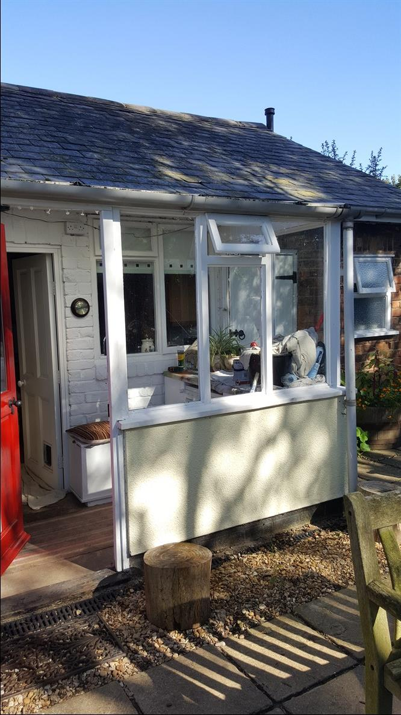
Replacement roof and frames to existing conservatory
Existing property:
Manor View is a residential semi- detached property located in Dawsmere, Spalding.
The existing property has exposed brick & painted render. The window frames are white and tiled roof.
Design and use:
The proposed replacement conservatory will be constructed of white woodgrain PVCu frames with double glazing and polycarbonate roof. Base will remain the same.
Size:
Position on property: Rear Elevation
Projection: 2.7m
Width: 1.5m
Additional floor space: no change
Access & Parking:
There will also be no changes to existing parking and access.
Landscaping:
The proposed works will not require any alteration to the existing rear garden or front garden.

