Post Development Habitat Information

Gedney Hill Play Park Project
Gedney Hill Playing Field
North Road
Gedney Hill
Spalding
Lincolnshire
PE12 0NS

Predevelopment

Baseline
- Field categorised as modified grassland in poor condition
- Path leading to the site is developed land sealed surface.

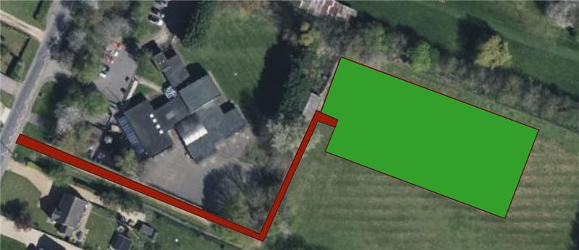
  - Sealed surface: Red
  - Modified grassland (poor condition): Green

Post development Baseline

The BNG Units were recalculated from the initial report by ProHort, owing to the fact that the whole area is not developed land.
- All grass matting has been calculated from the block plan and dimensions of each grass mat. The habitat type for grass matting used is the same as for grasscrete – ½ the value is poor condition modified grassland and ½ the value is developed land sealed surface.
- Sealed surface has been used for the extension to the path leading into the playground and the wet pour section.
- The cycle track has been categorised as ‘bare ground with a poor target condition’ for the whole length and 1m width.
- The rest of the site is retained as modified grassland in poor condition.

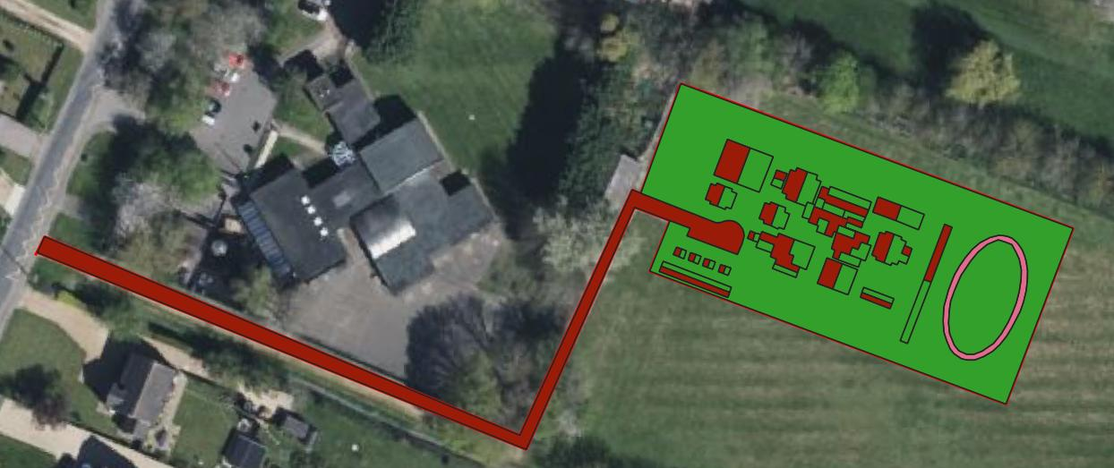
The highlighted results of the metric calculations without enhancements:
- Baseline units: 0.46
- Post development units pre-BNG enhancement: 0.39
- Unit deficit: 0.12

Habitat Enhancements
- Planting 6 trees with moderate target condition
- 100sqm of moderate condition Other neutral grassland (ONG)

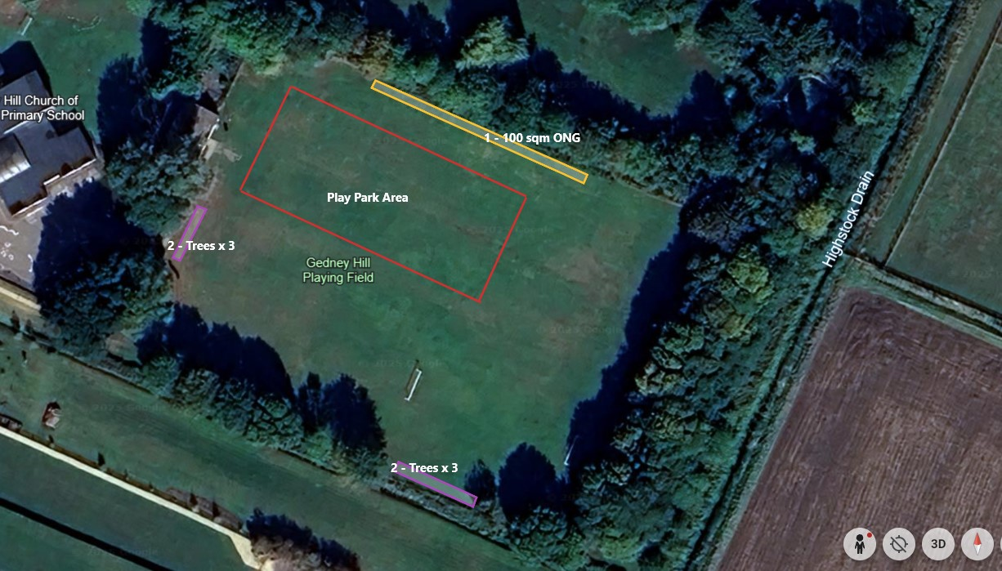
The highlighted results of the metric calculations with enhancements:
- Off-site baseline: 0.03
- Off-site Post Intervention: 0.74
- Off-site Net Change: 0.70
- Combined Net Unit Change: 0.63
- Total Net Unit Change: 0.63
- Total Net % Change: 137.89%

Habitat Management and Monitoring Plan
Summary of management plan
0.01 ha of other neutral grassland will be created to a moderate condition, with a range of species suitable for the local area, including grass species such as, common bent, rye and timothy.
0.072 ha of individual trees will be planted, using native species found within the immediate area, that suit the planting scheme for the project and provide additional food sources for bird species and invertebrates. Species such as Hornbeam, Field Maple, English Oak and Willow.

Timescales for Actions
Year 1 – creation of grassland and tree planting
Year 1-5 – annual monitoring and adaptive management
Aug-Sept – annual management of the grassland features

Monitoring Requirements
The main monitoring requirements will be during the establishment phase, during yeasr 1-5. This is to ensure that suitable establishment of the trees occurs, an adaptive management strategy can be taken as necessary.

Required Consents and Licenses
N/A

Funding
Funding to be supplied by the developer

Phasing Strategy
Once building work is completed and the landscaping phase undertaken. The phasing of the work will be as follow:
• Prepare the ground during the initial build phase, whilst machinery is present
• During Autumn, plant the trees for best establishment
• Grassland seed mix to be sown in early spring (March-May) or Autumn (October-November) depending on when the building phase is completed.
• Establishment of trees and wildflowers monitored in year 1 and 2, with a review in year 5 to adjust the management if necessary.

Roles and Responsibilities
Gedney Hill Parish Council are responsible for delivering the Management Plan

Land Use Summary
The site consists of closely mown, species poor grassland that has been managed as a lawn.

Monitoring Reports
Project Year | Month Report to be Submitted | Month Management Plan to be reviewed | Comments
Y1 | September | September or October | Report on results of initial grassland and individual tree creation measures.
Y2 | September | September or October | Report on results of grassland management and individual tree development.
Y3 | September | September or October | Report on results of grassland management and individual tree development.
Y4 | September | September or October | Report on results of grassland management and individual tree development.
Y5 | September | September or October | Report on results of grassland management and individual tree development.

Y10 | September | September or October | Report on results of grassland management and individual tree development.
Y15 | September | September or October | Report on results of grassland management and individual tree development.
Y20 | September | September or October | Report on results of grassland management and individual tree development and veteran feature analysis.
Y25 | September | September or October | Report on results of grassland management and individual tree development

Current Management
Regular mowing of the grassland, which is maintained as a lawn. All trees undergo minor pruning to maintain their shape or no management at all.

Overview of Proposed Site Use
The site is being changed to accommodate a play park. The area around the development, which is currently mown grass and trees, will accommodate the extra trees and Other Neutral Grasses. The main management prescription will be the management of the grassland, creating a suitable mowing regime to enhance species diversity, cutting and removing the arisings. The trees will have a suitable planting methodology and then monitored, with pruning minimised to allow suitable establishment.

Adaptive Management
Grassland
Monitoring will feed into management to ensure a moderate level grassland is created.
Establishment – monitoring needed to ensure suitable establishment – feedback into management plan in year 1-2, where additional seeding will occur if triggered.
Management – ongoing surveys through year1 – 5 will monitor management strategy. If species diversity drops, cutting timing can be changed to suit species present or additional species can be added.

Individual Trees
Establishment – monitoring needed to ensure suitable establishment – feedback into management plan in year 1-5, where additional management will occur if triggered, such as additional watering.
Day to day observations are possible from residents and will be fed back to management so decline is quickly recorded, outside of the standard methodology.

