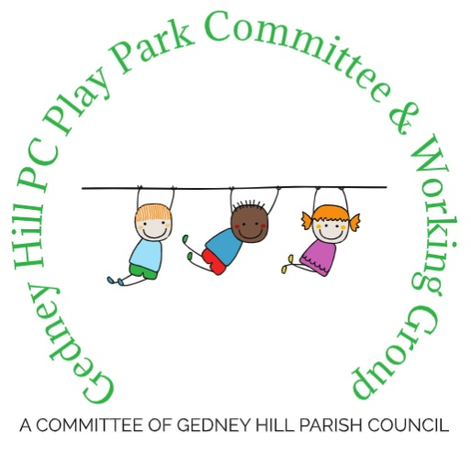

Gedney Hill Play Park Proposal:
Project Description for the Proposed New Playground at Gedney Hill Playing Field.

17 February 2025

Overhead Full Plan
See attachment ‘002-Overhead-Plan’ for larger file
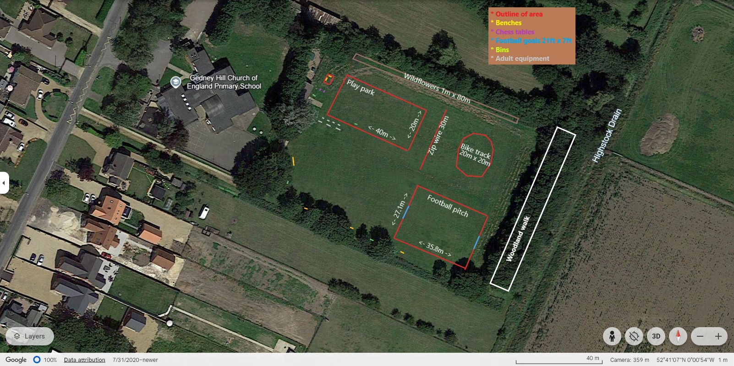
Overhead plan of play equipment within the fenced area
See attachment ‘003-Wicksteed-overhead’ for larger file
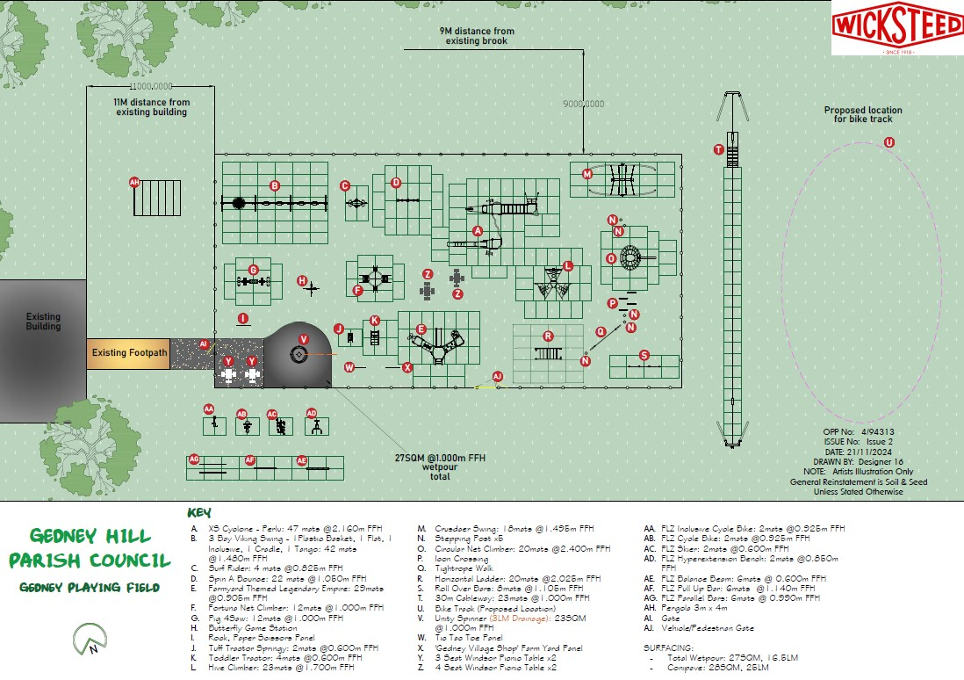
Playground equipment within the 20m x 40m fenced area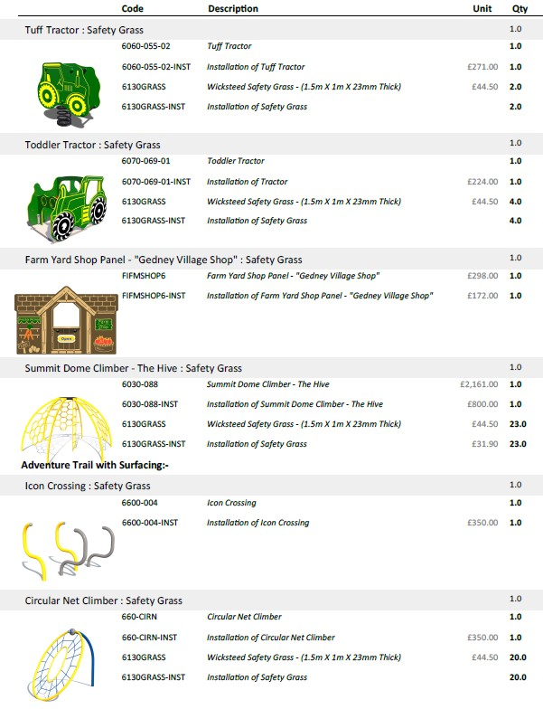
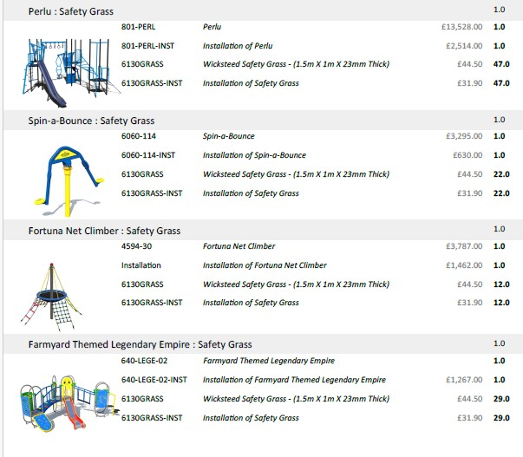
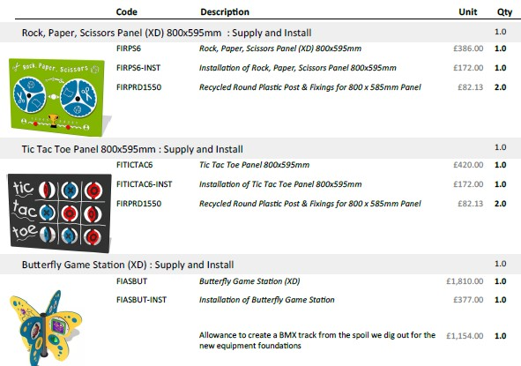
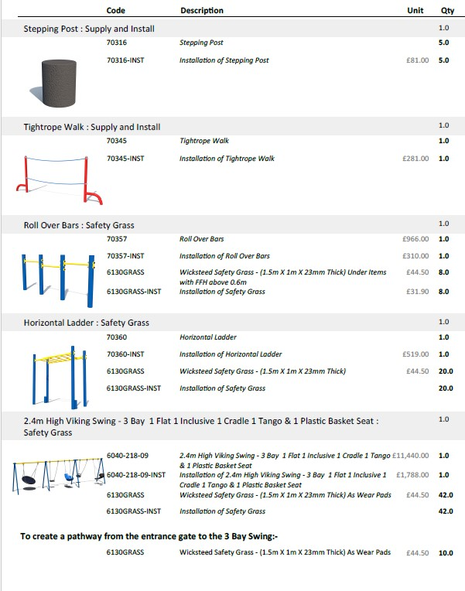

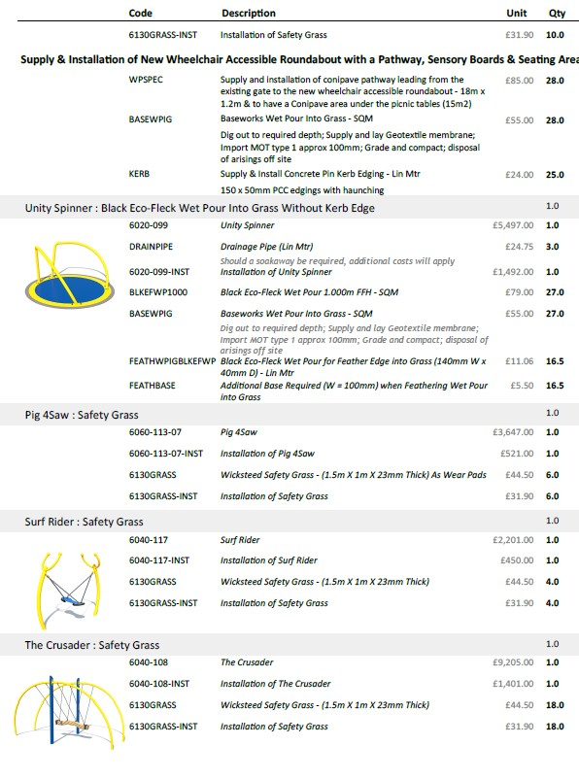

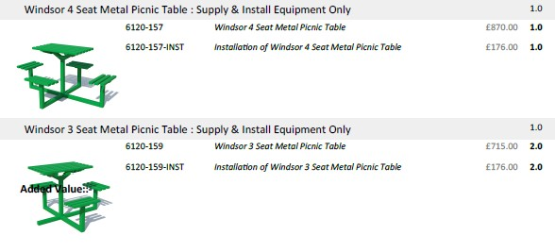
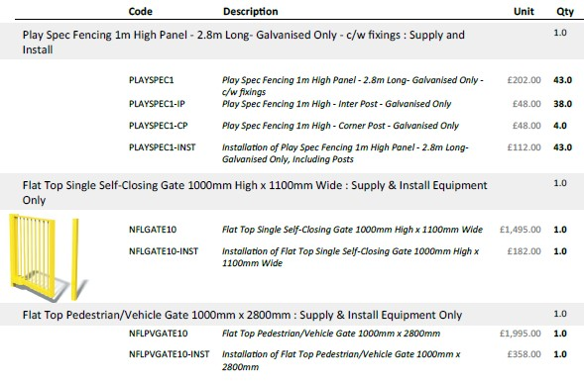
The equipment in the playground it made of metal and plastic, all equipment is under 4m high.
The fence is 1m high
Wet pour rubber is used for the base to the utility spinner. It is porous due to the small gaps between the rubber granules which allow water to drain through. (On page 4)
Conipave is used for the pathway and seating area, it is a water permeable surface. (On page 4)
Safety grass/ matting, which allows grass to grow through is used around the equipment to reduce wear and enhance safety.

Equipment located outside the fenced play area
Pergola
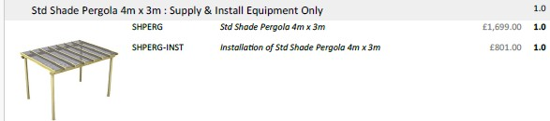

Zipline
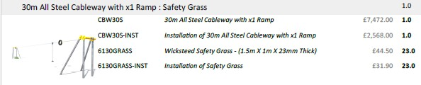

Adult exercise equipment
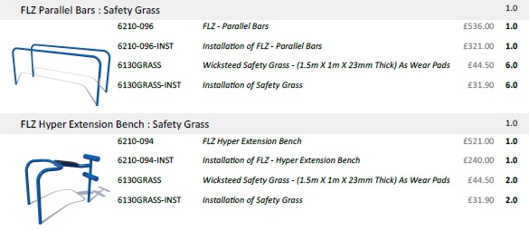
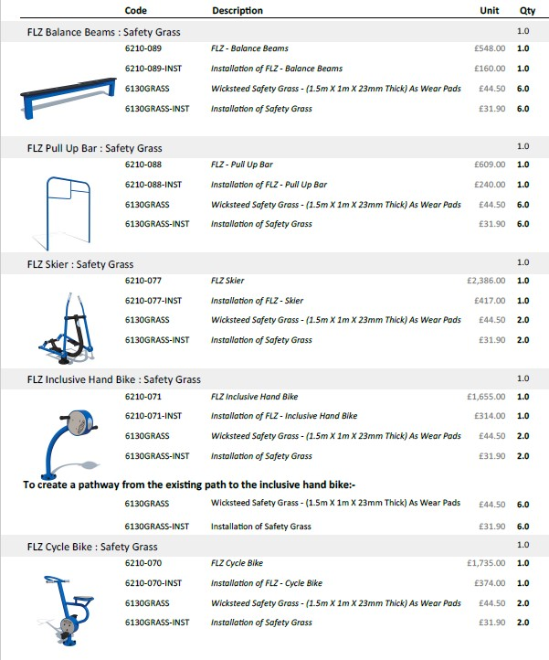

Four Benches
All benches will be installed with 0.3m x 0.3m width x 0.6m depth post mix for each bench leg. Each bench has 4 legs.
The benches are made from 6mm thick laser cut steel then crafted by hand and made into a bench seat on our OE frame at the standard length of 1600mm. There will be 4 benches of this type with different agricultural/ country themes on the back rest.

Four Bins
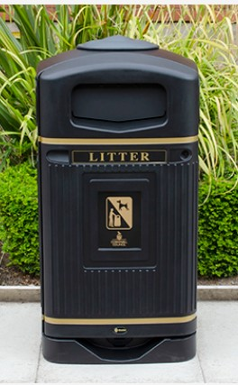
Bins will have ground anchors, so they are hard to move/ tip. The ground anchor is attached to the bin and goes into the current ground surface to secure. The Parish Council will take responsibility for emptying the park bins, which will have mixed waste.
Height: 1158mm
Width: 598mm
Depth: 553mm

Bike Track

Constructed from soil extracted from the play area site during installation of equipment. Mounds of soil will be compacted in a maximum 20m x 20m span.

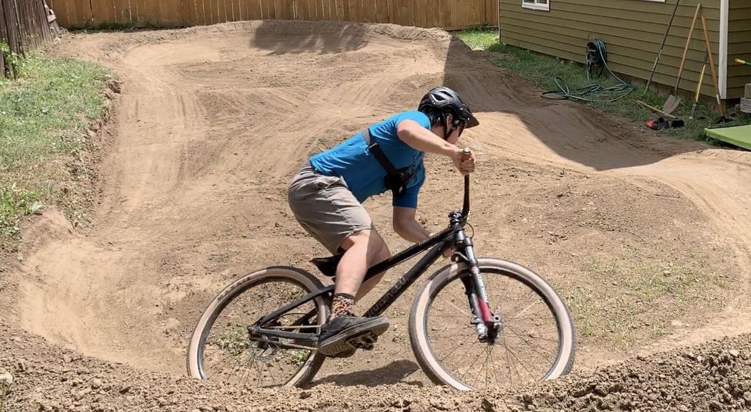

Chess Tables
The chess tables are installed directly on to the current surface with no extra fixing/ material. They are made of concrete. 2.5m x 1m
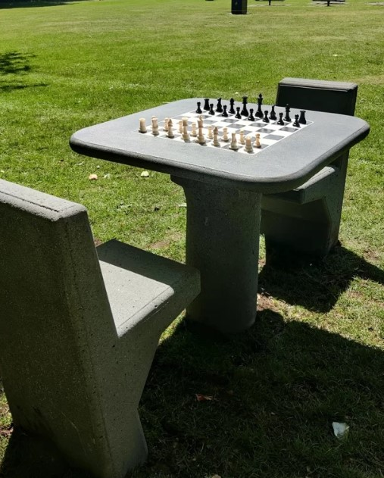

Bike rack
To be located on the West boundary next to the footpath, between the pavilion and park entrance. Length = 3m
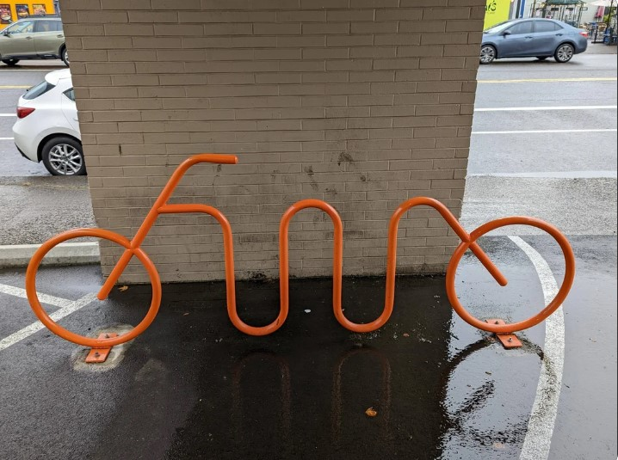

Wildlife and Nature Area
Wildflower seeds will be planted alongside the North boundary of the field. These will be 1m wide, from the ditch and 80m in length, providing food and habitats for pollinators, insects and other wildlife.
Nature walk will consist of pruning branches between the 2 sets of trees that run parallel to each other located on the East boundary of the park. Log piles will be created for habitats and some seating for the local children to learn in nature or for adults to enjoy the natural sounds of birds and other animals.
Owl box to be located within or next to the trees on the East boundary of the park. If installed on its own post (rather than a tree) the post will be no higher than 4m. The post is installed into the current ground. It is constructed with wood.

Planters wooden flower boxes will be located near the current pavilion and next to benches around the park, not only to improve aesthetics, but to incorporate differing flowers to attract pollinators, insects and other animals.
