BLOCK PLAN
AREA 130m x 130m A3
SCALE 1:500
CENTRE COORDINATES: 534374, 312331

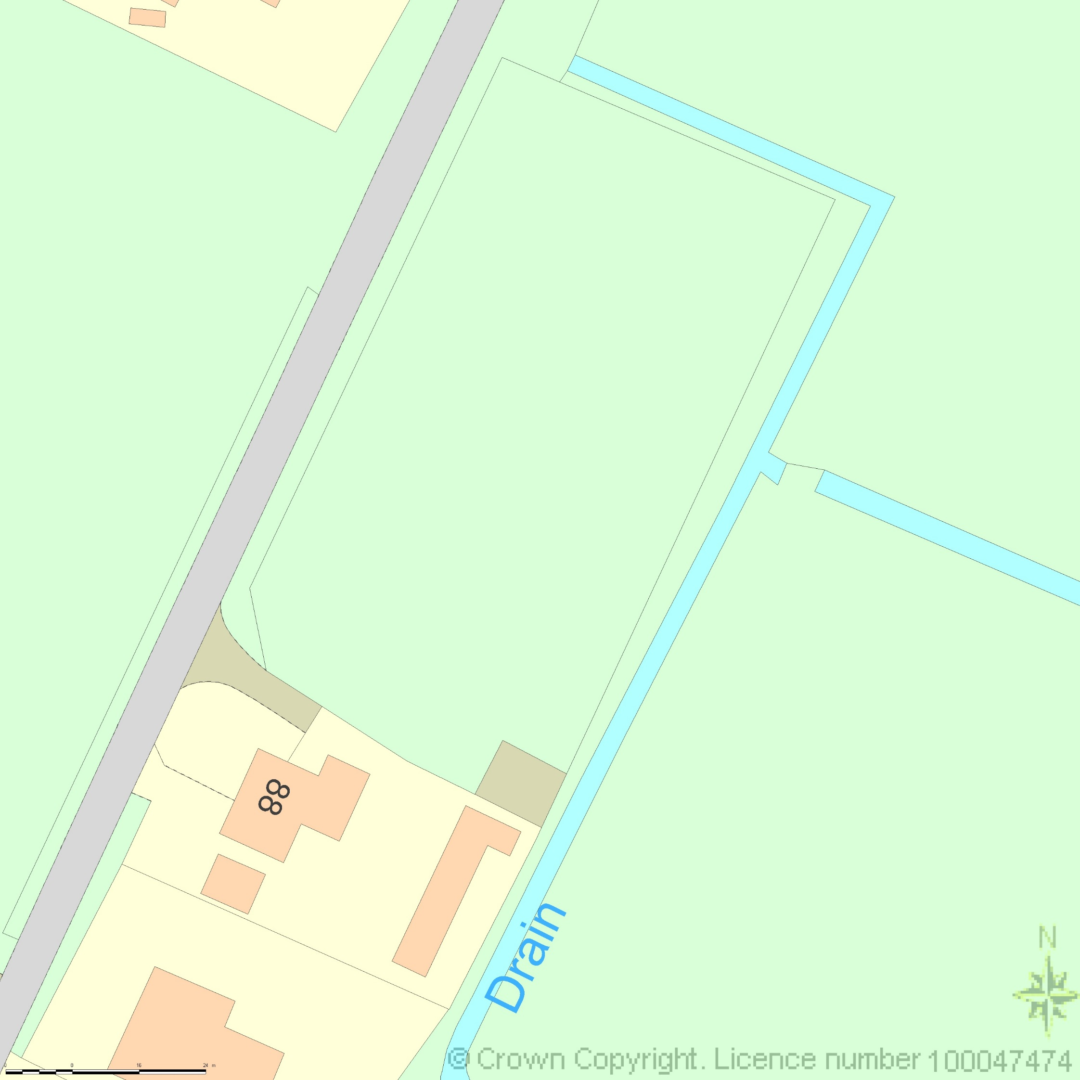

Key

Car Parking Area

Double Garage


Supplied by Streetwise Maps Ltd
www.streetwise.net
Licence No: 100047474
14/04/2014 09:02:45

