DESIGN & ACCESS STATEMENT
FLOOD RISK ASSESSMENT
RESIDENTIAL DEVELOPMENT
3 BOW GATE GOSBERTON LINCS
PE11 4ND

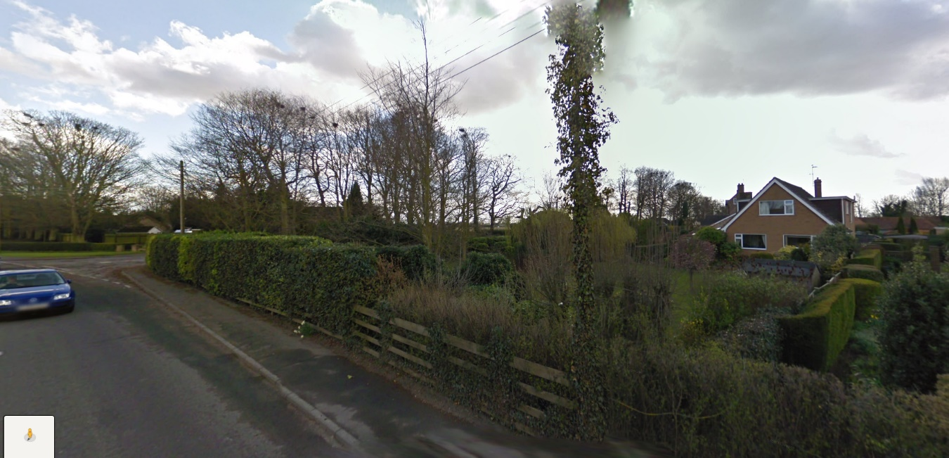

Introduction

This Design & Access Statement accompanies an outline planning application to develop this site for residential development.

This DAS has been written to meet the requirements of Article 4C of the Town & Country Planning (General Development Procedure) Order 1995 (as amended)

When preparing this application the following policies have been taken into account: -

NATIONAL PLANNING POLICY FRAMEWORK 2012
  - Section 6 – Delivering a wide choice of highquality homes
  - Section 7 – Requiring Good Design

SOUTH EAST LINCOLNSHIRE LOCAL PLAN
  - South East Lincolnshire – Proposed Inset Maps for ‘Other Service Centres and Settlements’

SOUTH HOLLAND LOCAL PLAN JULY 2006

- SG1 – General Sustainable Development
- SG2 – Distribution of Development
- SG3 - Settlement Hierarchy
- SG14 – Design and Layout of New Development
- SG15 – New Development: Facilities for Road Users
- SG16 – Parking Standards in New Development
- SG17 – Protection of Residential Amenity

These policies form the basis upon which this application has been designed and are in accordance with advice within Paragraph 55 of the National Planning Policy Framework, 2012 and are aimed at ensuring that new development is in a sustainable location and that the character of the countryside is protected.
One of the requirements for the South East Lincolnshire Local Plan seeks the development of the ‘Other Service Centres and Settlements’ the inset map No 18 for Gosberton indicates that the application site is situated within the identified development boundary of a `Minor Service Centre`.

An assessment of settlements and their sustainability credentials March 2019 in the South East Lincolnshire Local Plan identifies Gosberton as being a sustainable location for future development.

The Site

The site has an area 0.08ha and is adjacent to 3 Bow Gate Gosberton. The site is currently accessed directly off Bow Gate. The proposed access off high street affords good visibility in both directions and avoids any conflict with any existing trees. It lies in close proximity to Gosberton schools and shopping centre, and as such, is within easy walking distance to the services and employment facilities locally. There is regular public transport to Spalding and Boston where the public transport services expand further afield thus adding to the availability of services and employment facilities. The site currently consists of garden. The Site is Flood Zone 3 as shown on the Environment Agency Flood mapping.

Use

The application site currently consists of garden area.

Amount

Drawing no. 001 indicates the 1:2500 scale application site and where it is in relation to adjacent dwellings in that part of Gosberton. This also gives an indicative layout of a possible future dwelling which can be accommodated comfortably on the site.

Appearance

The proposed dwelling would be a 2 story dwelling designed to be of high quality and of a type that is in character with the area in general. The dwellings to the South, East and West are two story whilst the dwelling to the North is 2 story chalet type.
These details will be subject to a further submission. In terms of appearance it will be of paramount importance that the design and form protects the amenities of the surrounding residential dwellings to minimise overlooking and noise etc.

Access

The proposed drive will be as shown on the plan. Any garage will be set back a minimum of 10.0m from the edge of the carriageway to allow for turning space within the site to allow egress of vehicles in a forward gear.

Landscaping

TBC

Conclusion

An assessment of settlements and their sustainability credentials March 2019 in the South East Lincolnshire Local Plan identifies Gosberton as a Minor service centre and a sustainable location for future development. The plan also determines that this site, being for a single Dwelling, should be suitable for Market Housing only and that no affordable housing would be required.

The National Planning Policy Framework clearly states the policies and how there is a presumption in favour of sustainable development and how the housing supply needs to be increased.
The application site is within close proximity a bus route and to schools, shops and other facilities as previously described.

The proposed scheme will be a positive contribution to the character of the area, particularly in terms of the design, form and scale and will also be a positive contribution to the street scene. The proposal will be of a very high quality in terms of design and the use of materials. Para 55 of the NPPF refers to promoting sustainable development, which will enhance and maintain the vitality of rural communities within groups of smaller settlements. It also advises avoiding new isolated homes in the countryside unless there are special circumstances, which includes exceptional quality or innovative nature of design. It is intended that the design will help raise standards of design in architecture and will enhance its immediate setting.

Whilst the NPPF suggests the LPA policies are out of date in the Strategic and General policies the LPA states that “in towns, villages and in the open countryside the effective use of land and buildings is of great importance”.

The National Planning Policy Framework sets out the Governments policies and how they expect them to be applied. There is a presumption in favour of sustainable development and more importantly one of its main aims is to increase the supply of housing.

Policy SG7 refers to the requirement of properties to be energy efficient. We would like this dwelling to achieve a high EPC B rating.

In view of the above and the pre advise given, it is hoped that this application will be favorably considered.

FLOOD RISK ASSESSMENT
The site is situated in partially in zones 1 and 3 on the Environment Agency Flood mapping.
However, according to the 2017 South Holland Strategic Flood Risk Assessment, the site is located in an area deemed to be of no Residual Flood Hazard to the year 2115.
It is therefore proposed that:
The new dwelling will be two story. The Finished Floor Level of any new dwelling will be set at 3.65 O.D.
The applicant will register with the Environment Agency’s Flood line Warnings Direct Service.
Rainwater from the roofs of the dwelling should be discharged into soakaways and these should be designed to BRE Digest 365 and approved under Building regulations.

