L C Dobney

Design and Access Statement

Proposed siting of Residential Cabin

Cheal House Farm Cheal road Surfleet

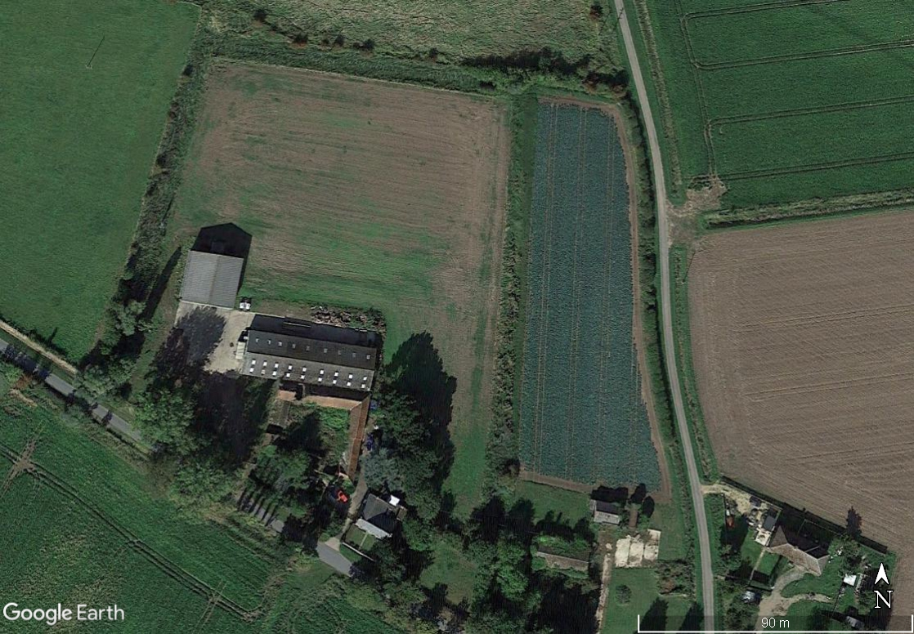

Google maps extract Cheal House Farm
L C Dobney

Contents
- Introduction
- The Application
- Site and Surroundings
- Planning Policy
- Design and Access
- Conclusions

- Introduction

This application relates to the proposed siting of a residential log cabin in the current farmyard at Cheal House Farm Cheal road Surfleet.
The site comprises of a collection of farm buildings the original buildings are brick built with a traditional roof. The large storage building is a steel frame clad building and on the west of the site is a modern operational grain store. The total site extends to .655Ha with a mixture of hardstanding and grassed areas as outlined in red on the plan below.

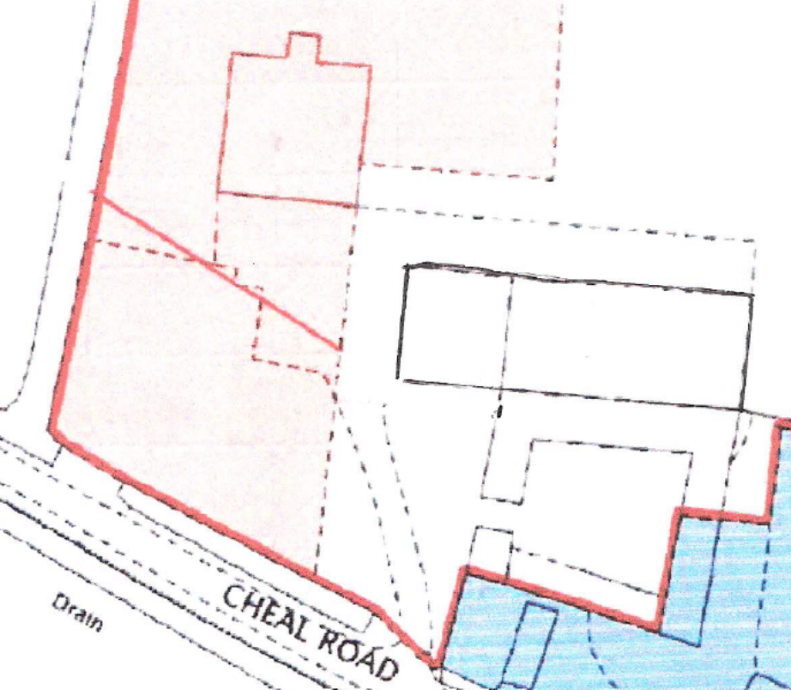
Existing Site plan

2.Application site and Surroundings

2.1 This application is for permission to site a one bedroomed log cabin on the site for use of the owner of the agricultural business operating from the site
2.2 The application site fronts on to the Cheal Road. On the north and west boundaries there is open farm land and to the east is a single residential dwelling.
2.3 The site benefits from a hedge with several trees in it along the road frontage to Cheal Road the other boundaries to the west and north are open there are mature trees on the eat boundary in the neighbouring property
2.4 The application site is in an area with occasional residential properties which have historically been used by agricultural workers. The location is approximately 1.4 miles from the village of surfleet.

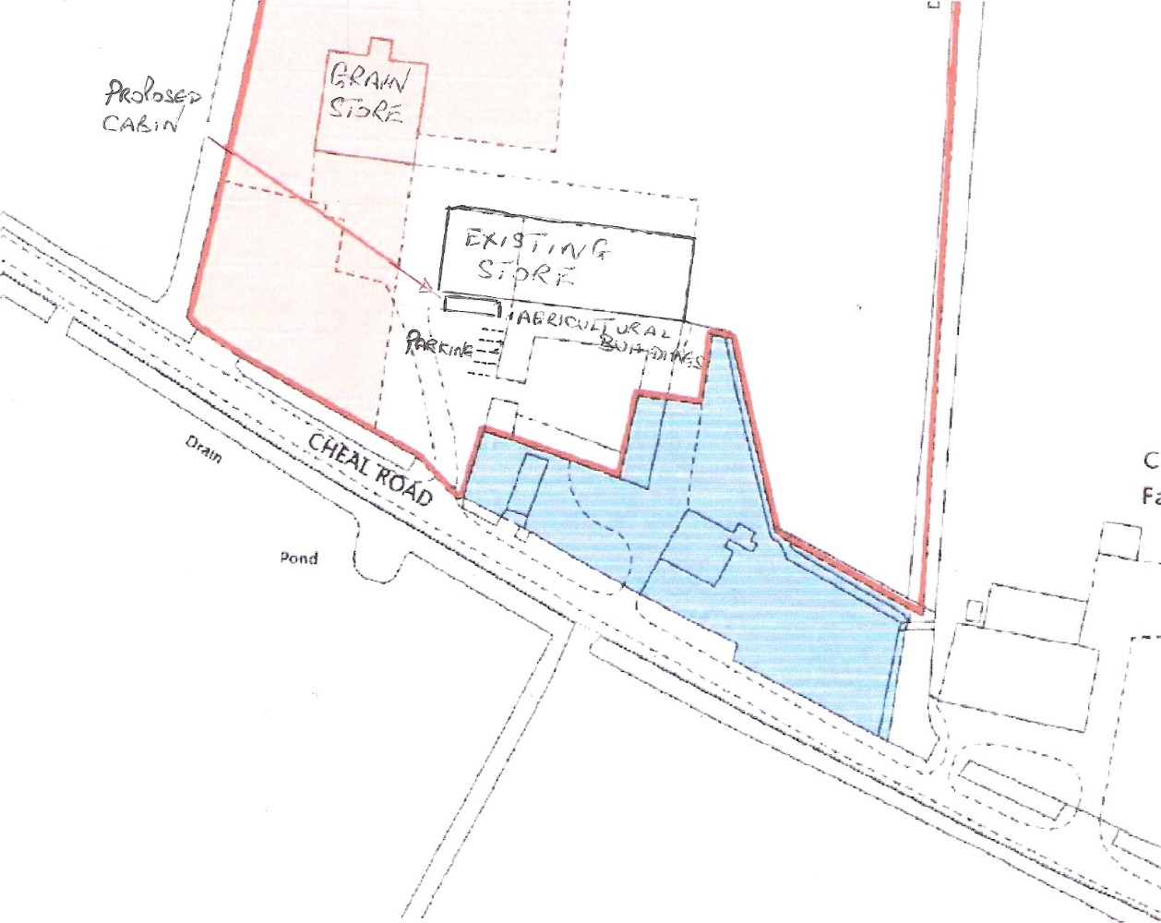
Proposed site plan showing proposed location of cabin and new parking provision
2.5 The site has an existing access to the adopted highway which it is proposed will be used for the residential access

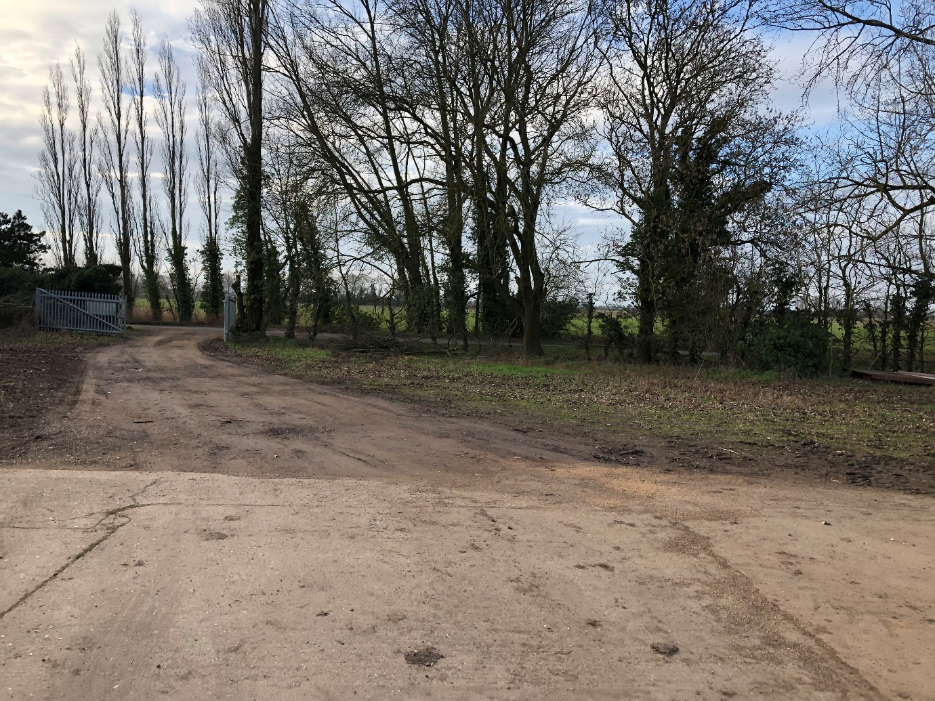
View from inside site to highway entrance

2.6 The site is in a low flood risk area according to Environment agency flood map for planning.
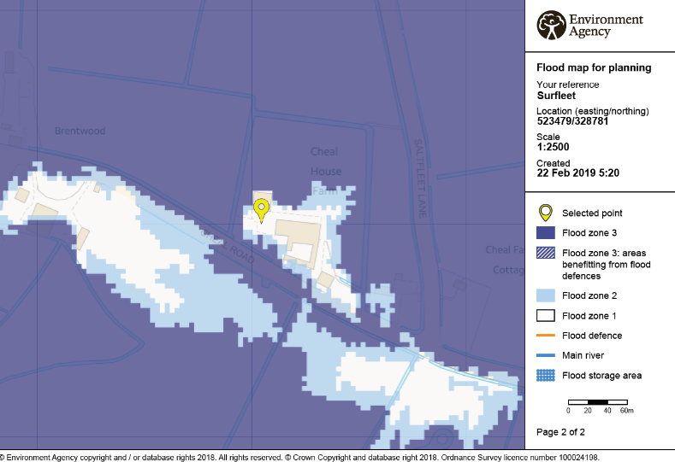
3.Planning policy
3.1 The relevant local policy is currently HS7of the South Holland Local Plan (2006)
3.1.1 The applicant has been operating an agricultural business from these premises since December 2016. The business operates as a limited company The applicant is the sole director and shareholder of L C Dobney Ltd Registered in England Co no 10540024
3.1.2 Initially this was on a part time basis but in the last 12 months the level of business has sustained a full-time basis. In the last six months one additional full-time worker has also been engaged in the business. This is largely a result of a considerable investment in the last 12 months in Agricultural Machinery by the business.
3.1.3 The latest filled accounts for the year to December 2017 ( Anex 1) show Capital and Retained profits of £18,000. The last years accounts are in the process of preparation by the company’s accountants. These will show a substantial increase in turnover as the business continues to grow and prosper.
3.1.4 The ability to install residential accommodation on site. Co located with the agricultural business will contribute to the sustainability of the business. Savings in accommodation rent and travel costs will reduce outgoings.
3.2 National Planning Policy
National Planning Policy Framework (2018) paragraph 79
This paragraph means that new homes may be permitted in the countryside where there is a need for a rural worker, specifically for those taking majority control of an agricultural business to live permanently at their place of work.
3.3 Business sustainability
Within the first two tears of operation this business has gone from a one-man part-time business to now supporting two full time people
The business specialises in filling the different seasonal demands for labour, equipment ans storage across a variety of crops.
Clients include local farmers together with larger corporate Growers/Packers, in Root crops. Brassicas and flowers.
being able to reside on site, will both increase security but also demonstrate to prospective and current clients an increased commitment to the business. This also will reduce travel costs and travel time particularly helpful in seasonally busy times.

4.0 Design and Access
4.1 The proposal is to install a proprietary built log cabin consisting of one-bedroom accommodation with Bathroom, Kitchen and living space.
4.2 It is proposed to site the cabin facing the front of the site, immediately at the front of the large storage building on the eastern part of the site.
4.3 The cabin will be installed on a new concrete slab with all the necessary services connected.
4.4 A permeable parking area will be provided for up to four vehicles as shown on the site plan. An area will be identified for the storage of domestic waste and recycling waste.
4.5 The cabin as proposed is constructed in composite material and is insulated to a good standard. The proposed cabin was manufactured by Ashwood model Qualiluminar and measures 38ft by 12ft.
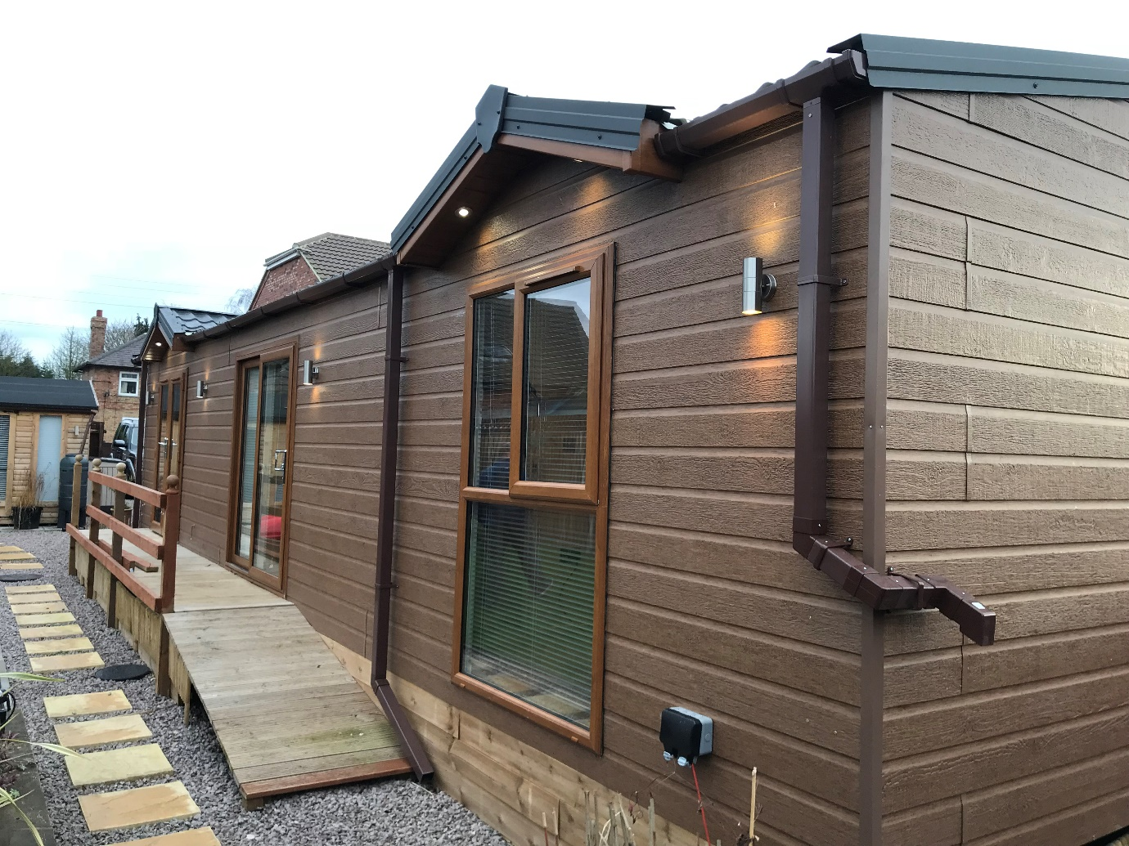
Proposed cabin in current location

4.6 Access
Access to the property is directly from thr adopted highway via the existing gated roadway.
4.7 Landscaping
The existing hedgerow and trees to the front of the site will be retained. Minor maintenance works are to be carried out during the appropriate season.
5.0 Conclusion and Recommendation
5.1 The site bring an existing agricultural site with and operational grain store and a thriving agricultural business demonstrates the suitability for the location of a single residential unit

5.2 The attached accounts show a viable and thriving agricultural business which is owned and operated, by a young entrepreneur businessman with a background and education in agriculture. The business has already created additional employment and is expected to produce further employment opportunities in the future.
5.3 The property has an adequate access from the adopted highway.
5.4 The current local plan policy HS7 supports this type of development.
5.5 The National Planning Policy Framework supports development in the countryside where there is a need for a rural worker, specifically for those taking majority control of an agricultural business to live at their permanent place of work.
5.6 this application should be approved for Full Planning Permission in order to support business development in a rural area and to support employment in agriculture in a rural environment.

22nd February 2019

