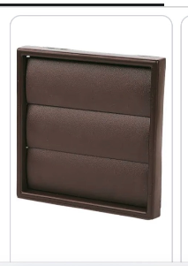 | Utility  On rear elevation
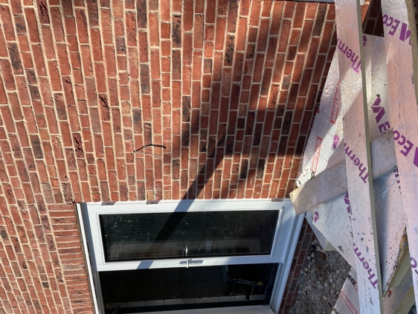  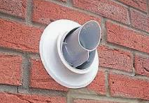 | Bolier Flue  Rear elevation next to lounge door.  Not installed yet but this is what we’ll be using.
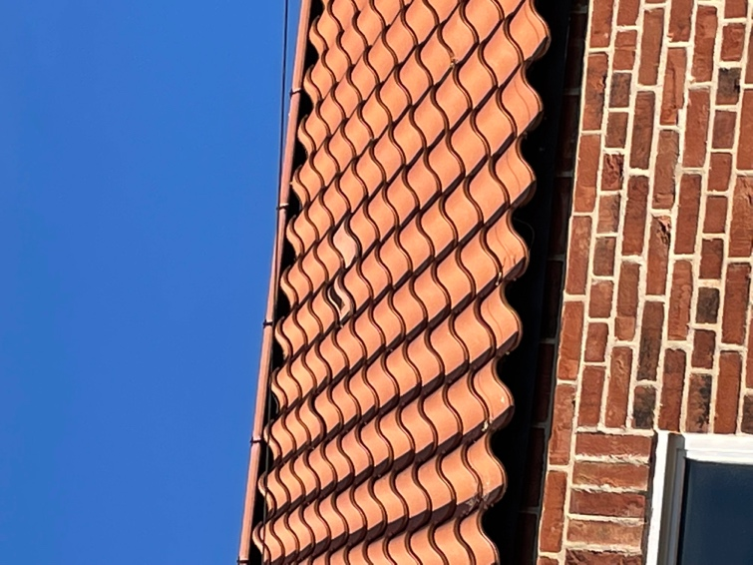  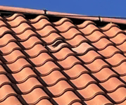 | Soil and vent pipe through vent tile in the roof
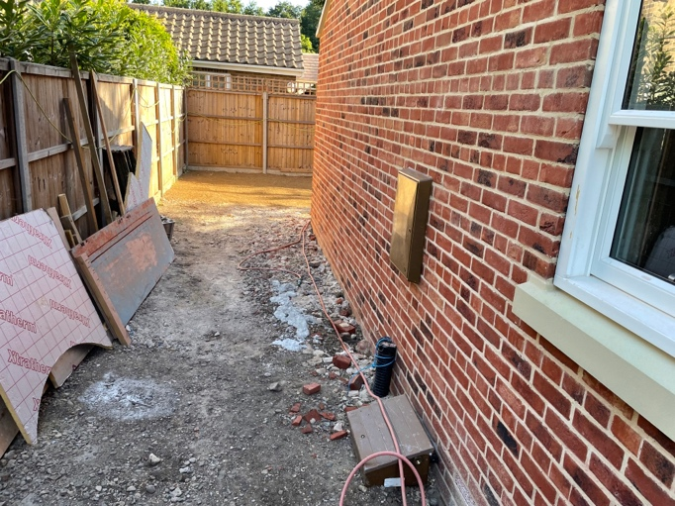 | Gas and electric meter boxes

