FLOOD RISK ASSESSMENT
110 Siltside, Gosberton Risegate, Lincolnshire, PE11 4ET

This Planning Application seeks permission for the change of use of existing residential swimming pool at 110 Siltside, Gosberton Risegate, Lincolnshire, PE11 4ET.

The site is located towards the western side of the village, on the northern side of Siltside. The site comprises a detached bungalow, with detached garage and enclosed swimming pool.

The proposal is to change the use of existing swimming pool from residential to commercial, exclusive use by family groups of up to 6 – primarily rehabilitation and disabilities. The internal and external layout of the swimming pool will not be affected.

The site is within Flood Zone 3, having a high probability of flooding from rivers and the sea, and is within the defended area of the South Holland District Council’s Strategic Flood Risk Assessment (SHDC FRA) map and is located in the Welland and Deepings Internal Drainage Board district.

Flood Risk Assessment

The map below is taken from the Environment Agency website and indicates the flood zones within the area, where the vast majority of Gosberton Risegate is within Flood Zone 3.
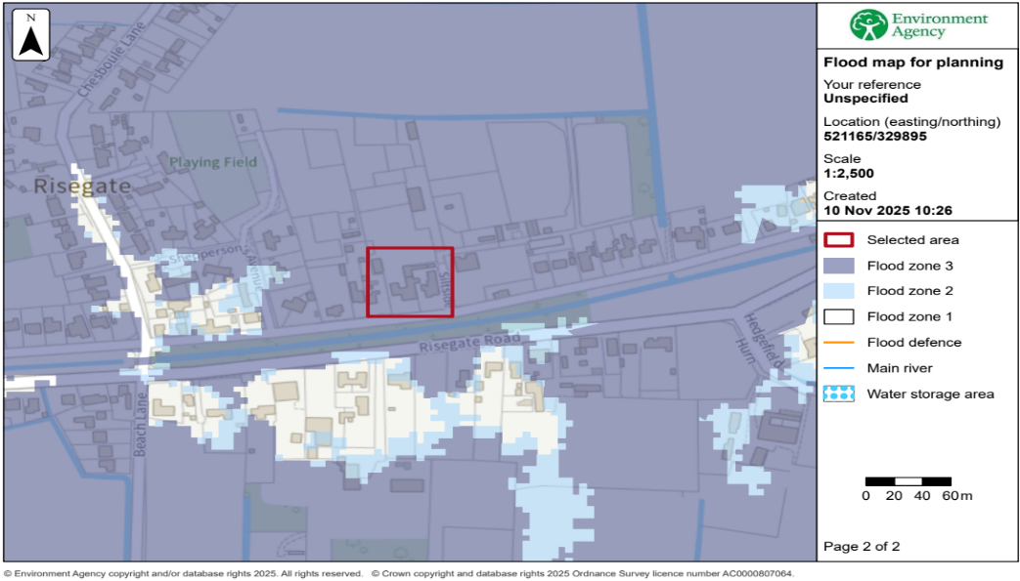

The GOV.UK Flood Risk website confirms that the site has a high probability of flooding from rivers and the sea.

The GOV.UK Flood Risk website confirms that the chance of surface water flooding at this location could be more than 0.1% (1 in 1000) each year.

Conclusions

The proposed development is within Flood Zone 3.

As the proposal simply involves the change of use of existing swimming pool, it will not be necessary to include mitigation measures such as raising floor levels.

In this case, the primary action to be taken in the event of a flood warning is evacuation. It is recommended that the occupants of the site should register to receive automatic flood warnings from the Environment Agency’s Floodline Warnings Direct Service.

Given the nature of the development, the proposal will not increase the risk of flooding elsewhere.

