413391 - Anglian Water - Holbeach-Boston Rd Tps

Scopes of works;

Following a recent customer reported complaint and a site visit completed by Lucy Telford, to provide NPTC trained operatives working at height with the use of a MEWP to cut down to ground level one small laburnum tree. Works will need to be completed for the customers side due to the road and the tight access within the site. All materials to be lowered into an allocated safe drop zone, chipped and removed from site using licensed waste carrier.

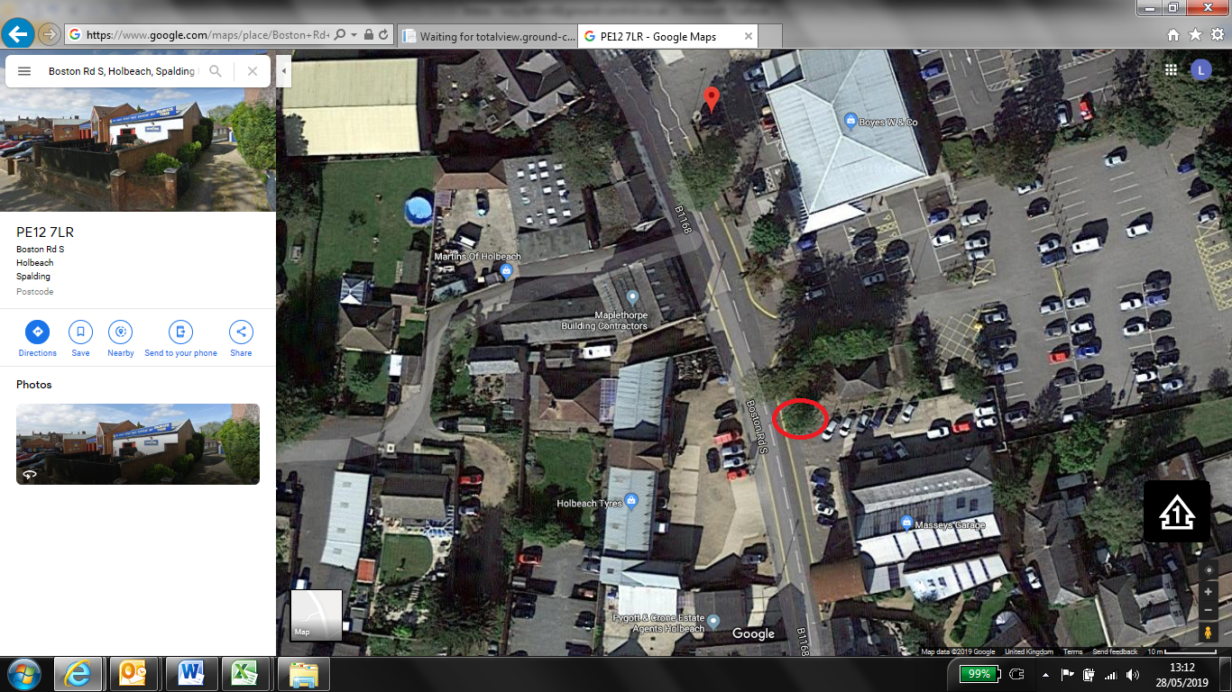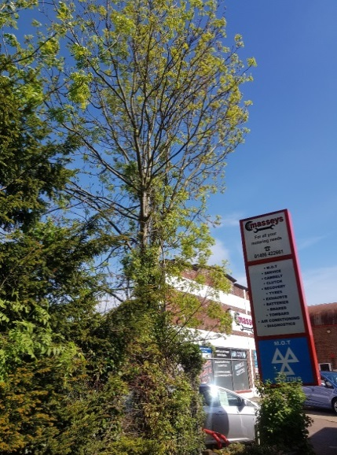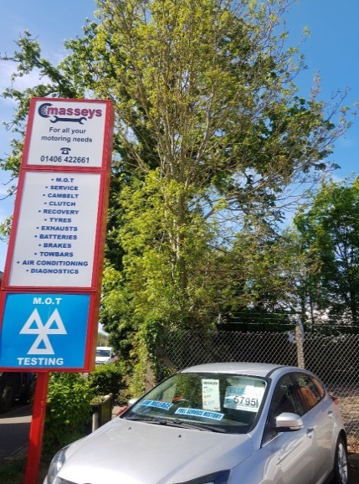
T1 – Small Laburnum Tree

