PLANNING STATEMENT

Proposed change of use to dwelling at Lazy Acre, Little Dog Drove, Holbeach St John

I am instructed by Mr E M McGowan to re-submit the attached application for full planning permission proposing the change of use of a redundant utility/amenity building at Lazy Acre that was originally constructed in support of the use of the land as a caravan and associated tented camping site to a single dwelling. In doing so, I refer to the meeting at Spalding on 30 October 2019 with Mr Richard Fisher when the practicality of making this re-submission was agreed.

The re-submission arises from the refusal of full planning permission by the Council on 22nd August 2019 under code number H09-0663-19. In summary, the decision notice indicated that the proposal had been assessed against Policy 1 of the South East Lincolnshire Local Plan, 2019. As the site was outside a settlement boundary it was necessary to demonstrate that it met the sustainable development needs of the area in terms of economic, community or environmental benefits. There was not considered to be an essential need for the development in this location on land-use grounds. The proposal was therefore contrary to Policy 1 of the South East Lincolnshire Local Plan 2019, and paragraph 79 of the National Planning Policy Framework 2019.

In addition, the building was regarded as new in construction and that it has no architectural or historical merit to justify a residential conversion, contrary to the requirements of Policy 23 of the South East Lincolnshire Local Plan.

A full response to these reasons for refusal is set out below.

In addition to the above refusal of full planning permission there is, as the Council is aware, a considerable planning history with regard to the land to which I now make brief reference. The background to the application lies, however, in the permitted development rights relating to the use of land as a caravan site that are set in Part 5 of Schedule 2 of the Town & Country Planning (General Permitted Development) (England) Order 2015. Class A relates to use of land, other than a building, as a caravan site in the circumstances referred to in paragraph A.2.

It is conditional at paragraph A1 that the use be discontinued when the circumstances specified in paragraph A2 cease to exist. All caravans should then be removed from the site as soon as practically possible. That is the situation here because, exemption certification by the Caravan and Camping Club no longer being applicable, and planning permission having been refused for the continuation of the use, the site is now closed, the owner haven taken no bookings since before planning permission was refused at appeal. The Council has, furthermore, since declined to issue a Certificate of Existing Use or Development under the provisions of Section 191 of the Town and Country Planning Act, 1990.

Very significantly, however, planning permission had been granted by the Council on 10 June 2010 (code: H09-0333-10) for the erection of the proposed utility/amenity building for the caravan site use. There followed a subsequent application for a non-material amendment to that planning permission (code: H09-0566-15) which was the subject of the Council’s approval on 21 September 2015. It is, clear that in deciding, having regard to the provisions of the Development Plan and other material considerations, that planning permission should be granted, there was an acceptance of the ongoing caravan and camping site use. Indeed, the reason for imposing condition 3 of the original grant of planning permission was stated to be:

“To ensure that the building is used solely for a purpose ancillary to the existing touring caravan and camping site and not for residential purposes. Residential use would be contrary to the provisions of Policy HS7 of the South Holland Local Plan 2006 and Planning Policy Statement 7 “Sustainable Development in Rural Areas”, both of which seek to control new residential development in the open countryside”.

The Reason for Approval indicated that the proposal was in accordance with policies LT7, SG13, SG14, SG15, SG16 & SG17 of the South Holland Local Plan 2006. The reasoning added:

“Concerns raised relating to the size and nature of the development, visual impact, amenity, ecology and highway safety had been carefully assessed, but are outweighed in this case by policies in favour of the proposal and other material considerations, including the imposition of appropriate conditions”.

The building is, for all practical purposes, complete although final fitting out had been suspended whilst the unsuccessful planning appeal was being decided. It is, therefore, redundant in regard to its original purpose and this application for full planning permission seeks to create an alternative, beneficial use.

The proposal.

Drawing JC/M228/2 again sets out details of the proposed change of use. Strict reliance is maintained on existing door and window openings to create the new dwelling. Its layout provides for a new kitchen/dining area/lounge, a double and a single bedroom and a small family bathroom. The attached Block Plan (JC/M228/14) shows the existing site layout including, in particular, the position of the utility/amenity building and the location of the existing septic tank. It also shows the existing site access and the surface water drainage system.

The proposal will utilise Little Dog Drove as the sole vehicular access. This highway serves a limited number of properties but it is of a width that is commensurate with the proposed usage of this existing building a one dwelling. The highway provides, in any event, a number of points where vehicles can wait, allowing one travelling in the opposite direction to pass. Previous objectors have claimed that Little Dog Drove lacks public vehicular passing places. This is disputed and there are ample opportunities, at reasonable intervals, for vehicles to pass within the boundaries of the highway. The Lincolnshire County Council did not object to the grant of permission with regard to the recent application.

The site has an existing hard surfaced, gated entrance from Little Dog Drove.

Relevant Planning Policies
(i) The Development Plan

For the purposes of Section 38 (6) of the Planning & Compulsory Purchase Act 2004, the Development Plan, as relevant to this application, comprises the South East Lincolnshire Local Plan (March 2019). Its Policies Map shows the application site to lie within an area termed “countryside”. It is considered that there are a number of policies which, where they accord also with the guidance set out in the National Planning Policy Framework (February 2019), should be given substantial weight in the making of a decision on this application, unless other material considerations indicate to the contrary:

- Policy 1 – Spatial Strategy.
- Policy 2 – Development Management
- Policy 3 – Design of New Development
- Policy 4 – Approach to Flood Risk
- Policy 23 – The Re-use of Buildings in the Countryside for Residential Use

(ii)National Planning Policy Framework (February 2019)

- Paragraph 11 – the presumption in favour of sustainable development
- Paragraph 47 – determining planning applications
- Paragraph 79c – isolated homes in the countryside

Policy Considerations

In view of the contested reasons for the recent refusal of full planning permission, I set out the requirements of Policy 1, particularly in respect of paragraph 1D, which relates to development in the countryside. It is permissive where it is “…necessary to such a location and/or where it can be demonstrated that it meets the sustainable development needs of the area in terms of economic, community or environmental benefits”. The way in which this development achieves the latter objective whilst respecting the character of the countryside is again set out below.

Policies 2 and 3 set out detailed development management and design requirements. Again, the primary objectives are clearly met. The utilisation of foul and surface water disposal arrangements that served the previous use well ensures compliance with the requirements of policy 4. Further comments are also set out below, although the recent decision found no conflict with their requirements.

Policy 23 of the South East Lincolnshire Local Plan deals with "the re-use of buildings in the countryside for residential use". It says:
Proposals for the conversion of existing buildings which are located outside defined settlement boundaries to residential use will be permitted provided that:

1 the building is structurally sound and capable of conversion without the need for significant extension, alteration or rebuilding;

2 the building is of architectural or historic merit or makes a positive contribution to the character of the landscape, to justify conversion to ensure retention;

3 the proposal is in keeping with its surroundings;

4 the design is sympathetic to the character and appearance of the building in terms of architectural detailing and materials of construction; and

5 development leads to an enhancement of the immediate setting of the building.

The policy indicates that where permission is granted, permitted development rights may be removed in order to control future alterations or extensions that may impact on the appearance and character of the surrounding area.

A further detailed response to the requirements of the policy is set out below.

The site is located within Flood Zone 3, but it is not considered that, in this instance, a full Flood Risk Assessment is necessary having regard to the site’s limited area, the background of long-term previous usage of the site and the existence of all its core facilities, including a package foul drainage treatment plant and established site drainage. The drainage system is designed to discharge so that it does not generate significant off-site run off, so avoiding any increased flood risk locally. Accordingly, the requirements of policy 4 are satisfied. An existing, approved foul drainage disposal facility accords with the requirements of the policy. It is highly unlikely that this small-scale housing development involved in this change of use will cause an unacceptable level of pollution of the surrounding area by reason of noise, light, toxic or offensive odours, air-borne pollutants or by the release of waste products. Facilities for the collection and disposal of refuse will accord with those administered in the area by the Council.

The site has already been sympathetically laid out and it has been absorbed into its surroundings by sensitive landscaping. The amenity building was constructed to a very high standard, whilst the peripheral planting and other landscaping became well-established. As the accompanying photographs demonstrate, the amenity building, seen below, rather than having “no architectural or historical merit to justify a residential conversion”, as alleged in the Case Officer’s report, was constructed to a very high standard. It was constructed using an expensive traditional facing brick that is sympathetic to the typical appearance of a small agricultural barn. It employs architectural details, including cottage verges and eaves details, that far exceed local requirements and it is finished with a roof of Welsh slate with traditional grey clay ridge tiles. These details are clearly demonstrated on photographs 1 and 2, included within this Statement.

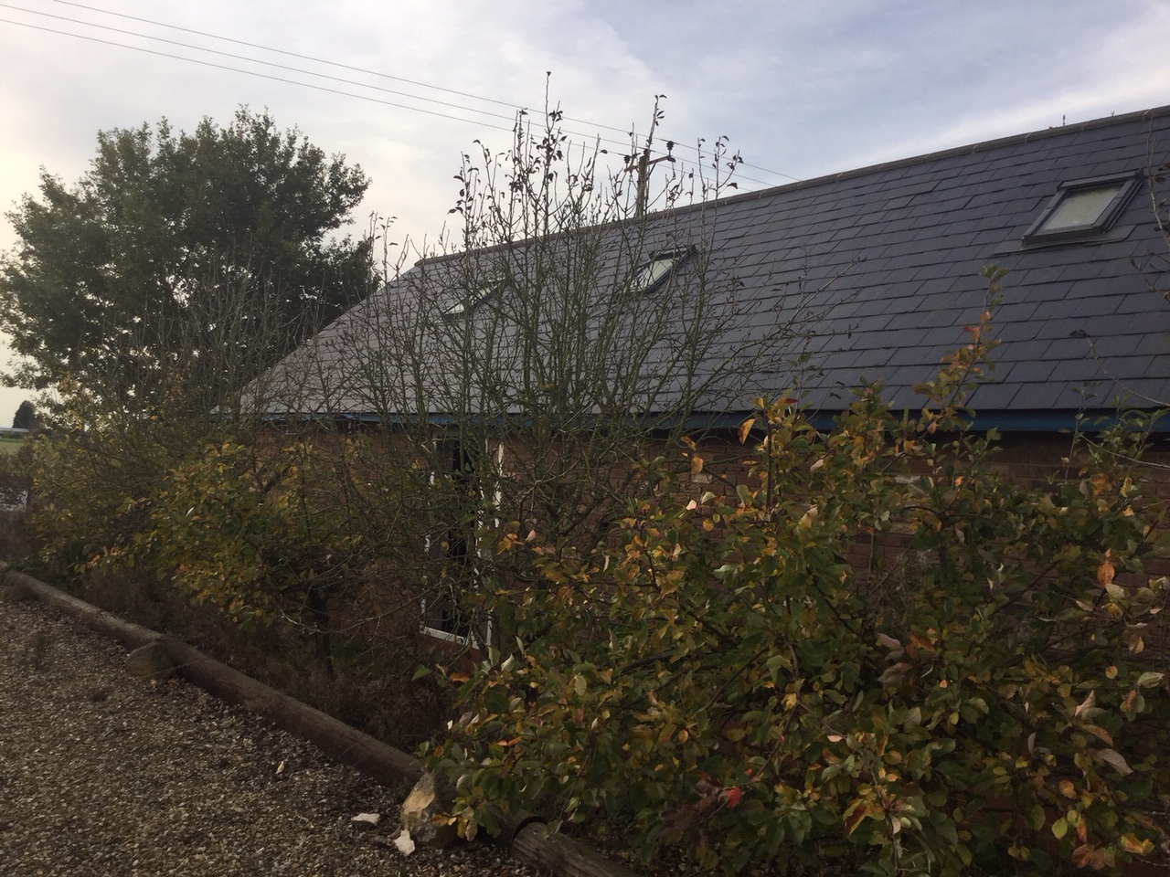
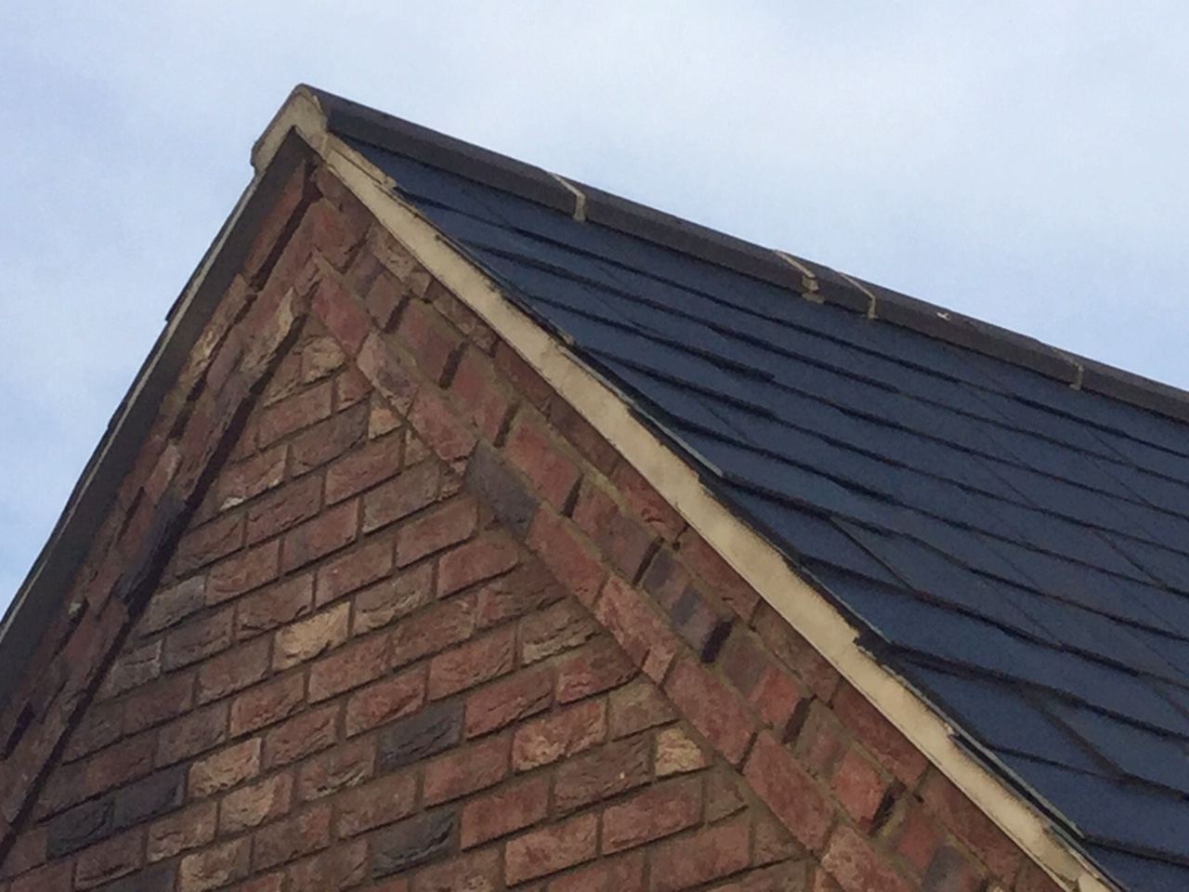

Photographs 1 (previous page) and 2 (above) show the building and the use of high quality materials and traditional construction details.

Unfortunately, the uncertainty of the planning situation has resulted in the landscaped areas becoming somewhat overgrown and some of the permitted ancillary buildings provided in support of the caravan site use now have a neglected appearance (see photographs 3 and 4 overleaf). The applicant is prepared to remove the redundant buildings if permission is granted. Rather, therefore, than being an unsustainable development, the proposal meets the three objectives as to sustainability set out in the National Planning Policy Framework.

Firstly, the completion of the development, and the future maintenance of the site, as a whole, will provide a modest degree of local employment. The decision notice accepts that the change of use will contribute towards the supply of housing in the locality whilst the opportunity to restore the previous high quality open landscaped appearance of the land, coupled with the removal of disused buildings, will have a highly beneficial environmental impact. This accords with the requirements of both local and national policies, as emphasised above.

The reasoned justification for the Local Plan policy 23 says that rural buildings, such as brick built barns, can make a significant contribution to the character of an area and so there is a concern that they should not remain vacant, underused will become derelict, detracting from the visual character and quality of the designated countryside. Policy 23 therefore makes provision for the conversion and re-use of rural buildings of this kind as dwellings.

The following paragraph says that, however, not all buildings in the countryside are suitable for conversion as they may be of insubstantial construction, of poor design or not in keeping with their
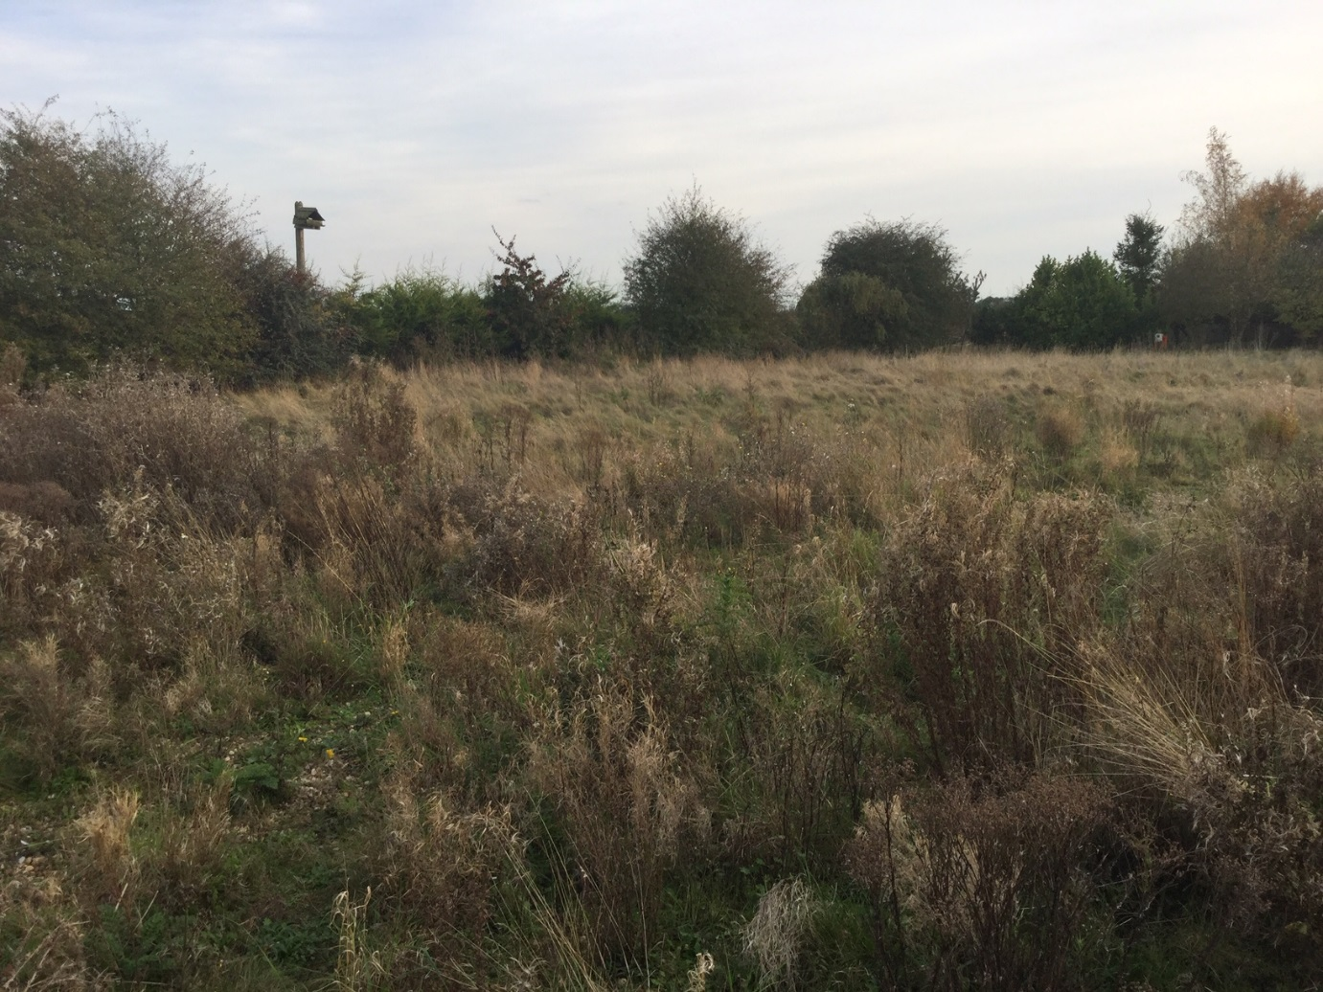

Photographs 3, above and 4, below show the overgrown current appearance of the site and its former buildings used as a site amenity

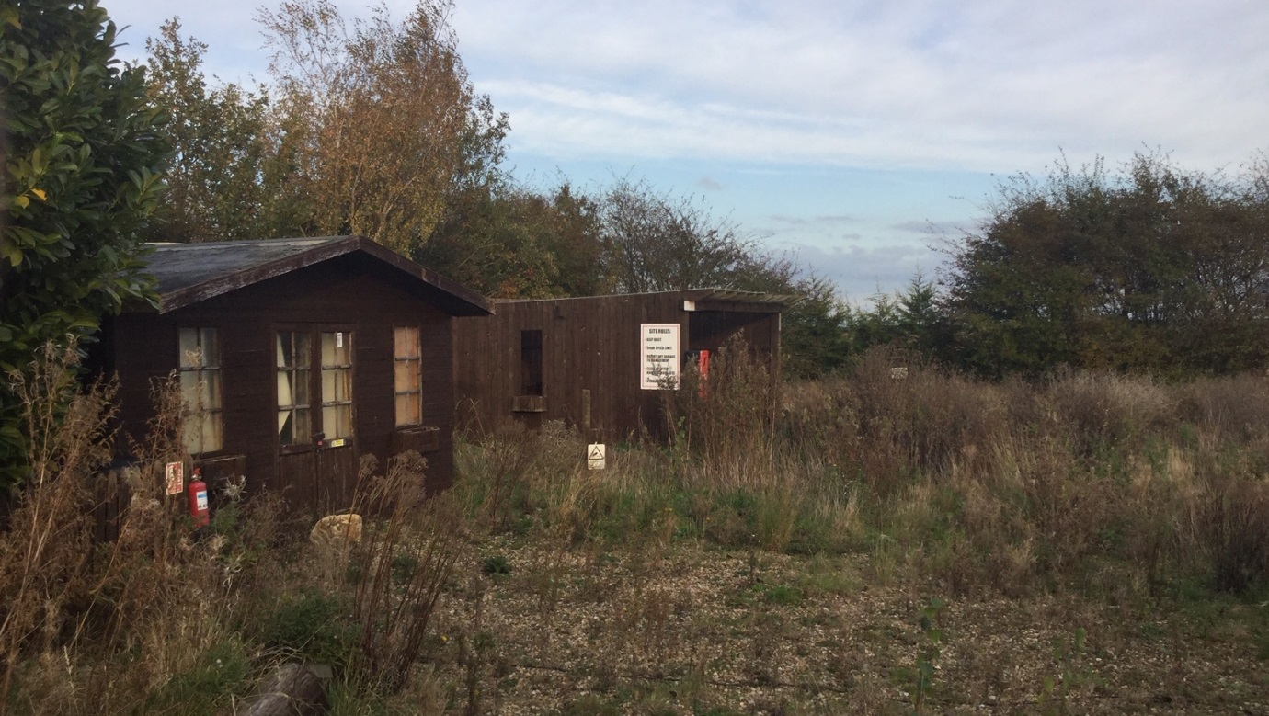

surroundings. Buildings to be converted should be structurally sound and proposals which require significant extension, alteration or rebuilding will not be acceptable. Far from having no architectural or historical merit (my emphasis), this is a building that demonstrates an entirely appropriate approach to the construction of a functional rural development. Whilst the issue of architectural or historic merit must be a subjective one, this building is worthy of retention in a new use that will secure its worthwhile future. It is far from being insubstantial, of poor design or not in keeping with its surroundings. It is, therefore, policy compliant.

In the above respect, strong disagreement and criticism is registered with the Case Officer’s report. The National Planning Policy Framework does not seek to avoid isolated homes in the countryside “unless there are exceptional circumstances”. These words do not appear. Instead, the Framework, at paragraph 79c), accepts a circumstance where “the development would re-use redundant or disused buildings and enhance its immediate setting”. The proposed dwelling, for the reasons set out in this Planning Statement, fulfils that requirement in its entirety.

As to other material considerations, the entrance and exit to and from the site meet normal highway standards. Parking and manoeuvring facilities are such that the future resident’s vehicles can enter and leave the site in forward gear. The development therefore provides for safe and convenient access for road users. Little Dog Drove carries only insubstantial vehicle movements and is entirely capable of being used as a “shared surface” by pedestrians, particularly those who wish to take benefit from the footpath system along Fleet Fen, a little over 400 metres distant.

As an entirely self-contained site, there are unlikely to be any adverse crime prevention considerations arising from the proposed change of use. Indeed, potential vandalism of the building and its eventual visual harm, including the urgent need for maintenance of the landscaped areas, will be mitigated by the change of use.

As reflected in the recent decision, the proposed change of use introduces no issue of overlooking or loss of privacy for any nearby resident nor, moreover, will the use of the building have any overbearing or overshadowing effect. The limited vehicular activity that will be associated with the change of use is readily capable of being absorbed into its surroundings.

This application proposes the retention of all existing trees and hedgerows and it does not have any adverse impact on other attractive landscape features. The applicant is, however, prepared to carry out further tree planting, should the Council consider it necessary, and he is keen to foster the maintenance of wildlife habitats and corridors

Taking into account all these considerations, it is considered that this is a proposed development that justifies the Council’s support. The grant of planning permission will regularise the existing land use situation and provide for the Council increased control over its proposed development. At the same time, it will permit a beneficial use for the building and land for which there is no viable alternative.

It is generally in accord with the Council’s policies set out in the Local Plan and with the key principles set out above that are enshrined in the National Planning Policy Framework. There are not considered to be any material considerations that would override the presumption in favour of the proposed development and it is, therefore, requested that planning permission be now granted.

If, however, you require any further clarification of the applicant’s intentions or further details with regard to the development, I shall be grateful if you will let me know as soon as possible after the validation and registration of the application. As a re-submission within 12 months of the recent refusal, no repeat planning application fee is payable.

John Church MSc, Dip TP, FRTPI
Chartered Town Planner
October 2019
Ref: M228

John Church Planning Consultancy Ltd
Rowan Cottage
Bakewell Road
Rowsley
Derbyshire DE4 2EB
Tel: 016297328098
E-Mail: mail@johnchurchplanning.co.uk

