FLOOD RISK ASSESSMENT

OUR REFERENCE AKW 900/11434

PROPERTY ADDRESS
Ashburton House
Penny Hill Road
Holbeach
Spalding
Lincolnshire
PE12 7RT
PROPOSED DEVELOPMENT
Installing a PVCU conservatory to the rear of the property
FLOOD RISK ASSESSMENT
We have checked the above property on the Environment Agency’s website to establish if it falls within any flood risk area. We can confirm that this property is showing to be in a Flood Risk zone 3.
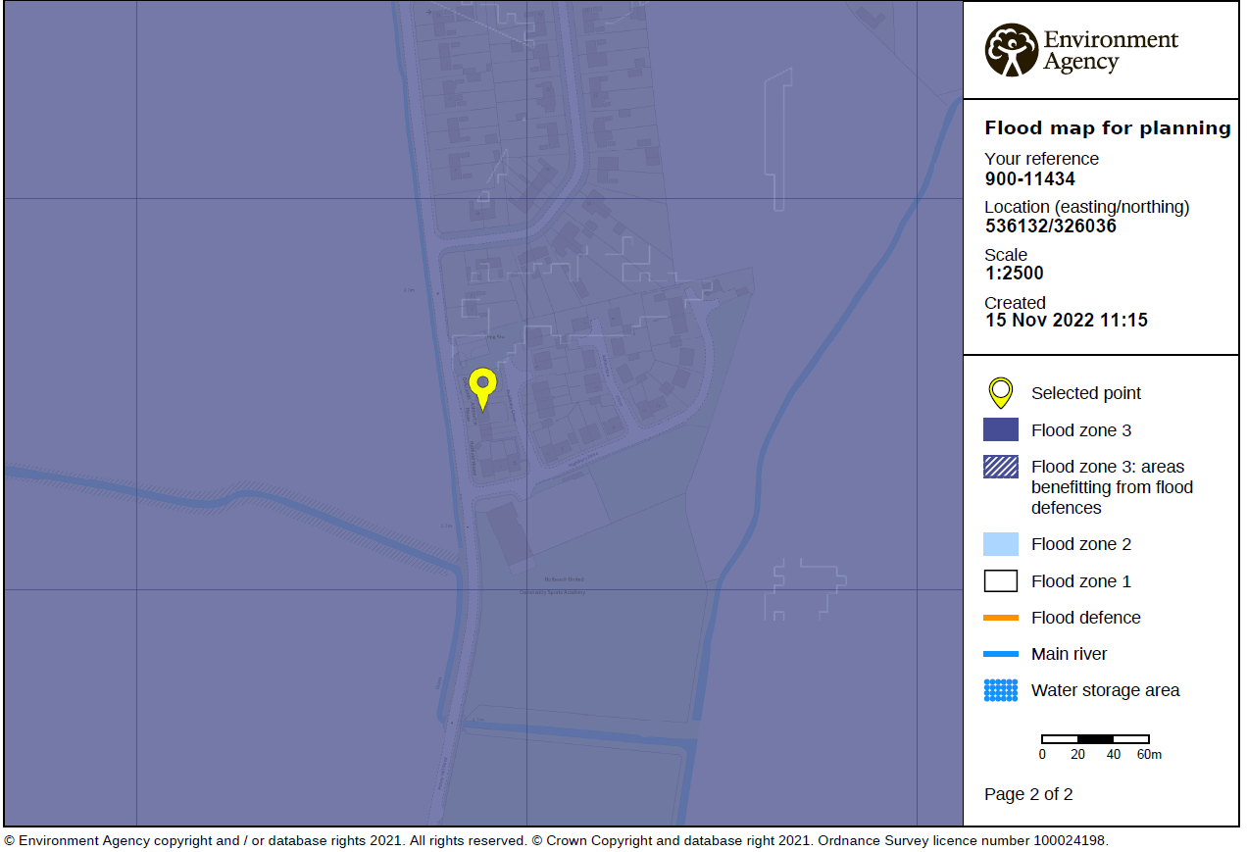

The property is located within a Flood Zone 3 - land assessed as having a 1 in 100 or greater annual probability of river flooding (>1%), or a 1 in 200 or greater annual probability of flooding from the sea (>0.5%) in any year

Please be advised that:
• The finished floor level of the proposed conservatory will be the same as the internal floor level of the existing property.
• As standard we would advise or install any electrical sockets at a high level as a precaution should any flooding occur as standard.
• The proposed conservatory will not be used for storage and therefore there would be no loss should flooding ever occur. Additionally, any furniture positioned in the conservatory will be removable in the event of flooding.
• Our client should already be aware if ever any flood warnings should occur and therefore would move possessions that may be affected to a higher level to avoid damage.
• The lands slopes down towards the south so any rainwater would

