Design and Access Statement for:
26 Market Street
Long Sutton
Spalding
Lincolnshire
PE12 9DF

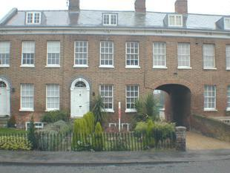

Prepared by Victoria Stanley- Ventrolla January 2017

Contents:
- Introduction
- Location, Context and The Building
- Significance and Vulnerability
- The Proposals

- Introduction
This statement relates to 26 Market Street which is a Grade II Listed Building. It has been prepared on the instructions of the property owners who wish to continue to improve the listed buildings dilapidated state by replacing the sash windows to the Front Elevation, having previously done the Rear Elevation (LBC number H11- 0641-14). The purpose of the statement is to assess the historical and heritage aspects of the building and the impact of the proposal.

- Location, Context and The Building
Number 26 is one of 4 terrace houses on Market Street, Spalding. The houses are Red brick, slate roof rendered Coped Gables. They are 2 storeys with basement and attic. There is a Central carriage way with a basket arch which is symmetrical between the properties either side. The owner now wishes to improve the Front Elevation to the same performance for the previously undertaken Rear Elevation where the sashes were replaced retaining and renovating the existing boxes.

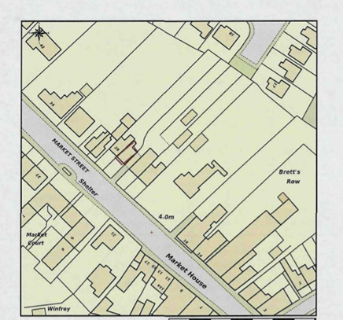

- The Proposal
The existing windows on the front elevation at the property have significant operational
issues and with badly rotten sills and are beyond repair after extensive checks. The windows will be fitted with a Draught Proofing system
and will be designed with a traditional glazing bar to match the Rear Elevation.

