

Flood Risk Assessment

Oldershaw’s of Moulton
Glebe Farm
Roman Bank
Spalding
PE12 8BB

Flood Zone 3 – Statement:
The site is within Flood Zone 3 – Grid Reference - TF 33332 27370 (as defined by the Environment Agency’s Flood Map). For this site there is no flood defences.
Existing minimum ground level is 3 meters AOD. Finish floor level will be as existing level to address the high flood risk.
Surface water will be dealt with by using their existing drainage system.

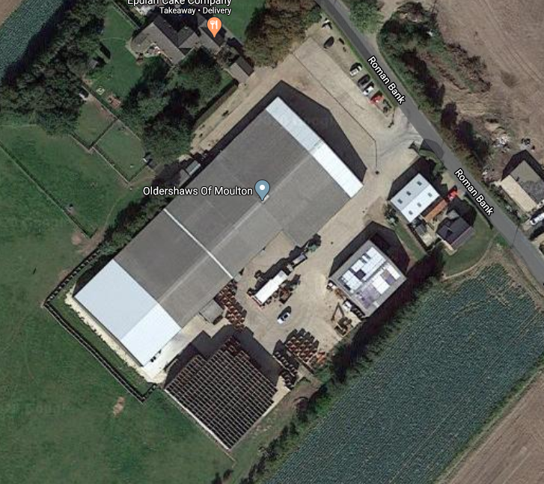
Proposed Site Location

