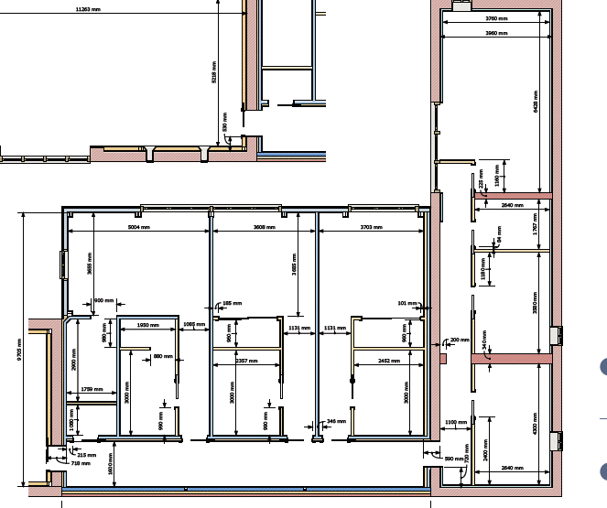
3
2
1

Point 1.
Existing wall is beyond repair and propose wall is taken down and rebilut with the same bricks to modern standards with a cavity wall. To be built on a strip footing of 600x300mm to match the footings of the bedroom section.
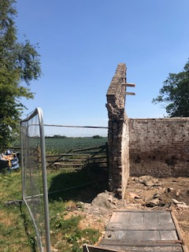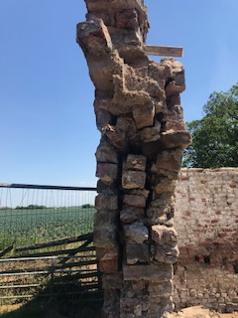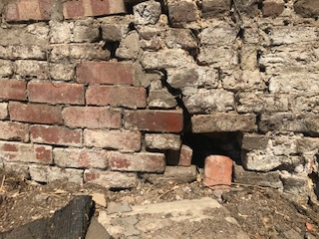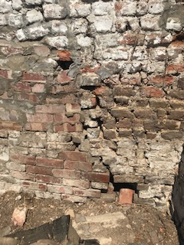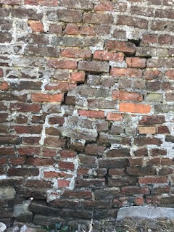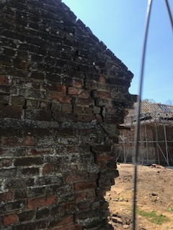
Point 2.
This wall was too unstable to keep up and was taken down for safety reasons. Poor condition referenced in the structural report by SRC. All bricks saved to be reused. To be rebuilt on a strip footing as stated above
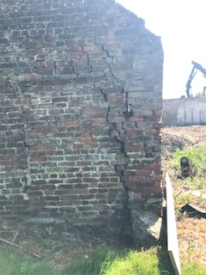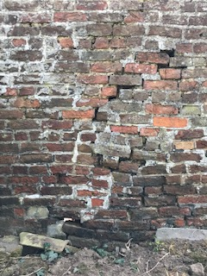

Point 3
The wall has been damaged in many areas from tree growth. Many years tree roots have grown through the walls and caused significant weakening. One end has crumbled away. Other areas show root damage. To be built back up using modern standards on strip footings stated above. Internal wall facing in to the hallway to remain exposed brick as per original plans but because the wall facing in to the bedrooms will be covered in plasterboard propose that blocks are used
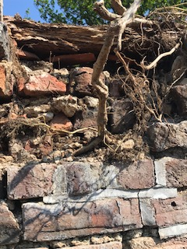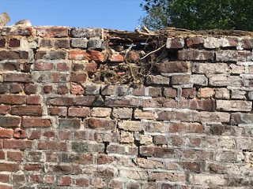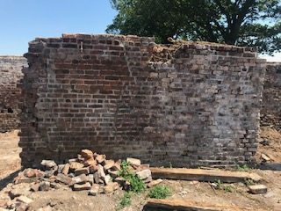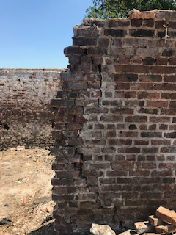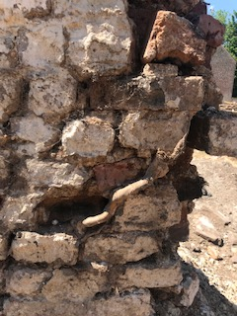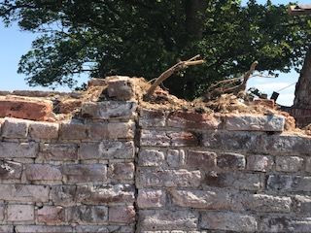
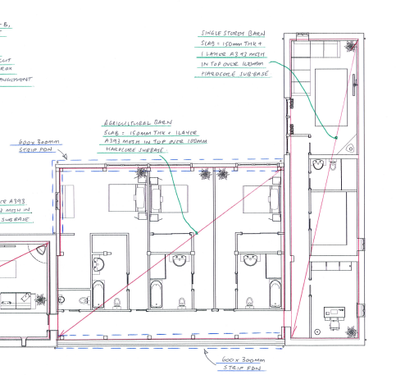
Plan to carry on strip footing through areas highlighted in red

