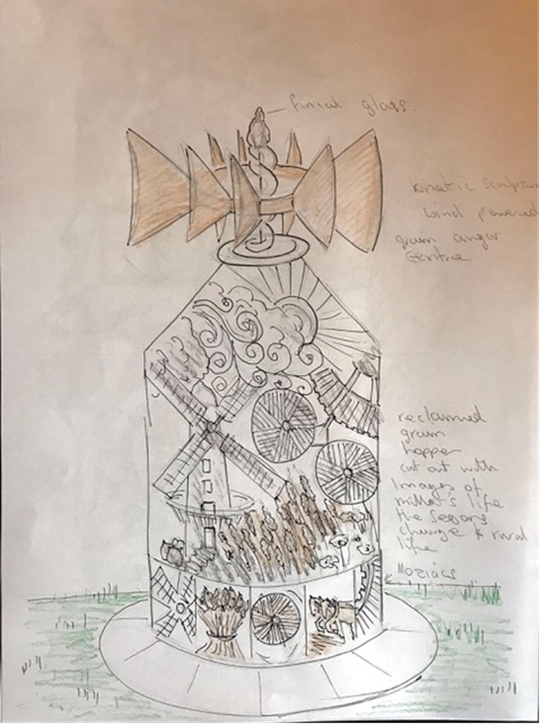
Artist’s Impression Moulton Mill Artwork

