DESIGN AND ACCESS STATEMENT SUPPORTED BY PLANS AND PHOTOS
Supporting Outline planning application in respect of land to the west side Eaugate Road Moulton
Background
The subject land is owned by Mr Howard Clark of Crown Hall farm Moulton Chapel Spalding.
The most recent use of the land has been for agricultural purposes but in the past there was a cottage with gardens occupying part of the site.
The application is therefore a fairly straightforward outline application residential use on land that has previously been used as a residential site and we have photographic evidence to support this as you will see from the attached photos.
We visited South Holland District Council offices in May 2016 and informally discussed a potential application with the duty planning officer who confirmed that an application was a worthwhile option.
We understand that there is a lack of potential development land available currently in the South Holland District and feel but a proposed residential development of individual plots would be consistent with both adjoining development on Eaugate Road as well as in the adjoining village of Moulton Chapel
According to our interpretation of the flood risk maps there is a risk on the opposite side of the road where there is a deep dyke but none on the West side of Eaugate road. The applicant has lived in the area all his life and is not aware of any flooding that has occurred to this area in living memory
Proposal
Taking into account local style of development both established and in recent years and taking into account the demand for individual plots and their lack of supply we believe that a development of five individual plots would be consistent with local development and satisfy demand in the market for reasonable sized individual plots.
Landscaping
There is no established trees or vegetation of merit on site that would justify retention and we believe that any development of individual plots is likely to include the establishment of trees and shrubs that would improve the general appearance of the area.
Access to each plot would be on an individual basis but this is a long straight typical fen road with good visual splays for vehicles accessing and leaving the plots
We know there is public transport running along this road presumably mainly or in part to service the school that is quite close to the subject site.
There is every likelihood that the plots will be developed by families may well support the local school. Having consulted Chairman and some members of the Parish Council they were keen to emphasise that additional support in terms of pupil numbers is desirable
Noise
The individual plots are not likely to appreciably cause a deterioration to the environment in terms of noise

Residential amenity
We have looked at the residential development in the nearby village of Moulton Chapel and it would appear there are quite significant numbers of individual plots that have been developed over a period of many years and that this proposed development is therefore not inconsistent with development that has been agreed to in the past.
The proposed development will be an outline application only and approval of reserved matters dealing with detailed design and layout will be dealt with by that more detailed application.
Conclusion

- The proposed development we believe accords with planning policy
- The density development is fairly low density and we believe accords with policy
- The type of development and density of developed is considered appropriate for the location of the site, this land having been partly occupied by a cottage in the past
- the proposed layout is consistent with surrounding development and houses
- there is demand this scale of development and particularly individual plots in rural areas
- the requirements of the highways department can we believe be accommodated
- implementation of the proposal will dramatically improve this part of the village
- parish council consultation informally was positive

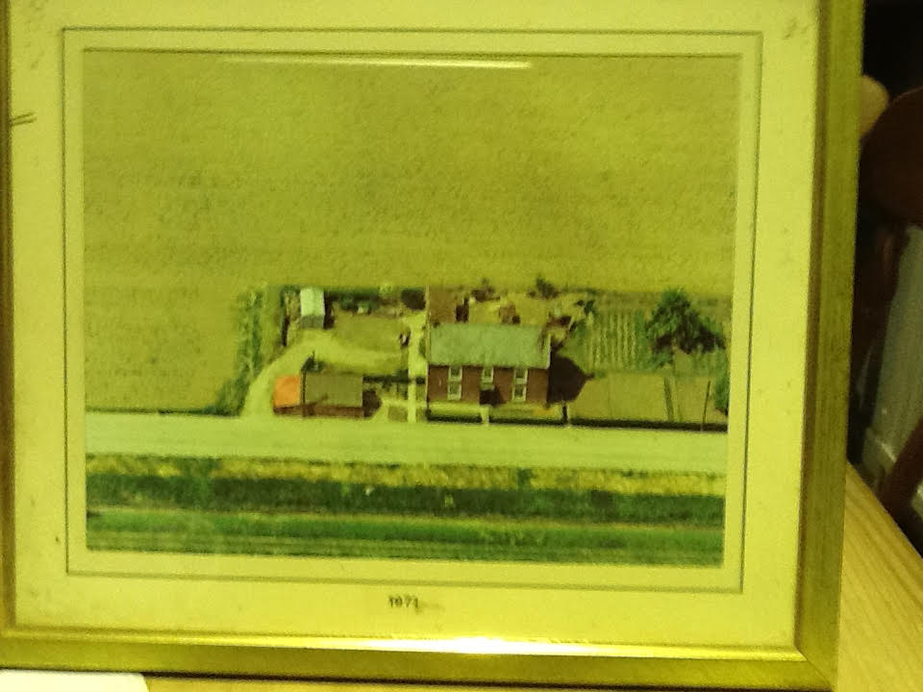
Photo showing cottage and outbuildings that occupied part of this application site before being demolished.

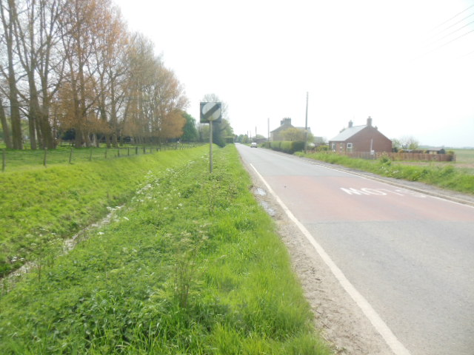

Drainage dyke on opposite side of road to the site shown as at risk from flooding but none occurred in applicants lifetime and no risk indicated on application site itself.
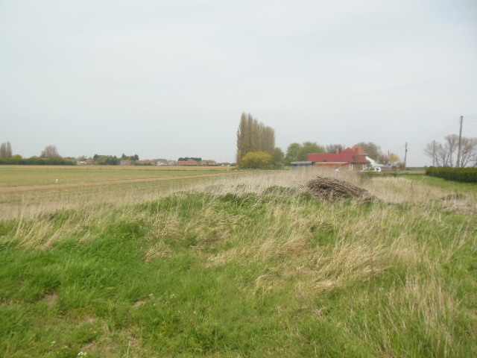
Looking towards the north end of the site residential development

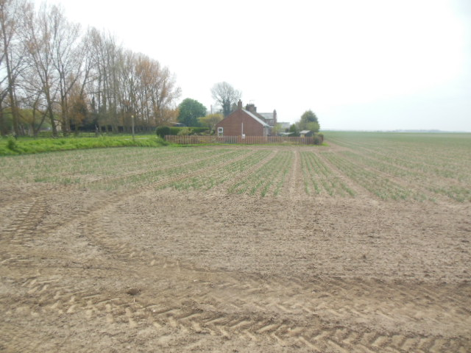

Looking towards the south end of the site residential development
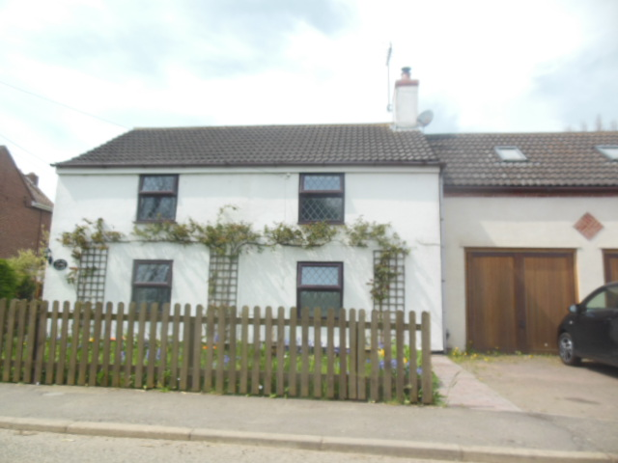
Example of detached house typically built near the school on Eaugate

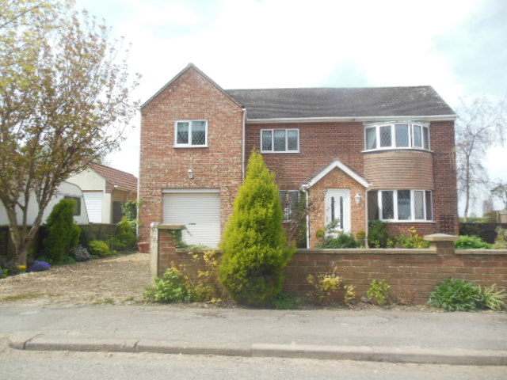
Example of detached house typically built along Eaugate

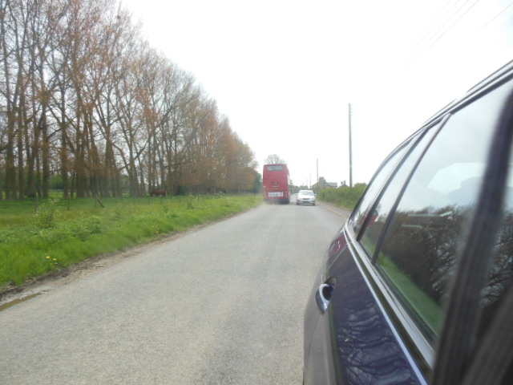
Bus route runs along Eaugate.

