Arboricultural report on trees at Rushmere House, Spalding Rd, Pinchbeck in line with BS5837:2012 -Trees in relation to design, demolition and construction.

Prepared by: John Wilcockson
Arboricultural Consultant.
Tech Cert (Arbor A)
Date: 14/10/15
Ref: Rushmere_house/AIA

Limitations of use and copyright: All rights in this report are reserved. No part of it may be reproduced or transmitted, in any form or by any means, electronic, mechanical, photocopying, recording or otherwise, or stored in any retrieval system of any nature, without our written permission. Its content and format are for the exclusive use of the addressee in dealing with this site. It may not be sold, lent, hired out or divulged to any third party not directly involved in this site without the written consent of John Wilcockson.

Contents
Instructions 3
Introduction 4
Tree survey 5
Legal Constraints 8
Arboricultural considerations in relation to development. 9
Rooting structure 9
Typical rooting structure of a tree 9
How can trees be damaged? 10
Tree survey findings 12
Arboricultural Implications Assessment 13
Recommendations 13
Appendix 1: Tree Inspection/Survey Results 14
Tree constraints plan 23
Suggested removals 24

Instructions

This report was commissioned by John Dadge of Barker Storey Matthews, with instruction to prepare a report using topo 16438ea-01 in line with BS5837:2012 Trees in relation to design, demolition and construction - Recommendations.
The objectives of this report are as follows:
- To make an assessment of the trees’ condition and identify any faults.
- To provide recommendations in line with BS5837:2012.

Introduction
This document has been prepared to fulfil the requirements for the proposal in accordance with the Department for Communities and Local Government guidance on information requirements and validation, and is set out in compliance with British Standard 5837 Trees in relation to design, demolition and construction recommendations 2012.
The initial tree survey is considered to be compliant with BS5837:2012.
All trees considered likely to be affected by the proposal were surveyed and the details are given in Appendix 3 Table.
The site surveyed is located between Spalding Rd and St Mary’s Ave Pinchbeck.
The site is largely screened from both roads by existing properties although glimpses of the trees on site can be seen from both roads.
The trees at the entrance can clearly be seen from Spalding Rd and contribute to the street scene in that location.
The site itself is expansive and contains a mix of established shrub beds, young and mature trees with a mix of both broadleaf and conifer. There are lawns in between the trees and large ponds to the east and south.
This report addresses the arboricultural issues relating to proposed development at the above site and identifies the arboricultural constraints.
If all the guidelines and principles outlined in this report are not adhered to, as with all development sites, there is a risk that the construction activities will result in damage to and potentially the death of the retained trees. Damage to the trees will significantly increase the risk of their health declining and may increase the risk of their complete or partial failure.

The success of the recommendations set out in this report are dependent on the development adhering to the principles set out within, which are to be approved and enforced by the Local Planning Authority (LPA). If the recommendations contained within this document are acceptable to the LPA then it is suggested that they be controlled by standard planning conditions.

Tree survey

The tree survey process consisted of a ground-based visual inspection only, and is applied only to the area proposed for development.
The survey includes an individual tree number listed sequentially as pet the provided plan, tree Species in both its common and botanical name, its height, stem diameter measured at 1.5m from ground level, spread of the radius of the crown by cardinal points, height of the crown above ground level, age classification its general condition and any general conditions structural or biological defects noted during the survey. An estimate of the remaining safe life expectancy (SLE) and the category as defined in BS 5837:2012 Recommendations cascade chart for tree quality assessment.
The root protection area (RPA) will be calculated from the stem diameter and this will identify the area which will require special protection during the works.
The survey data table is in the appendix attached to this report, and trees, their crown spread and the RPA are plotted onto the associated plan.
Trees on the site have been divided into one of four categories (based on the cascade chart for tree quality assessment). These are classed as A, B, C or U (Section 4 of BS 5837) within the table in Appendix 1, Table 2. This gives an indication as to the tree’s importance in relation to the site, the local landscape and, also, the value and quality of the existing trees on site. This assists informal decisions concerning which trees should be removed or retained should development occur. For a tree to qualify under any given category it should fall within the scope of that category’s definition (see below).
Categories A, B and C cover trees that should be a material consideration in the development process, each with three further sub-categories (i, ii, iii) which are intended to reflect arboricultural, landscape and cultural (nature conservation) values. Category U trees may have no significant landscape value but it is not presumed that there is any overriding need to remove these unless stated otherwise in the description and recommendations. They are for this reason not considered as being significant within the planning process. In assigning trees to the A, B or C categories, and the presence of any serious disease or tree–related hazard is taken into account. If the disease is considered fatal and/or irremediable, or likely to require sanitation for the protection of other trees it may be categorised as U with a recommendation for work or even removal, even if they are otherwise of considerable value.

Category (A): Trees whose retention is most desirable and are of high quality and value. These trees are considered to be in such a condition as to be able to make a lasting contribution (a minimum of 40 years) and may comprise:
(i) Trees which are particularly good examples of their species especially rare or unusual, or essential components of groups or of formal or semi-formal arboricultural features (e.g. the dominant and/or principal trees within an avenue);
(ii) Trees, or groups of trees which provide a definite screening or softening effect to the locality in relation to views into or out of the site, or those of particular visual importance (e.g. avenues or other arboricultural features assessed as groups);
(iii) Trees or groups of significant conservation, historical, commemorative or other value (e.g. Veteran or wood-pasture trees).

Category (B): Trees whose retention is considered desirable and are of moderate quality and value. These trees are considered to be in such a condition as to make a significant contribution (a minimum of 20 years) and may comprise:
(i) Trees that might be included in the high category but because of their numbers or slightly impaired condition (e.g. presence of remediable defects including unsympathetic past management and minor storm damage), are downgraded in favour of the best individuals;
(ii) Trees present in numbers such that they form distinct landscape features and attract a higher collective rating than they would as individuals. Individually these trees are not essential components of formal or semi-formal arboricultural features, or trees situated mainly internally to the site and have little visual impact beyond the site;
(iii) Trees with clearly identifiable conservation or other cultural benefits.

Category (C): Trees that could be retained and are considered to be of low quality and value. These trees are in an adequate condition to remain until new planting could be established (a minimum of ten years) or are young trees with a stem diameter below 150 mm and may comprise:
(i) Trees not qualifying in higher categories;
(ii) Trees present in groups or woodlands, but without this conferring on them significantly greater landscape value and or trees offering low or only temporary screening benefit;
(iii) Trees with very limited conservation or other cultural benefits.

Category (U): Trees that are considered to have no significant landscape value but it is not presumed that there is any overriding need to remove these unless stated otherwise in the description and recommendations. They are for this reason not considered as being significant within the planning process. These trees will be in such a condition that any existing value would be lost within 10 years and which should in the current context be ignored or removed for reasons of sound arboricultural management. Trees within this category are:
(i) Trees that have a serious irremediable, structural defect, such that their early loss is expected due to collapse, including those that will become unviable after removal of other category U trees;
(ii) Trees that are dead or are showing signs of significant, immediate or irreversible overall decline;
(iii) Trees infected with pathogens of significance to the health and or/safety of other trees nearby, or very low quality trees suppressing adjacent trees of better quality.
Detail of the tree survey is given in Appendix 1, Table 2.
The Soil type was not assessed.
This report is valid for one year from the date of site inspection. The condition of trees can change following severe weather conditions, the effects of diseases and pests, and other abiotic factors.

Legal Constraints
Where Local Planning Authorities assess trees as beneficial to the wider community in terms of their amenity value, they may be protected by a Tree Preservation Order (TPO).
If trees protected by a TPO or within conservation areas are cut-down, topped, lopped, uprooted or wilfully damaged or destroyed, the owner of the tree(s) and the contractor responsible for the work can both be legally prosecuted. The current maximum fine is £20,000 per tree at the Magistrates Court or unlimited fine at the Crown Court.
Trees that are dead or dangerous are exempt from legislation. It is common good practice to notify the LPA of intention to carry out work to trees that fall into these categories, preferably with some notice (e.g. one working week).
A leaflet produced by the DTLR (Protected Trees), covers the issues raised by this legislation.
Any works prescriptions for protected trees can be dealt with by way of inclusion into a Planning Application for development purposes; this avoids the need to make a separate tree application.
The current legal status of these trees has not been checked with the LPA but it is understood that the site is not within a Conservation Area nor are there any TPO trees.
Statutory wildlife obligations: The Wildlife and Countryside Act 1981 as amended by the Countryside and The Habitat Regulations 2012 provide statutory protection to birds, bats and other species that inhabit trees. All tree work operations are covered by these provisions and advice from an ecologist should be obtained before undertaking any works that might constitute an offence.

Arboricultural considerations in relation to development.

Rooting structure
Rooting structure is a key issue when dealing with trees and development. To ensure the survival of trees the British Standard Institute has introduced the concept of a Root Protection Area (RPA). The RPA is an area surrounding a tree that contains sufficient rooting volume to ensure the tree’s survival and is represented in square metres. (BS5837 2012 discusses the extent and for of a trees root system.)

The following diagram represents the typical rooting pattern of a tree. Note that 90% of the trees roots are usually located within the top 1m of soil and that roots may spread well beyond the canopy. Therefore, no works are allowed within the RPA. Even a small trench 0.5 metres deep to accommodate a cable or drain may lead to the loss of the tree. When work is proposed or is absolutely necessary within the RPAs of retained trees the proposals will only be considered if supported by an agreed robust and realistic Arboricultural Method Statement, following recommendations within BS 5837 2012.

Typical rooting structure of a tree

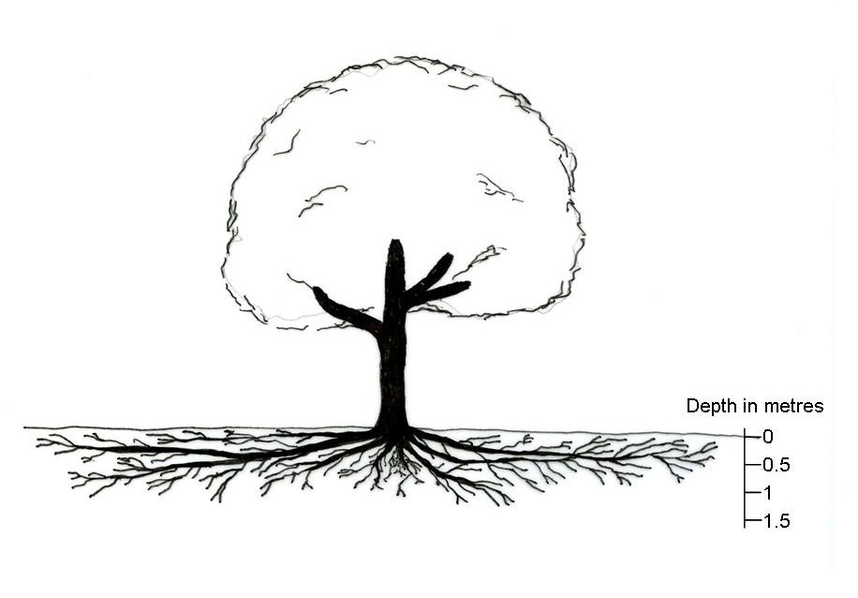

To successfully integrate trees into a development it will be necessary to allow enough space in the design to allow trees to mature and flourish and to agree protection measures during the entire construction phase. Trees should be considered at the earliest design stage to allow them to be successfully integrated into new development, a survey of trees on and adjacent to the site should be one of the first steps in the design process.

How can trees be damaged?

Compaction of the soil
When soil is compacted, the soil structure is damaged by removing the spaces between soil particles preventing the exchange of gases and uptake of nutrients by trees. The storage of materials, including bricks, soil, gravel and cement, and the movement of vehicles can cause compaction. One vehicle movement can cause sufficient compaction to damage a tree. Compacted ground may alter soil drainage, resulting in the ground becoming waterlogged. The storage of materials and the movement of vehicles within RPAs will only be permitted when it is shown to be absolutely necessary and supported by an agreed robust and realistic Arboricultural Method Statement.

Excavations
Excavations within the RPA are likely to cause root severance. This may lead to loss of vigour, reduced uptake of water and nutrients, allow access for decay organisms and may compromise the tree’s stability. Under exceptional circumstances, where excavation may be justified, hand digging will be required and the presence of an arboricultural consultant to supervise the works will be required on site.

Ground level changes
Both reduction and raising of soil levels can be detrimental even if this is only by a few centimeters. Reducing ground levels may sever roots, and can increase the drainage of a site thereby reducing water availability. Raising ground levels can cause compaction, and suffocate roots. There will be a presumption against the changing of ground levels within RPAs. Changing of ground levels within RPAs will only be permitted when it is shown to be absolutely necessary and supported by an agreed robust and realistic Arboricultural Method Statement.
Impact damage
This can be caused by machinery and includes torn branches, and damage to bark and trunk. Damaged areas of trees can allow the entry of decay organisms and reduced vigour. There will be a presumption against the movement of machinery and equipment within RPAs. The movement of machinery and equipment will only be permitted when it is shown to be absolutely necessary and supported by an agreed robust and realistic Arboricultural Method Statement.

Soil contamination
This can be caused by the spillage of oil, fuel and chemicals, mixing cement or other materials. To prevent leaching through the soil where significant tree roots can be found, all chemicals should be kept in a safe storage area downhill from trees at least 10m from the RPA. There will be a presumption against the storage of chemicals within 10m of the
RPAs of retained trees and storage will only be permitted when it is shown to be absolutely necessary and supported by an agreed robust and realistic Arboricultural Method Statement.
Fires
Conducted and radiated heat as well as flames will damage trees resulting in the loss and damage to both major and fibrous roots, and damage to the trees vascular system under the bark even if the bark does not appear burnt. Keep fires a minimum of 10m from the outer crown spread of any retained trees or vegetation. If this clearance is not achievable, all waste must be disposed of off-site.

Tree survey findings

A total of 50 individual trees were identified and surveyed on site, 2 have been assessed as Category B1 and the remainder as C1.
The majority of the trees on site are either early mature or mature with a small number of younger specimens.
Most of the Category C trees are in fair condition, equally, most have minor faults but these are considered proportionate to the age of the trees.
The following individual trees are worthy of note:-
T0286 – Hawthorn is a multi-stemmed specimen that is sub dominant to the surrounding trees which has resulted in an asymmetric crown and thin foliage. There are high levels of ivy on the main stem and into the crown itself.
T0290 – Malus sp is in poor condition, the top has snapped out – presumably storm damage.
T0292 - Field Maple is a poor specimen that has been shaded out by surrounding trees.
T0293 – Contorted Willow has an asymmetric crown and a large historic partially occluded wound/cavity. The wood around this wound appeared to be sound.
T0306 – Oak, whilst of reasonable form in terms of its overall crown shape, this specimen is multi-stemmed at around 2m with tight unions in evidence.
T0307- Hawthorn is a poor multi-stemmed specimen with a thin asymmetric crown and high levels of ivy on the main stem and lower crown.
T0309 – a mature Weeping Willow, the main stem is growing at angle of approximately 70 degrees and has an asymmetric crown.
T0317 – Blue Atlas Cedar, the apical leader appears to have been lost historically either following storm damage or as a result of insect damage. As is typical with the species, the tree has then produced multiple leaders. Although structurally sound at present, the resulting form is very poor and as this species has a tendency to lose limbs as they age, the risk of failure will increase.
T0323 is a relatively young variety of Norway Maple which is in decline, there is no evidence to suggest why.
T0330 is a reasonable specimen but has a Ganoderma fungal bracket at the base.

Recommendations

Carry out any works identified in the schedules – all works in line with BS3998:2010.
The plan on page 24 illustrates potential available space based on the removal of poorer trees and those agreed with the LPA Tree Officer.
These include T294-T298, T301-T318, T327-T330, (28 Cat C trees in total).
Whilst these removals seem dramatic, the loss of these trees will have no discernible effect on the landscape from a public perspective. These trees can only clearly be seen from neighbouring gardens and as such, cannot be considered for inclusion into a TPO.
The removals could be mitigated by a strong and sustainable landscape scheme once the overall design has been finalised to provide privacy from both within and without the site.
It is suggested that if any of the above trees are retained, in all likelihood, any new inhabitants would look to remove trees to increase amenity space within any proposed gardens. With this in mind, it is considered to be more practical to remove them at the outset and replace.
Any existing retained trees along with any new plantings could be protected in the short term by a specific planning condition.

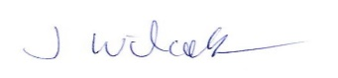
J Wilcockson 14th Oct 2015

Appendix 1: Tree Inspection/Survey Results

Table 1 SURVEY KEY: Abbreviations and categories used in the survey are as follows:
Tree Ref. | As per corresponding number on plan
Species | Common name and botanical name in italics.
Height | Estimated height in metres
Ø | Diameter measured in millimetres at 1.5m above ground level. # indicates estimate
Branch spread | Measured in metres from the stem to limit of canopy to four cardinal points, N, S, E, W
H.F.S.B/D. | Height (in metres) of First Significant Branch and Direction.
H.C.C. | Height of crown clearance - the height to the lowest branch attachments
Age Class | A description of the life stage of the tree.
Age Class | NP | Newly Planted – up to three years from planting in the stage leading to establishment
Age Class | Y | Young – Less than 1/3 of the natural life span
Age Class | EM | Early Mature – Between 1/3 and 2/3 of the natural life span
Age Class | M | Mature – Over 2/3 of the natural life span
Age Class | OM | Over Mature – Over 2/3 of the natural life span and in an obvious state of decline
Age Class | V | Veteran – Older than the typical age range of the species and has high conservation and amenity value
Condition: Physiological and Structural | Description of the observed Physiological (vital phenomena / organic functions) and Structural (supporting or essential framework) of the tree
Condition: Physiological and Structural | Good | A tree with no visible defects
Condition: Physiological and Structural | Fair | A tree with minor defects that if necessary can be addressed through maintenance or are of no long term significance
Condition: Physiological and Structural | Poor | A tree with major defects that cannot addressed through maintenance and could lead to its early decline
Condition: Physiological and Structural | Dead | Without life
Condition: Physiological and Structural | In addition specific diseases, defects or faults are described.
Preliminary Recommendations | Recommendations for tree work where observed as necessary, including further investigations of suspected defects which may require more detailed assessment. If blank no works are recommended. CBR – could be retained.
S.U.L.E. | Safe Useful Life Expectancy - estimated remaining contribution in years
S.U.L.E. | Less than 10 years |  | 10-20 years | 20 -40 years | More than 40 years
BS Cat. | Category Grading according to BS5837: U or A, B, C.
Root Protection Area. (RPA) | The root protection in m², as area and radial distance as measured from the centre of the tree stem. Where an # is present the R.P.A. cannot be achieved due to ground constraints, or it is located outside the site.
Miscellaneous
MS | Multiple stems
GL | Ground Level
Cavities | The physical size of cavities is measured in the following order: Height x Width x Depth. Measurements given are in millimetres.
DW | Deadwood considered for removal. Considered significant in size when at least 50mm in diameter x 1000mm length. Smaller sized pieces are not considered for removal unless stated.
IBU | Included Bark Union – bark growing in the joint of a union, possibly problematic as the incremental growth forces limbs of the union apart possibly causing at least one to fail over time.
The following pages show the results of the tree inspection. A ‘#’ adjacent to a figure within the table indicates an estimated measurement.

Client: BSM date: 2/10/15 Surveyor: John Wilcockson Weather: Dry, warm
Tree Ref | Species | Age Class | BS Category | Ø (mm) | Stem count | Height (m) | Lowest crown height. | 1st sig branch & direction | SULE | N | E | S | W | Condition: Physiological and Structural | Preliminary recommendations
282 | Sycamore  Acer pseudoplatanus | M | C1 | 400  380 | 2 | 18 | 2.5 | 2E | 40+ | 6 | 6 | 5 | 5 | Good condition, twin stem @ 0.6m, included union | Could be retained.
283 | Leyland Cypress  Cupressus × leylandii | EM | C1 | 250 | 1 | 10 | 1 | 1.8E | 40+ | 2 | 2 | 2 | 2 | Good condition, sub-dominant to 283. Moderate ivy. | Could be retained. Sever ivy
284 | Leyland Cypress  Cupressus × leylandii | M | C1 | 670 | 1 | 27 | 3 | 1.8E | 40+ | 3 | 3 | 4 | 3 | Fair condition, low levels of ivy | Could be retained. Sever ivy
285 | Leyland Cypress  Cupressus × leylandii | EM | C1 | 320 | 1 | 13 | 0.5 | 2E | 40+ | 2 | 2 | 2 | 2 | Fair condition, sub-dominant to 285. Moderate ivy. | Could be retained. Sever ivy
286 | Hawthorn  Crataegus  monogyna | M | C1 | 170  200  320  170 | 4 | 10 | 3 | 2N | 40+ | 4 | 4 | 4 | 2 | Poor condition, multi-stem, heavy ivy | Consider fell/replace or sever ivy if retained.
287 | Sycamore  Acer pseudoplatanus | M | C1 | 470 | 1 | 25 | 3 | 3S | 40+ | 5 | 6 | 5 | 4 | Fair condition, thin crown, no obvious defects | Could be retained.
288 | Weeping Willow  Salix babylonica | M | C1 | 730 | 1 | 19 | 3 | 1.8S | 40+ | 6 | 6 | 6 | 5 | Fair condition, moderate deadwood, minor storm damage | Could be retained. Remove deadwood >100mm
289 | Cherry Plum  Prunus cerasifera | M | C1 | 260 | 1 | 10 | 3 | 1.6S | 40+ | 3 | 2 | 2 | 4 | Fair condition, tight forks, congested and asymmetric crown | Could be retained.

Tree Ref | Species | Age Class | BS Category | Ø (mm) | Stem count | Height (m) | Lowest crown height. | 1st sig branch & direction | SULE | N | E | S | W | Condition: Physiological and Structural | Preliminary recommendations
290 | Wild Apple  Malus sp | EM | C1 | 230 | 1 | 7 | 1.5 | 3S | 40+ | 4 | 3 | 3 | 3 | Poor condition, top snapped out, minor deadwood | Consider fell/replace
291 | Field Maple  Acer campstre | M | C1 | 310 | 1 | 15 | 1.5 | 0.7S | 40+ | 4 | 4 | 4 | 4 | Good condition, no visible defects | Could be retained.
292 | Field Maple  Acer campstre | M | C1 | 150  120  200 | 1 | 12 | 2 | 0.5S | 40+ | 3 | 3 | 4 | 4 | Poor condition, sub-dominant to 288 | Could be retained.
293 | Contorted Willow  Salix babylonica Tortuosa | EM | C1 | 360 | 1 | 10 | 2.5 | 1.6S | 40+ | 4 | 3 | 4 | 4 | Fair condition, partially occluded cavity/wound at 2m, asymmetric crown, minor deadwood | Could be retained.
294 | Cherry  Prunus avium | M | C1 | 420 | 1 | 13 | 3 | 2N | 40+ | 6 | 5 | 4 | 5 | Fair condition, sub-dominant to 295, minor deadwood, minor ivy | Could be retained, sever ivy.
295 | Weeping Willow  Salix babylonica | M | C1 | 850 | 1 | 20 | 1.5 | 2S | 40+ | 11 | 7 | 8 | 8 | Fair condition, moderate deadwood. | Could be retained. Remove deadwood >100mm
296 | Rowan  Sorbus aucuparia | M | C1 | 200 | 1 | 7 | 2 | 1.5S | 40+ | 4 | 4 | 3 | 1 | Fair condition, asymmetric crown, sub-dominant to 296. | Could be retained.
NT1 | Cherry  Prunus avium | M | C1 | 400# | 1 | 15 | 3 | 1.5S | 40+ | 4 | 4 | 4 | 4 | Fair condition, off-site

Tree Ref | Species | Age Class | BS Category | Ø (mm) | Stem count | Height (m) | Lowest crown height. | 1st sig branch & direction | SULE | N | E | S | W | Condition: Physiological and Structural | Preliminary recommendations
297 | Leyland Cypress Cupressus × leylandii | M | C1 | 500 | 1 | 20 | 3 | 3N | 40+ | 3 | 3 | 3 | 3 | Fair condition, low levels of ivy | Could be retained. Sever ivy
298 | Leyland Cypress Cupressus × leylandii | EM | C1 | 240 | 1 | 12 | 0.5 | 2N | 40+ | 3 | 3 | 3 | 3 | Fair condition. | Could be retained.
299 | Tree of Heaven  Ailanthus Altissima | M | B1 | 490 | 1 | 25 | 10 | 3S | 40+ | 7 | 7 | 9 | 7 | Good condition, no visible defects | Could be retained.
300 | Leyland Cypress Cupressus × leylandii | EM | C1 | 330 | 1 | 15 | 2 | 2.5W | 40+ | 3 | 3 | 3 | 3 | Fair condition, no visible defects, sub-dominant to 0299 | Could be retained.
301 | Leyland Cypress Cupressus × leylandii | EM | C1 | 420 | 1 | 17 | 4 | 3W | 40+ | 3 | 3 | 3 | 3 | Fair condition, no visible defects. | Could be retained.
302 | Cherry  Prunus avium | M | C1 | 370 | 1 | 12 | 2 | 3E | 40+ | 3 | 4 | 4 | 5 | Fair condition, thin crown, minor deadwood. | Could be retained.
303 | Leyland Cypress Cupressus × leylandii | M | C1 | 360 | 1 | 18 | 3 | 3E | 40+ | 3 | 3 | 3 | 3 | Fair condition, tight forks, no other visible defects. | Could be retained.

Tree Ref | Species | Age Class | BS Category | Ø (mm) | Stem count | Height (m) | Lowest crown height. | 1st sig branch & direction | SULE | N | E | S | W | Condition: Physiological and Structural | Preliminary recommendations
304 | Sycamore  Acer pseudoplatanus | M | C1 | 320 440 | 2 | 18 | 3 | 2E | 40+ | 7 | 5 | 7 | 5 | Fair condition, twin stem @ ground level, included union, minor deadwood. | Could be retained.
305 | Cherry  Prunus avium | M | C1 | 480 | 1 | 16 | 3 | 2.5S | 40+ | 5 | 5 | 5 | 5 | Fair condition, minor deadwood. | Could be retained, remove deadwood >100mm
306 | Oak  Quercus robur | M | C1 | 650 | 1 | 20 | 3.5 | 2N | 40+ | 7 | 9 | 9 | 3 | Fair condition, moderate deadwood. | Could be retained, remove deadwood >100mm
307 | Hawthorn  Crataegus  monogyna | M | C1 | 200 120 120 | 3 | 12 | 3 | 2E | 40+ | 3 | 2 | 1.5 | 4 | Poor condition, multi-stem, heavy ivy, asymmetric crown | Consider fell/replace.
308 | Leyland Cypress Cupressus × leylandii | EM | C1 | 230 | 1 | 11 | 2.5 | 0.5E | 40+ | 2 | 2 | 2 | 2 | Fair condition, no visible defects. | Could be retained.
309 | Willow | EM | C1 | 240  290 | 1 | 10 | 3 | 3E | 20+ | 4 | 6 | 3 | 1 | Poor condition, leaning @ 70 degrees, tight unions, asymmetric crown | Consider fell replace
310 | Hawthorn  Crataegus  monogyna | M | C1 | 140  90  110  150 | 4 | 12 | 3 | 2.5E | 40+ | 3 | 3 | 3 | 3 | Poor condition, multi-stem coppice, minor deadwood | Could be retained.

Tree Ref | Species | Age Class | BS Category | Ø (mm) | Stem count | Height (m) | Lowest crown height. | 1st sig branch & direction | SULE | N | E | S | W | Condition: Physiological and Structural | Preliminary recommendations
311 | Norway Maple  Acer platanoides | M | C1 | 480 | 1 | 20 | 2 | 3S | 40+ | 6 | 6 | 7 | 5 | Old pollard stool @3m, tight forks, minor deadwood | Could be retained.
312 | Weeping Willow  Salix babylonica | M | C1 | 620 | 1 | 12 | 1 | 2N | 40+ | 8 | 8 | 8 | 1.5 | Fair condition, leaning @ 60 degrees, asymmetric crown | Fell/replace
313 | Silver Birch  Betula pendula | EM | C1 | 280 | 1 | 17 | 2 | 2E | 40+ | 3 | 2 | 4 | 4 | Good, no visible defects | Could be retained
314 | Silver Birch  Betula pendula | EM | C1 | 250 | 1 | 18 | 1.6 | 2S | 40+ | 1.5 | 1.5 | 4 | 1.5 | Good, no visible defects | Could be retained
315 | Silver Birch  Betula pendula | EM | C1 | 240 | 1 | 17 | 2 | 2E | 40+ | 2.5 | 3 | 3 | 1.5 | Good, no visible defects | Could be retained
316 | Alder  Alnus glutinosa | EM | C1 | 300 | 1 | 18 | 2 | 1.8E | 40+ | 2.5 | 4 | 4 | 4.5 | Fair, poor form, kink in min stem. | Consider fell/replace.
317 | Blue Atlas Cedar  Cedrus atlantica Glauca | EM | C1 | 330 | 1 | 10 | 2 | 1.5E | 40+ | 2 | 5 | 4 | 3 | Poor, top snapped out, multi-stem | Consider fell/replace.
318 | Crab Apple  Malus sylvestris | M | C1 | 330 | 1 | 10 | 2 | 1.5E | 40+ | 2 | 5 | 4 | 3 | Fair, no visible defects | Could be retained

Tree Ref | Species | Age Class | BS Category | Ø (mm) | Stem count | Height (m) | Lowest crown height. | 1st sig branch & direction | SULE | N | E | S | W | Condition: Physiological and Structural | Preliminary recommendations
319 | Dawn Redwood  Metasequoia glyptostoboides | EM | C1 | 450 | 1 | 22 | 1.2 | 3.5E | 40+ | 3 | 3 | 3 | 3 | Good, top broken out historically. | Could be retained.
320 | Leyland Cypress Cupressus × leylandii | M | C1 | 300 | 1 | 16 | 2 | 1.7S | 40+ | 2 | 2 | 2 | 1.5 | Fair condition, tight forks. | Could be retained.
321 | Leyland Cypress Cupressus × leylandii | M | C1 | 490 | 1 | 16 | 1.5 | 2E | 40+ | 2 | 1.5 | 2 | 2 | Fair condition, tight forks. | Could be retained.
322 | Weeping Willow  Salix babylonica | M | C1 | 720 | 1 | 17 | 1.2 | 3N | 40+ | 5 | 5 | 5 | 5 | Fair, storm damage, pollarded with reaction growth. | Could be retained.
323 | Norway Maple  Acer platanoides | Y | C1 | 240 | 1 | 11 | - | 1.8E | 40+ | 5 | 5 | 4 | 4 | Poor, in decline | Consider fell/replace.
324 | Weeping Willow  Salix babylonica | M | C1 | 1000# | 1 | 18 | 2 | 3E | 40+ | 9 | 7 | 9 | 9 | Good, moderate deadwood | Could be retained, remove deadwood 100mm+
325 | Willow leaf Pear  Pyrus salicifolia 'Pendula' | EM | C1 | 200 | 1 | 5 | 0.5 | 1.8E | 40+ | 2 | 2 | 2 | 2 | Good condition, congested crown. | Could be retained.

Tree Ref | Species | Age Class | BS Category | Ø (mm) | Stem count | Height (m) | Lowest crown height. | 1st sig branch & direction | SULE | N | E | S | W | Condition: Physiological and Structural | Preliminary recommendations
326 | Handkerchief Tree  Davidia involucrata | Y | B1 | 200 | 1 | 16 | 1.5 | 1.8E | 40+ | 4 | 3 | 4 | 4 | Good, slight kink in trunk, otherwise no visible defects | Could be retained.
327 | Silver Birch  Betula pendula | EM | C1 | 440 | 1 | 17 | 2 | 2W | 40+ | 4 | 2 | 4 | 4 | Fair, no visible defects | Could be retained
328 | Silver Birch  Betula pendula | EM | C1 | 160, 160 | 2 | 17 | 2 | 3S | 40+ | 2 | 2 | 4 | 3 | Good, lean 70 degrees south. | Consider fell/replace.
329 | Silver Birch  Betula pendula | M | C1 | 380 | 1 | 19 | 2 | 3N | 40+ | 4 | 7 | 4 | 2 | Fair, tight forks | Could be retained
330 | Cherry Plum  Prunus cerasifera | M | C1 | 430 | 1 | 14 | 1.5 | 1.2W | 40+ | 4 | 5 | 4 | 5 | Fair condition, tight forks, congested crown,  Ganoderma@ base | Could be retained.

Tree constraints plan
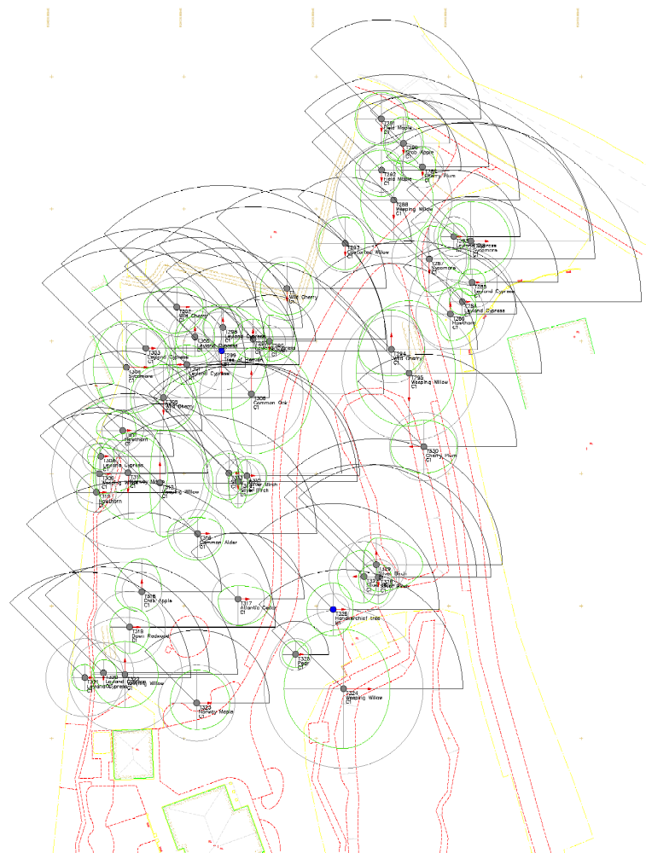

Suggested removals
