

www.parkerplanningservices.co.uk

www.parkerplanningservices.co.uk
Construction Management Plan
And Method Statement
Slipe Drove, West Pinchbeck
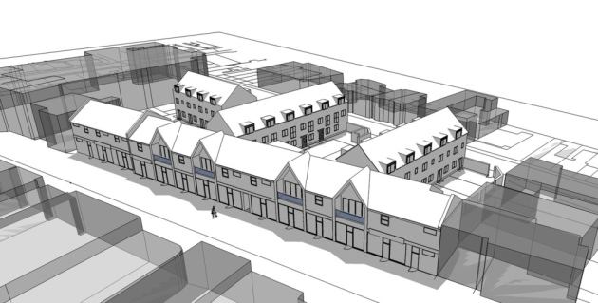

Our Offices:
NORFOLK T: 01603 516319 Norwich NR20 3LR
SUFFOLK T: 01284 336348 Bury St Edmunds IP33 1HQ
CAMBRIDGESHIRE: T: 01223 637283 Cambridge CB24 6WZ
LINCOLNSHIRE T: 01780 437333 Stamford PE9 2AE
ESSEX T: 01245 934184 Chelmsford CM2 7PX

Our Offices:
NORFOLK T: 01603 516319 Norwich NR20 3LR
SUFFOLK T: 01284 336348 Bury St Edmunds IP33 1HQ
CAMBRIDGESHIRE: T: 01223 637283 Cambridge CB24 6WZ
LINCOLNSHIRE T: 01780 437333 Stamford PE9 2AE
ESSEX T: 01245 934184 Chelmsford CM2 7PX

Prepared for Client:
G&L Developments Ltd

Former New Bridge Inn Site
Slipe Drove, West Pinchbeck

PREPARED BY: Tony Doyle BEng (Hons) MSc MCIHT

APPROVED BY: Tom Townsend
Prepared for Client: G&L Developments Ltd

Former New Bridge Inn Site
Slipe Drove, West Pinchbeck

PREPARED BY: Tony Doyle BEng (Hons) MSc MCIHT

APPROVED BY: Tom Townsend

REPORT INFORMATION
© Copyright Parker Planning Services Ltd.
No part of this report is to be copied or reproduced, both physically and/or electronically in any way without prior written consent of Parker Planning Services Ltd.
While every reasonable effort has been made to provide accurate and detailed information to the relevant professional standards at the time of writing of this report. However, Parker Planning Services Ltd. cannot be held responsible for errors, inaccuracies or omissions held within this report where 3rd party information has been used. Nor can the information in this report be used for works outside its remit.

© Copyright Parker Planning Services Ltd.
No part of this report is to be copied or reproduced, both physically and/or electronically in any way without prior written consent of Parker Planning Services Ltd.
While every reasonable effort has been made to provide accurate and detailed information to the relevant professional standards at the time of writing of this report. However, Parker Planning Services Ltd. cannot be held responsible for errors, inaccuracies or omissions held within this report where 3rd party information has been used. Nor can the information in this report be used for works outside the remit of a Transport Statement report.

Date of Application | March 2021
Local Planning Authority | South Holland DC
Applicant | G&L Developments Ltd
Development Description | Residential Development - Discharge of condition 9 of Approval H14-0951-20
Site Address | Slipe Drove, West Pinchbeck
Our Reference | 2771
Report Revision | V2


Contents
1 INTRODUCTON 4
2 DESCRIPTION OF PROJECT 5
3 RIDDOR & NEAR MISS REPORTING 13
4 SITE RULES 16
5 ENVIRONMENTAL RESTRICTIONS AND EXISTING ON-SITE HAZARDS 18
6 THE HEALTH AND SAFETY FILE 28

APPENDICES - To Be Populated by Principal Contractor During Construction
1 F10 Notification
2 Existing Records & Plans
3 Architects/Designers Drawings
4 Fire Procedures Documentation
5 Traffic Management Plan
6 Reporting of Accidents & Incidents
7 Welfare Facilities
8 Work Permits
9 Subcontractors Documentation
10 Information and Training
11 Monitoring
12 Health and Safety File Contents

- INTRODUCTON

  - This is the construction phase plan which incorporates the health and safety requirements of the Construction (Design & Management) Regulations 2015, has been prepared on behalf of G&L Developments.
  - This construction phase plan has been developed based upon the information received to date, including the pre-construction information provided by the Client / Principal Designer, and site visits undertaken by the Company.
  - The plan will be a live, dynamic document and will be subject to audit as detailed in the Health and Safety Policy of G&L Developments. It will be maintained and updated as necessary in order to ensure it adequately reflects the current stage of construction work.
  - G&L Developments are solely responsible for the continued update of this document and will populate the appendices.

- DESCRIPTION OF PROJECT
Project Description and Timeline Details

  - This project is located on land adjacent to Slip Drove on the former New Bridge Inn Site, West Pinchbeck, PE11 3NF
- Build and fit out of 7 no. dwellings;
- Installation of all necessary services and drainage;
- Provision of landscaping.

- Project commencement: June 2021
- Duration of project: 52 weeks
- Minimum time to be allowed between appointment of Principal Contractor and instruction to commence on site: 0 weeks
Details of Key Parties

  - Client and Principle Contractor - Carmine Pacca – G & L Developments 07979 977890
Existing Records and Plans

  - The Client and principle contractor has in their records:
- Designers’ drawings
- Existing services plans
- Ground investigation report

  - No preconstruction information was provided however it will be populated within this report as the development details are known.
Site Conditions

  - The site is located Slipe Drove on the former New Bridge Inn Site, West Pinchbeck PE11 3NF. The site was formally a pub and car park.
  - The site gently slopes from north to south, i.e. from plot 7 to plot 1. Overall there is a drop in site levels of around 1.5m.
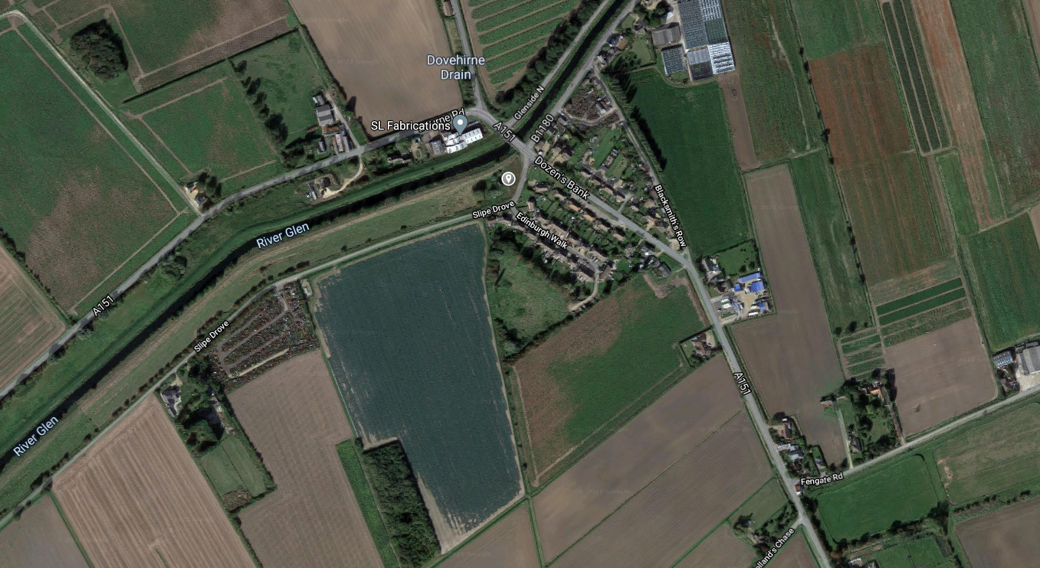
Image 1 – map showing the approximate location of the site - Source: Google Maps

  - A bore hole has been carried out on site down to a depth of 20m. The detail of the ground investigations will be appended to this report for all relevant parties to review prior to construction commencing in June 2021.
Management Structure & Responsibilities

  - The management of health and safety during the construction phase will be carried out by the implementation of the:
- Construction Phase Plan;
- Company Health and Safety Policy;
- Risk assessments and method statements;
- Safety inspections of the work in progress to ensure compliance.
  - The overall Company management structure and responsibilities can be found within the Company Health and Safety Policy and Procedures.

  - The key personnel for this project are as follows:
- Client and Principal Contractor - Carmine Pacca – G & L Developments - 07979 977890
- Principal Designer - Paul Lunn Architects - Fenton Cl, Peterborough PE7- 07703 163402
  - All contractors and sub-contractors report to the Client and Principal Contractors.
Health and Safety Goals

  - The health and safety management goals are as follows:
- To provide, so far as is reasonably practicable, a safe and healthy working environment for all operatives and visitors.
- To comply with the requirements of the Company Health and Safety Management System relating to the construction project.
- Zero reportable accidents and dangerous occurrences during construction.

Arrangements For Monitoring And Review Of Safety Performance

  - All contractors must appoint a site based person with sufficient knowledge and training to supervise and monitor the health and safety of their workforce. The appointed person should attend the site safety meetings and disseminate relevant information to their workforce.
  - Subcontractor supervisors are required to undertake monitoring of their own workforce to ensure safe working practices and use of personal protective equipment, as appropriate
  - The Site Manager will undertake regular inspections of the project and request the rectification of anything not meeting the required health or safety standard. Serious breaches will be brought to the attention of the Directors and work in the area stopped until it is safe to continue.
  - The Company Safety Advisers will complete independent site safety inspections as requested by the Directors, usually on a monthly basis unless otherwise requested.
  - When senior management visit site they will undertake a general inspection of all facilities and work under construction, setting a personal example by wearing all appropriate personal protective equipment and abiding by the site rules.
  - All Statutory Inspection Records are to be completed and held in the Site Managers office. These records are to be completed at the required intervals and made available for enforcing authorities if necessary.
  - When extreme weather conditions have occurred, i.e. storms, high wind, etc., the Site Manager will arrange for an inspection of all aspects of the project to take place prior to any construction work re-commencing.

Arrangements

  - Regular liaison between parties on site
  - A system of communication between all site operatives will be maintained by the Principal Contractor, through site induction briefings and toolbox talks.
  - All contractors must appoint a site based person with sufficient knowledge and training to supervise and monitor the health and safety of their workforce. The appointed person should attend site safety meetings and disseminate relevant information to their workforce.
Consultation With The Workforce

  - The site management team will consult on an informal basis with Contractors during the course of the project. All site operatives are required to inform site management of any Health and Safety issues causing concern, and this is covered during their induction.
  - The Principal Contractor operates an ‘open door policy’ whereby any site operative can discuss any issues/concerns with site management at any time.
  - All operatives working on site are required to understand health and safety site induction and have effective communication, to ensure the health and safety of themselves and others working on site. Where operatives fall short of this requirement they must be accompanied at all times by an interpreter who is fluent in both English and their native language.
  - Exchange of design information between key parties and handling design changes during the project
  - Any significant design changes specified for the project will be discussed directly between the construction team, designers, Principal Designer and the Client to ensure that any health and safety impact is assessed and communicated to those people who may be affected by the design change.
  - To enable the Principal Designer to undertake his duties, Designers need to cooperate in providing design information, risk assessments, etc. Regular Design Meetings/Workshops would ensure coordination of design, progress and communication of design risk assessments.
  - All work package contractors with a design involvement are reminded that they must comply with the Construction (Design and Management) Regulations 2015.
  - The following information must be submitted by the contractor to the Principal Designer in sufficient time to allow adequate consideration by the Principal Designer and where appropriate the Clients design team, prior to commencement of the relevant works:
- Suitable and sufficient information to demonstrate that health and safety issues have been adequately considered;
- A risk assessment;
- A list of health and safety hazards identified which cannot be designed out;
- A list of materials or substances which are specific or inherent in the design which are potentially hazardous to health and safety.
Advice And Assistance Will Be Sought From The Principal Designer Or Competent Person Where There Is Any Doubt.

  - The Principal Contractor must liaise with the Designers throughout the project to ensure that any design changes are detailed on the drawings to enable accurate ‘as built’ drawings to be issued post-construction.
Selection and Control of Contractors

  - The CDM Regulations 2015 require the Principal Contractor to ensure that all subcontractors appointed are competent to undertake their proposed role, and be able to demonstrate that such enquiries have been made.
  - Contractors must provide site specific risk assessments and method statements for the works they will be undertaking to the Site Manager for review and approval prior to works commencing.
  - All Contractors will receive induction training during their first day on site, and will be required to adhere to the site rules during the course of their work.
  - The Site Manager will be supported by the Directors in the control of contractors on site, where necessary.
Exchange Of Health And Safety Information Between Contractors

  - Exchange of information usually takes place on an informal basis, as dialogue during the course of the day. Where there is requirement for a formal exchange of information, this will be controlled by the site management team and documented in the form of memos, letters, drawings etc.
  - Site meetings are held whereby subcontractor supervisors attend to discuss forthcoming work, and ensure that issues are identified, discussed and resolved accordingly. Risk assessments and method statements provided by the subcontractors are reviewed by the Site Manager and any pertinent information brought to the attention of other contractors where necessary.
Site Security

  - Site security measures will be in place as soon as work commences and will be maintained at all times to prevent unauthorised access. The natural boundaries to the site will be used to prevent entry, and in addition the site gates will be closed to prevent unauthorised access.
  - Access to the construction phase will be controlled and secured at the end of each working day. Precautions will be taken to prevent children from accessing the site. All plant and equipment will be secured at cease work.
  - All construction areas are to be secured at cease work. All ladders must be removed or have an anti-climb device fitted at cease work to prevent use.
Site Induction

  - The Site Manager is responsible for providing induction training and will ensure that each site worker and visitor receives induction training.
  - This is to take place before the site operative starts work for the first time on site and will include details of the site rules and requirements.
  - Following the safety induction, all operatives must read the relevant job specific risk assessments and method statements produced and provided by their employer.

  - As part of the Method Statement contents, all Subcontractors are required to confirm that all of their operatives will attend an induction by the Principal Contractor prior to starting work.
  - Details of induction training will be held in Appendix 10.
On-Site Training

  - In addition to induction training tool box talks may be given on a regular basis, given by either the Site Manager or the subcontractor supervisors.
  - Records of all training are to be maintained and details of all personnel participating are to be recorded and held for the duration of the project.

Welfare Facilities and First Aid

  - Welfare facilities will comply with the Construction (Design and Management) Regulations 2015 and will be located in the front area of the site adjacent to plot 1.
  - A canteen / rest area and office will be provided by the Principal Contractor for use by all site operatives, and a 1+1 toilet. In the first instance this will be serviced by a diesel generator until the power is connected. Power and water is currently being commissioned onsite.
  - The location of first aid facilities and name of the first aider will be displayed in a prominent position. The supplies will be monitored by the First Aider, and restocked as necessary.
  - All welfare facilities are to be cleaned and monitored on a regular basis to ensure high standards of personal hygiene can be maintained. All personnel on site are to respect the welfare facilities and leave them in a clean and tidy condition.
  - The nearest Accident and Emergency Department is located approximately 24 miles away from the site at:
Peterborough City Hospital
Tel: 01733 678000
Edith Cavell Campus
Bretton Gate, Bretton
Peterborough
Cambridgeshire
PE3 9GZ

- RIDDOR & NEAR MISS REPORTING
Fatality/Specified Accidents/Dangerous Occurrence
  - The Site Manager will:
- Contact emergency services.
- Shut off area / plant / equipment where the incident occurred and secure area to prevent entry,
- Notify Senior Management who will inform the authorities,
- Make entry into the Accident Book and commence Initial Investigation,
- Ensure incident is reported to the Incident Reporting Centre via telephone 0845 3009923 (or website for dangerous occurrences).
- Cooperate, and assist as necessary, during the investigations.
Minor Accidents/Incidents
  - The Site Manager will:
- Enter details in the Accident Book, if applicable.
- Collect all possible information on the incident and where necessary carry out interviews with witnesses and implement measures to prevent a recurrence.
- If applicable, monitor absence of injured person to determine if a notification needs to be made to the HSE - in the event of the injured person being incapacitated for over 7 days, Head Office must be advised of all details.
  - The Principal Contractor will then report to the HSE in accordance with the Reporting of Injuries, Diseases and Dangerous Occurrences Regulations 2013 (RIDDOR).
  - Where an accident or incident occurs which involves a subcontractor, they are required to undertake the statutory RIDDOR reporting to the HSE if appropriate and provide the reference number to the Principal Contractor, and also undertake an investigation into the causes and measures needed to prevent a recurrence.
Production and Approval of Risk Assessments and Method Statements
  - This document will be supplemented by trade subcontractors’ documentation detailing the specific tasks and activities during the course of the works.
  - All Contractors’ Risk Assessments and Method Statements will be assessed to confirm competency of the Contractor to work on the project. All Risk Assessments and Method Statements for site work will be approved prior to any work commencing and these will be filed in Appendix 9.
  - There is no prescribed format against which risk assessment is to be undertaken, however they should follow the HSE’s 5 Steps to Risk Assessment and be undertaken by a competent person in order to be suitable and sufficient:
Step 1 – identify the hazards;
Step 2 – Decide who might be harmed, and how;
Step 3 – Evaluate the risks and decide on the precautions;
Step 4 – Record the findings and implement them;
Step 5 – Review the assessment and update if necessary
  - The control measures used to reduce risks, as far as is reasonably practicable, should follow the hierarchy of controls, as follows:
- Eliminate the hazard;
- Substitute the activity for a less hazardous one;
- Enclose the activity;
- Isolate the persons carrying out the activity;
- Provide personal protective equipment (last resort only) with adequate information, instruction, training and supervision.

  - Method statements must be provided, which incorporate the necessary controls detailed in the corresponding risk assessments, in order to provide a safe system of work.
  - To ensure that procedures are understood and worked to, the following information must be included as a minimum:
- Name of subcontractor;
- General description of the works (scope of works);
- Preparations required prior to the start of works:
- Safety of others;
- Segregation of work area;
- Access and egress to site / workplace;
- Emergency arrangements;
- Waste.
- Training requirements:
- Site induction;
- CSCS / CPCS;
- Task specific training.
- Monitoring arrangements (i.e. frequency of H&S inspections);
- Resources required:
- Plant/equipment;
- Materials (delivery/movement, etc);
- PPE
- Detailed method of the works (in the correct sequence) including the relevant controls
- detailed in the risk assessments;
- Supervisory arrangements;
- Occupational health:
- List of personnel briefed and signature;
- Date;
- Date of scheduled review.

- SITE RULES
- All persons are to report to the site office on arrival and enter their personal details in the control of entry book provided. The site manager/supervisor will use the control of entry book to account for all persons in the event of an emergency evacuation.
- All persons are to attend a site induction prior to entering the site for the first time.
- Visitors are to be accompanied at all times.
- All contractors and other employees are reminded that they have a legal duty of care and must comply with the requirements of the Health and Safety at Work Act 1974, and other legislation relevant to construction activities. Risk/COSHH assessments, method statements and other safety control measures must maintain safe and healthy working conditions to protect employees and others affected by their actions and the environment. All work is to be carried out in accordance with current best practice and trade standards. Horseplay will not be tolerated.
- Site clearance, dismantling and demolition operations pose additional hazards to general construction activities. All persons are to take extreme care when any of these operations are underway, only those workers actively involved are to be in the area. Be particularly alert for moving vehicles and plant. Never stand near or under a suspended load.
- All concerns relating to health and safety matters should be referred to the site manager/supervisor.
- All contractors are required to provide and maintain safe access to every place at which the contractors employees have at any time to work. All access equipment must be in a sound condition and well maintained.
- All excavations must be suitably secured and screened.
- Speed limits will be observed (5 mph).
- Welfare facilities are provided for the use of all site personnel; these must be kept clean and tidy.
- Any accident, injury or dangerous occurrence must be reported immediately to the Site Manager.
- All contractors are responsible for ensuring the site is kept in a clean and tidy safe condition both during and on completion of work. Good housekeeping standards are paramount.
- Hard hats, safety boots and high visibility clothing are to be worn at all times when on the site. Additional personal protective equipment (PPE) may have to be worn to ensure your health and safety, all persons must wear this PPE as directed.
- All contractors shall be responsible for the provision of protective equipment for his employees.
- Security of the site must be maintained at all times to prevent unauthorised access.
- Any hazardous substances, including flammable substances, must be brought to the attention of the Site Manager. They are to be removed from site at the end of the working day or appropriately stored and secured.
- No alcohol, or drugs shall be allowed on the site. Persons under the influence of drugs or alcohol will not be allowed on site, and will be subject to disciplinary action.
- Site operatives must not use any plant or equipment unless they are trained, qualified and authorised to do so.
- Reversing onto The Street without the assistance of a banksman is strictly prohibited.
Fire and Emergency Procedures

  - The means of raising the alarm will initially be verbally and a hand bell will then be provided. The emergency muster point is located at the front of the site, outside the main site gates.
  - A site layout drawing will be displayed in a prominent place which will outline the following:
- Traffic routes –pedestrian and vehicular
- Unloading area and turning point
- Fire assembly area and fire points
- First Aid provision/location
- Car parking facilities
  - An emergency contact list will be displayed with details of the following:
- Principal Contractor
- Health and Safety Executive (construction division)
- Environment Agency office
- Local hospital (with A&E)
- Police Force
- Fire Service
  - A Fire Safety Plan is included at Appendix 4 for completion prior to commencement, and this must be subject to regular reviews and, where necessary amendment, during the construction phase to ensure it remains suitable and sufficient as the build progresses.

- ENVIRONMENTAL RESTRICTIONS AND EXISTING ON-SITE HAZARDS

Safety Hazards - Delivery And Removal Of Materials
  - All delivery/collection drivers to report to the site officer upon arrival to site.
  - Deliveries will unload within the confines of the site. There is to be no unloading on Slipe Drove or on the access road into the site.
  - Slipe drove is wide enough to facilitate two way vehicle movement. The site was formally a public house with car park.
  - The car park has over footway dropped kerbs which are still in situ, however the public house has now been demolished.
  - Contractors vehicles will either be allowed to park on site if direct access is needed for tools and supplies and or they vehicles will be parked on the highway. Parking on the highway will not result in delay to other traffic users.
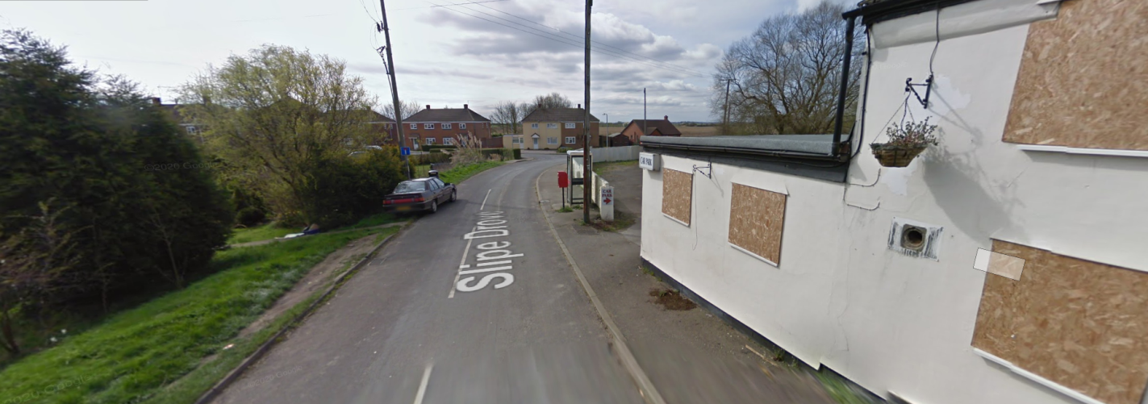
Image 2 – View along Slipe Road, looking south. The site entrance point is situated on the right hand side – Source: Google Maps

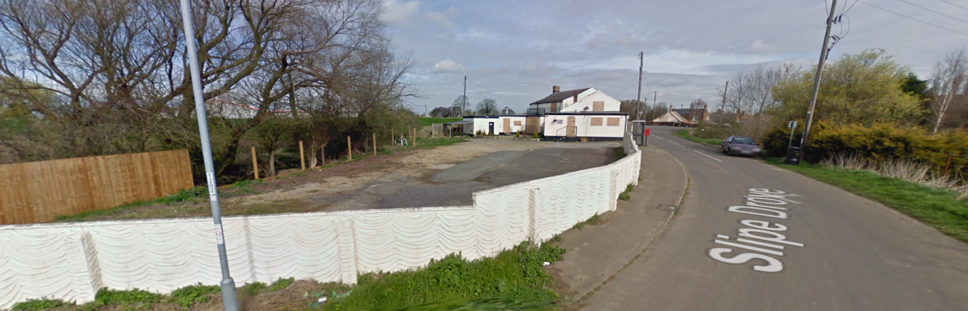

Image 3 – View along Slipe Road, looking north. The site entrance point is situated on the left hand side – Source: Google Maps

  - Waste materials will be stored in skips, which will be regularly emptied.
  - Removal of hazardous waste will be to a suitably licensed facility, with waste transfer notes obtained and held, in accordance with current legislation.
  - The attention of contractors is drawn to the fact that the site is situated within a residential area and deliveries must be planned to cause minimum inconvenience to local residents.
Dealing with Services

  - Existing services plans have been obtained and are the responsibility of the Principal Contractor.
  - The Principal Contractor is to ensure that all services are located, identified, marked and isolated/terminated prior to construction work commencing. A permit to work system will be utilised and the ground must be scanned for services prior to breaking ground in every case without exception. All works are to be undertaken in accordance with HSG47 and all services are assumed to be ‘live’ until proven otherwise.
  - Services installed during the project will be marked on drawings to show the ‘as installed’ service status, and copies of the drawings held on site.
  - Under no circumstances should road pins or other equipment be driven/hammered into the ground unless exact location of services is known and it is safe to do so.
  - Where overhead power lines are located then advice on safe working clearance must be obtained from the local Electricity Supply Company. A GS6 survey should be requested. Suitable restrictions must be in place, i.e. goal posts, plant height restrictors etc.
Accommodating Adjacent Land Use

  - The site is bounded by the River Glen and Slipe Drove to the west and east respectively. To the south is open scrub land, currently not in use.
  - Boundary fencing will be erected around the site.
  - There are no public rights of way affecting the site. There is a footway on the eastern boundary.
  - Works will only take place between the hours of:
- 07:30 – 17:00 Monday to Friday
- 08:00 – 13:00 Saturday
- There is to be no working on Sundays or bank holidays.
  - The Site Manager will ensure steps are taken to prevent the spread of mud onto the public roads and will monitor this on an ongoing basis. Control measures include the early installation of site roads and controlling traffic routes to ensure that vehicles do not drive over mud, thereby leaving the site in the same state in which they entered. The site roads and adjacent public roads are also swept when necessary. Additional control measures will be instigated if necessary.
  - The Principal Contractor will ensure that the site is secured at all times both during and outside of working hours. They are required to foster and maintain good relations with adjacent landowners/users and regularly liaise with them to ensure that any health and safety issues are identified, discussed and resolved accordingly. This will be particularly important with regard to noise and dust generation, traffic management (access/egress), site security etc.
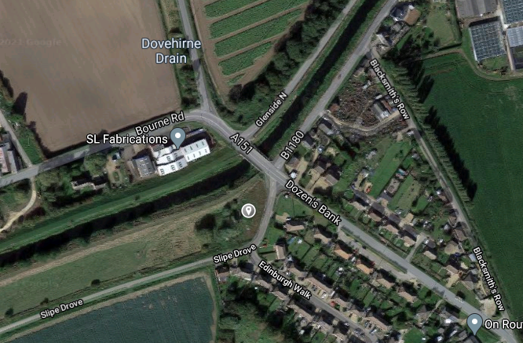
  - Levels of dust, noise and vibration must be kept to a minimum to protect the neighbouring residents and land users.
Image 4 – satellite view of the site and surrounding area – Source: Google Maps
Stability Of Structures

  - Advice will be sought from a structural engineer if in doubt or if any works which may affect stability of new structures are required, particularly to ensure that temporary works requirements are considered, planned and adequately designed.
  - Subcontractors are to utilise best practice at all times, e.g. ensuring mortar has hardened before increasing the height of brick or blockwork, to maintain structural integrity of the new build structure.
  - Materials must always be stored in a safe manner, taking into consideration stability and minimising the vertical height wherever possible.

Preventing Falls

  - In accordance with the Work at Height Regulations 2005, falls from height will be prevented by the provision of a safe system of work and corresponding risk assessments.
  - Collective fall protection (e.g. safe working platform) will be given precedence over individual fall protection (e.g. harnesses) wherever practicable, as required by the hierarchy of controls.
  - The hierarchy of control for the prevention of falls whilst undertaking high risk operations are:
- Evaluate the work to establish if working at height is necessary or if the work can be undertaken from an existing safe structure;
- Safe working platforms incorporating handrails and toeboards;
- Use of proprietary fall arrest systems such as ‘swaledeck’ for stairwells;
- Use of mobile elevating working platforms;
- Passive or collective systems such as safety nets, bean bags or air bags, which
- require no action by the user to work effectively;
- Work restraint systems, which include a harness and lanyard which is adjusted or set to a fixed length that physically prevents the person getting to the place where they could fall;
- Personal fall arrest system that uses a harness connected to a reliable anchor to arrest and restrict a fall and prevent the user hitting the ground.
  - Work at height systems are to be installed by competent persons, with hand over certificates provided to the Site Manager upon completion and checking. Scaffold is subject to 7 days statutory inspections, with records maintained and held on site.
Control of Lifting Operations

  - All lifting operations will be planned to ensure each element of the operation is carried out safely. The safe working load of the lifting equipment will be taken into account when selecting the equipment and planning the lift.
  - Lifting equipment will only be used and operated by trained, competent operatives in conjunction with a banksman and suitable lifting plan. Training certificates will be checked prior to starting and copies of training certification retained on site.
  - Lifting equipment and accessories are subject to statutory inspections as required by the Lifting Operations and Lifting Equipment Regulations 1998. Records of inspections will be maintained and made available upon request.
Maintenance of Plant and Equipment

  - All plant and equipment will be maintained in accordance with the manufacturers’ instructions and in accordance with current legislation.
  - Contractors are responsible for the examination, inspection and record keeping of their own equipment in accordance with the Company Health and Safety Policy and Procedures, however these records must be made available to the site manager for inspection upon request.
  - Inspections will be carried out and records kept on site.
Work on Excavations/Poor Ground

  - The maximum depth of foundations will be piled. Excavations of 2m will be carried out on site for sewerage treatment plant.
  - Suitable and sufficient support will be provided to excavations to prevent collapse, and trench boxes will be used to provide the support.
  - The tops of excavations will be protected by the provision of barriers to prevent falls into the excavation, and materials/equipment are not to be stacked close to the edge.
  - Additionally traffic routes and turning circles are to be positioned away from excavations wherever practicable and if vehicles/plant have to manoeuvre in proximity to excavations then stop blocks will be in place.
  - Excavations will be inspected by a competent person prior to entry in accordance with current health and safety legislation. Records of inspections will be held and made available for inspection upon request.

Traffic Routes and Segregation of Vehicles and Pedestrians

  - New access points will be created from Slipe Road to each of the new residential dwellings. A detailed design will be submitted to the highway authority for approval of carryout works on the highway.
  - Pedestrian routes will be established on site to provide safe access to work areas. Pedestrian routes will be either located a safe distance away from vehicles or provide physical protection.
  - The main duty to manage the traffic risks on site rests with the Principal Contractor, but all sub-contractors, plant operators, delivery and removal drivers, have their part to play. Where possible all vehicles are to enter and exit the site in a forward motion, however it is strictly forbidden for vehicles to reverse onto The Street without the assistance of a banksman at any time.
  - A specific Traffic Management Risk Assessment must be carried out by the Principal Contractor for the site to cover all site activities and third parties who may be affected by the works. This plan must be updated as construction work progresses. A Traffic Management Plan must be displayed in the site office and communicated to all relevant parties.

Storage Of Materials (Particularly Hazardous Materials) And Work Equipment

  - Materials and equipment are to be stored in a designated area of the site, which is to be secured at cease work.
  - Hazardous materials and substances will need to be stored in accordance with the requirements of their COSHH assessment – all subcontractors must bring these requirements to the notice of the Principal Contractor as soon as possible, as there may be a requirement to review the Fire Risk Assessment and/or Plan.
  - Materials should always be stored in a safe manner, taking into consideration stability and minimising the vertical height wherever possible.
  - Good housekeeping measures are to be in place at all times.

Dealing With Surface Water During And After Construction

  - The site is lower than the adjacent highway / footway therefore during construction surface was will be discharged onto type 1 / construction compounded surfacing.
  - A detailed surface water drainage strategy has been prepared for the site, a copy of which is with the Principal Contractor, which has been approved by the Environment Agency.

Health Hazards - Removal of Asbestos
  - Should any materials suspected to contain asbestos be discovered work must stop immediately, the materials be dampened down and covered. The Site Manager must immediately inform the Client and the Principal Designer, and a competent contractor employed to remove in accordance with current legislation.
Health Hazards - Dealing With Contaminated Land
  - The ground report does not detail any contamination.
  - The Contractor shall take adequate precautions, on exposing new materials, particularly below existing slabs, to wholly prevent airborne dust. The Contractor shall co-operate with the Principal Designer and Client in the development of the Construction Phase Plan prior to commencement of the work on site and in the maintenance of the Plan during the work on site.
  - Personal protective equipment must be worn by all site operatives, who will also be encouraged to maintain high standards of personal hygiene (i.e. hand washing) particularly prior to eating/drinking/smoking.
  - All site operatives are encouraged to report any health concerns immediately to the Site Manager.
Manual Handling
  - A forklift will be used to unload delivery vehicles, and move materials as close as possible to the working area.
  - Appropriate mechanical handling/lifting devices will be utilised wherever possible to avoid the need to manually handle loads.
  - Where this is not possible and manual handling is required, a risk assessment must be undertaken by a competent person and approved prior to the commencement of the work, taking into account the task, individual(s), load and environment.
Use Of Hazardous Substances (Including Health Monitoring)

  - The use of hazardous substances will be avoided wherever possible by product substitution; however COSHH assessments will be undertaken where necessary for existing and proposed substances/materials and the findings brought to the attention of relevant site operatives. All site operatives are encouraged to report any health concerns immediately to the site manager.
Reducing Noise, Vibration And Dust

  - Noise and vibration levels will be monitored by the site management team, and additional control measures implemented wherever necessary.
  - Collective protective measures are given precedence over individual protective measures, therefore equipment will be selected wherever reasonably practicable which produces minimum noise and vibration.
  - Dust suppression measures will be available and implemented where necessary during the redevelopment works.
  - Site activities will be coordinated to ensure that risks to third parties on site will be reduced wherever possible.
Exposure To UV Radiation (Including The Sun)
  - Site operatives are encouraged to keep covered up during the summer months by wearing suitable clothing. The use of sunscreen is also advised.
  - Welfare facilities are provided for the use of all site operatives, and water is available. Site workers should report any health concerns immediately to the site manager.
Any Other Significant Health Risks Leptospirosis (Weil’s Disease)
  - This is a serious, and sometimes fatal, infection transmitted to humans by contact with urine from infected rats.
  - Food and drink is to be consumed only in designed areas, which must be regularly cleaned to discourage rats.
  - Waste will be correctly disposed of and regularly removed from site.
  - All site operatives will be encouraged to maintain high standards of personal hygiene, i.e. hand washing, particularly prior to eating, drinking, smoking, etc.
  - Welfare and first aid facilities are available, and site operatives will be reminded to ensure that cuts and grazes should be washed immediately with soap and running water.
  - Site operatives should be aware of the symptoms (flu-like illness with a persistent and severe headache, which can lead to vomiting and muscle pains and ultimately to jaundice, meningitis and kidney failure) and obtain medical advice immediately if in any doubt.

- THE HEALTH AND SAFETY FILE
Layout and Format

  - The health and safety file will be compiled in hard copy format, in A4 binders, which will be produced upon completion of the works.
  - The contents of the health and safety file are as follows:
- BRIEF DESCRIPTION OF WORKS UNDERTAKEN
- SUPPLIER LIST
- SUBCONTRACTOR LIST
- GROUND INVESTIGATION REPORT
- ARCHITECTS DRAWINGS (as built)
- ENGINEERS DRAWINGS (as built)
- DESIGN RISK INFORMATION
- SERVICES DRAWINGS
- SERVICE HANDOVER CERTIFICATES
- SAFETY DATA SHEETS FOR HAZARDOUS SUBSTANCES/MATERIALS
- SPECIFICATIONS
- CLEANING & MAINTENANCE STRATEGY
- MAINTENANCE/SERVICE MANUALS & MANUFACTURERS INFORMATION
- GUARANTEES
Arrangements For The Collection And Gathering Of Information

  - The Principal Contractor is to ensure that appropriate information is provided by both themselves and their subcontractors, and passed to the Principal Designer promptly upon completion in the format as described above.
  - Details of the information required for inclusion in the Health and Safety File will be submitted to each subcontractor to ensure they are aware of the requirements and to enable prompt submission of the information.
Storage of Information

  - The Principal Contractor will store the information in a suitable manner until such a time as it is required by the Principal Designer for the production of the Health and Safety File.
  - The information will be provided promptly to the Principal Designer upon practical completion of the project.


parker planning services
Thanks for your valued business.

