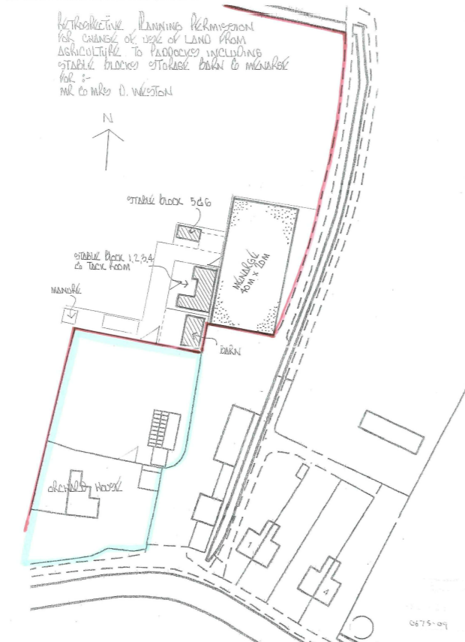
Stables 6 & 7
Hard Standing
Stables 1 – 5 and tack room
Purpose built muck heap
Barn
Arena 60x20m

