Supporting Statement
Change of use residential to business
Orchard House, Blue Gowt Drove, Spalding, PE11 3PX
For Sofia Jankiewicz Dressage

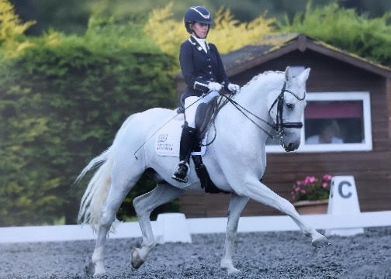

July 2020

- Introduction

1.1 The statement is in support of our planning application to change part of the existing stable block to business use. The application is to provide an opportunity to support Sofia Jankiewicz develop her dressage career and support her work in aspiring to be an Olympic dressage rider.

1.2 Orchard House is owned by the parents of Sofia Jankiewicz who have made the stable area on the Block Plan available for Sofia’s use in her dressage career.

2.0 Site Description

2.1 Orchard House is situated on the outskirts of the village of Pinchbeck, to the South, off Blue Gowt Drove.

2.2 Pinchbeck is a village and civil parish in the South Holland district of Lincolnshire, England. It is situated 2 miles (3.2 km) north from the centre of Spalding.

2.3 The application site edged blue, comprises the of 2 small stable blocks, 7 stables in total, a manège and hay store. The land and equestrian facilities are bordered on three sides by existing land owned by Orchard House.

2.4 The land is generally flat. It is well screened from the road (Blue Gowt Drove) by a mature hedgerow and trees and the buildings linked to Orchard House.

2.5 The land is currently divided into paddocks for horse grazing. The existing stable building situated at the end of the vehicular access, provides stables for 7 horses, a tack room and a store. These take the form of a U-shaped wooden building with a canopy which faces away from the road. To the front of the stables there is a concrete hardstanding which leads to the yard which is laid to gravel.

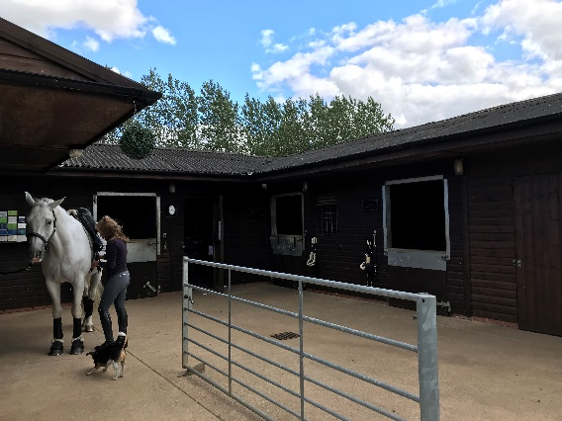 | 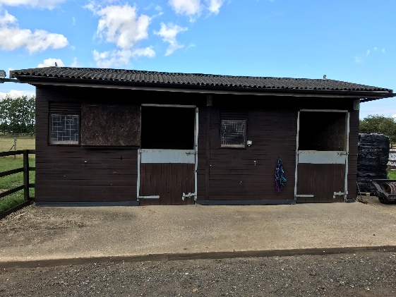

2.6 The hardstanding and yard area are fenced off from the fields.

2.7 The yard is accessed via double gateway on to a private driveway (8 cars min) and in turn leads to further hard standing capable of parking 20+ cars and allows good access for farm machinery for hay cutting or muck heap removal including the turning of such vehicles.

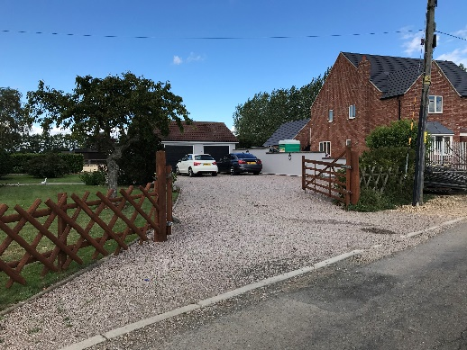 | 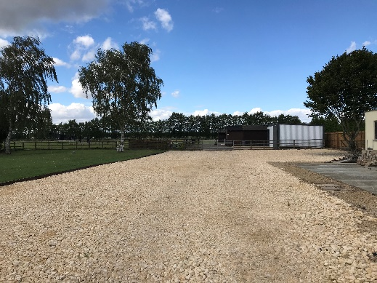

3.0 Development Proposal
3.1 This application proposes a change of use for part of the stable block to allow for up to 4 livery horses. The remaining stables will be for the use of Sofia Jankiewicz, who is pursuing a career in dressage.

3.2 Sofia started riding at a young age, taking to dressage and becoming an affiliated rider in 2012 at the age of 15. She currently trains with an international dressage riders, Jezz Palmer and Natalie Banks and International Dressage Coach Paul Fielder. Working at Advanced/PSG with her current horse and in the process of purchasing a young horse to bring up through the levels. The aim is to start producing a string of talented horses to reach Regional Championship levels and to progress to international dressage standards.

3.3 Sofia has represented England at the BD Youth Home Internationals on several occasions and achieved placings and top scores.

3.5 Sofia had ridden at the Sheepgate Under 25 Championships for the last 3 years and had success at team and individual level.

3.6 Sofia has attended many High-Performance camps over the past 7 years and became one of only 12 riders to reach the fully funded National Academy, in its first year.

3.7 In the longer-term Sofia is seeking to achieve inclusion in the GB team to represent Great Britain at the Olympics.

3.9 It is evident that Sofia requires the facilities to enable her to train with her horses on a regular basis to attain the standards necessary for international competition and ultimately to aspire to a position in the Olympic squad. Having up to 4 liveries allows her to become financially stable to continue her training and become more independent.

4.0 Planning History of the Site
4.1 Planning history of this site could be found on the Council’s web site, it is known that planning permission was granted in 2009 for the existing stables and ménage, which have since been in use for stabling horses that have occupied the land.
4.2 We purchased Orchard House in December 2019, and have already made improvements in land management, hedgerow conservation and external tidying up of yard and house. We have also, with planning permission extended the arena to Olympic size and installed mirrors to support Sofia’s development and training.
5.0 Issues for Consideration
5.1 It is proposed to have up to 4 liveries on full (or part livery). This will mean all the care, feeding and potentially exercising will be undertaken by Sofia and DIY livery will not be offered. This will limit the amount of time owners attend their horse each day, with DIY there would be a requirement to come up a min of 2 times a day, morning and evening to turn out/bring in, change rugs and feed etc. With full livery this is all taken care of – for the full time employed competition horse owner there is then only a requirement to attend to check/visit the horse and ride as needed. This is not a riding centre and aimed at the serious competitive rider that is seeking a calm environment to training and develop their horse.
5.2 The existing buildings will be used with no alternation required so there is no visual impact to take into consideration.
5.3 In terms of noise there will be limited traffic to and from our residence – this will be along Blue Gowt Drove from the West (Mill Green Road) so this will not interfere with our neighbours as we are the first house from Mill Green Road. Competition horses require a safe, calm space in which to live and train, it is very unlikely that any noise disruption will come form liveries as opposed to private use.
5.4 Access requirements. There is an existing access which serves the stables, and this will remain unchanged.
5.5 The stable block is bordered on 3 sides by existing land owned by Orchard House and the other side with next door who have been very supportive in the proposals.
5.6 The equestrian use is pre-existing and the change of use for a very small number of horses should not detract in any way the enjoyment of the 5 houses along Blue Gowt Drove. It will not introduce any new developments and is well screened by tree and hedgerows on 3 sides and an existing evergreen hedge around the arena.
5.7 A livery agreement will be made with each owner stating among other things the agreed times of operation – Summer visits between 8am and 7pm Winter months due to daylight hours 8am and 5pm. All riding and care can therefore be undertaken within daylight hours and avoid any artificial light being necessary to avoid any light pollution.
5.8 Parking – as referenced in 2.7, significant hard standing and vehicle access already exists which will more than meet any parking provision.
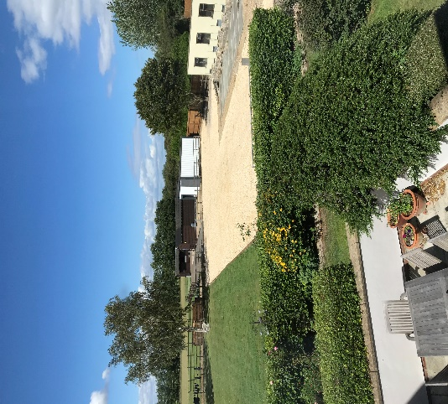
5.9 Storage of waste – already in place is a requirement to have the muck heap removed – if this is residential with 7 horses or part business the requirement is the same. There is a contract in place for muck heap removal by a local contractor and this is done on a regular basis to avoid any build up or unpleasant odour – this is also next to the private garden of Orchard House. A dedicated purpose-built muck heap has been added in the past month.
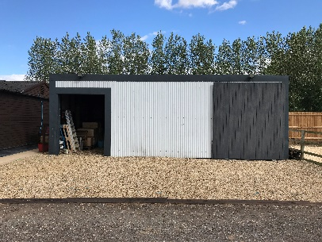
5.10 General Storage – There is an existing tack room, feed store and hay barn which will provide enough storage for livery owners as well as a double garage and old kennel block so ample storage exists.
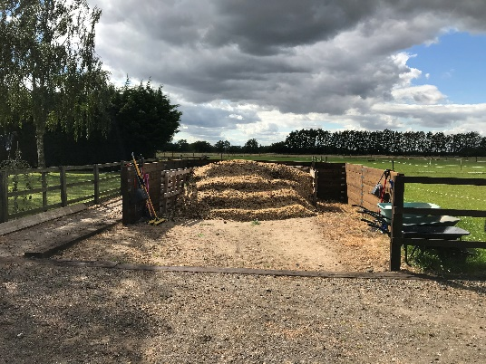

6.0 Conclusion and Summary
6.1 The proposed change of use relates to existing stables at Orchard House.
6.3 The application is to support Sofia Jankiewicz who is a national competitor in dressage and who is working towards a place in the Olympics. She currently stables horses at the site which she will be training in dressage and having business use for up to 4 horses will allow her to become financially independent and support her own career.
6.4. The equestrian use is pre-existing, and we believe the addition of 4 liveries in no way distracts the enjoyment for others in the local area and in fact supports a very real need in the area for top class equestrian facilities for the competitive rider and horse.
6.5 Relevant aspects of the local plan:
Local Plan reference - 4.2.11 National planning policy 9 supports the conversion of existing buildings and well-designed new buildings in the Countryside for economic development. Therefore, the provision and expansion of Other Employment Sites, including those in the Countryside, will be supported where it can be demonstrated to be sustainable and consistent with the requirements of Policy 7. However, the desire to promote rural employment must be balanced with the need to protect the existing character of the Countryside

Local Plan reference - 7.6.1 People's health and well-being is influenced by a broad range of factors, including (only listed relevant ones):
• whether they feel able to achieve personal goals and take part in society;
• whether they feel financially and personally secure;
• whether they have rewarding employment;
• the amount of physical exercise they take.
The above 2 aspects of the local plan are related to this change of use application, in providing self-employment opportunity for Sofia Jankiewicz in a rural setting, whilst protecting the existing character of the countryside as the equestrian facilities are already in use and have been for many years. The addition of up to 4 liveries in no way detracts from the existing setting.
Allowing business use will enable Sofia to become financially secure and work towards achieving her personal goals. It is also beneficial from a physical well being for riders and mental wellbeing for rewarding employment especially in the current Covid situation where part time pub and restaurant jobs are difficult to continue as a way of Sofia supporting her passion.

