Integrated Planning
and Design & Access
Statement

Site:
Wisteria Farm, Northgate,
Pinchbeck,
Spalding,
PE11 3TA
Applicant:
J W E Banks Ltd
Prepared by:
O. Staff
Revision:
P01 -July 2023

Contents
Introduction 3
Site Location 4
Neighbourhood Context 4
Existing Site 4
Site Constraints 5
Existing Buildings 5
Demolition 5
Adjacent Buildings 5
Landscaping 5
Site Opportunities 5
Views 5
Trees 5
Planning History 5
Flooding 5
Planning Policy and Material Considerations 6
Principle of Development 6
South East Lincolnshire Local Plan Policies 6
National Planning Policy Framework - July 2021 6
Permitted Development & Fallback Position 7
Class Q Fallback 8
Fallback Prospect 9
Assessment of Policy and Material Considerations 10
South East Lincolnshire Local Plan Policy Assessment 10
Class Q Fallback Position Assessment 12
Betterment 12
Sustainability 13
U-Values & Airtightness 13
Biodiversity 14
Precedents 15
Cheal Road, Gosberton 15
Crossgates Farm, Algarkirk 15
Poplar Farm, Algarkirk 16
Vicarage Lane, Scopwick 16
Round House Farm, Haven Bank 17
Sprite Lane, Billinghay 18
Village Street, Walcot 18
Summary 19
Design 20
Use 20
Amount 20
Site 20
Dwellings 20
Scale 20
Landscaping 20
Appearance 21
Materials 22
Plot 1 and 2 22
Plot 3 22
Access 22
Site Access 22
Proposed Parking Provision 23
Conclusion 23
Appendices 24
Appendix 1 – Existing Site Photographs 24
Appendix 2 - Judgement: Mansell V Tonbridge And Malling Bc [2017] Ewca Civ 1314. 25

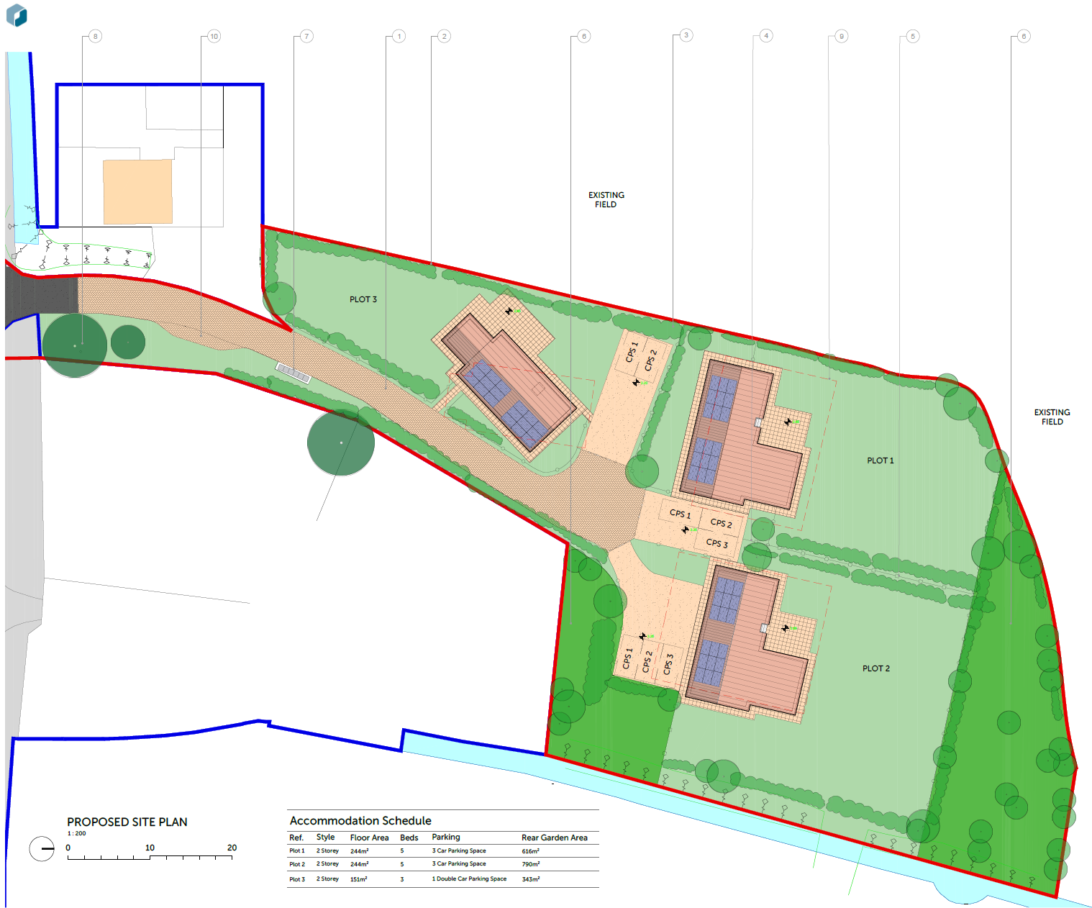
Introduction
This planning statement accompanies a planning application for a residential development of 3 no. new build dwellings at Wisteria Farm, Northgate.
Origin Design Studio Ltd has been appointed by J W E Banks Ltd to submit a planning application on a parcel of land which currently has three agricultural buildings, two of which have permission to be converted to residential dwellings. This document provides a rationale for justifying new build dwellings on the site and demonstrates planning betterment against any possible alternative.
Figure 1 – Proposed Site Plan

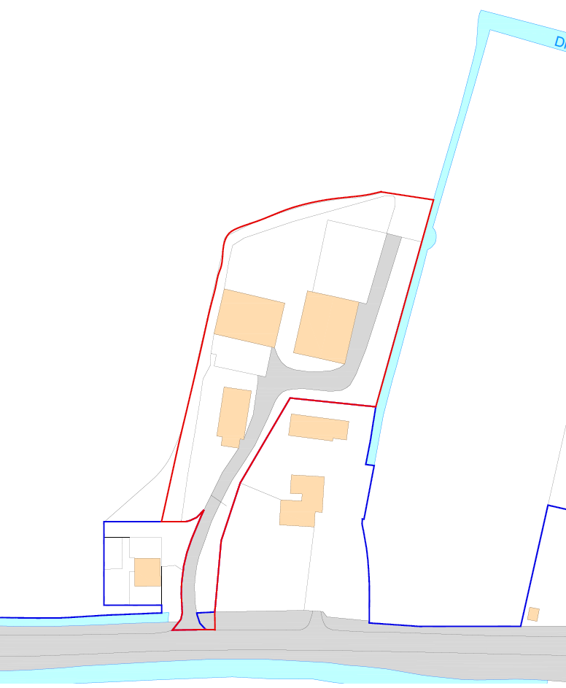
Site Location

Neighbourhood Context
The proposed site is located at Wisteria Farm in Northgate, Spalding. In planning policy terms, the site is classified as open countryside.
The site is located approx. 3.7 miles from the centre of Spalding.

Existing Site
The existing site contains three agricultural buildings and associated hardstanding.
The site is in a rural location, characterised by agricultural land. There is a cluster of dwellings immediately to the south of the site and further dwellings to the east along Northgate. Therefore, residential development in the area is sporadic but not entirely lacking.

Figure 2 - Red outlined area indicates site location

Site Constraints

Existing Buildings

Demolition
There are currently three agricultural buildings on site, two of which retain permitted development rights to be converted to residential dwellings. This application proposals the demolition of all agricultural units on site.
The existing buildings have a very limited contribution historically or architecturally and are therefore not worthy of retention.

Adjacent Buildings
The adjacent building to the south is a residential dwelling. The proposal has considered the existing amenity and care has been taken to ensure the spatial relationship is maintained and not worsened through inappropriate scale or placement.

Landscaping
The existing landscaping on site is proposed to be retained and for the most part remain unaffected due to proposed dwelling being sited on the existing buildings footprints.

Site Opportunities

Views
Due to the rural location, views towards the open countryside are achieved to some extent in all directions, however the desirable aspect is to the North and West. These have formed part of the determining factor in the orientating of the proposed dwellings, other dictating factors were ensuring the privacy of the existing neighbouring dwelling and those proposed.

Trees
As mentioned, the trees and hedges on site, although a constraint to be considered, also provide natural screening and privacy to the site. There is also the opportunity to include new planting which will add to the biodiversity of the site and bolster the screening.

Planning History
Two of the existing buildings on site have an existing permission to be converted to three dwellings via prior approval.
Details of this application are included below:
REF: H14-0922-22
Location: Wisteria Farm North Gate West Pinchbeck Spalding PE11 3TA
Description: Change of use of agricultural buildings to form 3 dwellings and associated works

Flooding
The site is in flood zones 1, 2 & 3, as a result a Flood Risk Assessment (FRA) has been prepared and submitted with this application. The floor levels of the proposed dwellings have been set in line with the recommendations outlined within the FRA.
The FRA also indicates that the sequential test has been passed due to the proposal for 3 dwellings not being considered to pose a greater risk than that which has and could be approved under permitted development.
It can be argued it would be unreasonable to expand the search area beyond the site, the application site is considered acceptable from a sequential perspective with no acceptable alternative presenting themselves with the immediate or wider search area.

Planning Policy and Material Considerations
Although the NPPF provides the national planning objectives for any planning application in England, the Local Planning Authority’s Local Plan policies must take primacy when an application is being determined. In this instance, at the time of writing, the South East Lincolnshire Local Plan (SELLP) takes primacy. The Plan was formally adopted in March 2019.
Decisions must be made in accordance with the development plan unless other material considerations indicate otherwise. Such material considerations can include emerging local plans, emerging neighbourhood plans, national policy, permitted development rights and extant planning permissions.

Principle of Development
The application as presented forms an unusual case insofar as it is correct to start the assessment of the principle of the development against the provisions of the adopted development plan but that the proposition being advanced by the applicant is that the fall-back position weighs significantly in this case. Indeed, the core case being advanced is that notwithstanding the provisions of the local plan pertinent to the settlement and countryside, these considerations are capable of being outweighed by other material considerations.
This section of the report therefore will provide a resume of the local plan policy considerations as well as national policy and guidance before an assessment of the fall-back position. Thereafter a conclusion on the principle of the development proposed will be made having regard to these considerations.

South East Lincolnshire Local Plan Policies
The relevant planning polices relating to the application are the following:
- Policy 1: Spatial Strategy
- Policy 2: Development Management
- Policy 3: Design of New Development
- Policy 4: Approach to Flood Risk
- Policy 28: The Natural Environment
- Policy 31: Climate Change and Renewable and Low Carbon Energy
- Policy 36: Vehicle and Cycle Parking

National Planning Policy Framework - July 2021
One of the overarching and central themes to the NPPF is the Government's absolute commitment to encouraging and achieving sustainable development and strong economic growth, and the crucial role and expectation that the planning system does everything it can to support this. The Government expects that the planning system should operate to encourage, and not act as an impediment, to sustainable growth.
In order to deliver sustainable development, paragraph 11 of the NPPF requires that Local Planning Authorities approve proposals that accord with the development plan without delay, and that where there are no development plan policies, or the most relevant policies are out of date, granting permission unless any adverse impacts of doing so would significantly and demonstrably outweigh the benefits.
Paragraph 12 states that the presumption in favour of sustainable development does not change the statutory status of the development plan as the starting point for decision making. Where a planning application conflicts with an up-to-date development plan, permission should not usually be granted. Local Planning Authority’s may take decisions that depart from an up-to-date development plan, but only if material considerations in a particular case indicate that the plan should not be followed. In this respect, the case being advanced by the applicant seeks to engage the guidance that enables decisions to depart from the development plan.
Chapter 5 of the NPPF addresses housing with paragraph 60 confirms the Government’s objective of significantly boosting the supply of homes. Further guidance at paragraphs 78-80 sets out the approach to rural housing. For rural areas sustainable housing development is about enhancing or maintaining the vitality of local communities ergo hamlets and the countryside, with generally poor accessibility to local services, are not therefore favoured locations for development.

Permitted Development & Fallback Position
The change of use of a building represents development in planning law. There are provisions within secondary planning legislation which allow for specified development to be undertaken without express planning permission (referred to as “permitted development”). The Government has introduced an ever-increasing and wide range of permitted development rights for a range of purposes from extending your home or for re-using office buildings or shops as dwellings. One such set of provisions allows for the change of use of an agricultural building to a dwelling without requiring the express permission of the Local Planning Authority, but subject to certain criteria being met and certain conditions being satisfied under Class Q, Part 3 of the Town and Country Planning (General Permitted Development) (England) Order 2015 or Class R.
Class Q enables permitted development, with certain criteria and restrictions relating to the following:
- Maximum floor areas
- Numbers of smaller and larger dwellings to be created
- Use
- Agricultural tenancies
- Retention of external dimensions
- Extent of building operations necessary for the building to function as a dwelling
- Location of the site (i.e. within a Conservation Area, AOND, World Heritage Site, National Park/ The Broads, part of a SSSI, safety hazard area, military explosives storage area)
Development is permitted subject to the developer first applying to the relevant Local Planning Authority for a determination as whether the “prior approval” of the Authority will be required as to:
- Transport and highways impacts of the development.
- Noise impacts of the development.
- Contamination risks on the site.
- Flooding risks on the site.
- Whether the location or siting of the building makes it otherwise impractical or undesirable for the building to change to a dwelling.
- The design and external appearance of the building.
- The provision of adequate natural light on all habitable rooms of the dwelling houses.
The LPA has 56 days to determine such an application. If a decision is not made then permission is automatically granted. The prior approval procedure is not available for retrospective development and if the development for which prior approval is applied for starts before formal determination, then it effectively disqualifies itself from the prior approval procedure.
In accordance with paragraph 12 of the NPPF, the Council need to consider the weight to be afforded to this prior approval scenario as an other material planning consideration, and how this needs to be weighed in the planning balance.

Class Q Fallback
The main precedent for the existence of a fallback position with regard to Class Q is Mansell v Tonbridge and Malling BC for which in September 2017, a judgement was handed down by the Court of Appeal. The case concerned the grant of planning permission for four houses on land currently occupied by a bungalow and a large agricultural building. In granting permission for the houses, the Council took into account the fact that the barn could be converted into 3 houses under Class Q and therefore the number of dwellings proposed would be the same as that which would have resulted from the conversion of the barn to 3 dwellings and retention of the existing bungalow. The aggrieved neighbour brought a Judicial Review with the permission initially being quashed by the High Court, but reinstated by the Court of Appeal, who found it was legitimate for the Council to grant the permission, even though no application for prior approval to convert the barn had been made. The Court of Appeal held in this case, the fact that an agricultural building could be converted (the fall-back position) is a material consideration when considering a proposal for new housing, provided that there is a realistic prospect of such a development going ahead. Lindblom LJ confirmed the legal considerations in determining the materiality of a fall-back position as a planning judgement were:
The basic principle is that for a prospect to be a “real prospect”, it does not have to be probable or likely: a possibility will suffice;
There is no rule of law that, in every case, the “real prospect” will depend, for example, on the site having been allocated for the alternative development in the development plan or planning permission having been granted for that development, or on there being a firm design for the alternative scheme, or on the landowner or developer having said precisely how he would make use of any permitted development rights available to him under the GPDO. In some cases that degree of clarity and commitment may be necessary; in others, not. This will always be a matter for the decision-maker’s planning judgment in the particular circumstances of the case in hand.
Lindblom LJ concluded in Mansell that the clear desire of the landowner to develop and maximise the value of the site was sufficient to demonstrate there was a real prospect of the Class Q fall-back position in that case. Therefore, whilst it was noted that many Local Planning Authorities would want to require a developer to go through the process of applying for determination as to whether prior approval is required for a proposed conversion under Class Q, and this would be preferable, applying the findings of Mansell, a Local Planning Authority cannot insist that a prior approval is first obtained before determining an application that relies on Class Q as a fall-back position.
Accordingly, the Class Q fall-back is engaged and therefore represents a material planning consideration in accordance with paragraph 12 of the NPPF.

Fallback Prospect
Prior to this application, a prior approval application was submitted and approved for two buildings on site to be converted to allow for two large dwellings and one smaller dwelling. The fallback position also does not require a Class Q to be gained, but just that it can be demonstrated that it could be. Therefore the proposal to construct three dwellings reflects what has already been granted approval through Prior Approval.
It was determined that the approved scheme did not make the most of the site’s potential and as a result an alternative sketch scheme was developed which has been the basis of the proposed GIA for the site.

Assessment of Policy and Material Considerations

South East Lincolnshire Local Plan Policy Assessment
The starting point for the consideration of all planning applications is the development plan as per Section 70(2) of the Town and Country Planning Act 1990 (as amended). In this case, in the absence of a neighbourhood plan, the development plan is South East Lincolnshire Local Plan (SELLP). The site is located within the countryside as set out within the plan. The plan has specific policies relating to development in the countryside (policy 22 & 23) however the proposal does not strictly accord with the criteria set out in the policy, such as being a replacement dwelling or the re-use of a building for residential dwellings.
It can be argued as a result the proposal conflicts with the local plan, however the fallback position in this case should be afforded a high degree of material weight in the planning balance.
Policy 1 outlines the spatial strategy for South East Lincolnshire and as such the site is defined as being in the open countryside. As a result, development will be permitted that is necessary to such a location and/or where it can be demonstrated that it meets the sustainable development needs of the area in terms of economic, community or environmental benefits.
Policy 2 relates to development management and defines further detail as to how sustainable development should be achieved.
One aspect of this is analysis of the size, scale, layout, density and impact on the amenity, trees, character and appearance of the area and the relationship to existing development and land uses. The proposal, as defined in the ‘Design’ section of this document is of a suitable size, layout and density. The proposal is also of high quality design and the orientation of the dwellings have been carefully considered in terms of solar gain/ preventing overheating as well as considering amenity of neighbouring dwellings.
The access also remains unchanged and the vehicle levels will not be greater than that required for the prior approval permission. It will also have no greater impact on the community services and infrastructure than the approved scheme.
As outlined in the FRA, flood risk of the site has also been carefully considered.
Natural habitats have also been retained and added to through this proposal.
Policy 3 relates to the design of new development and outlines how new development should be designed to create a sense of place. The proposal is in line with this through respecting the density, scale and massing of neighbouring dwellings. The proposal has also considered the orientation of the dwellings for the purpose of including renewables in the form of solar panels on the southern facing sections of roof.
The existing trees on site will be retained to promote and enhance biodiversity.
Policy 4 relates to flood risk and has been addressed within the included FRA, and the recommended construction and floor levels have been adhered to in the design.
Policy 28 relates to the natural environment and requires proposals shall provide an overall net gain in biodiversity. This has been demonstrated in the proposal through the retention of the existing landscaping which is reinforced with additional planting. There are also areas of dedicated bio-diversity zones with wildflowers, denser shrubs and trees to promote diverse wildlife habitats.
Policy 31 relates to climate change and renewable and low carbon energy. The dwellings will be more energy efficient than is able to be achieved through a conversion. This can be achieved through quality materials and improved insulation capabilities to maximise thermal performance. The energy generation for these properties is supplemented by on site, solar panel generation. The hot water system and heating is provided by Air Source Heat Pumps (ASHP) which are more efficient than conventional methods of heating and hot water supply.
Policy 36 relates to vehicle and cycle parking. The number of parking spaces provided for each dwelling are of a suitable level as well as enabling electric vehicle charging.

Class Q Fallback Position Assessment
The current planning application seeks permission for a total of three new build dwellings. This equals the number of properties approved in the class Q application.
The original application proposed a large expanse of land (around the demolished third unit) unassigned. The class Q legislation does not allow large amounts of curtilage and the location of this left over piece makes it impractical for continued agriculture and would become assimilated with the residential units. This would suggest the use of the land, as a whole, can achieve a better site arrangement.
The dwellings Gross Internal Area (GIA) also totals 639m² with 2 larger dwellings at 244m² and 1 smaller at 151m², the scale of development within the maximum limit of 865 m² allowed through a Class Q application.
The positioning of each dwelling would be on the footprints of the current units, this allows better distribution of the amenity space for the 3 plots, allows for the ability of meaningful biodiversity improvements.
Through the current approval, the potential for a Class Q fall-back exists, it should be afforded a high degree of material weight in the planning balance. Ordinarily as evident from the policy commentary above, new dwellings on the site would fail to accord with the spatial strategy and settlement hierarchy, such that the development would be resisted as it is contrary to policy.
However, the realistic prospect of a Class Q fall-back shifts the planning balance in this case and establishes that, under the provisions of permitted development, the site could be developed for a total of 5 dwellings and such a development is a real prospect.
The next key consideration, mindful of the approach in Mansell and planning appeal precedents, relates to whether the proposal subject to the planning application represents a ‘betterment’. In short new build dwellings by their very nature offer betterment with regard to thermal efficiency and airtightness.

Betterment
Due to the constraints of Prior approval permissions, the previous scheme would not make efficient or effective use of the site.
The proposed scheme keeps the development on the footprints of the existing units, the proposed units have a smaller footprint than the existing, reducing the density of development on site.
The splitting of the site into 3 residential plots and amenity space avoids pockets of land not associated with the residences but also not impractical land for continued agricultural use.
The ability to provide meaningful landscaping aimed to promote bio-diversity. The proposed site plan shows areas on the site set aside for less domesticated landscaping with the purpose of providing a net gain to the habitats.
The ability to build anew allows for higher quality construction, better air tightness and improved thermal performance, particularly better control over thermal bridging. The proposal also includes for the installation solar panels for on site power generation, something a Class Q application would not permit given the constraints on exceeding the original envelope.

Sustainability

U-Values & Airtightness
The proposed dwellings, due to being new build, will be an improvement in regard to energy efficiency. This will enable a more comfortable environment for the future occupants as well as being of benefit to the wider community through reduced emissions and energy wastage. New build dwellings being able to be constructed in a way which reduces the U-value of a dwelling to a level of which a conversion would not be able to achieve.
When comparing a development which utilises an existing building versus a new build dwelling, there are cases where the retention of the existing fabric of the building enables a more sustainable development. For example, when retrofitting an existing dwelling which already is constructed of thermal elements, this would often have a smaller carbon footprint than a new build, however this is not the case for an agricultural building. They lack the basic level of amenities suitable for human habitation.
When constructing a dwelling, the aim is always to create an environment which is comfortable for humans to live in, such as thermal efficiency, airtightness, and natural daylighting.
With an agricultural building, the objective is often secure storage for assets, crops, animals, supplies or machinery. Since with an agricultural building, you are starting with a point which is averse to human living standards, the extent to which additional materials, rebuilding etc are required and will still not result in a dwelling that is close to the standards achieved by a new build dwelling, even when building to modern, minimum standards.
Technology has allowed dwellings to become more thermally efficient such as the development of better performing insulation which improves U-values. U- Values assigned to a building element represent its ability to transmit heat from a warm space to a cold space within a building. The lower the value, the less heat is transferred through the element.
There is the ability to upgrade various elements in an old dwelling to improve the internal comfort and carbon footprint. As a result, in most cases, a new build dwelling will in fact have a smaller carbon footprint over the lifetime of the building, which through considering this is thinking with a much more sustainable, future thinking mindset.
A new build dwelling will enable a more comfortable environment for the future occupants as well as being of benefit to the wider community through reduced emissions and energy wastage. With a new build it is much easier to create an airtight, well insulated dwelling and avoid issues which arise from not fully knowing the history of the building or original construction. A new build also provides the opportunity to specify all construction elements, enabling greater flexibility and opportunity for creating a well-insulated and sealed building.
The building regulations include different targets for existing buildings undergoing conversion and new build dwellings. This is because by the nature of a conversion, they are unable to achieve the same thermal efficiency as new dwellings due to the existing constraints they have.
Approved ‘Document L Volume 1: Dwellings’ outlines maximum U-Value requirements for new fabric elements in existing dwellings, requiring roofs to achieve 0.15 W/m²K and floors 0.18 W/m²K. Whereas the notional dwelling specification for new dwellings, outline a dwelling to be constructed in line with much more stringent requirements, with U-value for roofs at 0.11 W/m²K and floors 0.13W/m²K. When compared, this is a significant improvement. We would recommend speaking to your building control officer for further insight into this.
Therefore, because of this, the economic and environmental benefit of a new build dwelling in the long term, particularly when compared to a converted agricultural building would be greater.
With the exception of U-value targets a conversion only records the energy performance of a building. There is no requirement to meet emission targets.
Further, the current Building Regulations aid in the plans to move towards net zero carbon. New homes and buildings in England have to produce substantially less CO2 under the current regulations. CO2 emissions from new build homes should be around 30% lower than under the previous standards. The new dwelling would be constructed in accordance with the building regulations and therefore provide betterment compared to the existing permission.

Biodiversity
The proposal includes for much greater biodiversity through more diverse native planting whilst also retaining the existing trees on site. We would be happy to accept a suitability worded planning condition which allows for full details to be submitted.

Precedents
There are a number of other developments which utilise the fallback decision. The first, as mentioned is the ‘Mansell v Tonbridge and Malling’ case, for which the precedent was initially set. The decision for which is included within this document as an appendix.
There are also a number of similar applications which have been decided close to the district.

Cheal Road, Gosberton
REF: H08-0443-22 - Erection of DwellingLocation Corner of Cheal Road/Saltfleet Lane Gosberton Fen Spalding
This scheme was approved by South Holland District council and the following was stated by the officer with regard to the fallback position:
‘In this case, the application property has a Class Q consent for a dwelling (ref. H08-0861-21). It seems likely that there is a clear desire by the landowner to develop and maximise the value of the
site. Moreover, the scheme approved under Class Q is the conversion of a non-typical residential appearance agricultural building into a dwelling. The current proposal is for a detached house that is in keeping with that of the vernacular Fenland Cottage in terms of design, scale and setting.
The proposal would deliver some benefits to the appearance of the site compared to the fallback position. This carries significant weight in favour of the proposal. On balance, taking account of the above considerations, it is considered in this particular case that the benefits of the proposed development compared to the identified fallback position are a material consideration which outweighs the conflict with the development plan and justifies granting planning permission for the proposal.’
Further to this the site is also similarly in a flood zone and therefore the following was stated:
‘The site is within Flood Zone 3 of the Environment Agency Flood Maps and is not impacted by increased hazard or flood risk on the 2115 South East Lincolnshire Strategic Flood Risk Mapping. Finished floor levels would be sited at 300mm above existing ground level. For this reason, a sequential or exceptions flood test is not required.’
This proposal also seeks to align the proposed floor levels with the recommendations of the prepared FRA. As a result this should similarly be deemed acceptable.

Crossgates Farm, Algarkirk
REF: B/22/0454 -Demolition of existing agricultural barns and erection of 3no. dwellings with associated accesses and change of use of agricultural land to residential curtilage at Crossgates Farm, Crossgate Lane, Algarkirk, Boston, PE20 2AJ
This scheme was approved by Boston Borough Council and had not previously had a Class Q permission gained on the site, however it was demonstrated that the site had the realistic prospect of gaining a class Q permission and therefore the fallback position was a material consideration.
The following was stated in the officer’s report:
‘In conclusion, the application site benefits from an extant consent to convert the existing agricultural building to a residential dwelling, with further evidence indicating that the large steel framed building on the site can be converted into 2no dwellings gives significant weight to establishing the principle of residential development on the site, despite the identified conflict with the development framework of the South East Lincolnshire Local Plan 2019.’
Similarly in this application, the proposal does not accord with the local plan policies, however due to the class Q permission being gained, there is a realistic prospect of the building being converted. The existing building also showed the potential to be converted into more dwellings than was proposed, similar to this site, creating betterment from the potential class Q.

Poplar Farm, Algarkirk
REF: B/22/0350 - Proposed construction of 5 No residential dwellings including a conversion and extension to existing agricultural building on site at Poplar Farm, Marsh Lane, Algarkirk, Boston, PE20 2AY
This scheme was approved by Boston Borough Council and proposed to construct 5 dwellings on a site with permission for 5 dwellings via class 2, split between two buildings. The following was stated in the officer’s report:
‘The existing buildings on site to be removed do not enhance the character of the area, although as agricultural buildings within a rural context do not cause harm to that character either. The proposed dwellings would be set back within the site but Plot 2 would be visible, particularly on approach from the south. These dwellings would be finished in black timber shingles, an uncommon material within the immediate context but would not be harmful and would be in keeping with the agricultural character of the site. Plots 4 and 5 to the rear 6 of the site are larger dwellings with a similar material palette. Each property has a brick single storey extension separated by a glazed link.
The existing character is rural, with scattered dwellings individually or in small clusters. The proposed form and scale of development would be out of character with this rural character. However, there is limited wider visibility of the site and the form and scale of the development would be largely unseen. As such the level of harm arising is limited.’
This proposal similarly seeks to replace agricultural buildings which do not enhance the character of the area and are not easily seen from the public realm. A mixture of more contemporary and traditional materials are also proposed (brick, timber cladding and standing seam metal) which although not seen together locally, are of high quality and reflect elements of the local vernacular in a new and interesting way. Plots 2-4 are also similarly set back and shielded from the road and therefore any deviation from the existing character will be negligibly harmful. Plot 1 however is road frontage and so continues the pattern of development along Barrier Bank.

Vicarage Lane, Scopwick
REF: 22/1447/FUL - Demolition of the existing agricultural barn and erection of 2 no. dwellings at Land Adjacent To 1 Vicarage Lane Scopwick Lincoln Lincolnshire LN4 3NT
This scheme was approved by North Kesteven District Council and proposed two dwellings on a site which had permission for dwellings via prior approval. The officer’s report said the following about the proposal:
‘The approved Class Q fallback position creates two detached dwelling in this location which are created by the partial demolition of the existing agricultural building on the site. This rectangular building is utilitarian and functional in its appearance being constructed of blockwork and cement fibre sheeting and is not of any architectural merit. The Class Q application did improve its appearance by the inclusion of a mixed render and timber clad finish but the form of the building was unchanged and the proposed dwellings were not of any significant architectural merit either. The overall design of the proposed dwellings by this application would result in betterment in terms of visual amenity as it of a much-improved design that responds to its context.
Furthermore, the applicant has highlighted that the fact the proposed new build dwellings will be built in accordance with current Building Regulations which require a higher standard of energy efficiency that would not be achieved through the conversion of the existing building.
It is noted also that the proposal includes the provision of solar panels which will generate on plot renewable energy to meet the energy needs of proposed dwellings’
This application similarly seeks to replace an agricultural building with little to no architectural or historic merit with high quality, well designed dwellings. The dwellings will also similarly be built in accordance with the current building regulations and achieve a higher standard of energy efficiency than required or achievable through converting the existing buildings. The scheme also includes for solar panels on the dwellings, providing renewable energy generation.

Round House Farm, Haven Bank
REF: S/207/02406/22 | Planning Permission - Erection of 2no. detached dwellings, existing agricultural barns to be demolished. | ROUND HOUSE FARM, HAVEN BANK, NEW YORK, WILDMORE
This scheme was approved by East Lindsey District Council and similarly proposed to demolish two agricultural barns (with permission via prior approval to convert to four dwellings) and build two new dwellings. This site similarly is also located within a flood zone. With regard to flooding, the officer’s report stated the following:
‘Officers accept the site having gained approval for four dwellings under part 3 of the GDPO, that an argument could be made in regards the application of the Sequential and Exception test (SET) with the site already having permission for housing…..
In line with the PPG as regards being pragmatic on the availability of alternative sites, it would in the Councils view be unreasonable to expand the search area, the application site is considered acceptable form a sequential perspective with no acceptable alternative presenting themselves with the immediate or wider search area. Given the previous application an argument could be made to further refine the search area to the site itself, irrespective of this both approaches would get you to a point of acceptability and appeasement of the sequential test.’
It can be argued that a similar conclusion can be drawn on this site in respect of flooding, since the site similarly has an existing permission for residential dwellings and that the wider area surrounding the site is similarly at the same risk of flooding and therefore there are no nearby sites sequentially better than the site. Further to this the scheme also proposes to either set the dwellings outside of the flood zone or raise the land and floor levels to achieve a level outlined in the submitted FRA.
The officer’s report also stated the following:
‘The design itself is sympathetic to the agricultural history of the site, whilst also being more aesthetically pleasing than conversion of the existing barns including layout, resulting a more comprehensive scheme.’
The proposal similarly is sympathetic to the history of the site and the design of the dwellings are more aesthetically pleasing than converting the existing barn.

Sprite Lane, Billinghay
REF: 21/0162/FUL | Erection of 1no. dwelling on the site of an existing agricultural building which is to be demolished. | Barn Off Sprite Lane Billinghay Lincoln.
This scheme was approved by North Kesteven District Council and similarly proposed to demolish an existing agricultural barn and build a new dwelling. It was determined that the fallback position was a material planning consideration, stating the following in the officer’s report:
The application, by virtue of the previously approved prior notification and the similar site area demonstrates there to be a realistic fall-back position. With this in mind the fall-back position becomes the determining consideration outweighing the considerations within local policy, particularly policy LP55 of the CLLP. Following assessment, the proposal is considered acceptable in principle and is of a design which is reflective of its agricultural origins whilst respecting and assimilating with the open countryside. The officer recommendation is therefore one of approval.’
Due to the existing permission via prior approval on this site, it can be demonstrated that such a development. This proposal was also similarly of a more contemporary design, utilising similar high quality materials such as metal cladding.
The proposal also included for an increase in site area, however this was seen as being acceptable by the officer stating the following:
‘It is noted that a slight increase is still proposed, measuring approximately 730sqm in comparison to 680sqm, however officers consider this marginal when taken in the context of the overall site. Additionally, the applications seeks to create a more 'regular' shape plot which also further compacts the residential curtilage without sprawling into the countryside beyond.’
This application similarly seeks to create more regular shaped plots through an increase in residential curtilage.

Village Street, Walcot
REF: 21/1376/FUL | Conversion of an agricultural building to 1no. dwelling with conversion of existing barn to provide garaging and the erection of 3no. additional dwellings. | Yard To The South Of Village Street Walcot Sleaford
This scheme was approved by North Kesteven District Council and similarly proposed to demolish an existing agricultural barn and build new dwellings. It was determined that the fallback position was a material planning consideration, stating the following in the officer’s report:
‘In the case of the application for Walcot, the fall-back scheme presented in the submission of the application is a worked-up proposal and on assessment of the scenario presented, Officers find that it would accord with the criteria set out under Class Q. Furthermore it is evident the applicant has, through this application and previous proposals, demonstrated that a re-development of the site is a “real prospect”…
Accordingly Officers find that the Class Q fall-back is engaged and therefore represents a material planning consideration in accordance with paragraph 12 of the NPPF.
….Having established that the Class Q fall-back exists, it is reasoned by Officers that such is
capable of being afforded a high degree of material weight in the planning balance. Ordinarily as evident from the policy commentary above, planning permission could reasonably be obtained for the conversion of the stone barn to a dwelling but otherwise 3 new dwellings on the site would fail to accord with the spatial strategy and settlement hierarchy of policy LP2 such that the development would be resisted as contrary to policy. However, the Class Q fallback shifts the planning balance in this case and establishes that, under the provisions of permitted development, the site could be developed for a total of 5 dwellings and such a development is a real prospect. With the above in mind, the next key consideration, mindful of the approach in Mansell and planning appeal precedents, relates to whether the proposal subject to the planning application represents a ‘betterment’ compared to the fall-back position and this is considered in detail below.
…..The revised scheme for determination, offers the opportunity for betterment in design terms giving the opportunity to create a comprehensive and cohesive scheme which covers the whole yard. This is a distinct advantage in terms of a design outcome rather than the relatively contrived form of development under Class Q with the conversion of functional agricultural buildings of no architectural merit or interest into dwellings which would result under the fallback position, and with very limited amenity afforded to the occupiers by the restricted curtilages allowed.’
As outlined above, the fallback position was afforded material weight and betterment was demonstrated. Similar types and levels of betterment are present in this application. In particular, both proposals offer a comprehensive and cohesive scheme which covers the whole site, rather than a contrived form of development through permitted development. Amenity is also improved in both schemes due to not requiring the proposal to include restrictive curtilages allowed under Class Q.

Summary
The above precedents each have similar aspects to the proposal and as a result the application should similarly be seen in the same light and recommended for approval based on the same justification.

Design

Use
The current use of the site is agricultural, however has a realistic possibility of being converted to residential via a Class Q application. The application also proposes a use of residential. The potential for residential development in this location sets a precedent for this use and therefore the proposed use is in line with this.

Amount
The site contains 3 existing buildings. The proposed development for the site is inspired by the agricultural developments and proposes 3 new residential dwellings in place of the existing ones.
Dwellings on Plot 1 and 2 is proposed to contain 5 bedrooms each, while Plot 3 proposes 3 bedrooms.

Site
The site layout has been designed to be an improvement on site, The proposed site layout ensures that each dwelling is placed strategically to maximize privacy and views. Proper orientation of the houses takes advantage of natural light and ventilation. The proposed dwellings are sited on the footprint of the existing buildings. It was determined that locating the dwellings closer to the access track with longer gardens would ensure better accessibility.
Plots 1 and 2 have a similar footprint and have been mirrored on the rear site for better access and planning.
Plot 3 is located closer to the entrance of the site and reflects the location of a traditional barn present on site.

Dwellings
The interior layout of the dwellings reflects modern living, The living spaces are on the ground floor with the bedrooms and bathrooms distributed on both the ground as well as the first floor. All plots also have an open plan kitchen dining area, with separate reception rooms. Plot 3 proposes for a double heighted Kitchen/Dining allowing in abundance light into the dwelling and a gallery on the first floor. The open plan living spaces have the direct access to the rear patio and the garden, allowing direct access to outdoor areas.

Scale
The scale of the proposed development has been designed to be sensitive to the setting. The dwellings are proposed to be 2 storeys in keeping with the neighbouring dwellings and the height of the existing building.
Given the surrounding context the proposed dwellings are of a suitable scale for the area and site. The gardens are also generously sized.
The total Gross Internal Area (GIA) of the dwellings is 628m² with Plots 1 and 2 are 242m² each and plots 3 is 144m². This overall GIA is comparable to the potential converted floor area of the existing class Q permissions which totalled 674m² split over 3 dwellings.
The height of the dwellings is also within the realms of that of the existing building. The existing buildings are approx. 5.9m and 8.3m tall and the proposed dwellings are between 6.1m and 7.8m tall.

Landscaping
The proposed landscaping scheme has been designed to enhance the site’s biodiversity. Currently, hardstanding areas are present on the site, while trees and shrubs are predominantly clustered in the northwest and along the access track.
The proposed scheme retains these trees and proposes new tree planting in the gardens of individual plots. New native hedge planting is also proposed to further improve biodiversity and natural screening to the plots. Further details are shown on the site plan submitted with this application.
To the north of the dwellings, an area is proposed to be allocated to promote biodiversity through the inclusion of ‘wilding area’ which will consist of native wildflowers to attract pollinators and provide habitats for wildlife.
These landscaping additions will provide a benefit and improvement on site.

Appearance
The design rationale for the proposal was to be in keeping with the agricultural aesthetic and allow for contemporary residential living. Plot 1and 2 have the aesthetic of a modern barn. The design proposes brick walls on the ground floor with a raised seam for cladding at the first floor and roofing.
For these dwellings, the Multi colour brick (Fig 5) and the green box profile cladding (Fig 6) will be used. These materials are chosen to blend in with the surroundings. The first floor is wrapped in the metal cladding as opposed to the bricks on the ground floor giving it a very modern aesthetic The openings (doors and windows) also have been inspired by modern farmhouse designs and are simple and have no ornamentation. The longer window on the whole of first floor enhances the overall look of the dwellings.
Plots 3 has a traditional approach. It proposes a traditional brick blend with timber cladding and detailing. The roof is a traditional clay pantile. This material palette is in keeping with both historic dwellings and the local vernacular. The overall form of the dwellings and site are reflective of the existing site and vernacular with well-considered and unique design.
For this dwelling, the red bricks(Fig 6) are laid in the flemish bond and will have a clay pantile roof(Fig 7) to give an overall traditional finish. The Openings are inspired by the form of the traditional openings and are arched with Header bricks surrounding the aluminium frames for doors and windows. The Double heighted door and circular windows have been provided to compliment each other elevate the exterior of the dwelling.

Materials

Plot 1 and 2
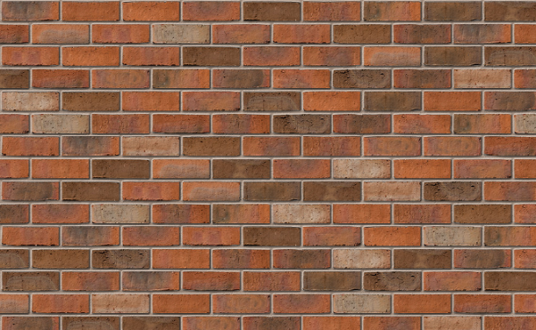
Figure 4 – Example of Brick Blend 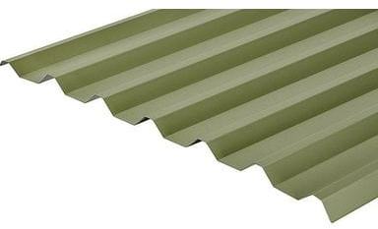
Figure 5 – Example of Sheet Cladding for Plots 1 and 2
The materials used for Plots 1 and 2 are Multi Red brick (Figure 4) and Metal profile Cladding (Figure 5).

Plot 3
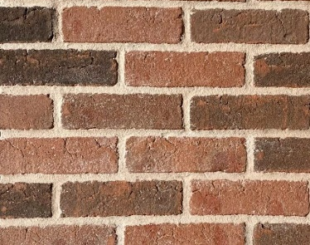
Figure 6 - Reference for red bricks for Plot 3

Figure 7 - Reference for Clay Pantile roof tiles for Plot 3
The materials used for Plot 3 are traditional red bricks (Fig 6) and Clay Pantile roof (Fig 7).

Access

Site Access
Access to the site is via an existing access which currently leads to the agricultural buildings. A shared surface drive serves all the 3 proposed properties with their allocated parking.

Proposed Parking Provision
Pots 1 and 2 have 3 car parking spaces and plot 3 has 2 car parking spaces.

Conclusion
This site has permission for the conversion of two agricultural units (and demolition of a third) into 3 residential dwellings. This application proposes development that provides 3 new build dwellings on the footprints of the existing structures.
Through a number of metrics we have justified that a new build scheme provides substantial betterment to the original approval of conversion.
The conversion with its limitations on sustainability, effective use of space and ecology represents a legitimate ‘fall-back position, the site will be developed on the basis of the class Q approval, however this application hopes to achieve the same density of residential development but with improved design, deliberate landscaping and enhanced thermal and sustainable performance.

Appendices

Appendix 1 – Existing Site Photographs
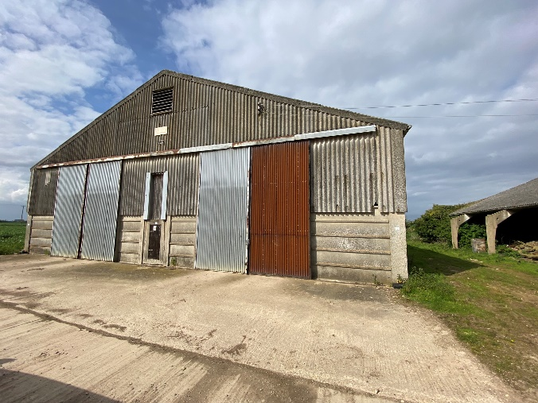
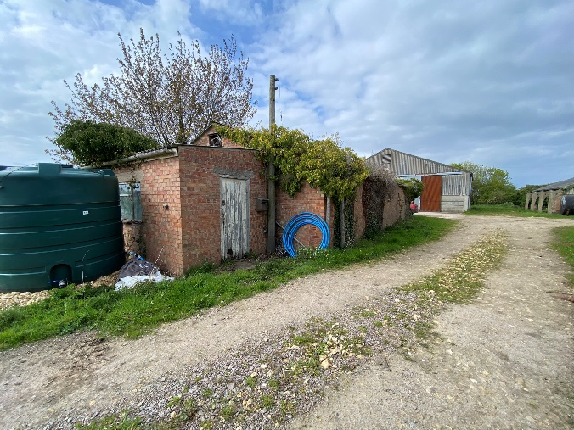
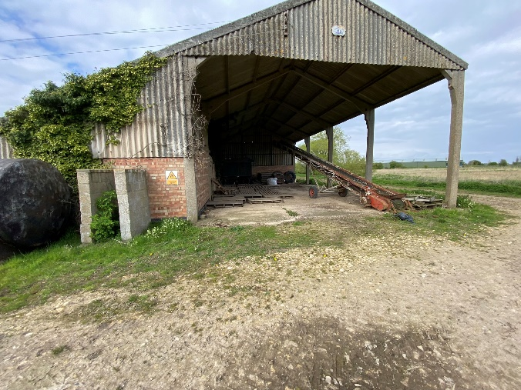

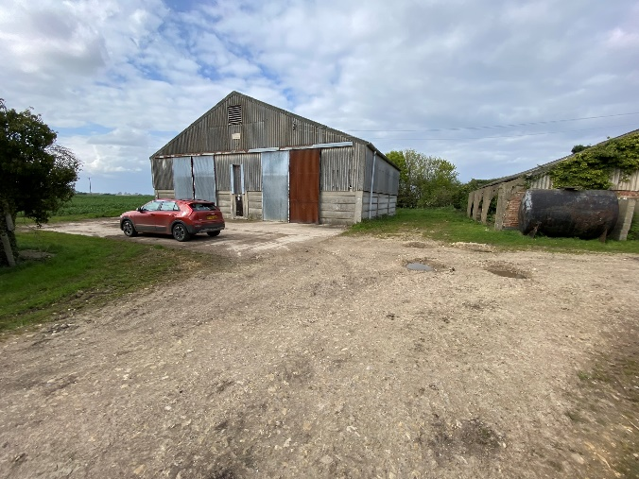

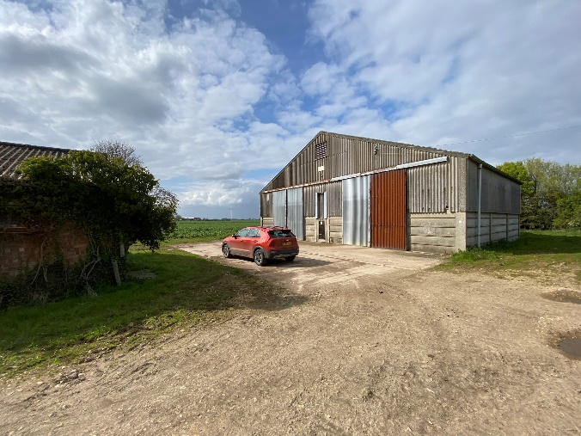
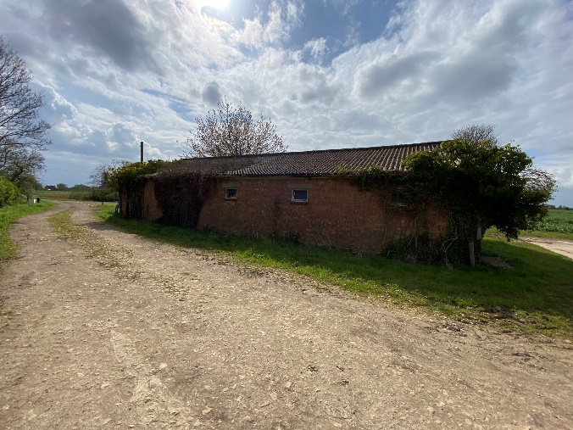

Appendix 2 - Judgement: Mansell V Tonbridge And Malling Bc [2017] Ewca Civ 1314.

