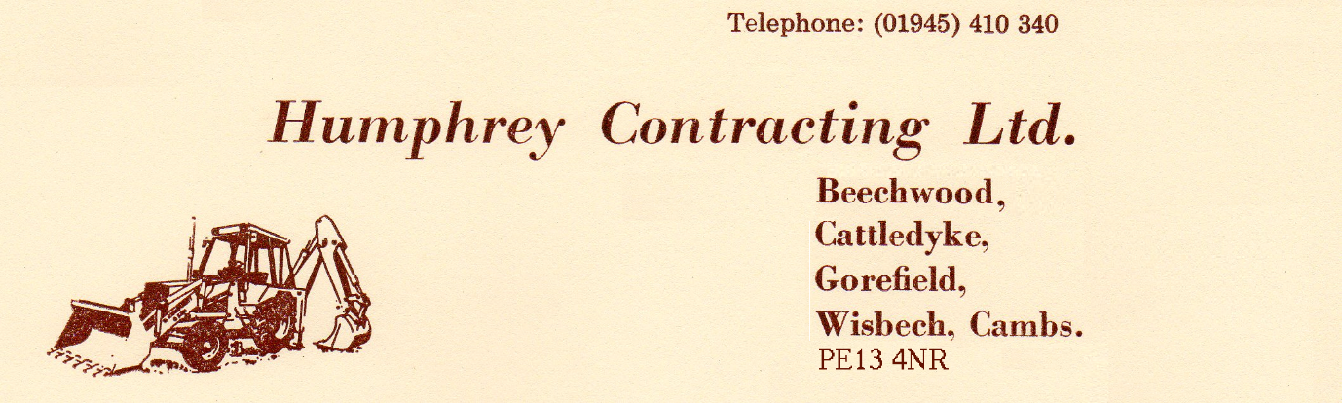


Company Site Rules 2018
Sections 7 & 8 of the Health and Safety at Work Etc. Act 1974 require employees to take care of their own safety and others who may be affected by their actions. In addition you must not tamper with, damage or remove any item of equipment provided for your safety. In order to comply with these requirements the following rules must be adhered to.
- All persons must report to the site manager on arrival at site.
- All persons must sign the site register when arriving and leaving site.
- All persons must follow any specific rules applicable to individual sites.
- All accidents, near misses and injuries must be reported to the site manager.
- All persons on site must wear safety helmets, hi-vis clothing and steel toed footwear, unless directed otherwise. It is your responsibility to ensure you have the correct equipment available to you. Damaged equipment should be reported to the site manager/employer who should arrange replacement.
- All persons must wear the correct Personal Protective Equipment suitable to the task, unless directed otherwise.
- No shorts to be worn on site at any time.
- All persons must follow instructions given by the site manager, company representative or safety advisor, unless it puts yours or others safety at risk.
- Ensure your work area is kept clean and tidy at all times. This is to prevent slips, trips and falls by you, your fellow workers or members of the public.
- All rubbish and debris must be removed from the work area and placed in the appropriate skip. If you make the mess you clear it up.
- All toilets, mess rooms and other welfare facilities must be kept clean and tidy. These facilities are provided for your benefit and it is your responsibility to keep them clean. If you discover anyone making a mess or not cleaning up after themselves, report this to the site manager.
- Report all unsafe conditions of areas of concern to the site manager immediately. If you do not do anything, you or one of your workmates could have a serious accident.
- Do not use defective tools or equipment. Report defects to the site manager immediately.
- Contractors must inform the site manager of any hazards substances they intend to use and make arrangements for their safe and secure storage.
- The use of drugs or alcohol on site will not be tolerated. Anyone found in possession/under the influence of drugs or alcohol will be removed from site.
- Plant and machinery must only be operated by authorised persons.
- Smoking is prohibited on site. Smoking to only take place in designated smoking area.
- Mobile phones must not be used while operating any plant or while driving a vehicle. Unless it work related, the use of mobile phones is prohibited during work hours (Excluding break times). Personal calls must only be taken during break times (Excluding emergency calls) Mobile phones must not cause a danger to you or others on site and therefore must only be used while in a safe place.
- Anyone found breaking or disobeying these rules will face disciplinary action.
- Any operative found committing an unsafe act likely to cause injury to themselves or others will receive a written notice that will be copied to their employer. This may prevent the individual carrying out future works for the company.
If these rules are followed, there is a chance that your working conditions will improve and become safer. Help us to help you.

