Humphrey Contracting LTD ENVIRONMENTAL POLICY

Humphrey Contracting LTD has recognised its responsibility for environmental matters. The Company operates a policy of effecting continual improvement and change in accordance with developing knowledge and changing environmental requirements.
Humphrey Contracting LTD’s staff is aware of their environmental responsibility and seek to continually develop the Company’s environmental compliance.
Due to the need for continual improvement, it can never be possible to detail fully the Company’s environmental activities, but the following specific objectives form the basis of the Company Policy:-

- All of the Company’s operation must be carried out with due regard to all appropriate and relevant Waste Management Legislation and Regulatory considerations.
- The Company will continue to make available, resources to ensure that suppliers and customers are made fully aware of their environmental and legislative responsibilities with regard to supply of goods and services.
- The Company will only use disposal facilities where the level of operational control and environ-mental compliance is deemed to be of a suitable level, and represents demonstrable responsible Waste Management. This therefore means that not all appropriately licensed disposal facilities will satisfy standards required by Humphrey Contracting LTD.
- The Company will ensure that vehicles and equipment used are well maintained, clean and are always operated within legal limits, taking advantage wherever possible of engineering modifications to reduce pollution and emissions, and to plan vehicle journeys carefully to save unnecessary consumption of energy.
- The Company operates a continual training programme to ensure that staff keeps up to date on the safe handling and disposal of all types of waste including difficult and dangerous wastes.
- The Company will take whatever measures may be necessary to ensure that manufacture, collection, transport, storage, recycling, reclamation and disposal facilities which it operates, is not and do not become hazardous to public health or the environment.
- The Company will ensure that any waste disposal company used will have a written agreement as well appropriate documentation to ensure that the Duty of Care (Section 34) of the Environ-mental Protection Act (1990) is fully complied with, regarding Controlled Waste transfer Notes and waste descriptions. The Company will ensure that every effort is made to police the compliance of third parties within this Legislation.
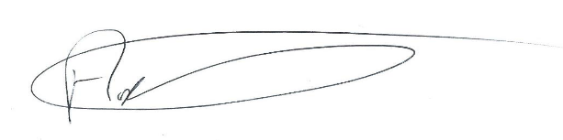

……………………………………………
Andrew Humphrey (Owner)

