Humphrey Contracting LTD Equal Opportunities Policy

The purpose of this policy is to set out Humphrey Contracting’s, commitment to eliminate unfair discrimination from all aspects of its work; to outline policy priorities and to give the methods for implementing, monitoring and co-ordinating progress towards the achievement of those policy objectives.

POLICY OBJECTIVES - The objectives of Humphrey Contracting LTD Equal Opportunities Policy is to eliminate unfair discrimination in relation to recruitment and selection procedures, and ensure equality of opportunity for all persons currently under employment/job applicants.
The relevant statutory requirements are contained in the Race Relations Act
1976, the Sex Discrimination Act 1975, the Equal Pay Act 1970 and the Disability Discrimination Act 1995. It is the intent of Humphrey Contracting LTD through the implementation of this policy, to fully comply with the company’s performance criteria on race equality and equal opportunities.

ORGANISATION AND IMPLEMENTATION - The Management has formally adopted the Equal Opportunities Policy, accepts responsibility for its implementation and for monitoring its effectiveness. The day to day responsibility or organisation and implementation lies with the management. Besides the statutory duty not to discriminate unfairly, all staff have the responsibility to ensure the positive application of the Equal Opportunities Policy.
Disciplinary procedures are in place to ensure there are no breaches in the policy.

MONITORING AND RESOURCES - The Management has a responsibility for monitoring progress and application of the policy. Regular reviews will be undertaken to monitor performance against the equality targets; to consider feedback on how the policy is operating and to set timetables where these are necessary. Humphrey Contracting LTD will make appropriate resources available, whether in terms of money or staff, to ensure full and effective implementation of this policy.

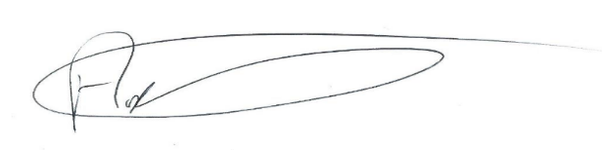

……………………………………………………………………..
Andrew Humphrey (Owner)

