DESIGN & ACCESS STATEMENT
Residential Development – Proposed building plot showing indicative layout for single dwelling with access / egress on to Main Road Quadring between 196 and 200 Main Road Quadring Lincs. PE11 4PJ

Client : Mr.P. Jackson, 5 Ashton Hall Drive, Boston, Lincs. PE21 7TG

Prepared by : M.J.Watson, 13 Wimberley Way, Pinchbeck, Spalding, Lincs PE11 3RY

Rev. A BNG Exemption Statement added mjw 12.8.24

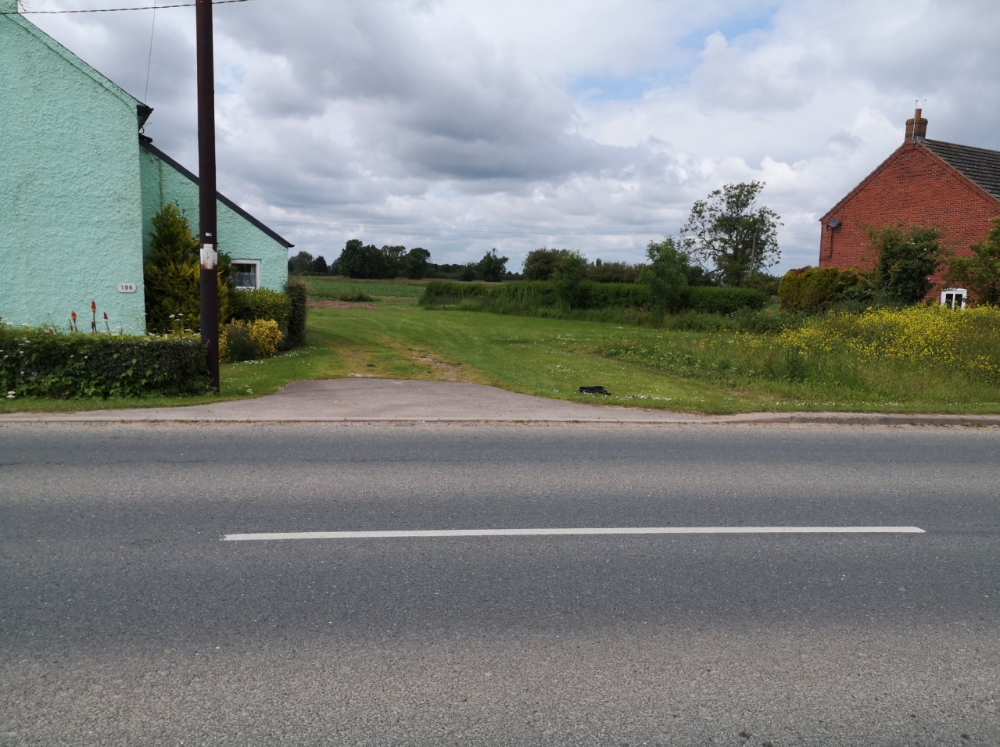

1.0 Introduction :

1.1 The following Design and Access Statement has been prepared to support an Outline Planning Application for residential development at the above address

1.2 The proposal is to create a residential building plot of approx. 0.09ha. (subject to further accurate site survey when the site is cleared) with new / existing vehicle access / egress onto Main Road Quadring Lincs PE11 4PJ

1.3 To be read in conjunction with the following :
Drawing No 681 / LP / BP / 2024
Flood Risk assessment and recommendations on limiting flood damage to building

2.0 Site History :

2.1 Agricultural land

3.0 Site & Location :

3.1 The site is situated on the outskirts of Quadring within South East Lincolnshire Local Plan 2011 – 2036 Adopted March 2019

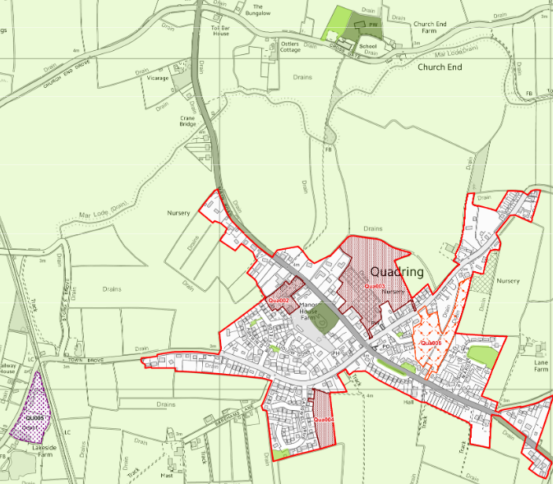

‘A’
3.2 The site is exclusively for a dwelling which is self – build or custom housebuilding, therefore is exempt for Biodiversity Net Gain.
A separate BNG Exemption Statement has accompanied this application

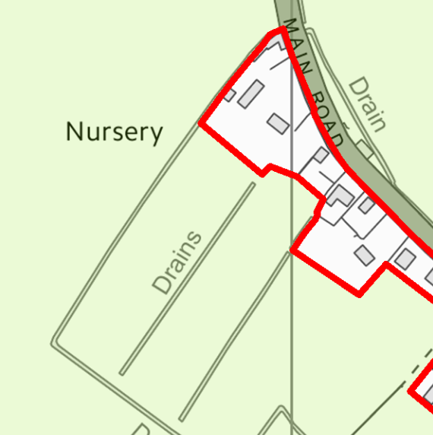

4.0 Amount :

4.1 The applicant is seeking Outline Planning Permission for one building plot for residential use with vehicle access / egress.
See attached drawings 681 / LP / BP / 2024 (indicative dwelling shown is a three bedroom detached bungalow with double garage ) with vehicle access / egress

5.0 Appearance :

5.1 The design & general appearance of the proposed dwelling will be dealt with at Reserved Matters Stage

6.0 Scale :

6.1 This will be dealt with at Reserved Matters Stage ( indicative dwelling shown is a three bedroom detached bungalow with double garage )
7.0 Layout :

7.1 This will be dealt with at Reserved Matters Stage

8.0 Landscaping :

8.1 Landscaping will be subject to a separate landscaping scheme
submitted at Reserved Matters Stage.

9.0 Access & Egress:

9.1 The proposed plot will utilize / increase the existing vehicle access /
egress with addition of tapered and dropped kerbs to suit.
All will be constructed to the Local Highway Authorities
specification.

10.0 Public transport:

10.1 The site is located within walking distance of a local bus service stops

11.0 Disabled access:

11.1 The proposed dwelling will conform to A.D. Part M 2004 Edition of the Building Regulations
A ramped footpath will be provided to the principal access / egress doors
Principle entrance doors will be a suitable width with appropriate thresholds
Internal doors will also be appropriate widths

26th June 2024

