DESIGN AND ACCESS STATEMENT
40 COWBIT ROAD, SPALDING, LINCOLNSHIRE, PE11 2RQ
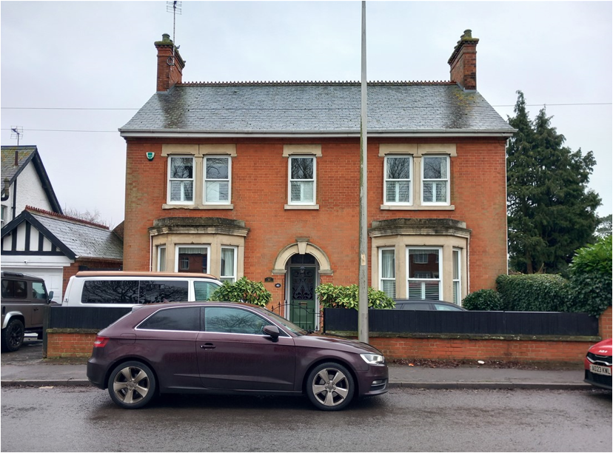
Anglian Home Improvements have been contracted to replace some windows at the property. The existing windows are becoming inefficient, and our customer wishes to upgrade their property accordingly.
We now intend to replace these windows with our white upvc windows that will replicate the ones that are there currently there while giving our customers the much-needed additional warmth and security to the property that double glazing can provide.
The property falls into a Conservation Area, as such the proposed windows will need to be in keeping with the area and its surrounding properties.
Property within the conservation area
SURROUNDING AREA: The surrounding properties are very similar in style and design.
LAYOUT: The new windows will replace the ones in situ and there will be no change in the aperture sizes.
SCALE: The windows will be in proportion to the house as they will be in the original openings. The windows will match in style and design as closely as possible.
LANDSCAPING: Our proposal will not require any landscaping as these are replacement windows.
ACCESS: Access will be gained by entering the property via the main entrance. If any special measures needed are with highways or any other property owners to install the windows or bring materials to site these will be discussed and arranged, as necessary.
APPEARANCE: We appreciate the importance of retaining the properties history and the importance of maintaining its unique features however we would ask that a fair balance is struck between the visual aesthetics of the property and the wellbeing and standard of living for the occupants.
A fair balance needs to be struck between the ideals of historical preservation versus the human rights of individual homeowners.
Our proposed windows are to be white upvc frames with double glazed sealed units.
These quality double glazed windows will enhance the property and the surrounding buildings while giving our customer the much-needed upgrade in performance.
In addition, draught proofing, sound insulation, and security measures will all be improved upon to the benefit of the quality of the life of the homeowners.
The following aspects of the proposal respect or enhance the heritage significance of the item or conservation area for the following reasons.
The new windows will have the same opening designs and will be in the existing brick openings.
The following aspects of the proposal could detrimentally impact on heritage significance. The reasons explained as well as the measures to be taken to minimise impacts.
The new windows will be double glazed, and this may show a little from the outside however this should not detract too much from the originals as they will be in the same style and will look visually improved from the current windows.
Trickle vents have been included as part of the recent legislation on ventilation and are shown on the plans but can be removed or conditioned to not be used if their inclusion is detrimental.
The following sympathetic solutions have been considered and discounted for the following reasons.
Anglian are a Green Deal provider and are environmentally responsible. We work with local authorities across the country and understand the importance of conservation areas. We regularly gain approval for our specialist windows in conservation areas and listed buildings and our products are now being recognised for their improvements in design.
We have tried to produce a range of windows which specifically address the design concerns commonly raised in connection with conservation areas or listed buildings.
DEVELOPMENTS WITHIN OR AFFECTING CONSERVATION AREA, LISTED BUILDING, OR ITS SETTING. We have carefully considered the proposed changes to the property and feel that the new windows should not have a detrimental effect on the property as a whole and its surrounding area or setting as the products are to be sympathetic in design as per the current frames.
Therefore, no additional harm will be caused by these new windows and the public benefit is the property owners can reduce their heating costs then reducing their carbon footprint which will not only help the property owners but the wider community long term.
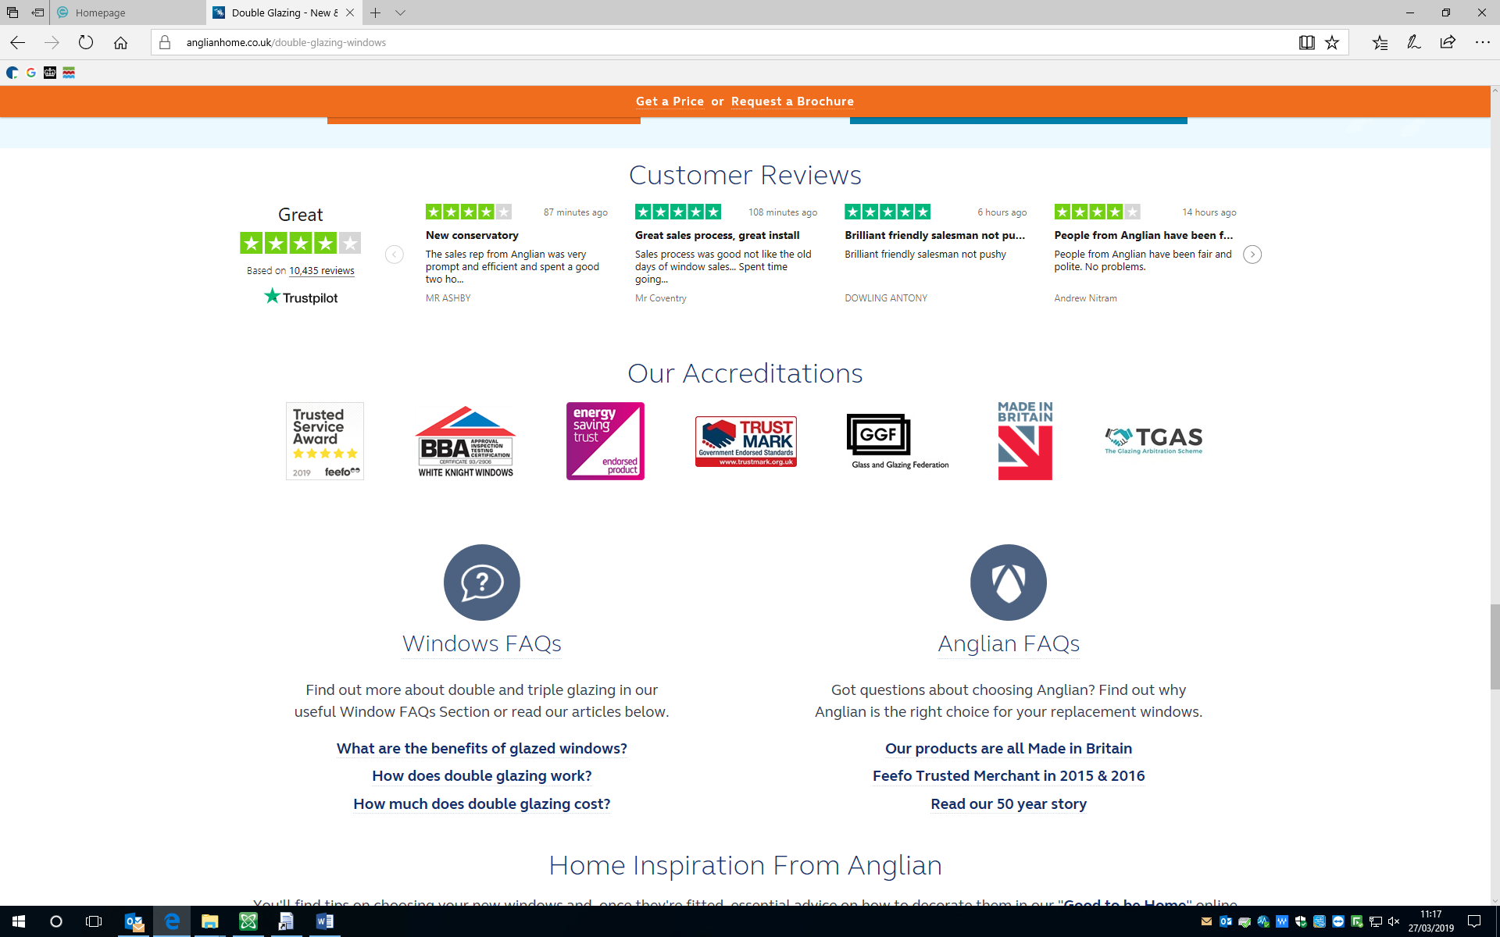

Existing Windows

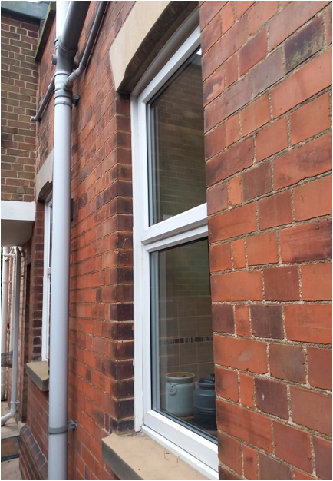
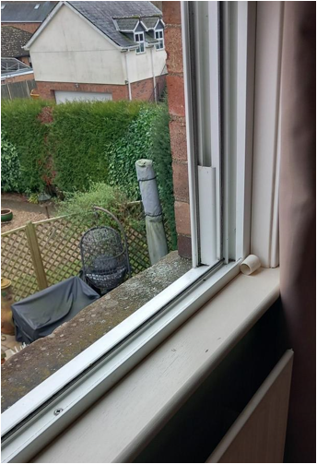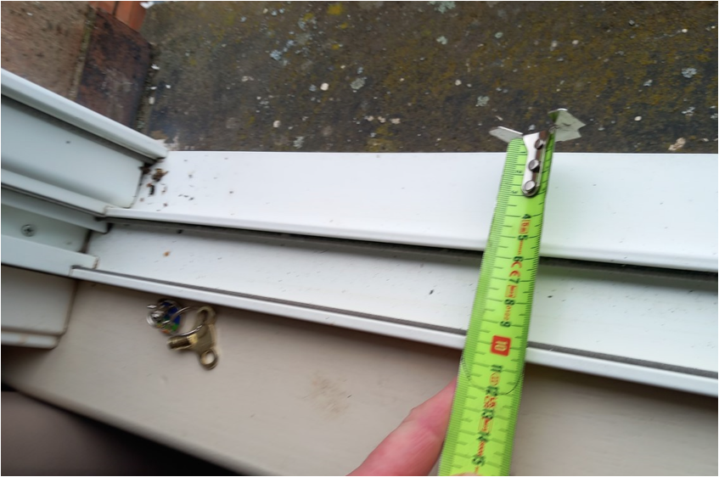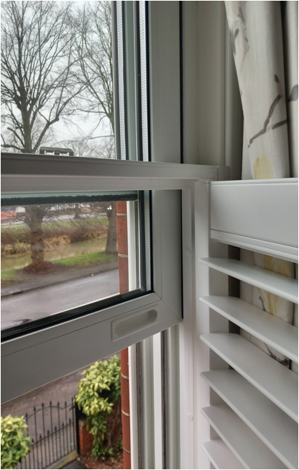

Proposed Plans
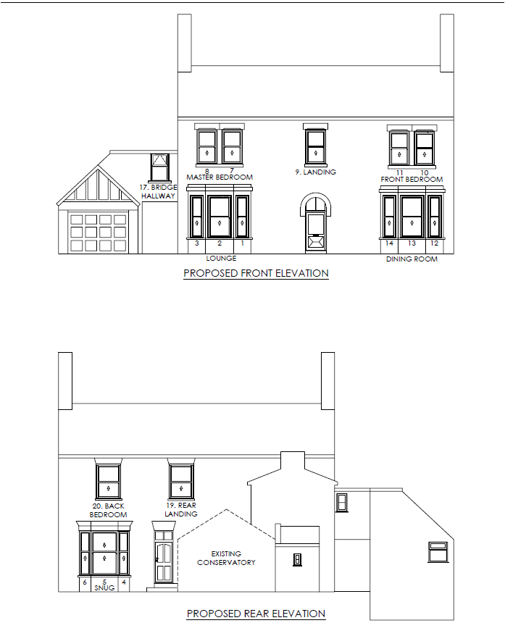
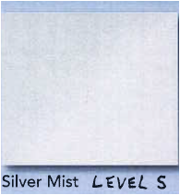 Obscure Glazing

Proposed Plans
