Design and Fire Statement Planning for the replacement of windows at:
40 COWBIT ROAD, SPALDING, LINCOLNSHIRE, PE11 2RQ
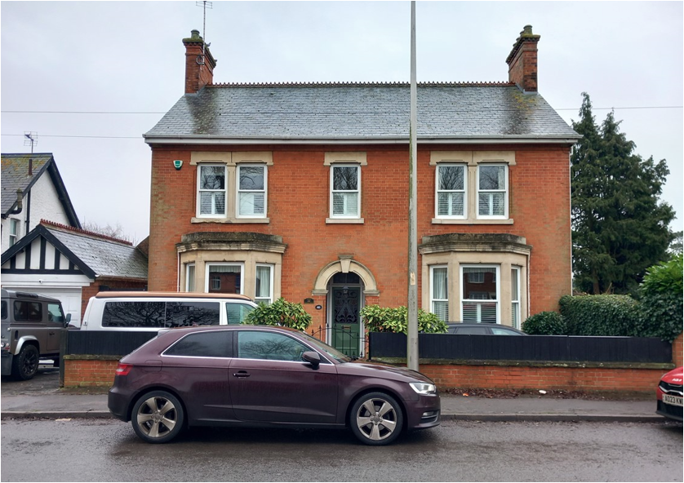
The property has its own entrance and exit doors. Whatever fire and evacuation system is currently in place for the owners of the property will remain intact and will not be altered in any way during the installation by Anglain Home Improvements.
The proposal to replace windows at the property.
The existing windows are to be replaced with high quality products. The new windows will be double glazed and will be much easier to open. The new replacement windows will not reduce or restrict any current means of escape. These new products are to be replaced double glazed units with low emissivity glass to minimise energy use of the house.
The new units will provide better weather proofing and thermal efficiency that the current ones there.
Anglian Home Improvements are FENSA registered.
Conclusion: As the application relates to the replacement windows at the property, there is no requirement for a separate fire statement and the above should be considered as a reasonable exception to the policy below

