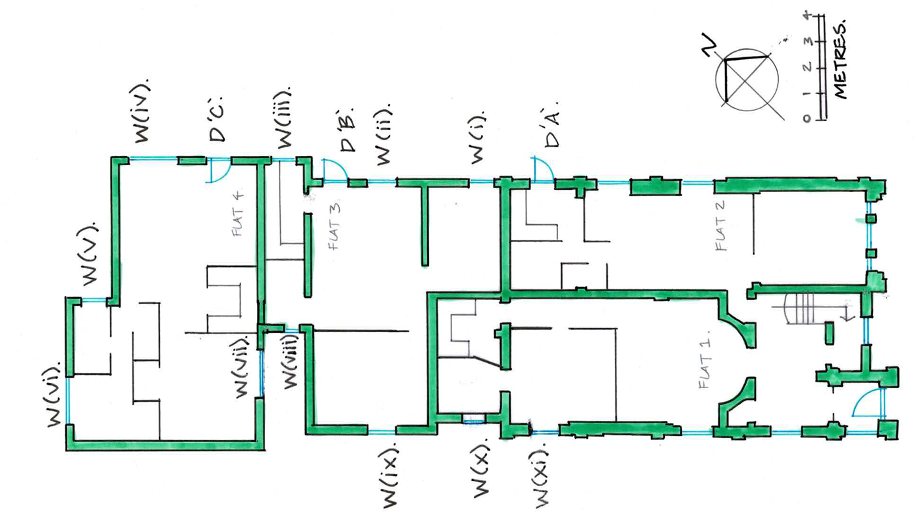
Ground Floor key plan for doors & windows 1:100 @ A3.
DRG No. TM/25/03. 26 March 2025. J.B.

