Heritage Impact Assessment
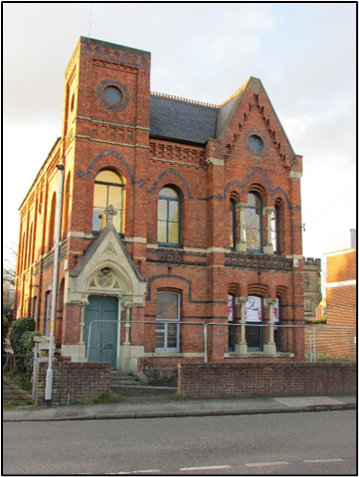
Part retrospective application for replacement fascias, windows & doors at 38 Spring Gardens, Spalding, Lincs, PE11 2XL for Mr Tariq Mahmood.

Jonathan Biggadike
Historic Buildings Consultant March 2025

Contents

1.0 Project Details Page 3
2.0 Introduction Page 3
3.0 Photographic Survey Page 3
4.0 Scope of Works Page 7
5.0 Significance of Heritage Assets Page 8
6.0 Justification & Impact Assessment Page 9

7.0 Conclusion Page 11

References/Bibliography Page 13
Appendices Page 14

Front cover (figure 1)- Principal elevation of the former Fitness Company premises (2021).

1.0 Project Details

Proposal: Replacement fascias, windows & doors (part retrospective).

Location: 38 Spring Gardens, Spalding, Lincs, PE11 2XL.
Client: Mr Tariq Mahmood.

Local Planning Authority: South Holland District Council.

Date: 18th March 2025.

2.0 Introduction

2.1 This report has been prepared to accompany the application for listed building consent for works which, in the main, relate to the modern extension to the rear of the original building. The exceptions to this are the first composite door (flat 2) and the reinstatement of the original opening and the installation of a sliding sash window (W(xi)). This window will match those currently proposed under LBC application (ref. no. H16-0191-25).

2.2 The building was designated as grade II listed in 2021 and is situated within the Spalding town centre conservation area. A Heritage Impact Assessment is therefore required under the recently revised National Planning Policy Framework (NPPF), paragraphs 207 & 213. The cultural and historic significance of the building and its context were considered at length in the comprehensive list description, as well as the Heritage Impact Assessment which accompanied the original applications for change of use and LBC. Subsequently, a Level 2 Building Recording was carried out by Steve Williams of Midlands Archaeological Services. As such, the scope of this report is limited to the windows and external doors which have been replaced. However, for ease of reference, the full listed description and Historic Environment Record entry are included in the appendices.

2.3 This report should be read in conjunction with the Window & Door Schedule together with the detailed drawing supplied by the manufacturer, George Barnsdale. A Key Plan has been supplied to enable cross-referencing.

3.0 Photographic Survey

3.1 Please note the following photographs date from the original assessment, by the author, in October 2021.

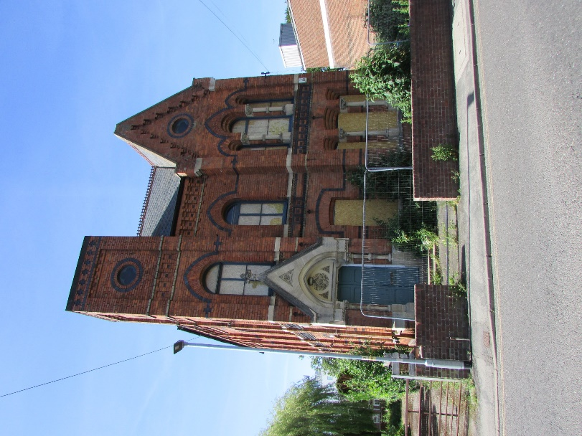
Figure 2 - Principal elevation to Spring Gardens.
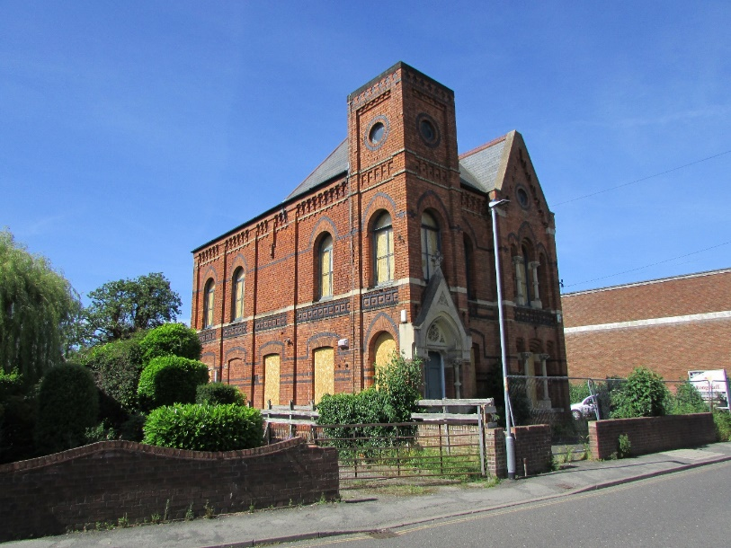
Figure 3 - South-west elevation.
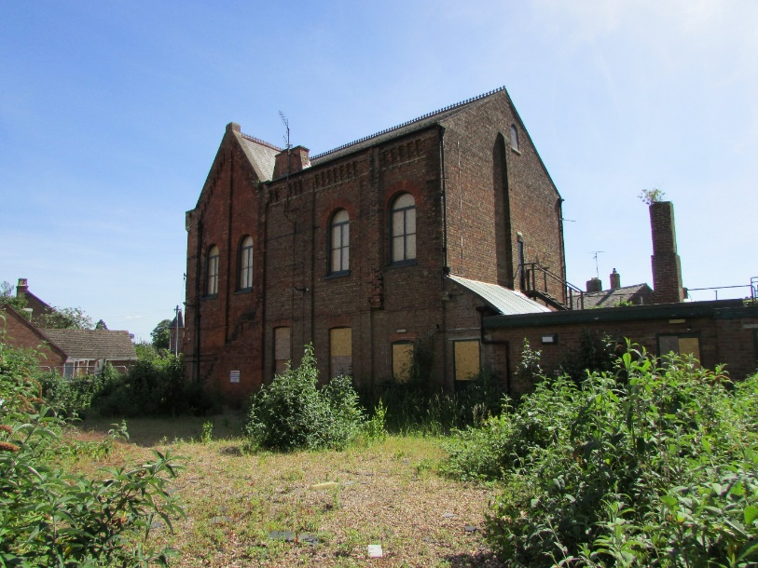
Figure 4 - North-east elevation.

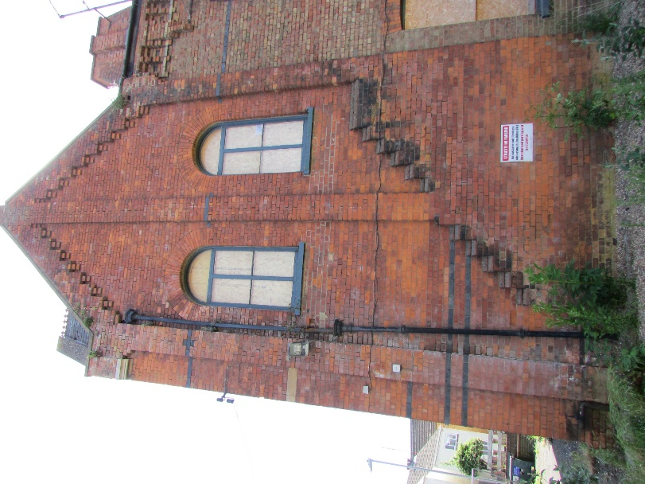
Figure 5 - Close-up detail of North elevation.
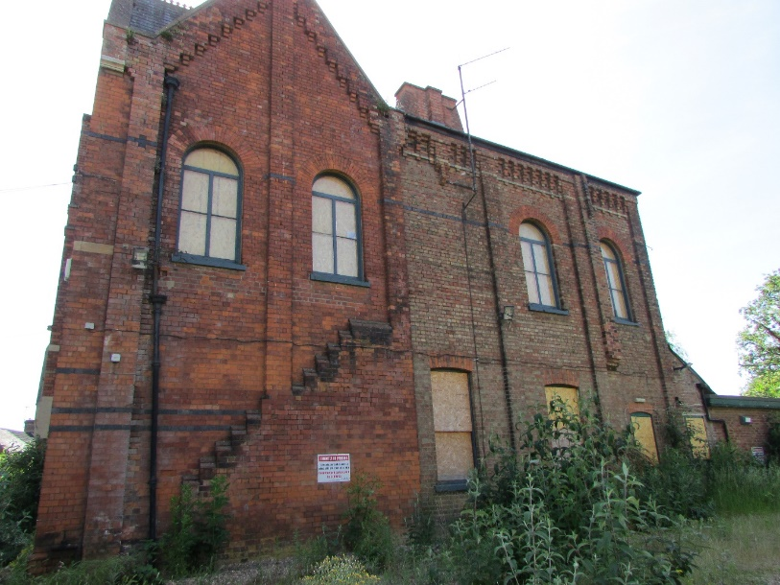
Figure 6 - As above.
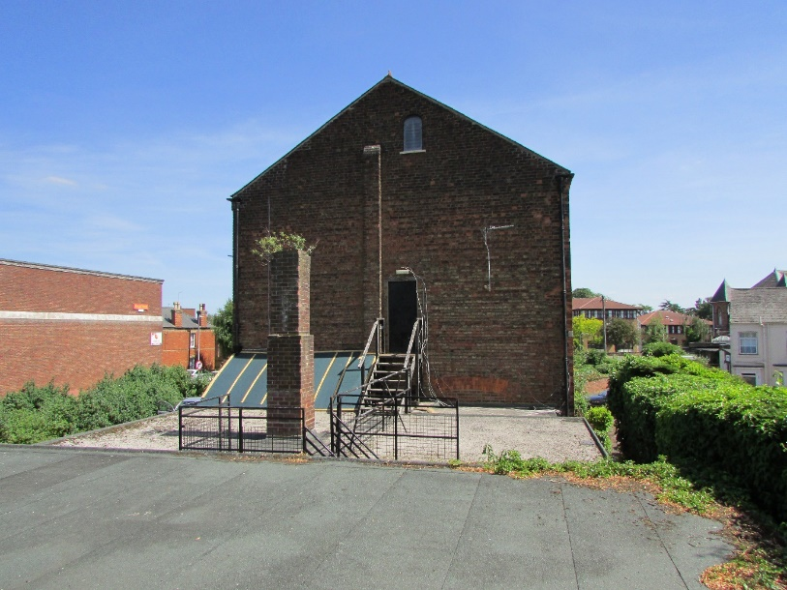
Figure 7 - Northwest elevation.

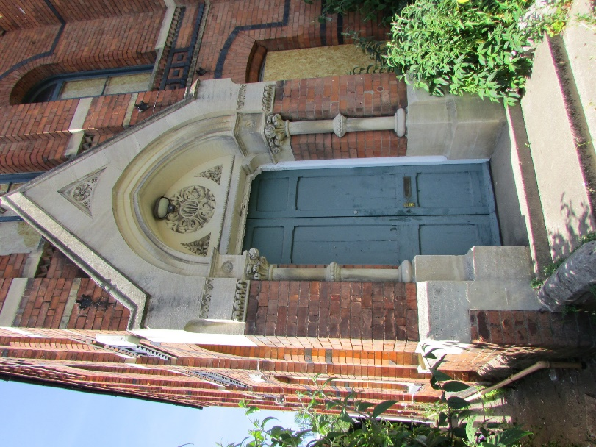
Figure 8 - Entrance porch.

4.0 Scope of Works
4.1 The windows, which have been replaced, were a mixture of timber and uPVC and had been badly vandalised. The replacements, which have already been installed, are white uPVC storm proof double glazed windows with plant-on trickle vents. This application seeks listed building consent for the regularisation of windows W(i) to W(x). It is proposed to replace the new uPVC window W(xi) with a traditionally styled sliding sash to match those adjacent (W14 & 15) which are currently under consideration (see H16-0191-25).
4.2 Subject to approval, the replacement window will also be manufactured by George Barnsdale, using engineered softwood timber which is FSC certified. All casements will be fitted with 16 mm, argon filled, double glazed gaskets. All to be finished with 4 no. coats of microporous paint (colour: Traffic White, RAL 9016). As illustrated on page 10, the sash window will have a swept head to match the profile of the cambered arches. The sash window will be fitted with discreet trickle vents.
4.3 To install the larger sliding sash window will require the careful dismantling of the brick infilling above and below the existing upvc window, as well as the visible concrete lintel. A small area of brickwork above the arch bulges out and so it is recommended that this is carefully dismantled by hand and re-laid using a matching lime mortar and brick bond. Under no circumstances should an Ordinary Portland cement mortar be used. A structural engineer will be required to advise on the necessary (and discreet) support required for the reinstated opening.
4.4 This application also seeks to regularise the external doors for flats 2, 3 and 4 (refs D(A), D(B) & D(C) respectively). These are composite engineered doors with a traditional appearance and a matt black finish (RAL 9005) with a Traffic White painted finish to the frames.
4.5 The final element of the works, highlighted by the enforcement officer, was the replacement white upvc fascias fitted around the flat roof of the modern extension. This replaced a dark painted plywood. It is proposed to retain this feature but apply a an appropriate upvc paint to reduce its visual impact. The chosen paint, by Kolorbond, has a matt black finish which is UV resistant and long lasting.

5.0 Significance of Heritage Assets

5.1 Significance can be defined as the sum of the cultural values which make a building or site important to society. When assessing significance numerous aspects are considered including age, rarity and intactness as well as architectural interest, historic interest, group value, social value, former uses and local distinctiveness. These aspects can be grouped under a series of 4 values outlined in Historic England’s Conservation Principles, Policies & Guidance (2008). These are explained below:

Evidential – ‘the potential of a place to yield evidence about past human activity’.

Historic – ‘the ways in which past people, events and aspects of life can be connected through a place to the present’.

Aesthetic – ‘the ways in which people draw sensory and intellectual stimulation from a place’.

Communal – ‘the meaning of a place for the people who relate to it, or for whom it figures in their collective experience for memory’.

5.2 The values given to each fall into the following 5 categories:

high/medium/low/neutral/intrusive.
High - a theme, feature, building which is important at national or international level, with high cultural value and an important contribution towards the character and appearance of heritage asset and its setting.
Medium - themes, features, buildings or spaces which are important at regional level or sometimes higher, with some cultural importance and some contributions towards the character and appearance of the heritage asset and its setting.
Low - themes, features, buildings or spaces which are usually of local value only possibly of regional significance for group or their value. Minor cultural importance and contribution to the setting or appearance of the heritage asset and its setting.
Neutral - these themes, spaces, buildings of features have little or no cultural value but do not detract from the character or appearance of the heritage asset and its setting.
Intrusive - themes, features, buildings or spaces which detract from the values of the heritage asset, its setting, character and appearance. Efforts should be made to remove or enhance these features.

5.3 The former Christian Association & Literary Institute building is a prominent and important High Victorian Gothic building. By virtue of its height, massing, fine detail and former communal uses it possesses high levels of interest.

5.4 The Historic England list description for the former Christian Association & Literary Institute is very comprehensive and, for ease of reference, is included in full in the appendices. As well as describing the building, it also provides a good insight into the significance of the building. It describes the Institute as a ‘visually arresting’ composition which demonstrates a high level of craftsmanship and has a good level of surviving historic fabric. Its historic value is as an illustration of the continued cultural and educational provision by the church towards the end of the 19th century. It unquestionably has a high value in each of the significance categories which has merited its designation as a grade II listed building’.

5.5 Unfortunately, the condition had deteriorated dramatically since the listing due to persistent anti-social behaviour and vandalism, including graffiti, destruction of floors, theft and the smashing of doors and windows. This has resulted in the lowering of the evidential value and particularly the aesthetic value of the interior.

5.6 The comparatively modern flat roofed extension to the rear of the historic building is an inappropriate and unsympathetic addition to the listed building. Its form, mass and detail are clearly utilitarian and at odds with the host building. It is therefore an intrusive feature on the designated heritage asset.

6.0 Justification & Impact
6.1 This current application follows preliminary enforcement action regarding unauthorised works, primarily to the modern rear extension. These works were carried out unwittingly by the developer, even though a positive dialogue had been established with the conservation officer regarding the replacement of windows to the original institute building with matching double glazed timber framed units. It was agreed, in principle, that the replacement of the specified windows and the existing pair of doors at the main entrance, with a single matching panel door, was acceptable, subject to detail and the necessary LBC application. These works are currently being considered by SHDC under listed building consent application reference H16-0191-25.

6.2 As already stated, the extension to the rear is modern and an inappropriate addition to the host building in terms of its form and detail. It is perhaps an anomaly that it was not excluded from the spot listing. Fortunately, it is located to the rear and will not be visible from the public realm once the adjacent development is completed, and boundary fence erected. The applicants clearly recognise their error and now seek to regularise and resolve some of the conservation and design issues.

6.3 The windows proposed as part of the currently pending application are of exceptional quality, produced by a local manufacturer George Barnsdale who have a national reputation.

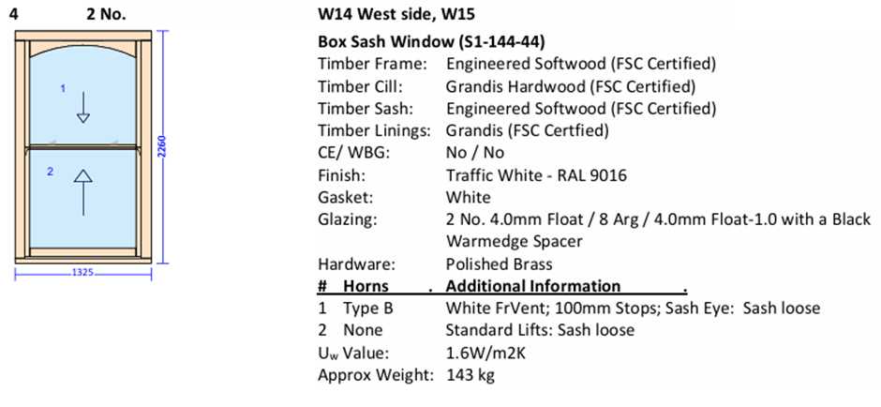
Figure 9 – Proposed George Barnsdale window for W14, W15 & W(xi).

6.4 This application seeks to regularise the three doors and all of the aforementioned windows except W(xi) which is on the original building. This is to be replaced with a sash window to match W14 and W15, as illustrated above.

6.5 The doors are a good quality engineered composite with a traditional appearance, not dissimilar to what was there previously. They are black to match the front door and have a uniform and consistent appearance. They are admittedly a modern treatment but in a modern extension located out of sight to the rear of the heritage asset. Admittedly, one of the doors is within the original footprint but, again, it will be out of sight. Each of the doors represents a modest enhancement improvement with improved security and daylighting.

6.6 Storm proof upvc windows are a well-established treatment for modern buildings and even occasionally for modern extensions to listed buildings. The grade II Bank House at , Gosberton (LEN 1064464) As a nearby example of this.

6.7 Several of the new windows are not visible from any public viewpoint or private garden. Windows (iii) and (iv) are currently visible across the former car park but will not be visible once the neighbouring site is developed. The willingness of the applicant to remove the new window in the previously infilled arch W(xi) is a significant enhancement to the host building, reinstating the original aesthetic and detail as well as an opportunity to repair the defective brickwork above and installing a window of the highest quality. It also represents a significant benefit for future occupants. This window is close to the shared boundary with the adjoining dwelling and so to avoid overlooking and protect the amenity of the neighbours the lower sash will be fitted with obscured glazing.

6.8 Considering the modern character of the building and its flat roof construction the replacement of the fascia was necessary. Whilst the applicant now understands that consent should have been sought first, he seeks to regularise this feature. However, to reduce its visual prominence in the short term it is proposed to paint the fascias with a matt black paint to help it recede visually.

7.0 Conclusion

7.2 The NPPF states that ‘where a development proposal will lead to less than substantial harm to the significance of a heritage asset, this harm should be weighed against the public benefits Including, where appropriate, securing its optimum viable use.’ The on-going conversion, refurbishment and reuse of the building will help to ensure its long term future and remove it from the Building at Risk (BAR) category.
7.3 The argon filled units in the modern extension will provide a significant upgrade in the thermal efficiency and performance of this part of the converted building, reducing its carbon footprint. This is all in accord with the requirements of The Historic England Advice Note (HEAN) 18 Adapting Buildings for Energy & Carbon Efficiency which has only recently been published. It complements the British Standard Institutions PAS: 2035 2023 Standards & Guidance on retrofit in domestic buildings. Both documents recognise the need for improved thermal performance to address climate change, advocating a holistic approach which is sensitive to the historic fabric and significance of heritage assets.

Jonathan Biggadike PG Dip LA CMLI
Historic Buildings Consultant & Chartered Landscape Architect
Affiliate member of the Institute of Historic Building Conservation

Dragonfly Building Conservation & Landscape Design Ltd
Registered Office: 6 Scoldhall Lane, Surfleet, Spalding, Lincolnshire, PE11 4BJ.
T: 01775 680595 M: 07772 509351 E: jbiggadike@outlook.com

References/Bibliography

Consultants’ Reports
Heritage Impact Assessment. October 2021. Jonathan Biggadike.
Level 2 Building Recording for 38 Spring Street, Spalding. Midland Archaeological Services. May 2024. Author Steve Williams.

National Policy & Guidance
Historic England. Conservation Principles, Policy & Guidance for the Sustainable Management of the Historic Environment. Pub. 23 April 2008.

Historic England. Statements of Heritage Significance: Analysing Significance in Heritage Assets. Published 21 October 2019.

Historic England. Historic Environment Good Practice Advice (GPA) in Planning 2: Managing Significance in Decision - Taking in the Historic Environment. 27 March 2015.
Historic England. Adapting Buildings for Energy & Carbon Efficiency (23 July 2024).
BSI - BS 7913 Guide to the Principles of the Conservation of Historic Buildings (Dec 2013).
Historic England Advice Note (HEAN) 2 Making Changes to Heritage Assets.
British Standard Institution PAS: 2035 2023 Standards & Guidance on retrofit in domestic buildings.

Appendices

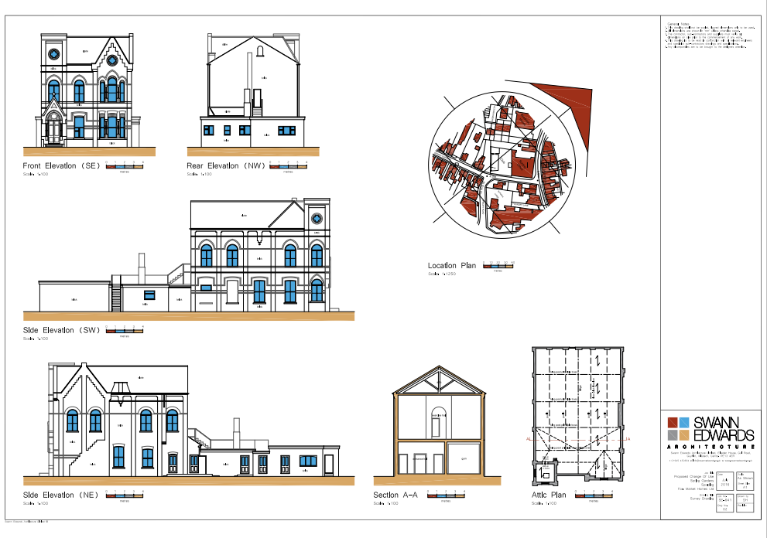

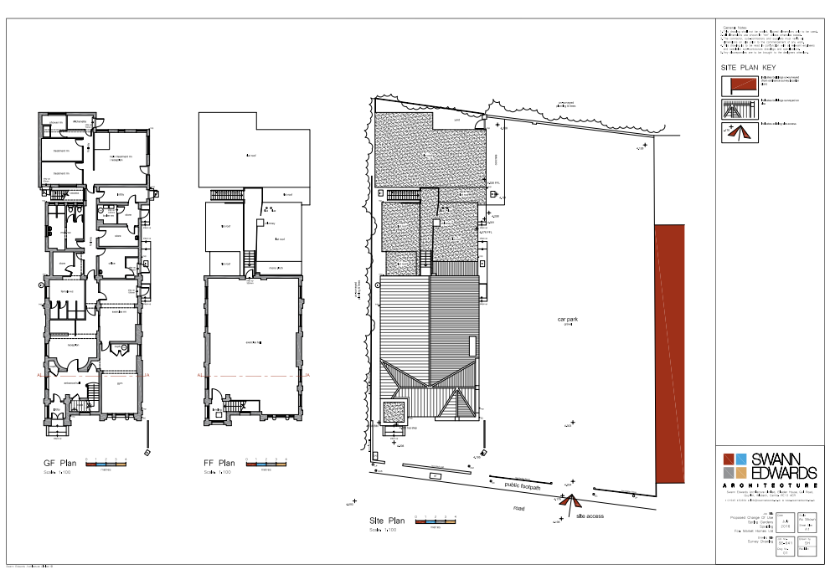

List description
- Location
Statutory Address:
38 Spring Gardens, Spalding, Lincolnshire, PE11 2XL
The building or site itself may lie within the boundary of more than one authority.
County:
Lincolnshire
District:
South Holland (District Authority)
Parish:
Non-Civil Parish
National Grid Reference:
TF2459622548
- Summary
Former Christian Association and Literary Institute built in 1871.
- Reasons for Designation
The former Christian Association and Literary Institute, built in 1871, is listed at Grade II for the following principal reasons:
Architectural interest:
* it has a visually arresting composition with the entrance bay assuming the appearance of a square tower which is beautifully balanced by the gabled end bay lit by two sets of tripartite windows in different styles; * it is unified by finely detailed ornamentation carried out in stone, moulded red brick and vitrified brick, creating a textural richness and demonstrating a high level of craftsmanship; * internally, the first-floor lecture hall remains as an impressive open space, and overall the original configuration is legible with a good proportion of the historic fittings surviving, including the staircase, moulded window surrounds, panelled doors and ceiling roses.
Historic interest:
* it is illustrative of the cultural provision that was made for communities as well as the dominance of the church during this period. Its impressive elevations were clearly intended to make a statement about the importance of literary and religious activities, and to attract new patrons.
Group value:
* it has group value with the Sessions House (1843) and the Police Station (1857) which are both Grade II listed and visible from the rear of the Institute to the north.
- History
Spalding is an old established market town situated on the River Welland some ten miles from its outfall in the Wash. The town was once a thriving port and a former seat of a powerful monastic order. The former Christian Association and Literary Institute (the Institute) bears a date stone of 1871. It was described in Kelly’s Lincolnshire Directory as ‘a building of red brick, in the French Gothic style, and contains lecture hall, reading and class rooms, with a library of 1,351volumes, and a residence for the caretaker’. The architect is not known. Institutes were often modest buildings but they could sometimes acquire architectural pretension and reflect confident working communities. They frequently served various functions and it is possible that the Institute was associated with the nearby Methodist Church to the north-east (since demolished). During this period many parish churches acquired a suite of ancillary buildings to accommodate a range of non-liturgical activities for which the main church was deemed unsuitable.
The Institute is depicted on the first edition Ordnance Survey (OS) map of 1889 as a long rectangular building with a narrow rear projection which may have been the caretaker’s residence. The footprint of the building does not change on the second and third editions of 1904 and 1931 but by the 1968 edition the rear projection has been rebuilt and enlarged. By the 1974 map it has again been extended to the rear. At some point around the 1930s the Institute was used as the Geest Social Club for the next fifty years and was then acquired by the Spalding Fitness Company in the late 1980s. It has been vacant for the past few years.
- Details
Former Christian Association and Literary Institute built in 1871.
MATERIALS: rich red brick laid in English bond with dressings in red brick, vitrified brick and limestone.
PLAN: the building has a narrow frontage facing south-east onto Spring Gardens and a long rectangular plan with rear extensions added in the second half of the C20.
EXTERIOR: the former Institute is in a flamboyant Venetian Gothic style with two storeys and an irregular three-bay facade. The floors are demarcated by a mixture of stone bands, brick cogging, and rows of sunken brick panels or square panels of vitrified brick which give the impression of coffering. The building has a pitched roof across the frontage with fleur-de-lis ridge tiles and a parapet at the north-east gable. The roof running at right angles along the rear is plain, although the eaves on the side and front elevations are embellished with brick machicolations.
The first bay is in the form of a three-stage square tower with an elaborate entrance on the ground floor. The double-leaf six-panel door has chamfered edges to the panels and is positioned under a kneelered stone gable with stone coping and a fleur-de-lis finial. The gable has a carved floral design in the gable head and waterleaf enrichment along the bottom. Set within the gable is a pointed arch resting on stone columns with Corinthian capitals and annulets. The recessed tympanum of the arch contains a circular date stone with the date 1871 surrounded by foliate carving; and the bottom edge is carved in a delicate chevron. The second and third stages of the tower have a recessed central panel. The second stage is lit by a four-pane window with wooden glazing bars set under a semi-circular brick arch of rubbed red brick with a pointed arch of vitrified brick above. The third stage of the tower contains a blind oculus with a double circular surround of brick headers. The second bay is lit on the ground floor by a tall window (not original) with a cambered top and gauged brick arch, under a band of vitrified brick which continues across the third bay. The first floor is lit by a semi-circular arch window under a pointed arch of vitrified brick which also continues across the third bay to form the window arches. The third gabled bay has tripartite windows on both floors in a slightly different design. Both have two mullions in the shape of stone columns (like those flanking the front door) but the ground floor windows have cambered upper sections whilst those on the first floor have pointed arches. The kneelered gable head is pierced by a blind oculus. It appears to have been originally surmounted by a finial but this has been removed.
The left return (south-west elevation) is divided into five bays by brick piers. On the ground floor the window in the first bay has been bricked up and a small horizontal window inserted in the C20. The second bay was originally bricked up and the next two bays are lit by one-over-one pane horned sashes with cambered upper sections. The first floor is lit by four-light windows with semi-circular upper sections, except for the third bay which is blind. Above all the windows are vitrified brick arches which continue across the elevation. The fifth bay consists of the tower which has the same treatment as on the front elevation, except the ground floor is lit by a semi-circular arch window.
On the right (north-east) return the gable end forms the first two bays which are divided by brick piers and lit by four-pane windows with semi-circular overlights under gauged brick arches. The position of the internal staircase is articulated by a diagonal line of stepped brick. Following this the elevation becomes plain in detail and is faced in inferior brick probably because it would not have been visible when first built due to the close position of an adjacent building (since demolished). It is divided into three bays by brick piers and lit by a combination of sash windows with cambered upper sections and fixed light, semi-circular arch windows. The rear C20 single-storey brick extensions are of standard construction and have flat roofs and are not included in the listing. INTERIOR: this retains numerous historic features including skirting boards, dado rails, picture rails, cornices and four-panel doors with chamfered edges to the panels. The small entrance lobby has a geometric tiled floor and leads into the entrance hall which provides access to the ground floor rooms and the staircase to the first floor. The closed well, quarter turn stair has a balustrade on the lower end with two balusters per tread that extend below the tread ends. The handrail twists at the end and is supported by a circular newel post with numerous annulets.
The first floor is one open space which presumably was the lecture hall. The high ceiling has a coved cornice and three intricately patterned ceiling roses where gas lights would previously have hung. The moulded window frames have recessed panels. The ground floor presumably contained the reading room, classroom and library but there are no surviving fixtures to indicate their former usage. The room in the south-east corner has been partitioned to create WCs but retains its cornice and two ceiling beams supported by pairs of shaped brackets.

