Landscape Management Plan
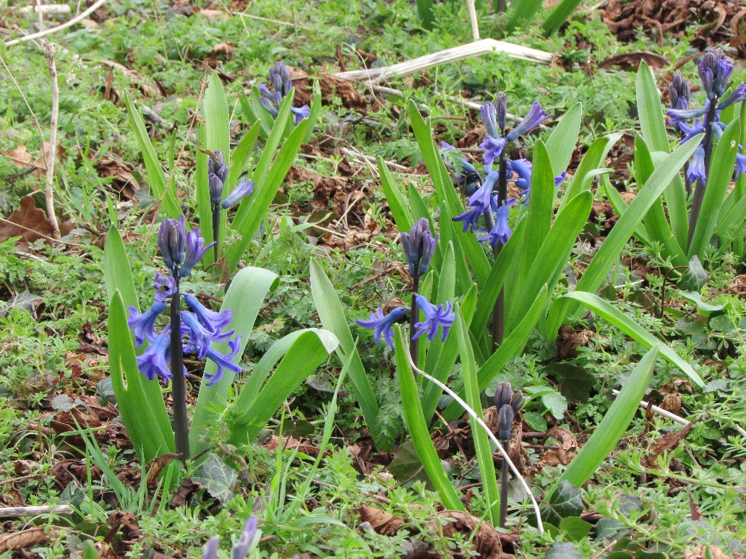

Proposed residential development
Parkside Crescent, Spalding, Lincolnshire, PE11 1RA.

Welland Homes Ltd

Jonathan Biggadike Chartered Landscape Architect April 2018

CONTENTS
1.0 Introduction Page 3
2.0 Aims & Objectives of the Landscape Proposals Page 3
3.0 Delivery Page 4
4.0 Landscape Planting Areas Page 4
5.0 Management Objectives & Regimes Page 5
- Proposed Specimen Tree Planting
- Proposed Native Hedgerows
- Proposed Ornamental Shrubs/Groundcover
- Amenity Grass & Bulbs
- Fencing & Gates

6.0 Integrated Pest Management Page 12
7.0 Implementation, Monitoring and Review Page 13

Appendices -
Soft Landscape Specification Page 15
Schedule of Maintenance Operations Page 17
Quantities/ Planting Schedule Page 19

1.0 INTRODUCTION
1.1 This report forms part of the submission to satisfy Conditions 8 & 10 of the planning approval H16-1245-16 granted on 7th March 2017. This application relates to the construction of 10 dwellings, vehicular access and the provision of parking courts. Condition 8 of the consent requires the provision of a detailed landscaping scheme to complement the development. Condition 10 requires the submission of a Landscape Management Plan including details of landscape maintenance.
1.2 This document should therefore be read in conjunction with the Landscape Masterplan (drawing no. WH/18/01) and the Detailed Planting Plans (drawing no. WH/18/02).
1.3 This report will endeavour to provide a design rationale for the proposed planting and other mitigation measures to help assimilate the proposals into their setting. The planting proposals submitted are a fully detailed scheme which can be implemented on site following the construction phase. The detailed proposals have been prepared to ensure the specified planting improves biodiversity and is beneficial to wildlife.
1.4 This Landscape Management Plan (LMP) will outline the management objectives and maintenance operations necessary for each type of planting. This it is hoped will ensure a successful establishment phase followed by a coordinated and consistently high standard of management beyond that initial period.

2.0 AIMS & OBJECTIVES OF THE LANDSCAPE PROPOSALS
2.1 As outlined below we hope to demonstrate that the chosen philosophy is well-conceived, appropriate for the site and in accordance with the requirements of both local and national guidance.
- Develop a verdant and robust landscape setting for the development which acts as a soft foil for built elements.
- Comply with the requirements of the Secure by Design initiative to create a safe environment for both residents and visitors. This is to be achieved by the clear delineation of defensible space, the use of deterrent planting, optimising sightlines for pedestrians, and the elimination of blind corners and hiding places.
- Introduce a reasonably wide variety of trees and shrubs to enhance visual interest and seasonal variety which, in turn, should safeguard against significant loss through disease or climate change.
- Introduce new structure planting to define the development edge and help assimilate it into its wider context.
- All new native planting to be of British provenance and should include less commonly used varieties e.g. Midland hawthorn (Crataegus laevigata).
- Create habitats, such as hedgerows, which can support populations of beneficial predator species to control common pests. Habitats which provide a nectar source, shelter and additional prey species all have the potential to increase beneficial predator numbers.
- Less intensive management of the native hedgerow to increase numbers of beneficial predators.
- Where possible protect new planting from vandals and browsing animals and pests including rabbits, roe and muntjac deer.

2.2 The preparation of the detailed planting proposals and the landscape management plan include a firm commitment (in accordance with the planning consent) that any defective planting is replaced, augmented and/or improved over time as appropriate. It also highlights legal obligations in relation to the duty of care to the public. Given the degree of public access there is a duty of care that all landscape components are safe and that all reasonable steps are taken to minimise risk of injury and damage to people and property.
2.3 Overarching all this the LMP provides a mechanism for monitoring and review. The commitment to this document ensures that management practices are monitored and, where necessary, reviewed on an annual basis in accordance with changing site circumstances and the views of key stakeholders.

3.0 DELIVERY
3.1 Welland Homes Limited will organize, oversee and finance maintenance and management operations on the estate development. The maintenance of private gardens will be the responsibility of the incoming residents as part of their tenancy agreements. The appointed landscape contractors will implement the proposed planting scheme and then manage and maintain it in perpetuity. This arrangement will ensure the planting areas are constantly monitored throughout the establishment phase and consequently any issues or problems that might arise can be dealt with in a prompt and appropriate manner.

4.0 LANDSCAPE PLANTING AREAS
4.1 The landscape areas subject to this Landscape Management Plan include the following components:
- Mixed native hedgerow beside Stepping Stone walk (public right of way).
- Thorny/deterrent boundary hedges.
- Limited specimen tree planting.
- Ornamental hedges and shrub beds including herb garden planting, low maintenance ground cover and specimen shrubs.
- Private lawns, amenity grass and spring bulbs.

5.0 MANAGEMENT OBJECTIVES & REGIMES
5.1 The following sections provide a description and specific management objectives for each landscape component along with the annual and occasional management regimes required. This section should be cross-referenced with the Schedule of Management Operations included in the Appendices.
5.2 Existing/Mature Trees
Description – There are a limited number of retained trees just beyond the northern boundary of the application site and also street trees to the west fronting Park Road.
Management Objectives
The management objectives for retained trees are to: Maintain the trees in as healthy and attractive condition, to ensure continuity in tree cover and their contribution to the landscape structure, biodiversity, and screening/amenity value of the site; and ensure that trees are healthy and safe, particularly in places close to public rights of way.
Annual Works
- Visual Inspection: Trees should be regularly visually checked for the presence of any diseased or rotten wood; fungal or other infections/disease; and stability. If any such issues are identified, then the advice of a qualified arboriculturist should be sought immediately.
- Annual Arboricultural Assessment: In any event, an Arboricultural Assessment should be undertaken once annually by a qualified arboriculturist inspecting the condition of existing trees including any cause of increased risk to people or property. Furthermore, during the Arboricultural Assessment, the health of the trees shall be monitored and any works required for health and safety or to promote the health and sustainability of existing trees shall be identified, scheduled and actioned at a suitable time of year following application and granting of appropriate consents by the LPA.

5.3 Proposed Specimen Trees
Description – Very limited new tree planting is incorporated to provide vertical interest and amenity value. Such tree planting will provide a soft foil to the built forms, particularly to the blank gable facing Park Road.
Management Objectives
The management objectives for new tree planting is to: Ensure the satisfactory establishment and growth of new tree planting typical of the respective species; Promote conditions so that trees are healthy and safe; and Ensure continuity of the design approach and amenity value of tree planting.
Annual Works
- General tree maintenance during establishment: Check all trees for firmness and stability in the ground. Check and adjust tree ties, replacing if necessary. Top up bark mulch levels where necessary around the base of new trees, using the same or similar product to that previously supplied to maintain an approximate depth of 50mm to reduce competition from weeds and retain soil moisture. Where trees are in grass areas, remove weed growth by hand and retain a circle of bark mulch (approximate radius of 500mm) to aid mowing and prevent damage to the main stem. All trees shall be fertilised using a suitable and approved liquid feed (N10:P15: K10) at a rate of 60g/m² during early May and again in late September. Prune back any diseased or rotten wood (including the removal of main stems and limbs) back to sound wood as required. Remove all cut material from site.

- Watering trees: Water trees during dry periods (being any period without substantial rainfall for 14 days or more), until trees are successfully established. Water at a rate of 25 litres per tree position into watering tubes, if installed. Apply water at a frequency of once per fortnight from April to the end of September (to a maximum of 15 visits). Increase watering frequency during any continuous hot weather lasting more than 7 days. The frequency of these visits will vary according to climatic conditions. Where restrictions are placed on the use of water, sources and costs of obtaining second class water shall be investigated. Any tree failures or excessive die back from drought stress will be made good.

Occasional Works
i) Checking and removal of tree stakes and ties: Review the need for tree stakes and ties annually for up to 6 years. Remove stakes and ties between 4 to 6 years after planting, but be sure trees are firm and stable. Stakes and ties removed shall be cut at ground level, below lowest grass height (to prevent snagging mower blades) or pulled from the ground and the post holes filled with suitable topsoil. If the tree is found to be weak or unstable after the stakes have been removed, then check the base of the tree for signs of rot. If rotten or unlikely to stabilise, remove the tree and replace. If the tree is free from rot or other cause of its instability, then reinstate a tree support, using 100mm diameter chestnut stake and single tie. The stake should be pushed into the ground with a post rammer, to a depth of 600mm and cut to one third the height of the tree. Fix the tree stem with a rubber tie and spacing device attached to at a point no more than 25-35mm below the top of the post, to prevent chaffing against the post in high winds. Remove old posts and ties and arisings and dispose off site.
ii) Long-term tree surgery works: After 10-20 years of maintenance as above (or earlier if required), newly planted trees will reach semi-maturity and may need corrective surgery. Trees should become subject to the annual Arboricultural Assessment and any works recommended shall be carried out in accordance with previous recommendations.
iii) Tree replacement and enhancement of tree cover: Any tree that dies or is necessarily felled, but which is not removed as part of a programme of tree removals, shall be replaced with a tree of appropriate species and stock size. Such replacement shall be with a tree of either the same or similar species as those existing. The option for replacing with a different species is to allow some flexibility avoiding problems encountered with 'Same Species Disease' and to ensure sustainable tree cover in the interests of visual amenity. Possible damage to drainage/services and adjoining building foundations must be considered before choosing a replacement tree species and location. Where alternative species are being considered, then the species should be suitable to the character of the location and adjoining trees. Once annually the site shall be considered for the need for any strategic replacement or enhancement planting, to broaden the age diversity of trees and tree groups, in the interests of the long-term sustainability of strategically important vegetation. Trees should be a minimum stock size of standards (10-12cm girth), and implemented and maintained in accordance with good horticultural practice. Replacement and enhancement planting is best undertaken during the planting season (November through to March inclusive).

5.4 Proposed Native Hedgerow
Description - New mixed native hedgerow is proposed alongside the existing public right of way leading to Stepping Stone Lane footbridge. It will provide enclosure and screening, as well as a deterrent to miscreants. The new hedgerows will consist of a mix of native species providing optimum value to wildlife, providing both shelter and food.
Management Objectives - The management objectives for new hedgerow planting is to: Ensure the satisfactory establishment and growth of new hedgerow planting with specified heights (see below), form and density according to species; Maintain planting in a healthy and attractive condition of value to wildlife.
The following hedge heights are recommended: 1.8-2.1m beside the rear boundary fence to plot 5droping down to 1-1.2m at the southern end of the parking court.
Annual Works
- Weeding and general maintenance: Remove all weed growth by hand as necessary to ensure weed free and tidy planting areas. Seven visits are required per growing season. Visits should occur approximately monthly in the growing season, subject to weather conditions from April to October, with an extra visit outside of the growing season in December or January to inspect the condition of the beds. Take great care not to disturb sheet or bark mulch; top up bark mulch levels where necessary for the first 3 years, using the same or similar product to that previously supplied to maintain an approximate depth of 50mm to reduce competition from weeds and retain soil moisture. Note: For planting using a non-biodegradable weed suppressant membrane, reduce visits to 4 times per year in the growing season. Where a biodegradable weed suppressant fabric has been used, this will have disappeared within the establishment phase. Weeding frequency should therefore be varied according to the site and density of vegetation cover and in any event, should be between 4 and 8 i.e. whatever is required to achieve a weed free scheme. All weeds shall be removed from the site.
- Cutting / trimming of hedges: Cut native hedgerow is no more than once a year, outside the bird nesting season. Cut larger stems, and prune any diseased rotten wood back to sound wood. Remove all cut material from site.
- Watering of hedgerows: Water hedges during dry periods (being any period without substantial rainfall for 14 days or more). Water shrubs to field capacity (minimum 10 litres per m²) applying water in the morning or early evening to reduce evaporation. Apply at a frequency of up to 2 times per week from April to the end of September (to a maximum of 20 visits in any one calendar year) as required during any continuous hot weather lasting more than 7 days. The frequency of these visits will depend on an assessment of climatic conditions. Where restrictions are placed on the use of water, sources and costs of obtaining second class water shall be investigated. Any transplant/tree failures or excessive die back from drought stress shall be made good.

Occasional Works
Gapping up and replacement of hedgerows: Remove failed plants and replace with a plant of the same species, and appropriate size. Gap up areas of less dense growth with additional plants as required planted in a single row to achieve a continuous hedge alignment, taking due allowance for the natural growth and regeneration of cut material. Include any works necessary to enable planting to be properly carried out i.e. removal and disposal of dead material off site and for topping up/replacement of bark mulch.

5.5 Proposed Ornamental Shrubs/Groundcover
Description – a variety of flowering shrubs, herbs and groundcover will be used in Planting Beds A to E in combination with specimen shrubs. This planting is chosen as a low maintenance option which will provide a continuous food source for wildlife and is complimentary to the specimen trees.
Management Objectives
The management objectives for new shrub and groundcover planting are to: Ensure the satisfactory establishment and growth of new ornamental planting; Maintain planting in a healthy and attractive condition and ensure continuity of the design approach and amenity value of planting.
Annual Works
- Weeding: Remove all weed growth by hand as necessary to ensure weed free and tidy planting areas. Eight visits are required per growing season. Visits should occur approximately monthly in the growing season, subject to a weather conditions from April to October, with an extra visit outside of the growing season in December or January to inspect the condition of the beds. Take great care not to disturb sheet or bark mulch; top up bark mulch levels where necessary for the first 3 years, using the same or similar product to that previously supplied. Note: For planting using a nonbiodegradable weed suppressant membrane, reduce visits to 4 times per year in the growing season. Where a biodegradable weed suppressant fabric has been used, this will have disappeared within the establishment phase. Weeding frequency should therefore be varied according to the site and density of vegetation cover and in any event, should be between 4 and 8 i.e. whatever is required to achieve a weed free scheme. All weeds shall be removed from the site.
- Spot Herbicides: Where required, persistent perennial weeds can be controlled using herbicide. For planting beds containing herbaceous plants and shrubs, apply a suitable folia-acting systemic translocated herbicide using a weed wiper device to avoid killing wanted plants. The use of herbicides should only be made following a risk assessment to consider potential effects on the environment and on human health, but also spray drift killing the wrong plants. The purchase, transport and storage of herbicides are regulated by Part III of the Food and Environment Protection Act 1985, Control of Pesticides (Amendment) Regulations 1997; the Health and Safety at Work Act 1974; the COSHH Regulations, the product COSHH sheet and EC Directive 91/414/EEC (the “Authorization Directive”) and the Plant Protection Products Regulations 1995 as amended by the Plant Protection Products (Basic Conditions) Regulations 1997. All herbicides must have an appropriate full or “off-label” approval for use in a relevant situation. Refer to the Pesticide Safety Directive, for which the website is given here for your assistance: www.pesticides.gov.uk. All pesticides shall be applied in suitable calm weather conditions; allow for repeat spraying as required to achieve a complete kill. Apply herbicide as required and at intervals to ensure no regeneration of weed, usually equating to four sprays per year during the growing season at 6-week intervals, from late April onwards. The timing of visits may vary according to weather conditions. Extreme care must be taken to avoid damage to surrounding plants and grass, and to avoid spray drift. Any damage resulting from incorrect usage, spillage, and spray drift, to be rectified immediately.
- General planting maintenance: At each visit firm in and straighten any loose plants. Top up bark mulch levels where necessary for the first 3 years, using the same or similar product to that previously supplied to maintain an approximate depth of 50mm to reduce competition from weeds and retain soil moisture. All shrubs shall be fertilised using an approved liquid feed (N10:P15:K10) at a rate of 60g/m² during early May and late September.
- Pruning of ornamental planting: Prune back shrubs in the period between October to March in accordance with sound horticultural practices, pruning back to a node, shoot or bud; prune out dead, leggy and broken branches, without damage to the natural habit or appearance of plant without box clipping or rounding off plants. Prune out crossover branches, invasive suckers, dead wood, damaged stems, any spindly growths and any epicormic growth that will weaken the plant. Prune back Rosacaceous and quick and leggy growing plants much harder than other species, but prune back by no more than 30% in any one-year. Prune Cornus varieties back to 200mm above ground every 3rd year, but retaining any young growths. Cut back Lavender after flowering. In terms of herbaceous plants cut back all deciduous grasses in spring by removing dead stems before new growth starts to appear. Prune Geraniums hard after flowering to reduce foliage by 80%.
- Watering: Water both shrubs and specimens during dry periods (being any period without substantial rainfall for 14 days or more). Water all shrubs to field capacity (minimum 10 litres per m²) and water all large specimens at 10 litres each. Apply water at a frequency of up to 2 times per week from April to the end of September (to a maximum of 15 visits in any one calendar year) as required during any continuous hot weather lasting more than 7 days. The frequency of these visits shall be dependent upon an assessment of climatic conditions. Where restrictions are placed on the use of water, sources and costs of obtaining second class water shall be investigated. Any plant failures or excessive die back from drought stress shall be made good.

Occasional Works
Replacement and enhancement planting: Cut back any shrubs and herbaceous plants where they have become old, misshapen, leggy or they have lost their vigour. Also, prevent encroachment onto carriageway or parking bays. Specimens, shrubs or herbaceous plants that fail to show growth or develop full foliage (including plants damaged during management operations), where such plant failure leaves a gap in the foliage not filled by adjacent plants, shall be replaced with stock of the size, species and quality originally specified. Include any plants that are destroyed by vandalism, theft or similar cause. Specimens, shrubs or herbaceous plants so replaced shall be the same as those specified, previously supplied and approved. Nursery stock shall be container grown and shall be a minimum stock size of a 1L pot. Planting should be implemented and maintained in accordance with good horticultural practice. Include any works necessary to enable planting to be properly carried out i.e. removal and disposal of dead material off site and for topping up/replacement of bark mulch. Once annually the site shall be considered for the need for any strategic replacement or enhancement planting, to broaden the age class of vegetation in the interests of the long-term sustainability of strategically important vegetation.

5.6 Proposed Amenity Grass & Bulbs
Description – Spring bulbs are to be incorporated into both new and existing areas of cultivated amenity grass. Due to the presence of bulbs these grass areas will generally be subject to a lower frequency cutting regime for aesthetic reasons, the height of the sward can be varied according to amenity and to ensure nature conservation benefits.
Management Objectives
The management objectives for amenity grass areas will be to: To ensure the satisfactory establishment of the low maintenance grass sward and bulbs; and to maintain healthy and suitable grass areas, appropriate to function and use.
Annual Works
i) Mowing and edging: Amenity grass areas shall be mown in order to maintain the visual amenity of the area. Mowing frequency and height shall be adjusted the function and use of each area. All grass shall be mown initially with a rotary mower once during the spring (mid-March), to a height of 50mm and thereafter using a cylinder mower, collecting the arisings each time, and removing off site. Delay cutting of grass areas containing bulbs, (including a 150mm margin) until late June once bulbs have finished flowering and the leaves have wilted after deadheading bulbs in May. Soft edges between grass areas and planting beds shall be kept free from grass by cutting the grass with a ‘half-moon’ edging tool to ensure a neat, clean-cut finish once per year at the start of the growing season. The edge of paving and shrub beds shall be kept free of grass using strimmers or edge clippers once per month during the growing season.

ii) General lawn care: the application of an approved turf fertilizer, selective weed killer and moss retardant in May and September is optional. If chosen it should be applied strictly in accordance with the manufacturer’s instructions, Control of Pesticide Regulations, COSHH Regulations and product COSHH sheet in suitable weather conditions. Otherwise amenity grass areas shall be weeded either by hand or (especially persistent weeds) herbicide treated in order to maintain the visual amenity of the area.
iii) Watering amenity grass areas: During the first 3 years following initial seeding or following re-seeding operations, water amenity grass areas during periods of extreme drought (2 or more weeks without substantial rainfall) to a maximum of 15 occasions. After establishment continue to water only if deemed to be required. To aid the natural establishment of grass areas, only water where unavoidable, where the grass is going brown and appears to be suffering from severe drought stress. When watering, water to field capacity (minimum 20L/m2) in the morning or in the evening to reduce water evaporation, when the water is more likely to reach the roots. The frequency of watering will be dependent upon climatic conditions. Where restrictions are placed on the use of water, sources and costs of obtaining second class water shall be investigated.
Occasional Works
Replacement of failed turf: Small areas of dead, dying or failing grass and bulbs shall initially be made good through changes to the mowing regime or through temporary protection of high wear areas using temporary fencing or similar. Larger areas of degradation may require re-cultivating and reseeding. Cut out sections of distressed and failing or dead areas of turf using a suitable turf-stripping machine or for small areas by hand. Supply and lay new turf of a suitable standard and lay flush with existing sward, filling any cracks and top dressing with a 70:30 ratio mix of sand and screened topsoil. This sand/soil mix shall also contain grass seed of the same or similar species to the turf. For more wholesale degradation of the turf sward, the entire area will require to be re-seeded. Cultivate or power-harrow the affected area until a fine tilth is achieved (removing stones greater than 20mm) and grade until level with adjoining areas. Apply a pre-seeding fertilizer at a rate of 70g/m² and seed with a general amenity seed mix, raking until the seed is a few millimetres below the surface. Water thoroughly and maintain the soil in a moist condition, removing stones, weeding and mowing until the grass is established.

5.7 Proposed Fencing & Gates
Description – A timber post & rail is proposed at the southern end of the parking court to discourage unplanned pedestrian desire lines and prevent vehicle overrun. Temporary protective fencing may be used in specific locations to define and enclose new planting areas. 1.8m close-boarded fencing is to be used to enclose all rear gardens. The use of temporary rabbit – proof fencing (complete with rounded and pointed stakes) is recommended for the native hedgerow and front gardens to plots 1 to 4. This will ensure the success of these, initially vulnerable, planting areas.
Management Objectives
The management objectives for these areas will be to: protect new planting from browsing animals. To ensure fencing and gates are safe, functional, sound, clean and free from dilapidations, hazards, rot, vandalism or damage.
Annual Works
General maintenance for timber fences: Inspect posts, rails, styles, braces, fixings, latches, bolts, fasteners and paint or stain work. Check that posts are upright and firm. Ensure that fixings show no signs of rust. Record all defects carefully and make arrangements for making good, repair adjusting, tightening or re-painting/ staining as required within seven days.
Occasional Works
Changes and renewals for fencing and gates: Where scheduled inspections report defects to other enclosing elements, that need wholesale replacement, extension or alteration in order to function satisfactorily and to minimise risk of injury or harm, and where such items are found to be beyond repairable condition, then these changes or renewals should be effected immediately. Demolish and remove defective elements and replace or add posts, struts, gates or wire as appropriate. - including carting away the failed and excavated or broken out materials to skip, ensuring all new elements match those existing in all respects, both the material type and gauge/ dimensions and the decorative finish and colour.
Any protective fencing is intended to be removed once a satisfactory establishment phase is complete. This will be subject to an assessment by the landscape contractor on behalf of the management company but is likely to be somewhere within the first 3-5 years of planting.

6.0 INTEGRATED PEST (WEED, INSECT, AND DISEASE) MANAGMENT
“Integrated Pest Management, or IPM, is an approach to pest control [weeds, insects, and diseases] that uses regular monitoring to determine if and when treatments are needed, and employs physical, mechanical, cultural, and biological tactics to keep pest numbers low enough to prevent intolerable damage or annoyance. Least-toxic chemical controls are used as a last resort.”
As well as the benefits to biodiversity there are significant cost savings to be gained by this approach. General IPM Steps and Methods IPM Steps Include:
1) Prevention first: plant vigorous, pest-resistant, site-adapted varieties. Plan cultural practices to minimize pests (watering, mulching, pruning, etc.).
2) Identify/know the pest (weed, etc.) life cycle.
3) Set action thresholds – tolerate some damage.
4) Monitor regularly (keep records of monitoring).
5) When pests exceed threshold, use control method with the least non-target impact. (Try cultural, physical, or biological methods first. Avoid using pesticides if practicable. Any pesticides used must be non-residual/biodegradable. As a last resort, use spot applications of least toxic chemical.) Only treat when the pest is most vulnerable and its natural enemies are in their least susceptible life stage.
6) Keep records of control methods and results, evaluate, and adapt cultural practices.
7) Replace problem plants/designs with more pest, disease, and weed-resistant varieties.
Integrated Pest Management techniques for controlling weeds include mulching, pulling, allowing plantings to grow densely and shade ground, heat and hot water controls. As a preventative measure control all weeds before they go to seed. If herbicides must be used, choose the least toxic available and spot apply on weeds. The use of Pre-emergent herbicides is to be discouraged – maintaining a thick mulch layer combined with mechanical weeding is as effective.

7.0 IMPLEMENTATION, MONITORING AND REVIEW
7.1 Welland Homes Limited will coordinate all management of the site in perpetuity in accordance with this Landscape Management Plan and the accompanying maintenance schedule.
7.2 The landlord may appoint from time to time consultants to provide specialist advice, monitoring or to undertake a watching brief in relation to particular aspects of this site or specific maintenance operations. This may include suitably qualified ecologists, arboriculturists, landscape architects, engineers and/or health and safety professionals.
7.3 All works, materials and operations will be in accordance with relevant legislation, British Standards, Regulations (including the CDM Regulations) and Codes of Practice.

7.4 Process for Monitoring and Review
7.4.1 The Landscape Management Plan and maintenance schedule will be monitored and assessed for their effectiveness on an annual basis for the first 7 years following the completion of the development.
7.4.2 Each annual review will be coordinated and completed by a suitably qualified representative of the management company. The review will include advice from specialist consultants as required (such as an arboriculturist, ecologist, project landscape architect or landscape manager.
7.4.3 To this end the review shall may include (as appropriate):
Specialist reports - advising on aspects such as protected species, general sylvicultural husbandry and health and safety issues; Records or attendance sheets demonstrating the maintenance work undertaken; and a walk over assessment of the landscape areas to assess landscape components and their condition, and the need for enhancement.
7.4.4 The review should identify any changes to site conditions and circumstances, whether the aims and objectives of the Landscape Management Plan are being met, and where identified changes are needed to existing management practices and timeframes. Furthermore, any strategic enhancements, including new and replacement planting should be identified and priorities established for undertaking these works.
7.4.5 Within 1 calendar month of the review, a revised Landscape Management Plan shall be produced (if appropriate) and circulated to stakeholders. Within 7 years of the completion of the site, then the revised document shall be submitted to the LPA as a non-material amendment to the previously approved Landscape Management Plan.
7.5.6 After the first 7 years, the Landscape Management Plan will be reviewed every five years, or as required to ensure the satisfactory management of the landscape in perpetuity.

Jonathan Biggadike
Chartered Landscape Architect
telephone: (01775) 680595
mobile: (07772) 509351
email: jbiggadike@outlook.com

APPENDICES

SOFT LANDSCAPE SPECIFICATION
1. General Matters
All works shall be carried out in accordance with BS4428, Code of Practice for General Landscape Operations. Where the specification below contradicts forms of any British Standards, the specification below shall take precedence.
2. Herbicides and Pesticides
a. Herbicides and Pesticides shall be listed in the current Agricultural Chemical Approval Scheme, approved under the Control of Pesticide Regulation 1986 treated. All applications of herbicide shall be undertaken in strict accordance with the Control of Substances Hazardous to Health (COSHH) regulations and be applied in accordance with current legislation (FEPA) by licensed operators. Rates shall be as recommended by the manufacturer.
b. The management company and landscape contractor must take all reasonable precautions to protect the health of human beings, creatures and to safeguard the environment. Care must be taken not to damage shrubs, trees, bulbs, grass surfaces or other planted material, whether owned by the Employer, or other parties and damage caused shall be made good at the Contractor’s expense. To these ends maximum precautions must be taken to obtain accurate application of herbicides during suitable weather conditions.
3. Ground Preparations, Topsoil
a. Imported topsoil – Topsoil whether retained or imported shall comply with BS3882.1994.
b. Subsoil treatment – Prior to spreading topsoil, the subsoil shall be cleared of all rubbish, stones, bricks, concrete and other foreign matter. The subsoil shall then be thoroughly cultivated so that it is loose and free draining to a depth of 300 mm.
c. Finished levels of topsoil in beds after settlement shall be 50 mm below paving level to allow for mulch and 150 mm below the damp proof course level of any adjoining buildings. Turf shall be 50 mm above adjoining pavements, inspection covers and kerbs.
4. Plant Material
Plant material shall be good quality, well-shaped and with an adequate root system in compliance with the relevant British Standards BS3936 and BS4043.
5. Handling of Plant Material
To be in accordance with the Plant Handling Code by HTA and BS4043 for root balled trees. Adequate protection shall be given to all trees and plants to preclude failure due to lack of moisture of exposure during temporary storage on site. Bare root plants must be heeled in on the day of arrival and no bare roots shall be exposed at any time. All plants be moist at the time of planting.
6. Planting, Staking Protection
All work shall be carried out in accordance with BS4428 and BS5236 by qualified or experienced staff in accordance with recognised good horticultural practice.
7. Trees
a. Tree planting shall be done before shrub planting commences.
b. Tree pits shall have a width 300 mm greater than the width of the root ball and a depth of at least 200 mm greater than the root ball depth. Bare root tree pits shall be 600 mm cube for standard. The topsoil excavated shall be left alongside the pits for re-use. Any subsoil arising from pit excavations shall be removed off site. Sides of pits shall be roughened and the bottom loosened to a depth of 150 mm.
c. Staking – Stakes to be peeled, 75 mm diameter pointed with no snags or projections as per BS4428. All trees below 10 cm girth shall be single staked, driven in the ground to 900 mm below finished levels, tops to be just below the canopy. Ties to be Rainbow type or similar approved product with a buffer.
d. Trees above 10 cm girth shall be double staked with 50 – 75 mm diameter staked driven vertically into the bottom of the pit close to either side of the root ball to a depth of at least 900 mm below finished level. The tops of the stakes shall be 150 mm below the canopy. Each tree shall be securely fixed to the stakes with two reinforced 2.5 cm wide rubber or Hessian tree tie loops, fixed to the stakes with galvanised clout nails. Along roads the stakes shall be positioned parallel to the kerbs.
8. Mulch
All planted areas and 1 m2 around the stem of all trees in grass shall be mulched with a 50 mm layer of graded bark (15 – 50 mm diameter). Bark should be capable of good stability and be subjected to wind blow. Mulch shall be applied after watering. The final level after soil settlement, planting and mulching shall be even with adjacent kerbs and paved surfaces and 50 mm above adjacent lawns.

Schedule of Maintenance Operations
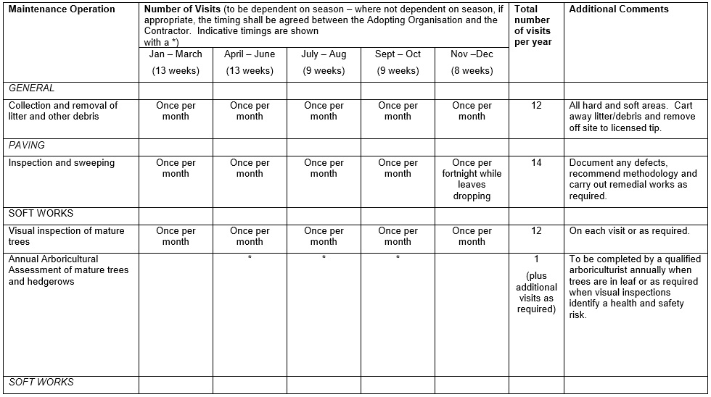

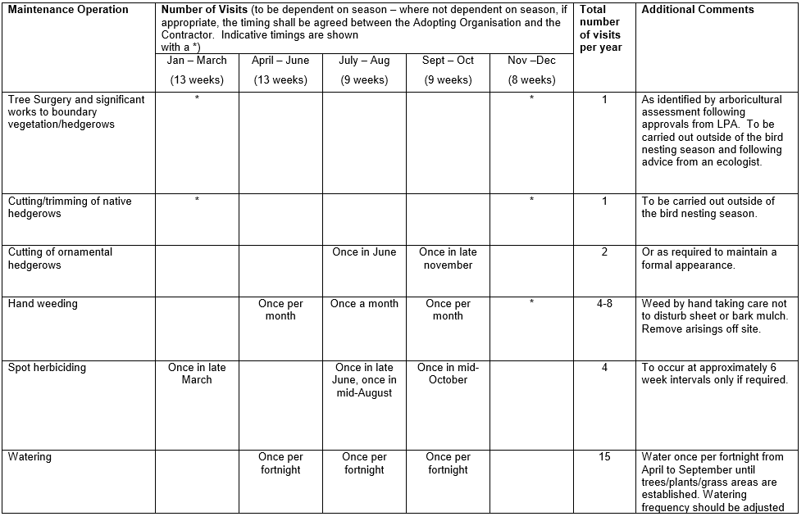

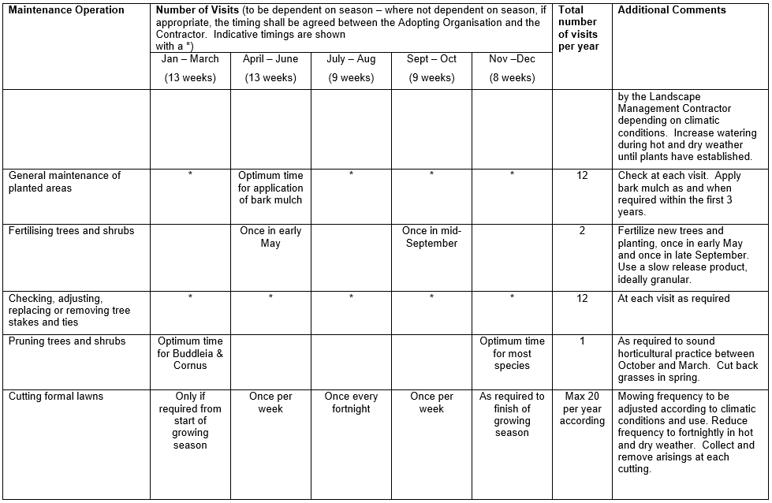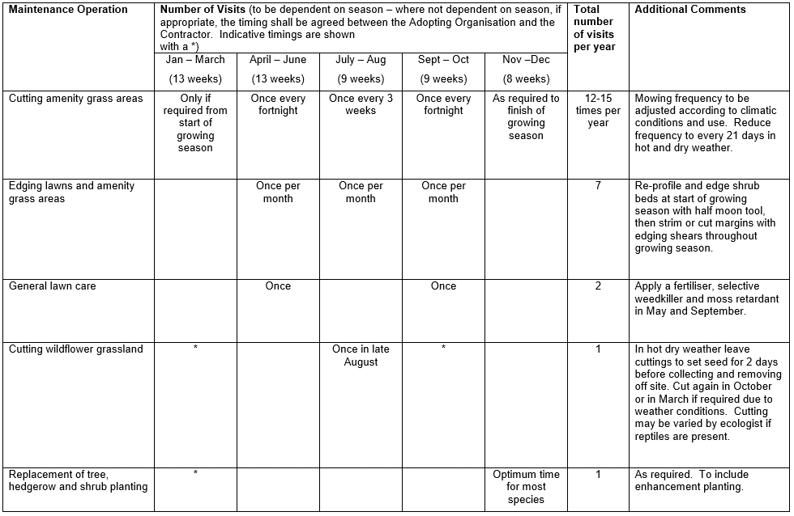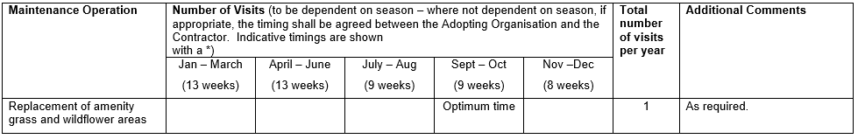

PLANTING SCHEDULE
TREES
No. Botanical Name Common Name Size/Form Root

1 Betula pendula ’Dalecarlica’ Swedish birch Feathered B.R.
1 Betula utilis Birch Feathered B.R.
1 Sorbus x arnoldiana ‘Schouten’ - L.S. B.R.

SHRUBS
1 Buddleia ‘white profusion’ Butterfly bush 40-60cm C3
9 Brachyglottis ‘sunshine’ - 30-40cm C3
20 Buxus sempervirens Box 20-30cm C3
6 Caryopteris X clandonensis - 30-40cm C3
‘Heavenly Blue’
3 Fatshedera x lizea Tree ivy 40-60cm C3
1 Hamamelis mollis Chinese witch hazel 60-80cm C10
3 Hebe ‘mid-summer beauty’ 20-30cm C2
22 Hypericum calycinum Rose of Sharon 30-40cm C2
3 Juniper communis ‘compressa’ - 20-30cm C2
1 Osmanthus delavayii - 20-30cm C3
9 Perovskia atriplicifolia ‘Blue spire’ Russian sage 20-30cm C2
9 Phlomis fruticosa Jerusalem sage 20-30cm C3
3 Rosemarinus ’Miss Jessop’s upright’ Rosemary 20-30cm C2
9 Salvia officinalis ‘grandiflora’ Sage 20-30cm C2
2 Sambucus nigra ‘Aurea’ Golden Elder 40-60cm 3L
9 Santolina chamaecyparis Cotton lavender 20-30cm C2
1 Syringa vulgaris ‘Katherine Havemeyer’ Lilac 30-40cm C3

HEDGE TRANSPLANTS
80 Crataegus monogyna Hawthorn 1+1 B.R.
80 Crataegus laviegata Midland hawthorn 1+1 B.R.
60 Fagus sylvatica Common beech 1+1 B.R.
30 Prunus spinosa Blackthorn/sloe 1+1 B.R.
10 Ilex aquifolium Holly 30-40cm 1L.

ORNAMENTAL HEDGING
60 Berberis thunbergii Barberry variety 30-40cm C3
15 Cistus X purpureus Rock rose variety 30-40cm C3
50 Lavandula spica ‘Hidcote’ Lavender variety 15-20cm C2
10 Rosa rugosa ‘Alba’ White dog rose 40-60cm B.R.

GROUNDCOVER
30 Cornus canadensis - 15-20cm C2
30 Hedera helix ‘Buttercup’ Ivy variety 30-50cm P9
35 Hedera helix ‘Hibernica’ Irish Ivy 30-50cm P9
12 Vinca major Periwinkle 30-40cm C2
40 Vinca minor ‘Alba’ Lesser periwinkle 20-30cm C1

HERBACEOUS PERENNIALS
15 Lamium galeobdolon variegatum Ornamental dead nettle C2

BULB PLANTING
- 150 no. Narcissus pseudo-narcissus Daffodil.
- 50 no. Tulipa ‘Arkadia’. Lily flowered tulip.
- 50 no. Tulipa ‘White Triumphator. Lily flowered tulip.

Planting notes for bulbs.
Ideally bulbs grow best when planted during their dormant period in the late summer and autumn. For maximum effect they can be planted in large drifts in grass and under trees as shown in the accompanying planting plans. The key to successful planting is good preparation, making sure that the ground is weed free and the grass is cut short. In general, all should be planted at a depth equal to the height of the bulb, except daffodils which should be planted 10 cm below the finished ground level.

