Application for Full Planning Permission by

Tina Dolby
for
The Change of Use of Land to an Enclosed Dog Paddock

at

Land at sycamore Farm Redden Flowers Holbeach Road Spalding, Lincolnshire, PE12 6JP.

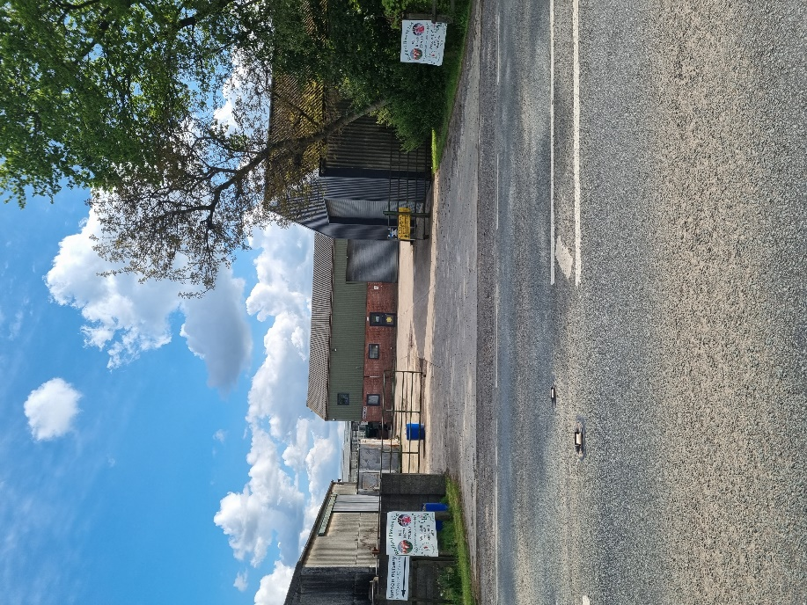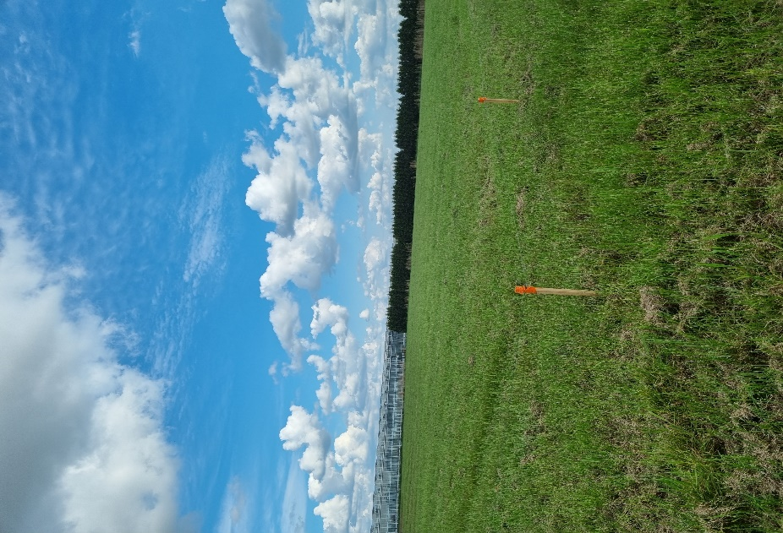

PLANNING STATEMENT

Date: 11/05/2023
Our Ref: Tina Dolby

PLANNING STATEMENT

This Planning Statement is to be considered in conjunction with the submitted drawing and Business Plan and forms our full justification for the proposed development in the context of national planning guidance and local planning policy.
Full planning permission is sought for the change of use of a grassed area to an enclosed dog walking paddock, as described within the following Statement. A proposed site layout plan is provided in order to show how the site will be laid out, how it will be accessed, and how the development will sit in relation to the surrounding land and the local area in general. The other details submitted include a site location plan, an existing site layout plan (on the same drawing) and Business Plan to describe the development as proposed.

The Site and Surroundings
Field is at the back of Sycamore Farm Holbeach Road located off the A151, which links, the A16 Spalding Boston and Holbeach.
Proposed Happy Tails & Dirty Paws Dog Paddock can be seen on the plan photograph below.

The application site itself is a near-rectangular parcel of land that is currently not used. The land is associated with the property of Redford Flowers Limited formerly Sycamore farm, and access to it is gained via an access track running between current farm building.

The land is used for Redford Flowers Limited a commercial nursery, recently laid to grass not in use.

The application site is level, laid to grass and measures 0.56 ha in area. The site contains no trees,
Access into the site is between through the same entrance as Redford Flowers and through their yard area. Followed by a hardcore path then a proposed extension of wood chipping to the gated site entrance.

There are no structures within the application site and no services (gas/electricity) that pass over or under it. There are no known public footpaths that cross the site or run adjacent to it,

Planning History
The Council’s website offers no planning history for the application site.

The Proposed Development
Planning permission is sought for the change of use of the land to allow it to be used as a secure and enclosed dog paddock, for private hire purposes.
The new use of the land will allow users to train, walk and exercise their dogs within a safe, enclosed field, which can be booked for hourly sessions (or longer if required), using an online booking system.
The use will allow owners to walk their dogs off the lead, without fear of the dogs running away or being in conflict with other dogs and/or their owners. This is particularly beneficial for dogs that may be nervous, aggressive, anti-social, have poor recall skills, have a disability or for when puppies that need to be trained away from other distractions.
Only customers who have registered to use the facility and who have booked to use the paddock will be granted access and there will be no overlaps in bookings to ensure that there is no conflict in the use of the dedicated parking area.
Further information on how the business will operate can be found in the submitted Business Plan, which forms part of this application.
Other than the fencing and access gates already referred to, there will be no permanent development on the site, Within the site itself, there will be a moveable field shelter, for customers to use in inclement weather, a bench for customers to rest on, and dog agility structures, all of which will be moveable around the site, allowing for variety for the dogs and for the ease of mowing the field. A self-closing dog waste bin, which will be located inside the enclosure and emptied frequently to a commercial bin located outside the gated area for ease of emptying by a licenced waste contractor.
Through providing a safe and secure dog walking service for local residents, which will add to the local economy accordingly, the proposed use of the site will only make minimal changes to its character and appearance, which will be entirely acceptable within the wider context of the site the site can easily be transferred back to grassland with removal of fencing and gate.
The Covid pandemic resulted in increased dog ownership throughout the UK, and with more dogs, and more people working from home, or during more flexible hours, there is a greater need for such a facility.
Access into the site will be via the existing entrance to Redford Flowers where, beyond the access gates, the existing grass will be replaced with a woodchipped surface, and 2 parking spaces will be created. There will be sufficient space within the site for vehicles to turn and leave the site in forward gear.
The hours of operation for the dog walking paddock would be from 7am to 8pm between April and September, and from 7.30am to 4pm from October through to March.

Planning Policy
Relevant national Government planning guidance in this case is contained within the National Planning Policy Framework (the ‘NPPF’), as revised in July 2021.
The NPPF makes it clear in Section 2 that the purpose of the planning system is to contribute to the achievement of sustainable development. At paragraph 8 it identifies sustainable development as being ‘economic’, ‘social’ and ‘environmental’ whereby all planning proposals should contribute to building a strong, responsive, and competitive economy, support strong vibrant and healthy communities and contribute to protecting and enhancing our natural, built, and historic environment. Comment - The proposed development will clearly help to contribute to the local economy through the start-up of a new business venture, at the same time as having no detrimental impact on the local environment.
Paragraph 9 of the NPPF goes on to state that planning decisions should play an active role in guiding development towards sustainable solutions and, in doing so, should take local circumstances into account to reflect the character, needs and opportunities of an area. Comment - The proposed development achieves these aims as this will be a new rural business that will serve the local population (and beyond), where it will contribute to the local economy and will support local employment.
Paragraph 11 of the NPPF puts forward the presumption in favour of sustainable development and, in terms of decision making, states that development proposals that accord with an up to date ‘development plan’ should be approved without delay. Comment - It will be argued below that the proposed development will be in accordance with the ‘development plan’ and should therefore be approved accordingly.
Section 6 of the NPPF relates to ‘Building a Strong, Competitive Economy’ and paragraphs 84 and 85 provide support for a prosperous rural economy. Part a) of paragraph 84 allows for the development and diversification of agricultural and other land-based rural businesses and part c) promotes leisure developments that respect the character of the countryside. Part d) goes on to allow for the development of accessible local services. At paragraph 85 the NPPF recognises that, where development may not be well-served by public transport, it remains sensitive to its surroundings and does not have an unacceptable impact on local roads. Comment – The change of use of this land will clearly allow for a new, land -based business that will promote leisure uses and which will provide an accessible local service that will benefit the local economy. For these reasons it is clear that the proposed development would be compliant with these parts of the NPPF.

Section 9 of the NPPF relates to ‘Promoting Sustainable Transport’ and at paragraph 111 it states that development should only be prevented or refused on highway grounds if there would be an unacceptable impact on highway safety or the residual cumulative impacts on the road network would be severe. Comment – With, on average, only 1 vehicle an hour accessing the site, during main daylight hours, there is no way that that use of the site will have an unacceptable impact on highway safety within the area and impacts of road use to access the premises will in no way be severe.
Section 11 of the NPPF relates to ‘Making Effective Use of Land’ and, at paragraph 119, states that planning policies and decisions should promote an effective use of land in meeting the need for homes and other uses, while safeguarding and improving the environment and ensuring safe and healthy living conditions. At paragraph 120 a) it states that planning decisions should encourage multiple benefits from urban and rural land, especially where this would improve public access to the countryside. Comment – The change of use of this land will comply with the provisions of this condition and will allow dog walkers who, for whatever reason are unable to walk openly in the countryside, to access a safe, open countryside location for recreational purposes.
Section 14 of the NPPF refers to ‘Meeting the Challenge of Climate Change, Flooding and Coastal Change’ and, at paragraph 159, states that inappropriate development in areas at risk of flooding should be avoided. At paragraph 168 the NPPF states that, for minor development proposals and certain changes of use, a site-specific flood risk assessment may be required. Comment – The use of a field for an alternative use in this instance is replacing a ‘less vulnerable’ use with another ‘, and the only site users would be customers and their dogs. Customers would clearly not use the site if there was any chance of flooding so, in terms of flood risk, the proposed use of the site is far better than the existing use. The advice within the NPPF on the requirement for a Flood Risk Assessment is unclear, so we are taking view that simply changing the use of the field to allow for people with their dogs to use it as opposed to layed to grass, will not require a supporting FRA at planning application stage.
Section 15 of the NPPF relates to ‘Conserving and Enhancing the Natural Environment’ and encourages all development to enhance the natural and local environment by (inter alia) minimising impacts and providing net gains for biodiversity. Comment – The applicants will improve the levels of biodiversity on the site through allowing a wild area which, over time, will clearly help to ‘green’ the site at the same time as appealing to birds, insects and other wild species that may be attracted to this area.
The ‘Development Plan’ in this case is formed by the Southeast Lincolnshire Local Plan 2011 to 2036, which was adopted on the 8th March 2019.
Proposals falls outside the mapped areas and is in an open area.

It is clear from the attached photos that the entrance into the site is within the settlement boundary of Spalding, but the majority of the site is within the open countryside.
Policy 1 of the Local Plan sets out the Council’s ‘Spatial Strategy’ for development within the District and, with regard to proposals within the open countryside, states that development will be permitted where it is necessary in such a location and/or where it meets the sustainable development needs of the area in terms of economic, community or environmental benefits. Comment – The proposed development has to be located in a rural area by its very nature and, in terms of sustainability, will clearly benefit the local economy, the community (local dog walkers) and the environment, as a result of the planting that has taken place.
Policy 2 focusses on ‘Development Management’ and is a criteria-based policy which serves to allow development that is acceptable in terms of (inter alia) size, scale, layout, use, amenity, landscaping, materials, access and vehicle generation, infrastructure, pollution, flood risk and ecology. Comment – In our opinion the proposed development meets all of these requirements which therefore makes the proposal fully complaint with Policy 2 of the Local Plan.
Policy 3 of the Local Plan relates to the ‘Design of New Development’, but this policy is not directly relevant to the development proposed as there is no ‘design’ involved in the change of use of the land.
Policy 4 of the Local Plan sets out the Council’s ‘Approach to Flood Risk’ and, in relation to proposals for a change of use, states that such proposals will be supported (for buildings) where they do not pose an increase in risk to people. Comment – As the proposed development is only a change of use of land and not a building, and will only change the use of the field from a grassed fallow area, to a dog walking field, used by people and dogs, there will be no increase in risk from flooding in order to require the need for the submission of a Flood Risk Assessment. Further comments are given on this point in the ‘Other Material Considerations’ section of this Statement.
Policy 28 relates to ‘The Natural Environment’ and seeks to protect, enhance, and manage the natural assets of the District. Part 3 of this policy relates to gaps in the ecological network and serves to support development proposals that provide an overall net gain in biodiversity. Comment – The application site is layed to grass already. In order to increase biodiversity within the area a portion of the field will remain wild.
Policy 36 focusses on ‘Vehicle and Cycle Parking’ and seeks to ensure that all new development provides vehicle and cycle parking in accordance with the adopted parking standards. All parking spaces should be fit for their intended use in terms of size and design. Comment – There is no recognisable ‘standard’ for parking levels to support the intended use of the site. However, with most visitors using the field individually, or in pairs/as a couple, and having sole use of the facility for their booked timeslot, then it is highly unlikely that there will ever be more than 1 car on the site at any one time. 2 parking spaces will be provided in order to cover for any unforeseen overlaps in use, which will be more than enough to serve the use. One of the parking spaces will be large enough to be fully accessible by a disabled person.
There are no adopted ‘Supplementary Planning Documents’ or ‘Supplementary Planning Guidance’ documents that are relevant to a proposal of this type.

Other Material Considerations
The South east Lincolnshire Strategic Flood Risk Assessment (2017) needs to be taken into consideration in the determination of this planning application as the entire area within which the application site is location (and for many miles around) is within Flood Zone 3.
Section 12 of this document relates to ‘Site Specific Flood Risk Assessment’ and mirrors the advice given in Section 14 of the NPPF wherein an FRA should accompany all proposals for new development located within Flood Zones 2 and 3. However, at paragraph 12.1.4 it states that an FRA will only be required for a change of use where the new use would be to a more vulnerable flood risk classification. Comment – In this case we are not changing the use of the land to a more vulnerable use in flood risk terms, so it is not considered that an FRA is required in support of this application. Moreover, we are of the opinion that the proposed use of the land is preferable in terms of flood risk,
More information on enclosed dog paddock within the UK can be found on the British Dog Fields website, which can be accessed via the link below. This includes advice on starting a dog field business, the planning process and the need for a formal permission, details on leasing land, and a ‘search’ system in order to locate the nearest enclosed dog walking field using a postcode or address.
https://britishdogfields.com/

Conclusions
The above paragraphs show that the proposed development is wholly in accordance with the national planning guidance set out in the National Planning Policy Framework.
At a local level, it is clear that the proposed development complies with the relevant policies within the adopted ‘Development Plan.’ For these reasons, it is considered that the proposed development is wholly compliant with both national planning guidance and local planning policy.
With no other material considerations to indicate that the development should be resisted, and in accordance with paragraph 11 of the NPPF and Section 38(6) of the PCPA 2004, it is respectfully requested that the development is ‘…approved without delay’.
It is therefore requested that planning permission is granted accordingly.

