Proposed planning permission- Rush Hour Escape Rooms LTD
3B Red Lion Street
Spalding
PE11 1SX

1. Change use of property
Converting the property to D2 - Assembly and Leisure. Escape room activity. Opening Tuesday - Sunday 10am-9pm.
The proposed planning is for two units of offices approximately 50sq metres per unit.

2. Signage
Outside the building will comprise of three signs near the door on the exterior of the building. This will include a hanging sign and one signs with logo and more information to the side of the door. The sideway sign above the door will be approximately 50cm x 50cm. The signs to the side of the door will be slightly smaller.

3. Building control
The two units will have very minor alterations. On the first floor there will be no building works required. The escape room will only need to have minor adjustments to doors with locks and a full CCTV system will be installed.
On the top floor of the building is a proposed stud wall being put up across the width of the room. A door will need to be added into the wall as well as a hatch on the floor for an alternative escape route out of the activity room. This unit will also feature CCTV and various electronics and lighting changes to suit the theme of the escape room.

4.Fire/Health and safety
Emergency exit buttons will be added to each room. This will ensure that when the room is locked, the occupants can leave whenever they need to in case of an emergency. Both units will also be checked and signed off for the safety of the occupants with relation to electronics and fire safety.

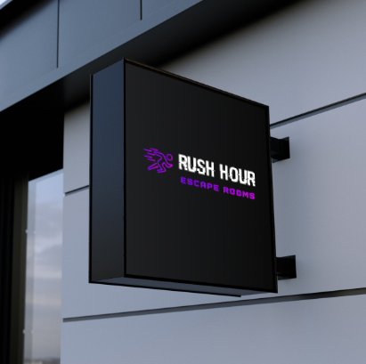

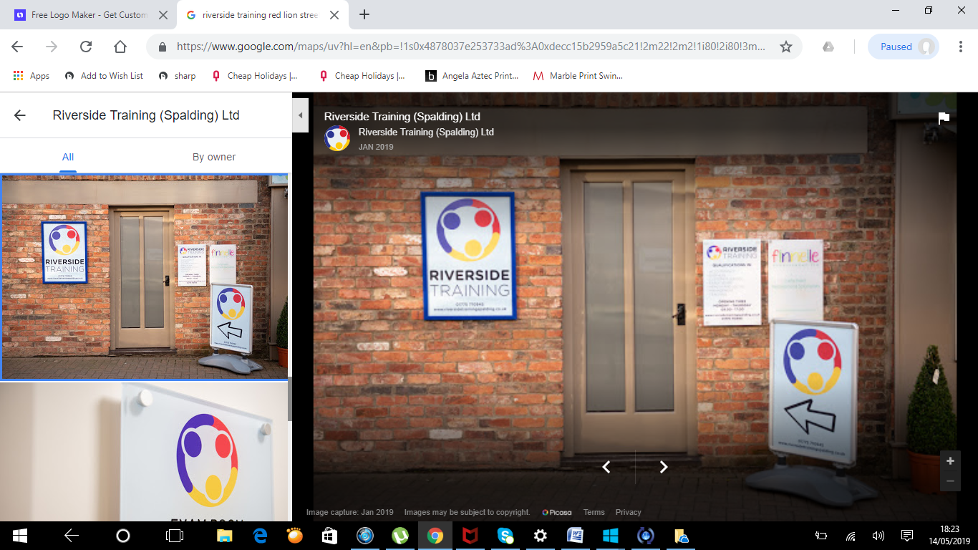

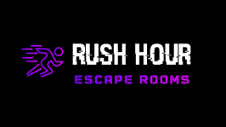

]
Proposed rooms
First floor- 3A Red Lion street
NO BUILDING REQUIRED
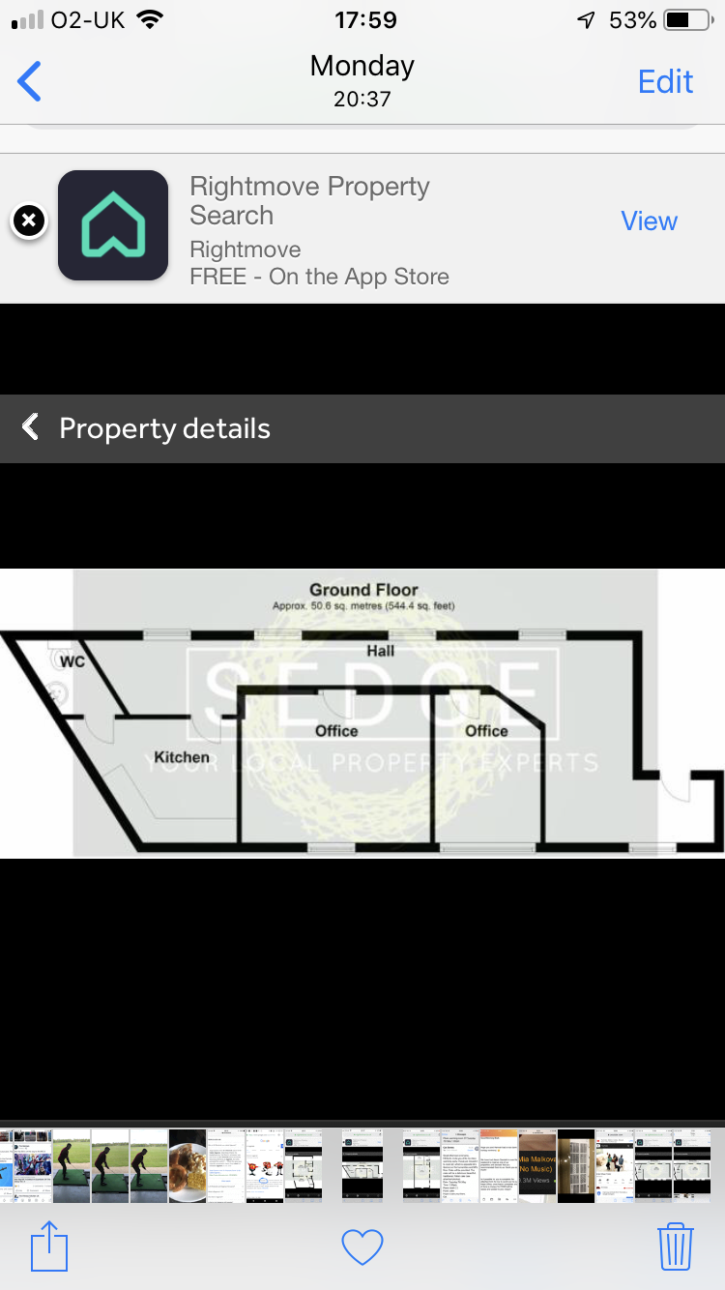

Top floor 3C Red Lion Street
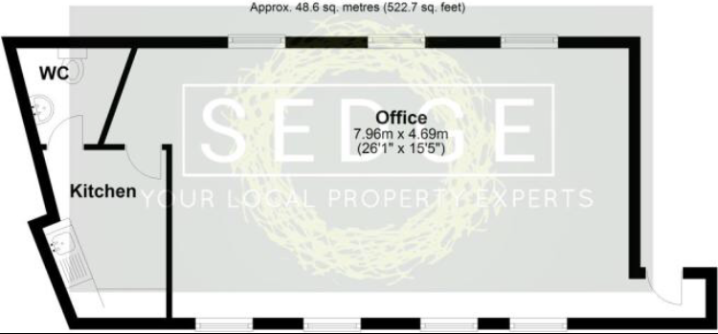

Building adjustments
Control counter. PC + Cameras

Entrance door to be added
Stud wall to be built across the room
Door into kitchen- Second part of the escape room
Floor exit to be added. Escape hatch

