Proposed Plan to Open an Enclosed Dog Paddock
—Happy Tails & Dirty paws Dog Paddock—

Intro Statement
The dog paddock had now been in operation since 11th August 2023.
We have many returning customers and have had no complaints about noise.
Personally, I have owned my oldest dog now since 2018 Getting a second dog in 2022.
My first dog has a nervous disposition making me wary around other dogs.
The freedom that is offered by an enclosed paddock area can teach agility and let them both run about in safety.
I have canvassed dog owners on the usage of dog paddocks, and they agree they use them but there are not enough about.
I grew up with dogs in a rural location and dogs just love to run about.
I now live in Spalding and the opportunity to walk dogs. Is limited.
A safe enclosed area to walk, train, play and desensitise can be a real-life saver in reversing the damaging results of crowded situations as well as helping those dogs with reactivity issues, nervousness, and recall problems to have a safe worry-free place to have their dogs off lead.
It is also helpful to owners with mobility issues assisting with helping to maintain their independence to walk their own dog. The demand for safe dog walking exercise areas has increased exponentially in recent years especially during covid-19 pandemic with the significant rise in dog ownership.
Being a dog owner myself I have seen new enclosed dog paddocks beginning to pop up across the country but there is far more demand than there is supply.

Proposed Operation
- The field is fully fenced with 6ft high agricultural posts and heavy duty weld mesh fencing wire in keeping with the countryside environment with a large 14 ft gate for access needs.
- The fence will enable people to walk their dogs off lead without fear of them running off or being a danger to any livestock or protected wildlife.
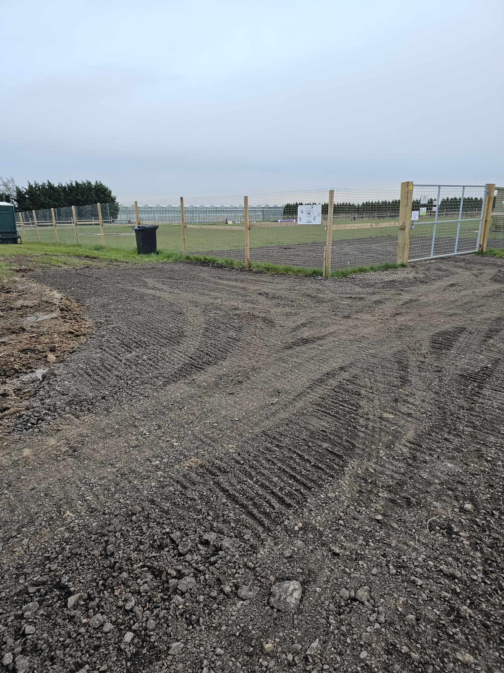

- The site also benefits from space for a private enclosed parking area which is entered via the field gate entrance accessed from the driveway off the track, once closed on entry this will create a safe area to get the dogs from the car straight onto the field. For the parking area we would like to have it for a maximum of four vehicles per individual booked slot laid using road plainings.
- Inside the field will be the provision of a dog waste bin. This will be emptied into a larger bin on the outside which will be emptied at regular recommended intervals via a waste management company.
- Also, in the field we would like to place a field shelter for any spontaneous inclement weather as well as a form of shade from the sun. (Please see photo) Plus a moveable picnic style bench. Field shelter is of wood construction. 9 feet by 16 feet
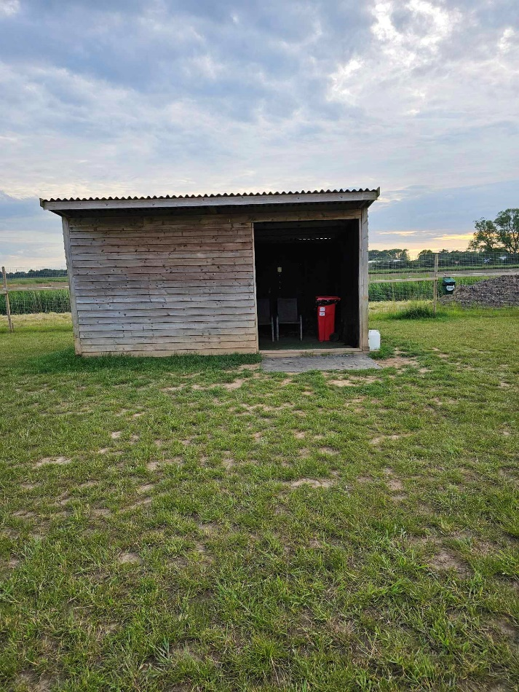
- Also, for dog enrichment/ interactive play we would like to provide moveable agility equipment low-level jumps/ weave poles. Agility equipment provides exercise both mentally and physically for both dogs and their owners it promotes focus and with that good behaviour creating a positive involvement for the dogs. All dogs enjoy sniffing, exploring, and interacting with their owners so we will have areas of long grass for additional mental stimulation for those dogs that enjoy foraging and sniffing.

(Examples of the agility equipment)
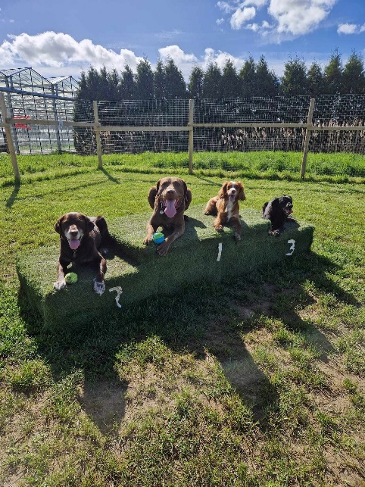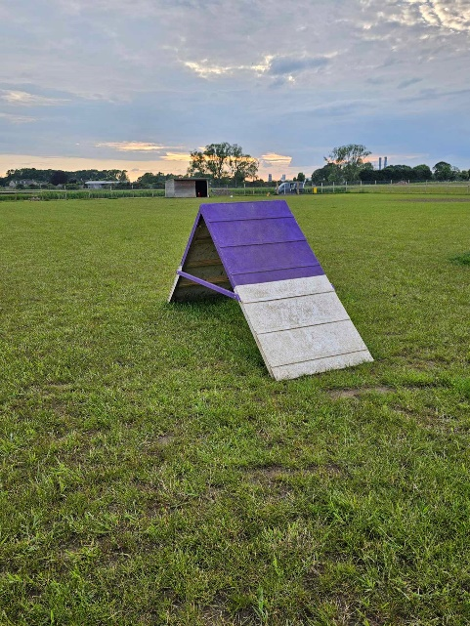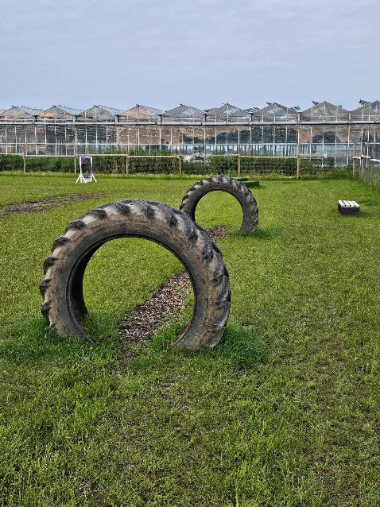

- The proposed hours of operation will be daylight hours only 7 am -8 pm April to
September (summer months) and 7 am – 4 pm October to March (winter months).
- The use of the field will be by appointment only, each person will book an exclusive 50 min slot via an online booking and payment system. They will have exclusive use of the field to walk/exercise their dog(s). A limit of currently 6 dogs proposing to increase to 10 dogs each booked session will be enforced. Each slot will have a 10-minute buffer between bookings which will be maintained to ensure there is no overlap between users. This will be achieved by booking arrival times being on the hour and exiting the site completely 50mins later.

